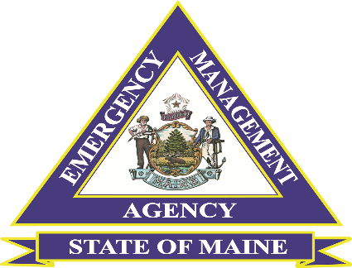

Maine Voluntary Organizations Active in Disaster

ICS 100 and ICS 200 Virtual Courses Announcement

The Maine Emergency Management Agency (MEMA) and the Maine Voluntary Organizations Active in Disasters (MVOAD) are partnering to deliver ICS 100 and ICS 200 Virtual Courses. The target audience for the Courses is VOAD Members, Government, Non-Government, Private and Non-Profit Agencies and Organizations. All Courses will be offered in two parts.

Target Audience: VOAD Members, Government, Non-Government, Private, and Non-Profit Agencies and Organizations.

ICS 100 Introduction to the Incident Command System

This 6-hour, 2-part foundation-level course is a virtual interactive course that introduces the Incident Command System (ICS) and provides the foundation for higher-level ICS training. This course describes the history, features and principles, and organizational structure of the ICS. It also explains the relationship between ICS and the National Incident Management System.

ICS 200 Incident Command System for Initial Response

This 6-hour 2-part course is a virtual interactive course that is designed to enable personnel to operate efficiently during an incident or event within the ICS. ICS-200 provides training and resources for personnel who are likely to assume a supervisory position within the Incident Command System (ICS).

Those who register for the course will receive an email confirmation with a TEAM’S invitation no less than 48 hours prior to the course session, Course Participants will be emailed a Certification of Attendance following the successful passing of a post course examination and the delivery of all sessions.

The course will be offered on several dates and times to accommodate the availability of participants at no cost. For further questions, please get in touch with Bill Guindon, MEMA Mass Care Coordinator, at 207-458-2867 or william.guindon@maine.gov
ICS 100 (No Prerequisites)
ICS 100 Part A (Select only 1 session per Day)
October 7, 2026, Time: 1:00 am to 4: 00 pm Registration Deadline: 10/1
October 7, 2026, Time: 6:00 pm to 9:00 pm Registration Deadline: 10/1
ICS 100 Part B (Select only 1 per session Day)
October 15, 2026, Time: 9:00 am to 12:00 pm Registration Deadline: 10/9
October 15, 2026, Time: 6:00 pm to 9:00 pm Registration Deadline: 10/9

ICS 200 (Prerequisites ICS 100 or IS 100 C)
ICS 200 Part A (Select only 1 session per Day)
November 5, 2026, Time: 9:00 a.m. to 12:00 p.m. Registration Deadline: 10/30
November 5, 2026, Time: 6:00 p.m. to 9:00 p.m. Registration Deadline: 10/30
ICS 200 Part B (Select only 1 session per Day)
November 11, 2026, Time: 9:00 am to 12:00 pm Registration Deadline: 10/30
November 11, 2026, Time: 6:00 pm to9:00 pm Registration Deadline: 10/30
To register, follow this link: https://forms.cloud.microsoft/g/0Mc6v18Ed1
Or Scan QR Code
