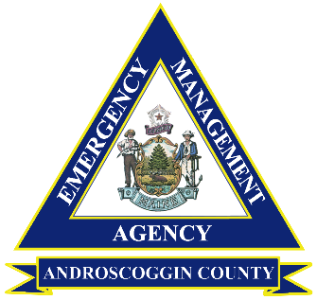NIMS 402 aims to familiarize senior officials with their role in supporting incident management within the National Incident Management System (NIMS). There are no prerequisites for this course.

Androscoggin County Emergency Management Agency is hosting **NIMS 402:** Incident Command System Overview for Senior Officials

Topics include (but are not limited to): What is NIMS, Preparedness, ICS Organization & Features, Emergency Operation Centers, The MAC Group and Joint Information System

Registration Information:

|  |  |
| --- | --- |
| First Name |  |
| Last Name |  |
| Organization / Agency |  |
| Title |  |
| Email Address |  |
| Phone Number |  |
| Dietary Restrictions |  |

**Date:** 12/2/2024

**Time:** 5:00PM-9:00PM

**Location:** Androscoggin County EMA, 45 Oak Street, Lewiston, ME

*The EMA office is located in the basement of Lewiston Central Fire Station*

Dinner and refreshments will be provided

**REGISTRATION DEADLINE: 11/25/2024**

Please return completed form to [elivak@androscoggincountymaine.gov](mailto:elivak@androscoggincountymaine.gov).

Confirmation of course registration will be sent upon receipt.