WHAT IS SALT BRINE?
Salt brine is water saturated with sodium chloride, or more simply, rock salt dissolved in water. It is part of MaineDOT’s anti-icing program to take a proactive approach to controlling snow and ice on Maine’s highways.

WHEN IS SALT BRINE USED?
Salt brine is used in two ways: 1) it is sprayed onto the pavement before a storm (this is known as “pre-treating”), and 2) it is sprayed onto rock salt as it is being applied (this is known as “pre-wetting”).

PRE-TREATING
Pre-treating is a snow fighting strategy used in anticipation of road/bridge frost or warmer winter storms (normally above 20º F). Salt brine can prevent frost for up to three days. If applied just before a winter storm, salt brine will begin working as soon as the first snowflake falls and will delay the accumulation of snow and ice on the pavement.

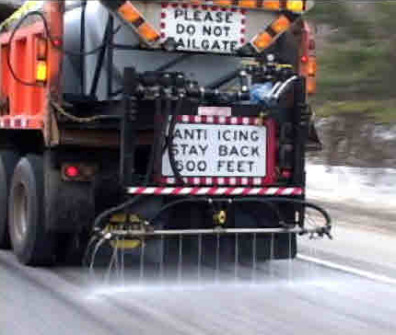

PRE-WETTING
Once a winter storm is in progress, salt brine is sprayed onto the rock salt, as it is applied, to accelerate the melting of the snow and ice. This process activates the rock salt and helps it stay on the pavement instead of bouncing off the roadway. Pre-wetting with salt brine in this manner helps reduce the amount of rock salt that MaineDOT must use overall.

WHY DOES MaineDOT USE SALT BRINE?
Salt brine costs roughly 1/10th of other liquid chlorides. In addition, salt brine allows MaineDOT crews to be proactive and get a jump-start on winter storms. This means that MaineDOT crews can have entire routes pre-treated before the driving conditions decline and the snow and ice will be prevented from bonding to the pavement surface – which is the main purpose of an anti-icing program. As a result, the roads return to bare pavement much quicker once the storm has ended.

HOW IS SALT BRINE
APPLIED TO THE ROAD WHEN PRE-TREATING?
Motorists can expect to see MaineDOT crews pre-treating the roads with salt brine using specially modified tanker trucks, trailers, or units that slide into the back of a typical plow truck. Most of this equipment is capable of spreading salt brine over one, two, or three lanes of pavement.

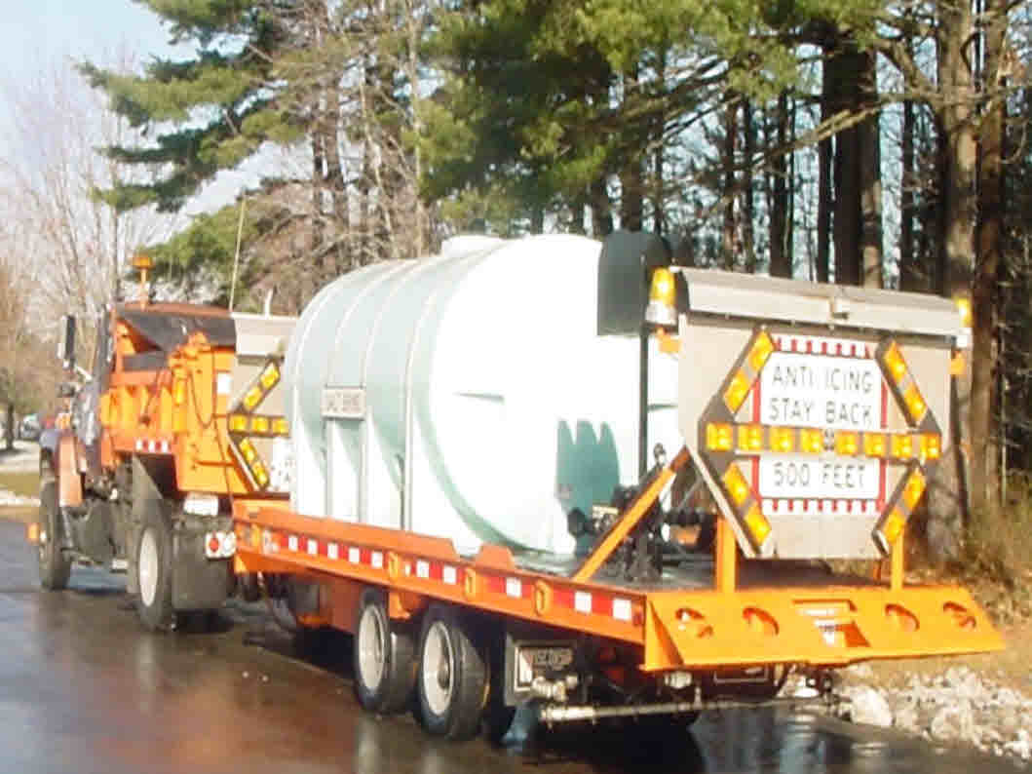

WHAT SHOULD I DO WHEN FOLLOWING A VEHICLE APPLYING SALT BRINE?
Vehicles applying salt brine usually travel at speeds of less than 40 miles per hour. Motorists should stay back at least 100 feet from the vehicle.

WHEN DOES MaineDOT USE OTHER LIQUIDS?
The effectiveness of sodium chloride (rock salt or salt brine) decreases as the temperature drops. Therefore, as storms become colder (usually below 20º F), snow fighters must use chemicals that work more effectively at lower temperatures to pre-wet the rock salt. Liquid calcium or magnesium chlorides are the most common options. Presently, MaineDOT uses a magnesium chloride blend that contains a lower chloride percentage and is recognized as being “Designed for the Environment” by the EPA.
