Maine – New Hampshire Connections Study
Pedestrian and Bicyclist Origin and Destination Survey
Summary Report
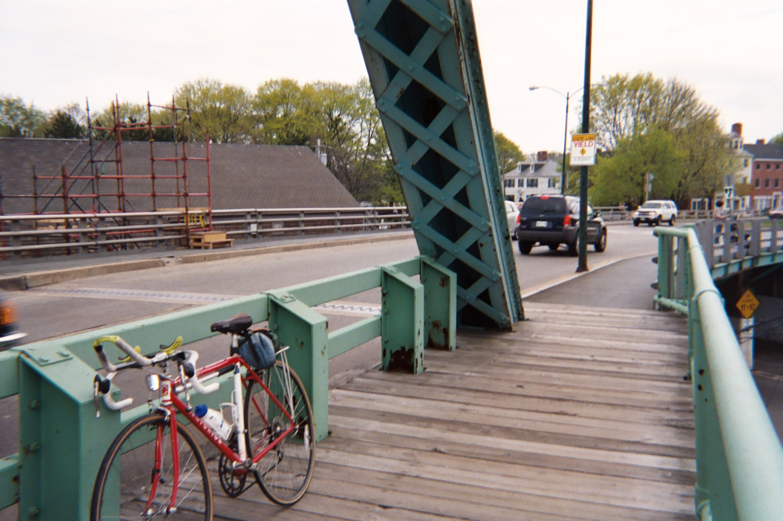

Prepared for:

Maine Department of Transportation
New Hampshire Department of Transportation




Prepared by:


August 2009

Table of Contents
Section 1 Purpose and Conduct of the Study 3
Section 2 Survey Results 5
2.1 Pedestrian and Bicyclist Volumes 5
2.2 Transport Type 6
2.3 State of Residence 7
2.4 Trip Purpose 8
2.5 Frequency of Bridge Usage 11
Section 3 Conclusions 13

Table of Figures
Figure 1 – O&D Survey Form 4
Figure 2 – Comparison of Weekday Bike-Ped Counts, July 15th vs. July 16th, 2009 5
Figure 3 – Bridge Crossing Transport Type 6
Figure 4 – Transport Type Comparison, Weekday Peak Hour vs. Off-Peak Hour 7
Figure 5 – State of Residency, Bicyclists and Pedestrians 7
Figure 6 – State of Residency Comparison, Bicyclists vs. Pedestrians 8
Figure 7 – Trip Type Summary, Weekday vs. Weekend 9
Figure 8 – Trip Purpose by Transport Type 10
Figure 9 - Trip Origin and Destination as Related to the Study Area 11
Figure 10 – Frequency of Usage Summary 12

Purpose and Conduct of the Study
In July 2009, a pedestrian and cyclist origin-destination survey was conducted on the south side of Badger Island, at the north end of the Memorial Bridge (US-1) between Kittery, ME and Portsmouth, NH. The purpose of the survey was threefold:
- to understand the characteristics of pedestrian and cyclist usage of the U.S. Route 1 river crossing;
- to understand the common types of trips made by pedestrians and cyclists that use the Memorial Bridge; and,
- to help identify and evaluate the potential impacts of alternative transportation strategies on bicyclists and pedestrians.

The O&D survey was conducted on two days—Thursday, 16 July 2009, and Saturday, 18 July 2009. These days were chosen in order to observe any fluctuation in pedestrian and cyclist patterns between weekdays and weekends. Each survey was conducted in two 3-hour blocks: from 11am to 2pm, and again from 3pm to 6pm. Interviewers requested pedestrians and cyclists to stop by word of mouth, as well as by holding signs that stated ‘Bicycle Survey, Please Stop’. Those unwilling to stop and participate were thanked and allowed to continue. The survey took less than thirty seconds, and caused no delay in sidewalk traffic.

The survey was designed to gather the following seven pieces of information:

- Direction of travel (NB vs. SB)
- Transport type (pedestrian vs. bicycle)
- State of permanent residence
- Frequency of travel (both in terms of days per week and months per year)
- Trip origin (location at which the current trip started)
- Trip destination (location at which the current trip will end)
- Trip purpose

The survey form used by HNTB to collect the data is depicted in Figure 1.

Overall, a total of 242 bicyclists and pedestrians were interviewed—117 during the weekday survey, and 125 during the weekend survey. This represents a statistically valid sample size, yielding a confidence level of 95% with a confidence interval of ±6%.

In addition to performing interviews, HNTB also performed 10-hour counts of all bicyclists and pedestrians. Although not all bicyclists and pedestrians were interviewed, all were counted. These counts were conducted on 3 different days: Wednesday, 15 July 2009 (a sunny weekday); Thursday, 16 July 2009 (a cloudy weekday); and Saturday, 18 July 2009 (a sunny weekend).

Figure 1 – O&D Survey Form

Survey Results
This section will review the key results of the O&D survey. The first portion of this section will look at patron characteristics, while the second portion will examine trip characteristics.

Pedestrian and Bicyclist Volumes
As noted earlier, pedestrian and bicyclist volumes were recorded on three different days. Cameras were used to count on Wednesday, July 15th, while HNTB personnel provided field counts on Thursday, July 16th, and Saturday, July 18th. Figure 2 summarizes the total hourly counts recorded on these three days. It should be noted that Wednesday, July 15th and Saturday, July 18th were primarily sunny and warm, while Thursday, July 23rd was cloudy and cool.

Figure 2 – Comparison of Weekday Bike-Ped Counts, July 15th vs. July 16th, 2009
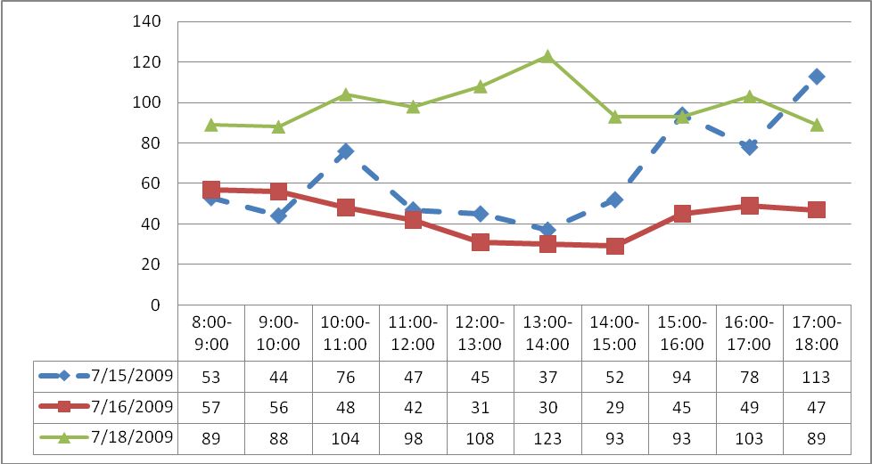

The dashed line in Figure 2 depicts pedestrian and bicycle traffic on a good weather day; these volumes experienced a notable increase in volume from 3pm onward. The red (thick) line, on the other hand, was recorded on a cooler, cloudier day. Its volumes did not fluctuate as much throughout the day. Overall, bike-ped traffic was nearly 50% higher on the “good weather” weekday as compared to the cloudy weekday.

The green (thin) line depicts Saturday volumes. These volumes were highest of all days counted. Overall, approximately 100 bike-ped crossings per hour were recorded during the Saturday count.

A comparison of bike-ped counts with vehicle counts indicates that approximately 5-7% of all the people crossing the Memorial Bridge are bicyclists or pedestrians.

Transport Type
As the surveyors approached willing participants, their method of transport was classified as either “pedestrian” or “bicycle”. Figure 3 summarizes the results of these classifications.

Figure 3 – Bridge Crossing Transport Type
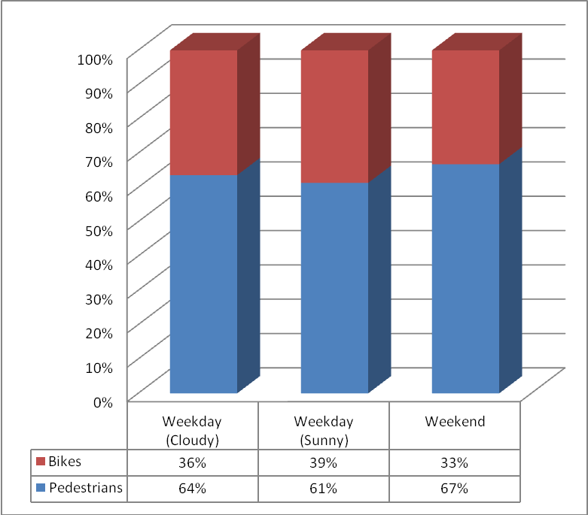

It is interesting to note that the distribution of pedestrians verses bicyclists remains relatively consistent, regardless of the type of day (weekday vs. weekend) or weather conditions (sunny vs. cloudy). In all cases, the split is roughly one-third bicyclists and two-thirds pedestrians.

Figure 4 compares the choice of transport type during the peak hour with the choice of transport type throughout the rest of the day. This data is drawn solely from the weekday data.

Figure 4 – Transport Type Comparison, Weekday Peak Hour vs. Off-Peak Hour
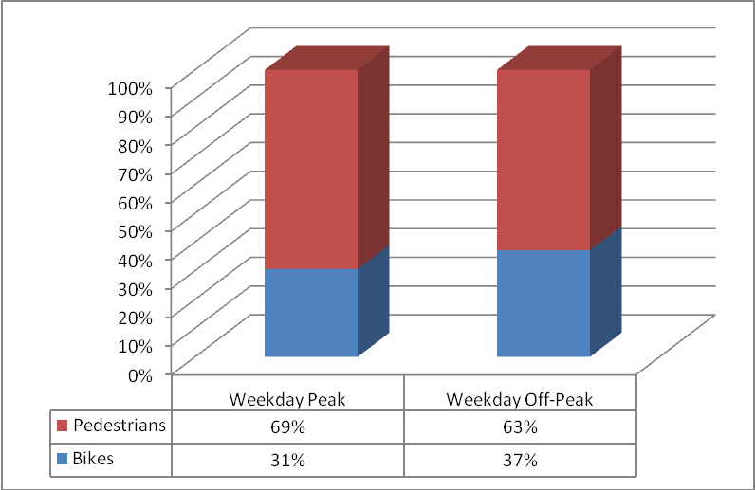

As Figure 4 illustrates, pedestrians make up a slightly higher share of the crossing volume during the peak hour, as compare to all other hours. However, the difference is not significant. Once again, the split during both time periods is very nearly one-third bicyclists and two-thirds pedestrians.

State of Residence
Pedestrians and cyclists were asked their state of residency. The results are summarized in Figure 5.

Figure 5 – State of Residency, Bicyclists and Pedestrians
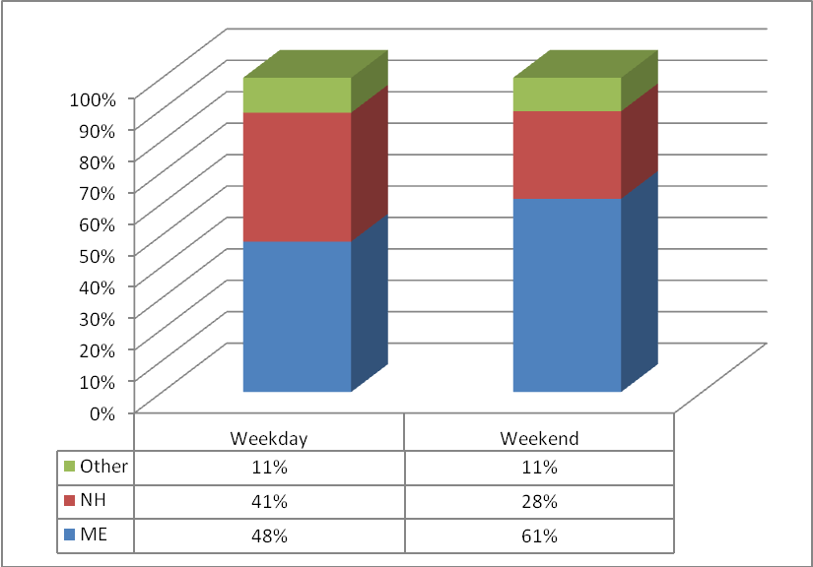

Maine residents, regardless of weekday or weekend, make up the greatest proportion of bike-ped traffic. Maine residents make up 48% and 61% of weekday and weekend bike-ped traffic, respectively, whereas New Hampshire residents make up 41% and 28% of weekday and weekend bike-ped traffic, respectively. This is likely because there are more Maine residences within a half-mile radius of the bridge than there are New Hampshire residences. While Badger Island and the north shore of the Piscataqua River consist primarily of homes, the south shore of the Piscataqua River consists primarily of commercial properties. Note that for both week days and weekends 11% of all bicyclists and pedestrians are from states other than Maine and New Hampshire.

Figure 6 illustrates how the state of residency varies by transport type.

Figure 6 – State of Residency Comparison, Bicyclists vs. Pedestrians
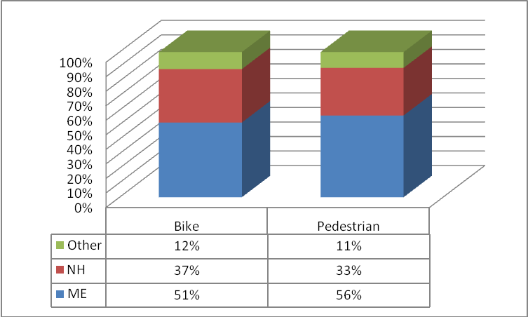

It appears that Mainers make up just over half of both bicyclists and pedestrians, while New Hampshire residents comprise just over one-third of both bicyclists and pedestrians. The remaining 10% of users—both bicyclists and pedestrians—are made up of people from other states. In other words, the composition of bicyclists (in terms of state of residence) is very similar to the composition of pedestrians.

Trip Purpose
The identification of trip purpose is an important component of any origin–destination study. For the purpose of this pedestrian and bicycle origin-destination survey, participants were asked to categorize their trip purpose into one of the following nine categories:
- Exercise – Pedestrians or cyclists utilizing the bridge for the purpose of exercise.
- Recreation/Leisure – Persons utilizing the bridge for the purpose of recreation or leisure, such as sightseeing.
- Work/Home – Persons crossing the bridge in order to go from home to work or from work to home.
- Personal Business – Persons conducting personal business such as visiting the bank or travelling to a doctor’s appointment by crossing the bridge.
- Shopping – Pedestrians or cyclists crossing the bridge in order to shop at a grocery store or mall.
- Food – Persons utilizing the river crossing for the purpose of visiting a restaurant.

The results are summarized in Figure 7:

Figure 7 – Trip Type Summary, Weekday vs. Weekend
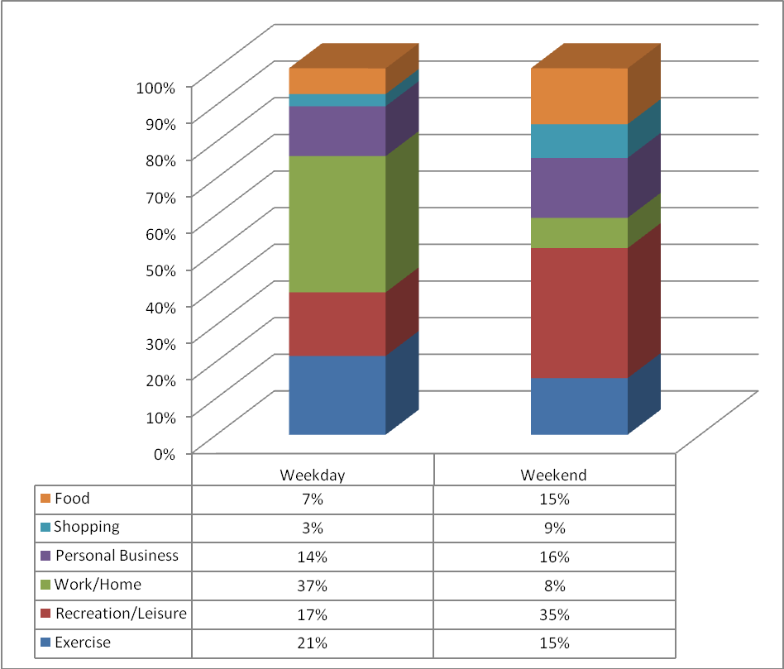

The following observations may be drawn from Figure 7:
- The most common type of trip on weekdays was between work and home, accounting for over one-third of all bridge crossings during the survey period.
- Conversely, “recreation/leisure” trips were the most common type of trip on weekends. These trips accounted for over one-third of all weekend trips during the survey period.
- The combination of “exercise” and “personal business” trips remained fairly consistent. Taken together, these two trip types comprised about one-third of all trips on both weekdays and weekends.
- The combination of “food” and “shopping” trips changed significantly from weekdays to weekends. On weekdays, the combination of these two trip types comprised one out of every 10 trips. On weekends, they comprised one out of every 4 trips.

Figure 8 examines the relationship between transport type and trip type. The data is broken out by weekday vs. weekend.

Figure 8 – Trip Purpose by Transport Type
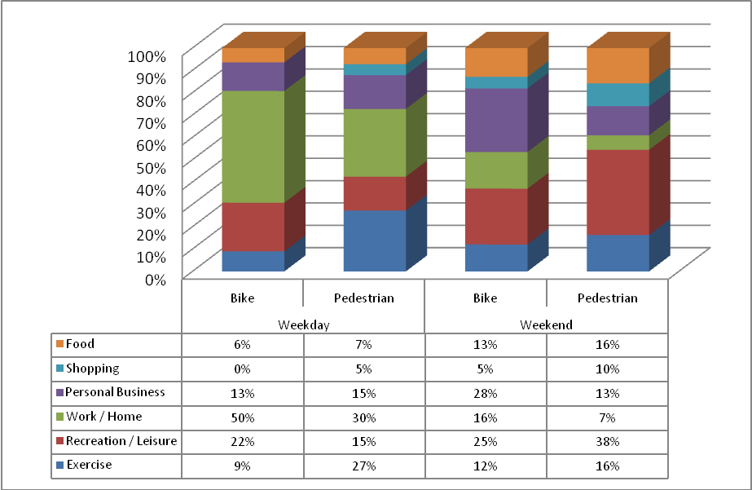

The following observations may be drawn from Figure 8:
- Bicyclists, in general, have a higher propensity for making commuting trips. On both weekdays and weekends, commuters (i.e. those making work / home trips) make up a greater share of bicycle trips than pedestrian trips.
- Pedestrians, in general, have a higher propensity for exercising, particularly on weekdays.
- Shoppers make up a negligible portion of bicycle trips, presumably because of the difficulty in carrying objects while bicycling.

It is also important to understand the origin and destination of each trip as it relates to the study area. Moreover, each trip can be broken down into one of the following categories:
- Interior – Interior: Trips both starting and ending within the study area
- Interior – Exterior: Trips starting within the study area and ending outside the study area.
- Exterior – Interior: Trips starting outside the study area and ending inside the study area.
- Exterior – Exterior: Trips both starting and ending outside the study area.

Based on the origins and destinations provided by the interviewees, the trips have been broken down into the four aforementioned categories as shown in Figure 9.

Figure 9 - Trip Origin and Destination as Related to the Study Area
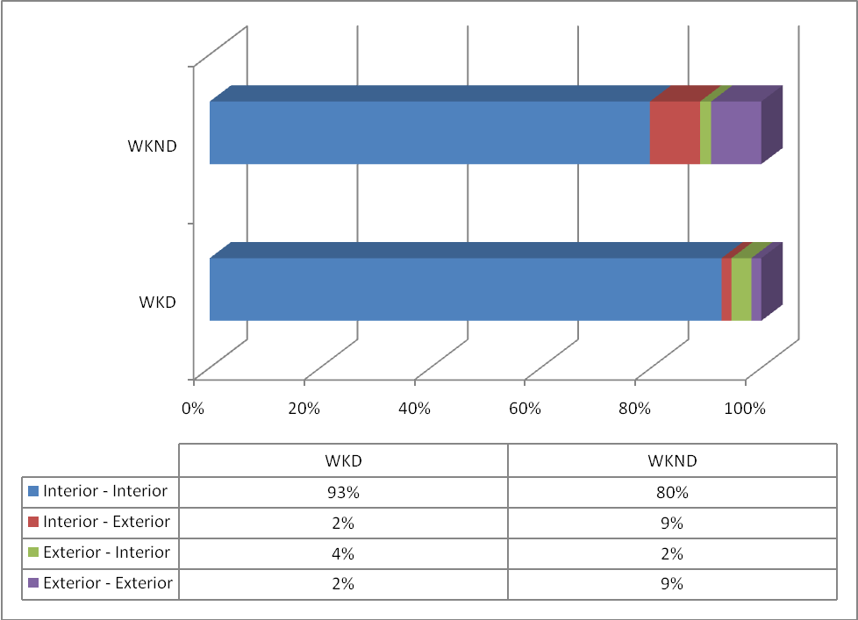

As Figure 9 illustrates, by far the most common type of trip is the Interior–Interior trip. This trip type accounts for 93% of all weekday and 80% of all weekend bridge crossings. The share of trips with one end outside the study area grows from weekdays (7%) to weekends (20%). This suggests that weekend bike-ped trips are probably longer in length than weekday trips.

Frequency of Bridge Usage
In order to better understand the frequency with which pedestrians and bicyclists use the Memorial Bridge, two additional questions were asked. The first question was “How many trips a week do you make across the bridge on foot or by bike?” The second question was, “How many months out of the year do you cross the Memorial Bridge on foot or by bike?”

Based on the responses to this question, respondents were grouped into one of four basic categories:
- Infrequent, seasonal user – A person who uses the bridge 3 or fewer times a week, for 6 or fewer months out of the year.
- Frequent, seasonal user – A person who uses the bridge 4 or more times a week, for 7 or more months out of the year.
- Infrequent, year-round user – A person who uses the bridge 3 or fewer times a week, for 7 or more months out of the year.
- Frequent, year-round user – A person who uses the bridge 4 or fewer times a week, for 7 or more months out of the year.

Figure 10 provides a summary of the responses to these two questions.

Figure 10 – Frequency of Usage Summary
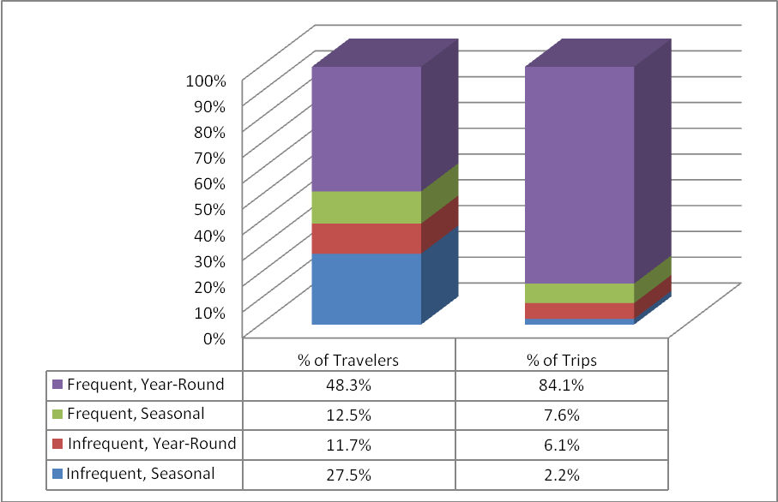

The following observations may be drawn from Figure 10:
- About half of the bicyclists and pedestrians that were surveyed use the bridge frequently on a year-round basis.
- These “frequent, year-round” users account for over 84% of all bike-ped trips on the bridge during the year.
- A little over one-fourth of the bicyclists and pedestrians that were surveyed use the bridge on an infrequent and seasonal basis.
- These “infrequent, seasonal” users account for only about 2% of all bike-ped trips on the bridge during the year.
- The remaining user groups (“frequent, seasonal” and “infrequent, year-round”) comprise about 25% of the users and about 14% of the trips.

A more detailed review of the trip frequency data indicates that the average person surveyed uses the bridge 180 times per year—or, on average, once every other day throughout the year.

Conclusions
The following conclusions can be drawn from this report:
- Bicyclists and pedestrians account for about 5-7% of all the people that cross the Memorial Bridge.
- Bike-ped traffic tends to increase significantly (by approximately 50%) on “good weather” days.
- Pedestrians outnumber bicyclists by a ratio of two-to-one. This ratio stays consistent regardless of time of day or type of day (weekday vs. weekend).
- Bike-ped traffic consists of approximately 50% Maine residents and 40% NH residents. About 10% of bike-ped users come from residents of other states.
- The most common weekday trip is that of a commute to and from work, accounting for about 37% of weekday bike-ped trips. By contrast, the most common trip on weekends was recreation or leisure, accounting for about 35% of all weekend trips.
- Exercise and personal business trips remain fairly consistent throughout the weekday and weekend days. Together, these trip types comprise 30-35% of all bike-ped trips.
- Over 80% of all bike-ped trips begin and end within the City of Portsmouth, NH and Town of Kittery, ME.
- About half of the pedestrians and bicyclists that were surveyed are frequent users that cross the bridge throughout the year.
- These “frequent, year-round” users account for about 85% of all bike-ped crossings.
- Occasional users (i.e. users who cross the bridge 3 or fewer times per week for 6 or fewer months out of the year) account for 27% of the users but only 2% of the crossings.
- The average pedestrian and bicyclists uses the bridge approximately 180 times per year.

