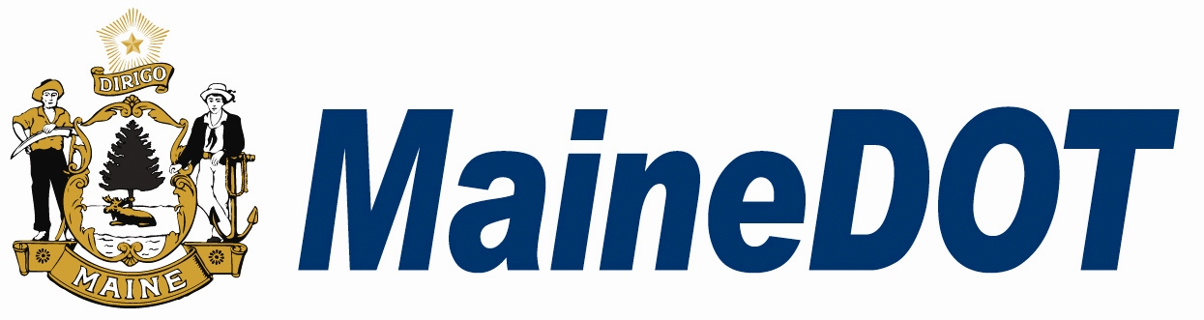
Date Letter of Intent
Received

(For MaineDOT Use Only
Maine Department of Transportation
Small Harbor Improvement Program

Letter of Intent to Apply Form

Name(s):
Title:
Mailing Address:
Municipality: | State: | Zip:
Daytime Phone No.: | Email:

******************************************************************************************************************************************
Please complete the following form due and email to chris.mayo@maine.gov
Communities should submit separate letters of intent form(s) for each proposed project

- Specific location and project scope/description (40 words or less (use bullets if appropriate), please attach map and/or drawing if available):

- Estimated total project budget (please attach line item budget if available): $

- Estimated funding request: $

- Estimated local funding (minimum 50% of Total Project Cost): $

- Please list name, email address, and phone number of local contact for site visit:

*******************************************************************************************************************
By signing this Letter of Intent, the municipality is agreeing to explore the development of a project application for the Small Harbor Improvement Program. MaineDOT will schedule a site review for your Municipality upon receipt of a signed Letter of Intent Form.

Authorized Signature:
Date:
_____________________________________________________ ____________

(Name)

_____________________________________________________

(Title)

_____________________________________________________
******************************************************************************************************************************************
Please return this form to Chris Mayo, Small Harbor Improvement Program Manager, (tel: 207.624.3409, chris.mayo@maine.gov ) MaineDOT, 16 SHS, Augusta, ME 04330-0016

