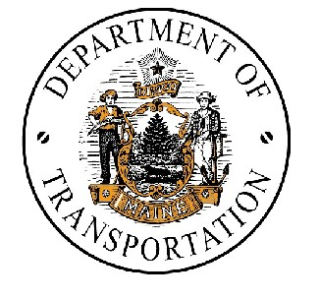 | STATE OF MAINE  DEPARTMENT OF TRANSPORTATION

NOTICE OF PUBLIC MEETING

IN

REGARDING

p.m. AT

The Maine Department of Transportation has developed preliminary plans for the proposed

A plan of the proposed project is available for public inspection at one week prior to the public meeting.

Representatives of the Maine Department of Transportation will be present on evening at 7:00 p.m. to explain proposed details, listen to concerns, receive comments, and answer questions about the project from all interested parties prior to proceeding to final design.

Accommodations will be made for persons with disabilities. Auxilliary aids will be provided upon advance request.

Any inquiries regarding this project may be directed to the attention of , Project Manager, Maine Department of Transportation, Urban and Arterial Highway Program, Child Street, 16 State House Station, Augusta, Maine 04333-0016. Telephone (207) 624-3480

Project Identification Number/Federal Aid Project Number

TTY Telephone 888-516-9364

