Maine Statewide Strategic Transit Plan

MaineDOT Statewide Strategic 1 / 5More at:  https://www.maine.gov/mdot/longrangeplan Transit Plan (SSTP)
Learn more about the Maine SSTP and its importance before getting started on the survey

MaineDOT Statewide Strategic Transit Plan (SSTP)
Please take a moment to tell us what you think and help us understand how we can improve transit in Maine.
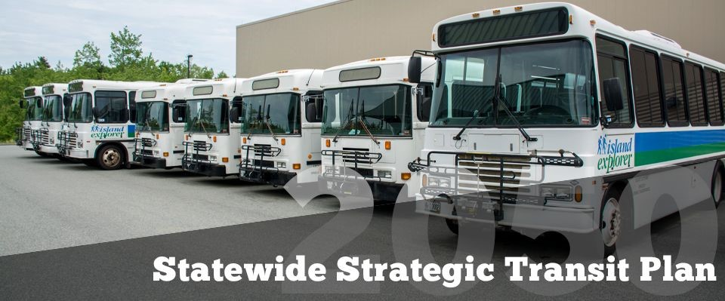
a group of buses parked next to each other
What is considered to be transit? Transit in Maine includes all buses, trains, ferries, and any demandresponsive transit services such as paratransit that may operate in vans or other vehicles. Taxis, Uber, and Lyft are not considered transit.

Who is the intended audience for the Statewide Strategic Transit Plan? The SSTP will serve as a guide for state agencies, metropolitan planning organizations, transit providers, and other key stakeholders to improve Maine's transit system.

When will the SSTP be complete? MaineDOT's current Long Range Transportation Planning process includes a statewide long-range plan, active transportation plan, aviation plan, rail plan, and transit plan. A draft SSTP is expected to be available this fall, with the final plan completed in early 2023.

What will I be asked about and how will my responses be used? You will be asked several questions about how you currently use transit and how you would like transit in Maine to be improved which will inform the Statewide Strategic Transit Plan.

Will my responses be anonymous? Your answers to these questions are completely anonymous and no personally identifiable information will be collected.
a yellow and blue logo
What is the Maine SSTP and how can I help?
The Maine Statewide Strategic Transit Plan is being developed to improve transit across the state. Key tasks include an Existing Conditions Assessment, a Needs Assessment, and an Assessment of System Innovations and Efficiencies. As part of the plan, we want to hear from Maine residents about how they envision the future of transit in Maine. We would like to know how you currently use transit and what kinds of improvements would help make the system better.

Top priorities for transit in Maine 2 / 5
Please rank 5 of the 11 items above the line in your preferred order.

Top priorities for transit in Maine
This question will give us an idea of the top priorities for transit in Maine.
Please drag 5 of the items above the line in your preferred order.

Frequency of Transit Services
Hours of Transit Services
Regional Transit Services
Local Transit Services
Reliability of Transit Services
Speed of Transit Services
Comfort of Transit Facilities
Transit Schedules and Information
Ease of Payment Options
Better Flexible Transit Services
Better Fixed-Route Transit Services
Frequency of Transit Services

a group of red buses parked in a parking lot
Transit vehicles run frequently so I have more options throughout the day.

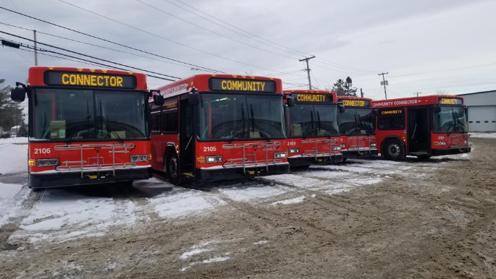
Hours of Transit Services
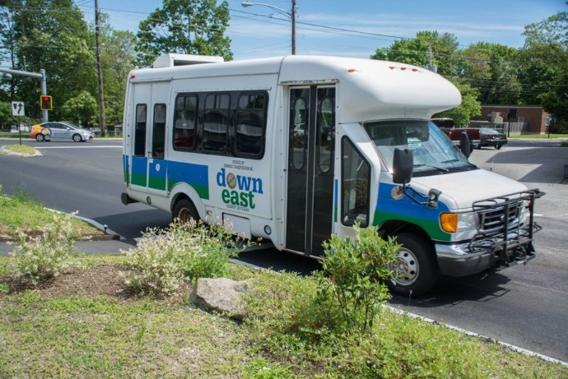
a bus on the street
Transit service is available throughout the day, including early in the morning and late at night, seven days a week.

Regional Transit Services
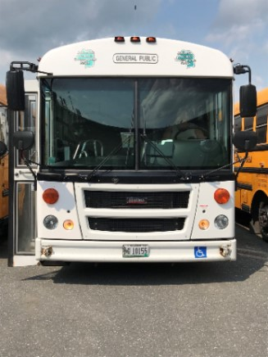
a bus parked in a parking lot
Transit goes to more destinations within and across regions, so I can use transit for longer journeys.

Local Transit Services
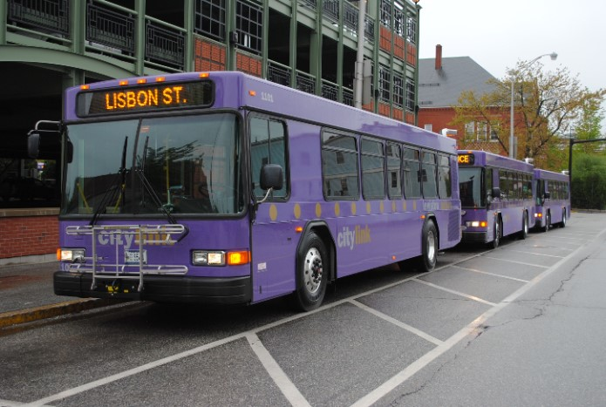
buses parked on the side of the road
Transit goes to more local destinations in and around cities and town centers.

Reliability of Transit Services
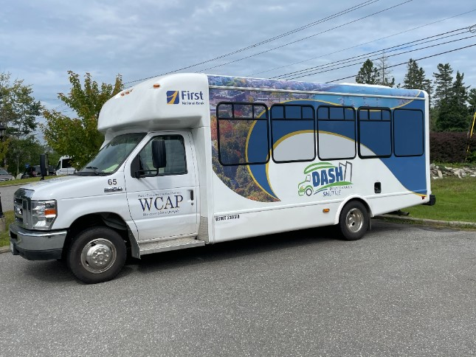
a white van on the side of the road
Transit vehicles generally arrive and get me to my destination on time, and service is rarely canceled.

Speed of Transit Services
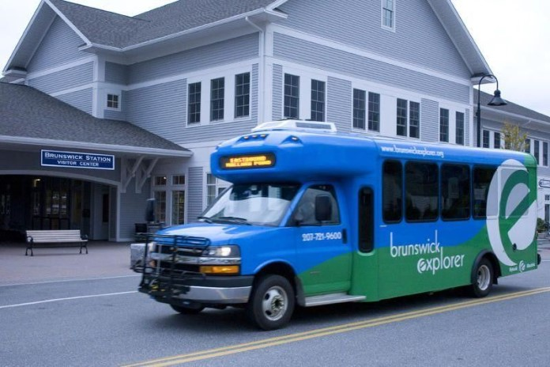
a blue bus parked on the side of the road
Transit gets me to my destination quickly and efficiently. Connections between transit routes or providers are fast and efficient.

Comfort of Transit Facilities

a couple of buses parked in front of a building
Transit stops and vehicles are comfortable, convenient, and safe.

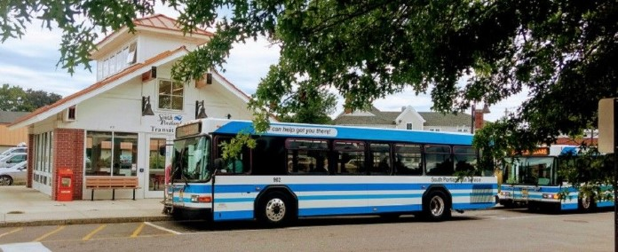
Transit Schedules and Information
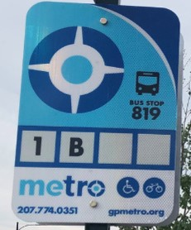
a sign with a blue circle and white text
Transit schedules and route information are easy to access and understand.

Ease of Payment Options
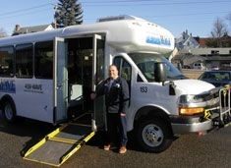
a person standing next to a van
A variety of simple payment options allow me to pay online, use a card or ticket, or pay with cash.

Better Flexible Transit Services
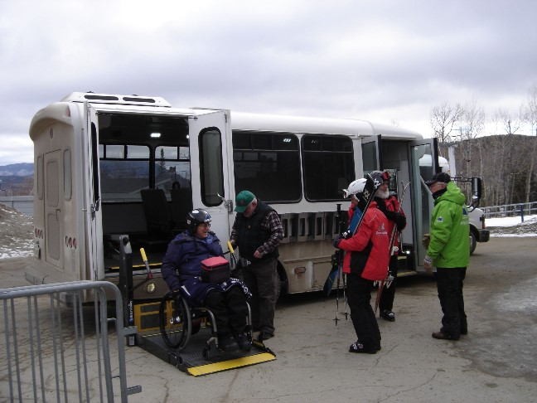
a group of people standing next to a bus
Transit includes more on-demand, flexible, door-to-door options.

Better Fixed-Route Transit Services
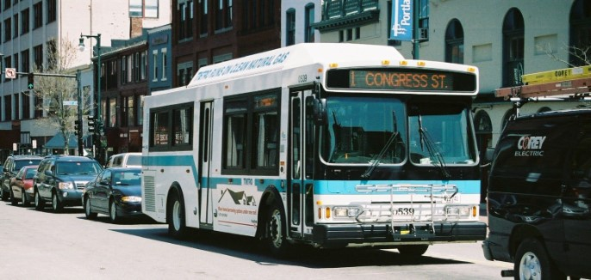
a bus driving down the street
Transit is focused on fixed-route services, running on consistent routes and schedules.

General Comment

Funding the Transit System 3 / 5
Please use the sliders to tell us how you think we should be spending our transit funding.

Funding the Transit System
This question will give us an idea of how transit resources should be allocated.
Please use the sliders to fill the bar and meet the target.
a woman pushing a shopping cart next to a man in a wheel chair

Quality of transit services
Funds improve the quality of Maine's existing transit system, which may include making transit more reliable and more pleasant, and technology improvements like real-time bus tracking.
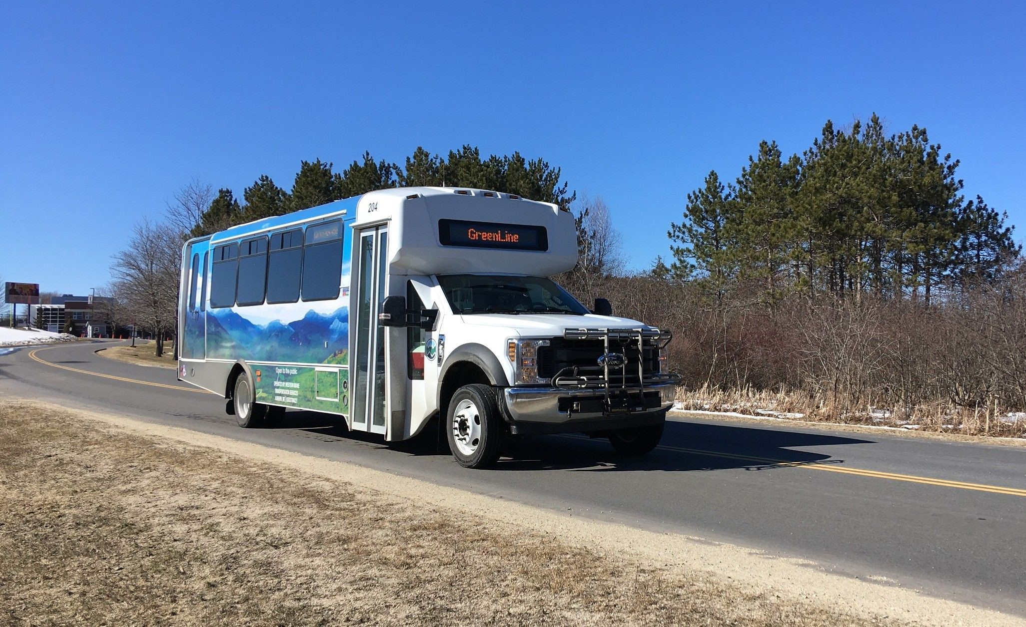

Notch 0
Notch 1
Notch 2
Notch 3
Notch 4
Notch 5
a bus on the road

Geographic coverage of transit service
Funds go towards providing transit to and from more areas of Maine, with more local and regional routes throughout the state.
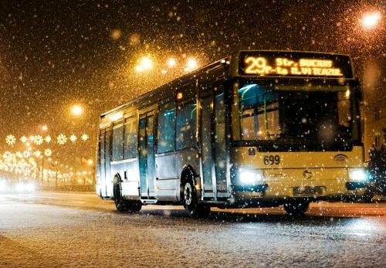

Notch 0
Notch 1
Notch 2
Notch 3
Notch 4
Notch 5
a bus on the street

Frequency and timing of service
Funds go towards making transit more frequent, extending service on weekends, and adding service earlier in the morning and/or later at night.
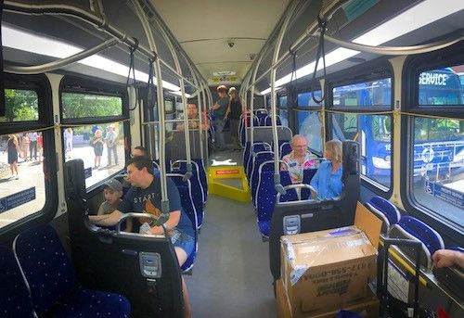

Notch 0
Notch 1
Notch 2
Notch 3
Notch 4
Notch 5
people on a bus

Affordability and ease of payment
Funds go towards making transit more affordable. Fares are low or even free for qualified individuals. A variety of payment options are available so I can pay online, with my phone, use a card or ticket, or pay with cash.
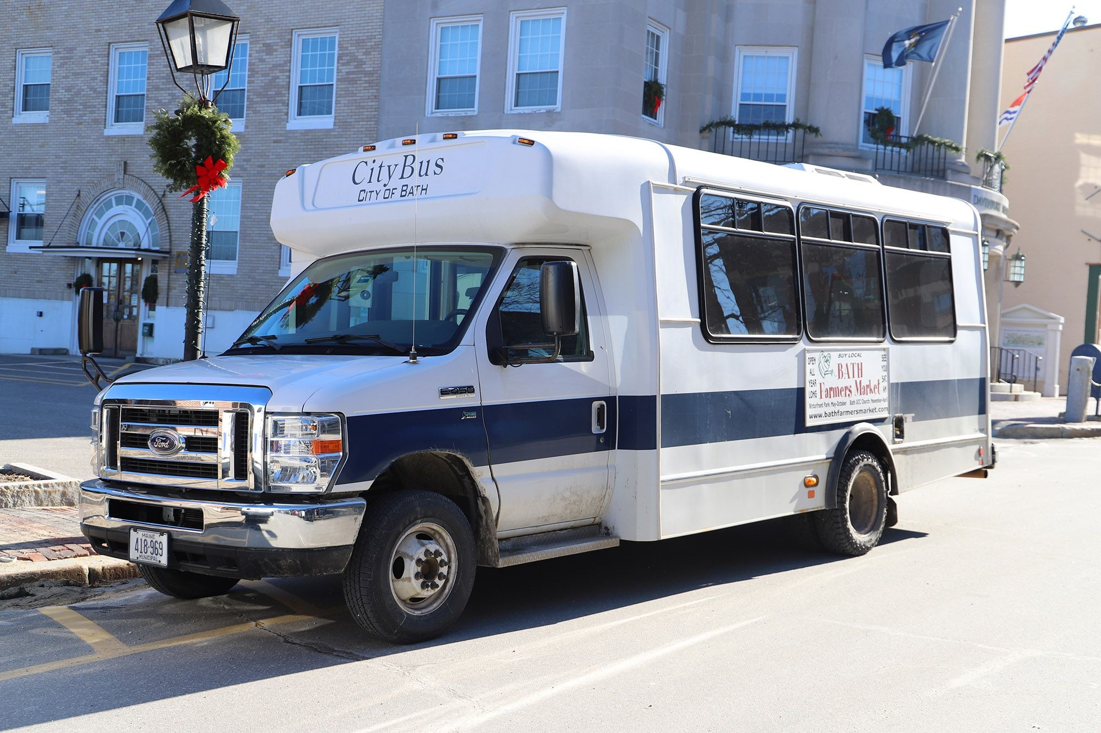

Notch 0
Notch 1
Notch 2
Notch 3
Notch 4
Notch 5
a white bus parked on the side of a street

New transit options
Funds go towards new transit options, such as flexible and on-demand micro transit or high-capacity services like bus rapid transit.
Notch 0 Notch 1 Notch 2 Notch 3 Notch 4 Notch 5
Please use the sliders to fill the bar and meet the target.

General Comment
-

Transit Use 4 / 5
Please tell us how you currently use transit.

Transit Use
These questions will help us understand how and why people are currently using Maine's transit system.
Please answer each question.

Frequency
How often do you use the following modes of transit in Maine?
Local bus

Daily
Several times a week
Weekly
A few times a month
Almost never
Never
Intercity bus

Daily
Several times a week
Weekly
A few times a month
Almost never
Never
Ferry

Daily
Several times a week
Weekly
A few times a month
Almost never
Never
Rail
Daily
Several times a week
Weekly
A few times a month

Almost never
Never
Demand response service

Daily
Several times a week
Weekly
A few times a month
Almost never
Never

Reasons for Use
Reasons for Use
Why do you use transit? Please check up to 3 reasons.

I don't own or have regular access to a vehicle
I don't have a driver's license
I have a disability that prevents me from driving
Transit is less expensive than other modes
Transit is more convenient than other modes
Transit is better for the environment
I don't use transit
Other

Trip Purpose: Bus and Demand Response
Trip Purpose
When you use the bus, what is the purpose of your trip? Please check up to 3.

To get to work
To get to school
To run errands
To visit friends or family
To get to medical or other necessary appointments
To get to recreational activities
Other
I don't use the bus
When you use demand response service, what is the purpose of your trip? Please check up to 3.
To get to work
To get to school
To run errands ₋

To visit friends or family
To get to medical or other necessary appointments
To get to recreational activities
Other
I don't use demand response service

Trip Purpose: Rail and Ferry Service
Trip Purpose
When you use rail service, what is the purpose of your trip? Please check up to 3.

To get to work
To get to school
To run errands
To visit friends or family
To get to medical or other necessary appointments
To get to recreational activities
Other
I don't use rail service
When you ferry service, what is the purpose of your trip? Please check up to 3.

To get to work
To get to school
To run errands
To visit friends or family
To get to medical or other necessary appointments
To get to recreational activities
Other
I don't use ferry service
General Comment

Wrap Up 5 / 5
Please tell us about yourself. All information is confidential. Click finish when you are done.
Demographic questions

What is your home zip code?

What is your age?

Less than 18
18-24
25-44
45-64
65+
What is your annual household income?

Less than $10k
$10k-$25k
$25k-$50k
$50k-$75k
$75kk-$100k
$100k-$200k
More than $200k
What is your race/ethnicity? Please check all that apply.

Asian
Black or African American
Hispanic or Latino
American Indian or Alaska Native
Pacific Islander
White
Other
What is your sex?

Male

-

Female
Other
Do you have a disability? Please check any that apply.

No
Hearing difficulty
Vision difficulty
Cognitive difficulty
Ambulatory difficulty
Self-care difficulty
Independent living difficulty
Are you an individual in recovery?

Yes
No
Please share any additional comments.

Thank You!

Thank you for joining the discussion on Maine's Statewide Strategic Transit Plan! Your valuable input will help us make important decisions about the future of Maine's public transportation network. Please reach out if you have further comments!
General Comment
-
logo
Wrap Up
Thank you for your input so far!
Please answer a few additional demographic questions, and remember to click FINISH when you are done. And please share this survey and help us spread the word about Maine's Statewide Strategic Transit Plan.

Our Partners:

-

logo

Thanks for participating!
You can now close this browser.
-
-

