VINALHAVEN FERRY
“M/V CAPTAIN CHARLES PHILBROOK”
and

“M/V CAPTAIN E. FRANK THOMPSON”
Rockland – Vinalhaven Island︱ 15 miles︱1 hour 15 minutes

Effective January 2, 2022

Monday through Saturday
DEPART VINALHAVEN | DEPART ROCKLAND
7:00 am | 7:00 am
8:45 am | 8:45 amª
10:30 am | 10:30 am
12:00 pm | 12:00 pm
1:30 pm | 1:30 pm
3:15 pm | 3:15 pm

Sunday
DEPART VINALHAVEN | DEPART ROCKLAND
8:45 am | 8:45 am
10:30 am | 10:30 am
1:30 pm | 1:30 pm
3:15 pm | 3:15 pm

ª Ferry may depart Rockland 10 minutes late on Tuesdays due to fueling the vessel.
On New Year’s Day, only the 10:30 departure from Vinalhaven and the 12:00 from Rockland will operate.
NOTE: If you have a non-reserved vehicle or truck leaving Vinalhaven, please contact the Vinalhaven terminal for vehicle line up instruction, 24 hours prior to departing from Rockland.

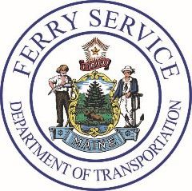
Maine State Ferry Service 79 Sands Road
Vinalhaven, ME 04863
207-596-5450
Maine State Ferry Service PO Box 645
517a Main Street Rockland, ME 04841-0645
207-596-5400

