Maine State Ferry Service
Tariff No. 8 - New Rates Effective May 21, 2018

ALL ROUTES (Vinalhaven, North Haven, Swans Island, Frenchboro, Islesboro, and Matinicus) -
Any Terminal Origination/Destination

Adult Round-Trip Passenger* | $ 11.00
Child Round-Trip Passenger* | $ 5.50
Vehicle, Less Than 20ft, Round-Trip (Includes Ticket for Driver) | $ 30.00
Truck One-Way or Round-Trip Per Foot | $ 2.50
Adult Bike Round-Trip | $ 20.00
Child Bike Round-Trip | $ 10.00
Reservations | $ 15.00

*Round-trip walk-on passenger tickets are no longer origin/destination based, meaning both portions of a round-trip ticket may be used in any combination effectively for one passenger to take two (2) one-way rides on any route served by the Maine State Ferry Service. For example:
- A passenger may utilize the first portion of a MSFS passenger round-trip ticket for passage from Rockland to North Haven and then the second portion of the round-trip ticket for passage from Vinalhaven to Rockland (assuming they took a private boat from North Haven to Vinalhaven).
- A passenger may utilize the first portion of a MSFS passenger round-trip ticket for passage from Rockland to Matinicus and the second portion of the ticket again for passage from Rockland to Matinicus (assuming they flew off Matinicus at some point in between).
- A passenger may utilize the first portion of a MSFS round-trip ticket for passage from Islesboro to Lincolnville and then utilize the second portion of the ticket for passage from Bass Harbor to Swans Island.
- Any combination of two (2) one-way rides to any mainland/island terminal in the MSFS system is now available for a passenger, allowing customers the greatest flexibility of ticket usage.
Maine State Ferry Service Tariff No. 8
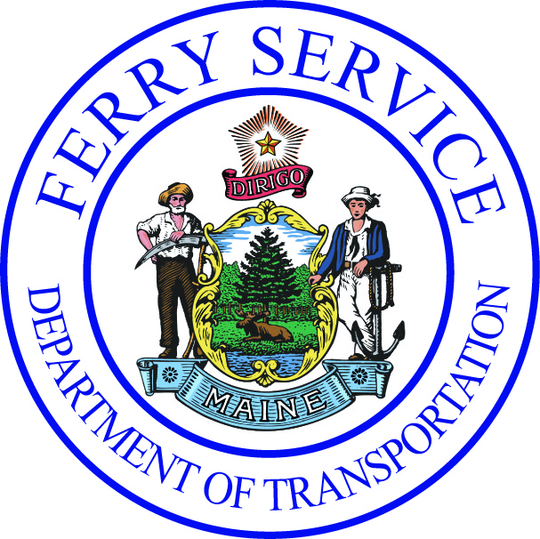
SPECIFIC DETAILS OF NEW FLAT RATE STRUCTURE
- New structure focuses on significantly decreasing overall truck/freight rates across the service to $2.50 per foot, as truck rates have a direct impact on the cost of goods and services to and from the island communities, particularly businesses and year-round residents. The only increase in the per foot rate is on Islesboro, where the island rates from the Islesboro to Lincolnville raise from $1.70/$1.75 to $2.50 and the per foot mainland rate Lincolnville to Islesboro raises slightly from $2/2.25 to $2.50.

- One-price for any ride structure significantly simplifies the system, which will allow for the near-term utilization of advanced technology and greatly improve customer service. It eliminates any discrimination in rate pricing from island to island and mainland to island. It treats all users of the ferry system equally and fairly, and spreads the operating costs of the service to all users evenly, in line with how highway fund dollars are distributed statewide (based on operational need, rather than population, geography, etc.).

- The new pricing structure was constructed starting with the previous island pricing for Vinalhaven/North Haven/Swans Island. To achieve equalization of the rate structure from there:

- All mainland ticket prices from VH/NH/SI decreased, with only modest increases in pricing for passenger/vehicle tickets for residents on the island.
- Rates for Matinicus and Frenchboro - the most remote islands with limited ferry service - decrease significantly, with the intent to assist with the sustainability of those islands.
- Rates to/from Islesboro were raised to equalize all pricing across the system. Even after raising prices, the new rates to ride to or from Islesboro remain similar or lower to costs for comparable island ferry routes, such as those in Casco Bay.

- Reservation and Bike Rates were increased in response to the large number of comments at public hearings about the underpricing of those tickets.

- One-way passenger and vehicle tickets were eliminated, to simplify the system. However, round-trip passenger tickets will now be available for use on any ferry route, rather than restricted to an origin/destination.

- Commuter and Excursion tickets (which have low sale volumes) were also eliminated as there was limited justification to further subsidize a subsidized system, particularly if there was no administrative savings to warrant the decreased ticket prices. Once new technology is implemented, MSFS will revisit if a commuter pass if feasible.

- Tickets sold prior to effective date of the last Tariff No. 7 update on April 1, 2012 will expire under the new rate structure. Customers will have until May 21, 2018 to upgrade unused tickets sold prior to that date to comparable tickets under the Tariff No. 7 pricing mainland/island pricing structure.

- MSFS will allow 90 days for round-trip and one-way Matinicus and Frenchboro tickets sold from April 1, 2012 to May 21, 2018 be exchanged on a one-for-one or two-for-one basis. On August 13, 2018, all mainland, Matinicus and Frenchboro tickets sold under the Tariff No. 7 pricing structure will expire.

- Islesboro mainland and all Island rate tickets sold under the Tariff No. 7 pricing structure will not expire. Customers will be able to exchange those tickets for a non-cash value upgrade voucher, based on the original price of the ticket(s) to purchase round-trip tickets under the new flat rate system. No refunds of any old tickets will be issued.

- The new flat rate structure will allow the MSFS to move away from an antiquated pricing structure that is difficult to justify. Future increases to rates to meet operational needs will be straightforward and easier to implement, particularly once enhanced data is available as a result of long overdue technology upgrades.

Maine State Ferry Service

