[DRAFT]

MEMORANDUM OF AGREEMENT

BETWEEN THE US ARMY CORPS OF ENGINEERS,
ADVISORY ACHP ON HISTORIC PRESERVATION, MAINE DEPARMENT OF TRANSPORTATION,
AND MAINE STATE HISTORIC PRESERVATION OFFICER REGARDING
STONE BOX CULVERT (#910881) REPLACEMENT
YORK COUNTY, MAINE
WHEREAS, the Maine Department of Transportation plans to fund the Stone Box Culvert (#910881) Replacement Project (undertaking) between Sanford and Alfred, Maine, pursuant to the National Historic Preservation Act of 1966, 54 U.S.C. 306101 et seq; and
WHEREAS, the US Army Corp of Engineers (ACOE) is the "Agency Official" responsible for ensuring that the undertaking complies with Section 106 of the National Historic Preservation Act (NHPA) ((54 U.S.C. § 306108), as amended, and codified in its implementing regulations, 36 CFR Part 800, as amended (August 5, 2004);
WHEREAS, the MaineDOT proposes to design and construct the undertaking and has been delegated responsibilities by the ACOE; and
WHEREAS, the undertaking consists of replacing the Stone Box Culvert (#910881) with a precast concrete box culvert; and

WHEREAS, ACOE has defined the undertaking’s area of potential effects (APE) as displayed in Attachment A; and

WHEREAS, ACOE has determined that the undertaking has an adverse effect on the Stone Box Culvert (#910881), which is eligible for listing in the National Register of Historic Places under Criteria A, and has consulted with the SHPO pursuant to 36 CFR Part 800, the regulations implementing Section 106 of the National Historic Preservation Act (54 U.S.C. § 306108); and

WHEREAS, ACOE has ensured that the local significance of the Stone Box Culvert (#910881) will be captured in compensatory mitigation; and

WHEREAS, ACOE has consulted with the Aroostook Band of Micmacs, Houlton Band of Maliseet Indians, Passamaquoddy Tribe, and Penobscot Nation of the proposed action in accordance with 36 CFR Section 800.3 (f)(2). Emails were sent to the tribes on June 20, 2019, in accordance with their preferred method of receiving information from the Department of Transportation. The Houlton Band of Maliseets responded on June 20, 2019, the Passamaquoddy Tribe responded on July 1, 2019, and the Penobscot Nation responded on July 29, 2019. All indicated that this undertaking will have no impact on a structure or site of historic, architectural or archaeological significance to the Tribes; and

WHEREAS, in accordance with 36 CFR 800.2(c), ACOE has requested input from consulting parties in a manner that reflects the nature and complexity of the undertaking and its effects on historic properties. No requests for official consulting party status were received; and
.
WHEREAS, in accordance with 36 CFR 800.2(d), ACOE has requested input from the public in a manner that reflects the nature and complexity of the undertaking and its effects on historic properties. No responses from the public were received; and

WHEREAS, in accordance with 36 CFR Section 800.6(a)(1), ACOE has notified the ACHP of the potential for an adverse effect determination. ACOE has invited the ACHP to consult on November 15, 2019, and the ACHP has chosen to participate/not participate in the consultation pursuant to 36 CFR Section 800.6(a)(1)(iii) on Month, Date, Year; and

WHEREAS, in accordance with 36 CFR Section 800.6(c)(2), ACOE has invited the MaineDOT to be an invited signatory and in accordance with 36 CFR Section 800.6(c)(3);

NOW, THEREFORE, the ACHP, ACOE, and the Maine SHPO agree that the undertaking shall be implemented in accordance with the following stipulations in order to take into account the effect of the undertaking on historic properties.

STIPULATIONS

ACOE, with assistance from MaineDOT, shall ensure that the following measures are carried out:

- Continued Coordination with Maine SHPO
MaineDOT will continue to coordinate with the Maine SHPO on best practices to identify stone box culverts in Maine with the goal of developing historic context documentation that details character-defining features and integrity of stone box culverts in Maine.

- Duration
This agreement will be null and void if its terms are not carried out within five (5) years from the date of its execution. Prior to such time, ACOE may consult with the other signatories to reconsider the terms of the agreement and amend it in accordance with Stipulation VIII.

- Post-Review Discoveries
If potential historic properties are discovered or unanticipated effects on historic properties found, ACOE shall consult in accordance with 36 CFR Section 800.6(c)(6). If any unanticipated discoveries of historic properties or archaeological sites are encountered during the implementation of this undertaking, MaineDOT shall suspend work in the area of the discovery in accordance with Maine Department of Transportation Standard Specification 105.9: Historic and Archaeological Considerations and DOT shall immediately notify the ACOE. In compliance with 36 CFR §800.13, ACOE shall notify within 24 hours the ACHP, the Maine SHPO, and, if applicable, federally recognized tribal organizations that attach religious and/or cultural significance to the affected property. The Maine SHPO, the ACOE, MaineDOT, and Tribal representatives, as appropriate, may conduct a joint field review within 72 hours of the notification to the ACOE. The ACOE, in consultation with the appropriate parties, will determine an appropriate treatment of the discovery prior to the resumption of construction activities in the area of the discovery.

- Discovery of Human Remains
MaineDOT shall ensure that any human remains and/or grave-associated artifacts encountered during the archaeological investigations are brought to the immediate attention of the ACOE, the Maine SHPO, and any federally recognized Tribes that may attach religious and/or cultural significance to the affected property. Notification will be within 48 hours of the discovery. No activities which might disturb or damage the remains will be conducted until ACOE, in consultation with the appropriate parties, has developed a treatment plan that considers the comments of the appropriate parties. All procedures will follow the guidance outlined in the National Park Service Publication National Register Bulletin 41: Guidelines for Evaluating and Registering Cemeteries and Burial Places, taking into account the Native American Graves Protection and Repatriation Act of 1990 (PL 101-601). If Native American cultural materials are encountered during the course of the project, MaineDOT will abide by the Maine Department of Transportation Standard Specification 105.9: Historic and Archaeological Considerations by stopping all activities in the area of discovery and notifying ACOE, Maine Historic Preservation Commission (MHPC), Advisory ACHP on Historic Preservation (ACHP), the Aroostook Band of Micmacs, Houlton Band of Maliseet Indians, Passamaquoddy Tribe, and Penobscot Nation. Stipulation III of this agreement will be followed; and

- Reporting
Each year following the execution of this agreement until it expires or is terminated, MaineDOT shall provide all parties to this agreement a summary report detailing work undertaken pursuant to its terms. Such report shall include any scheduling changes proposed, any problems encountered, and any disputes and objections received in MaineDOT’ s efforts to carry out the terms of this agreement. Failure to provide such summary report may be considered noncompliance with the terms of this MOA; and

- Dispute Resolution
Should any party to this agreement object at any time to any actions proposed or the manner in which the terms of this MOA are implemented, ACOE shall consult with the objecting party(ies) to resolve the objection. If ACOE determines, within 30 days, that such objection(s) cannot be resolved, ACOE will:

  - Forward all documentation relevant to the dispute to the ACHP in accordance with 36 CFR Section 800.2(b)(2). Upon receipt of adequate documentation, the ACHP shall review and advise ACOE on the resolution of the objection within 30 days. Any comment provided by the ACHP, and all comments from the parties to the MOA, will be taken into account by ACOE in reaching a final decision regarding the dispute.

  - If the ACHP does not provide comments regarding the dispute within 30 days after receipt of adequate documentation, ACOE may render a decision regarding the dispute. In reaching its decision, ACOE will take into account all comments regarding the dispute from the parties to the MOA.

  - ACOE’s responsibility to carry out all other actions subject to the terms of this MOA that are not the subject of the dispute remain unchanged. ACOE will notify all parties of its decision in writing before implementing that portion of the Undertaking subject to dispute under this stipulation. ACOE’s decision will be final.

- Resolving Public Objections
At any time during implementation of the terms of this Agreement, should any member of the public raise an objection in writing pertaining to such implementation to any signatory party to this Agreement, that signatory party shall immediately notify ACOE. ACOE shall:
- Immediately notify the other signatory parties in writing of the objection. Any signatory party may choose to comment on the objection to ACOE.
- Establish a reasonable time frame for this comment period. ACOE shall consider the objection, and in reaching its decision, ACOE will take all comments from the other parties into account.
- Within 15 days following closure of the comment period, ACOE will render a decision regarding the objection and respond to the objecting party. ACOE will promptly notify the other signatory parties of its decision in writing, including a copy of the response to the objecting party. ACOE’s decision regarding resolution of the objection will be final.
- Following the issuance of its final decision, ACOE may authorize the action subject to dispute hereunder to proceed in accordance with the terms of that decision. Nothing in this paragraph creates additional legal rights or responsibilities on the ACOE that are not already afforded under the NHPA.
- ACOE’s responsibility to carry out all other actions or terms of this MOA that are not he subject of the objection remain unchanged and may proceed.

- Amendments
If any signatory to this MOA, including any invited signatory, determines that its terms will not or cannot be carried out or that an amendment to its terms must be made, that party shall immediately consult with the other parties to develop an amendment to this MOA pursuant to 36 CFR §§800.6(c)(7) and 800.6(c)(8). The amendment will be effective on the date a copy signed by all of the original signatories is filed with the ACHP. If the signatories, including any invited signatory, cannot agree to appropriate terms to amend the MOA, any signatory may terminate the agreement in accordance with Stipulation IX.

- Termination
If the MOA is not amended following the consultation set out in Stipulation VIII it may be terminated by any signatory or invited signatory. Within 30 days following termination, ACOE shall notify the signatories if it will initiate consultation to execute an MOA with the signatories under 36 CFR §800.6(c)(1) or request the comments of the ACHP under 36 CFR §800.7(a) and proceed accordingly.

- Coordination with Other Federal Reviews
In the event that another federal agency not initially a party to or subject to this MOA receives an application for funding/license/permit for the Undertaking as described in this MOA, that agency may fulfill its Section 106 responsibilities by stating in writing it concurs with the terms of this MOA and notifying the ACOE, SHPO, and the ACHP that it intends to do so, and adherence to the terms of this MOA.

ATTACHMENT A

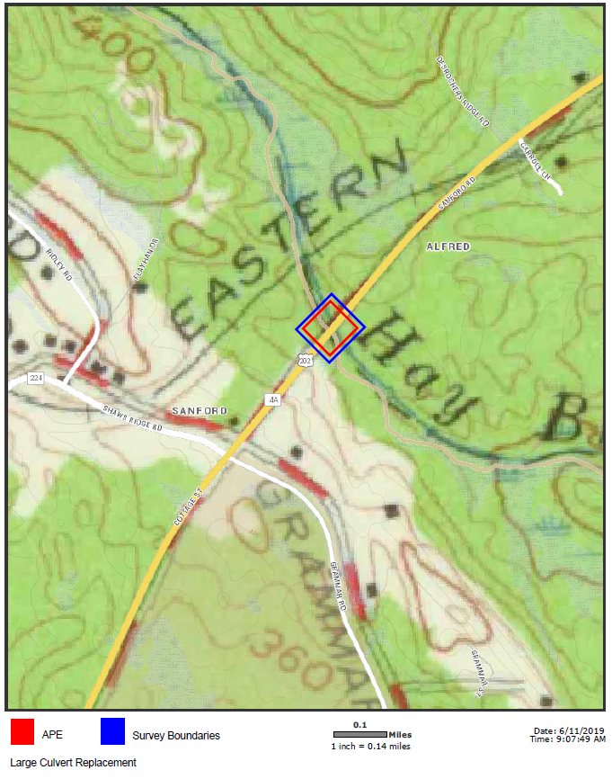

SIGNATORIES:

US Army Corps of Engineers

______________________________ Date

SIGNATORIES:

Maine State Historic Preservation Officer

______________________________ Date
Kirk Mohney
State Historic Preservation Officer

SIGNATORIES:

Advisory ACHP on Historic Preservation

_______________________________Date
John M. Fowler
Executive Director

INVITED SIGNATORY:

Maine Department of Transportation

_______________________________Date
Bruce van Note
Commissioner

