

Disadvantaged Business Enterprise Program
Maine Department of Transportation
Civil Rights Office
#16 State House Station
Augusta ME 04333-0016

Website: http://www.maine.gov/mdot/civilrights/dbe

Rev. 1/18

TABLE OF CONTENTS

Objectives ~ 49 CFR §26.1 4
Applicability ~ 49 CFR §26.3 5
Definitions ~ 49 CFR §26.5 5
Non-discrimination Requirements ~ 49 CFR §26.7 5
Record Keeping Requirements ~ 49 CFR §26.11 5
Bidders List ~ 49 CFR 26.11(c) 6
Maintain and Retention of Records of Certified Firms ~ 49 CFR 26.11(d) 6
UCP Information to OST~ 49 CFR 26.11(e) 6
Federal Financial Assistance Agreement ~ 49 CFR §26.13 7
Original on FileSUBPART B - ADMINISTRATIVE REQUIREMENTS 8
DBE Program Updates ~ 49 CFR §26.21 8
DBE Liaison Officer (DBELO) ~ 49 CFR §26.25 9
DBE and Minority Owned Financial Institutions 49 CFR §26.27 9
Prompt Payment/Return of Retainage ~ 49 CFR §26.29(a) (b) 10
DBE Directory ~ 49 CFR §26.31 10
Over-concentration ~ 49 CFR §26.33 10
DBE Business Development Program ~ 49 CFR §26.35 11
Program Promotion and Considerations for Selection Criteria 11
Monitoring and Enforcement Mechanisms ~ 49 CFR §26.37 11
Fostering Small Business Participation ~ 49 CFR § 26.39 12
SUBPART C - GOALS, GOOD FAITH EFFORTS AND COUNTING 13
Set-asides or Quotas ~ 49 CFR §26.43 13
Overall Goals ~ 49 CFR §26.45 14
Transit Vehicle Manufacturers Goals ~ 49 CFR §26.49 14
Breakout of Estimated Race-Neutral & Race-Conscious Participation ~ 49 CFR §26.51 (a-c) 14
Contract Goals ~ 49 CFR §26.51 (d-g) 14
Good Faith Efforts Procedures ~ 49 CFR §26.53 15
Good Faith Efforts When a DBE is Replaced on a Contract ~ 49 CFR §26.53 16
Counting DBE Participation ~ 49 CFR §26.55 16
Joint Checks ~ 49 CFR §26.55 (c)(1) and §26.71 (b) 17
SUBPART D - CERTIFICATION STANDARDS 18
Certification Process ~ 49 CFR §26.61 and §26.63 18
Certification Determining Business Size ~ 49 CFR 26.65 19
Certification Determining Social and Economic Disadvantage ~ 49 CFR §26.67 19
Certification Determining Ownership ~ 49 CFR §26.69 19
Rules Governine Determining of Control ~ 49 CFR §26.71 20
NAICS Codes ~ 49 CFR §26.71(n)(1) 22
Certification – Other Rules ~ 49 CFR §26.73 22
Unified Certification Programs ~ 49 CFR §26.81 22
Procedures for Certification Decisions ~ 49 CFR §26.83 22
Interstate Certification ~ 49 CFR §26.85 23
Denial of Initial Request for Certification ~ 49 CFR §26.86 24
Removal of DBE Eligibility ~ 49 CFR §26.87 24
Suspension of Certification ~ 49 CFR §26.88 25
Certification Appeals ~ 49 CFR §26.89 25
SUBPART E – COMPLIANCE AND ENFORCEMENT 25
Information, Confidentiality, Cooperation ~ 49 CFR §26.109 26
Appendices to the CFR – Guidance, Guidelines, Application 26
ATTACHMENTS 27
Attachment 1 28
Organizational Chart
Attachment 2 29
Bidder’s List Survey Form
Attachment 3 30
DBE Special Provision
Attachment 4 33
MaineDOT DBE Utilization Forms
Attachment 5 38
Certification of Final DBE Payment Forms
Attachment 6 41
Commercially Useful Function
Attachment 7 43
Prompt Payment Provision
Attachment 8 44
Personal NetWorth Statement and General Instructions
Attachment 9 49
Maine Freedom of Information Act and Confidentiality of DBE Records
Attachment 10 50
Template of UCP Agreement
Attachment 11 51
MaineDOT Regulation Regarding Debarment
Attachment 12 58
Definitions

Objectives ~ 49 CFR §26.1
The Maine Department of Transportation (MaineDOT) has established a Disadvantaged Business Enterprise (DBE) program in accordance with regulations of the U.S. Department of Transportation (USDOT), 49 CFR Part 26. The MaineDOT receives Federal financial assistance from the USDOT, and as a condition of receiving this assistance, the MaineDOT has signed an assurance that it will comply with 49 CFR Part 26.
The objectives of MaineDOT’s DBE Program are:

(a) To ensure nondiscrimination in the award and administration of DOT assisted contracts in the Department's highway, transit, and airport financial assistance programs;
(b) To create a level playing field on which DBEs can compete fairly for DOT-assisted contracts;
(c) To ensure that the Department's DBE program is narrowly tailored in accordance with applicable law;
(d) To ensure that only firms that fully meet this part's eligibility standards are permitted to participate as DBEs;
(e) To help remove barriers to the participation of DBEs in DOT-assisted contracts;
(f) To promote the use of DBEs in all types of federally-assisted contracts and procurement activities conducted by recipients.
(g) To assist the development of firms that can compete successfully in the marketplace outside the DBE program; and
(h) To provide appropriate flexibility to recipients of Federal financial assistance in establishing and providing opportunities for DBEs.
The Maine Department of Transportation (MaineDOT) is committed to engaging small disadvantaged, minority and women-owned business enterprises as defined herein in all contracts to the maximum feasible extent, and will continue working to ensure the maximum feasible opportunity for these businesses to participate in contracts financed in whole or in part with federal funds.
The MaineDOT’s Disadvantaged Business Enterprise (DBE) Program has been carefully designed to incorporate 49 CFR Part 26, issued in February 1999, replacing 49 CFR Part 23, as amended. It also incorporates any new rule changes and will continue to be amended as new rules are promulgated. This Program, as set forth herein, is intended to remedy past and current discrimination against disadvantaged business enterprises; ensure a “level playing field”; foster equal opportunity in USDOT-assisted contracts; improve the flexibility and efficiency of the DBE Program; and reduce burdens on small businesses.
In keeping with MaineDOT’s multi-modal focus, responsibility for carrying out the Program is Department-wide. MaineDOT will ensure that its contractors, subcontractors, consultants and other parties indicated by federal law will meet the Program requirements. Additionally, MaineDOT recognizes the importance of small businesses in Maine’s economy, and will work cooperatively with any and all other parties who also act in good faith to enhance development and growth opportunities of small businesses owned by disadvantaged individuals, minorities and women.
MaineDOT, as the certifier of all DBEs in Maine, will be diligent in ensuring that all DBEs certified in Maine have met the requirements set forth in 49 CFR 26.
MaineDOT is committed to maintaining regular, open, constructive communication with both minority and majority interests. The Department continues to encourage frank and open discussions about the Program.

Applicability ~ 49 CFR §26.3

As a recipient of federal financial assistance, the MaineDOT is required to administer a DBE program in compliance with all laws, regulations and Executive Orders and guidance and will utilize Federal–aid highway funds authorized under Titles I and V of the Intermodal Surface Transportation Efficiency Act of 1991 (ISTEA), Pub. L. 102-240, 105 Stat. 1914, Titles I, III, and V of the Transportation Equity Act for the 21st Century (TEA-21, Pub. L. 105-178, 112 Stat. 107.

The MaineDOT is the recipient of Federal transit funds authorized by Titles I, III, V, and VI of ISTEA, Pub. L. 102-240 or by Federal transit laws in Title 49, U.S. Code, or Titles I, II, and V of the Teas-21, Pub. L. 105-178.

The MaineDOT is the recipient of Federal airport funds authorized by 49 U.S.C. 47101, et seq. for the Augusta State Airport and any federal funding used toward Statewide System Plan Updates.

The MaineDOT is a recipient of Federal Rail Administration funding through American Recovery and Reinvestment Act, TIGER grant.

Definitions ~ 49 CFR §26.5

The MaineDOT will use terms in this program that have the meaning defined in Section 26.5. These definitions can be found electronically by clicking on Attachment 12 of this document.
For the purposes of this program, a socially and economically disadvantaged individual means any individual who is a citizen (or lawfully admitted permanent resident) of the United States and who is—
- Any individual who a recipient finds to be a socially and economically disadvantaged individual on a case-by-case basis.
- Any individual in the following groups, members of which are rebuttable presumed to be socially and economically disadvantaged:
  - “Black Americans,” which includes persons having origins in any of the Black racial groups of Africa;
  - “Hispanic Americans,” which includes persons of Mexican, Puerto Rican, Cuban, Dominican, Central or South American, or other Spanish or Portuguese culture or origin, regardless of race;
  - “Native Americans,” which includes persons who are American Indians, Eskimos, Aleuts, or Native Hawaiians;
  - “Asian-Pacific Americans,” which includes persons whose origins are from Japan, China, Taiwan, Korea, Burma (Myanmar), Vietnam, Laos, Cambodia (Kampuchea), Thailand, Malaysia, Indonesia, the Philippines, Brunei, Samoa, Guam, the U.S. Trust Territories of the Pacific Islands (Republic of Palau), the Commonwealth of the Northern Marianas Islands, Macao, Fiji, Tonga, Kiribati, Tuvalu, Nauru, Federated States of Micronesia, or Hong Kong;
  - “Subcontinent Asian Americans,” which includes persons whose origins are from India, Pakistan, Bangladesh, Bhutan, the Maldives Islands, Nepal or Sri Lanka;
  - Women;
  - Any additional groups whose members are designated as socially and economically disadvantaged by the SBA, at such time as the SBA designation becomes effective.

Non-Discrimination Requirements ~ 49 CFR §26.7

The MaineDOT will not exclude any person from participation in, deny any person the benefits of, or otherwise discriminate against anyone in connection with the award and performance of any contract covered by 49 CFR Part 26 on the basis of race, color, sex, or national origin.

In administering its DBE program, the MaineDOT will not, directly or through contractual or other arrangements, use criteria or methods of administration that have the effect of defeating or substantially impairing accomplishment of the objectives of the DBE program with respect to individuals of a particular race, color, sex, or national origin.

Record Keeping Requirements ~ 49 CFR §26.11

The MaineDOT will report DBE participation to USDOT as follows:

As Recipients of FAA funding, the MaineDOT will submit annually the Uniform Report of DBE Awards or Commitments and Payment Form, as modified for use by FAA recipients.

As Recipients of FHWA funding, the MaineDOT will report DBE participation on a semi-annual basis (June 1 and Dec 1), using Uniform Report of DBE Awards or Commitments and Payment Form.

As Recipients of FTA funding, the MaineDOT will report DBE participation on a semi-annual basis (June 1 and Dec 1), using Uniform Report of DBE Awards or Commitments and Payment Form. These reports will reflect payments made to DBEs on DOT-assisted contracts.

Bidders List ~ 49 CFR 26.11(c)

The MaineDOT has created and will maintain a bidders list. The purpose of the list is to provide as accurate data as possible about the universe of DBE and non-DBE contractors and subcontractors who seek to work on our USDOT-assisted contracts for use in helping to set our overall goals. The bidders list will include the name, address, DBE and non-DBE status, age of firm, and annual gross receipts of firms.

We will collect this information by use of a survey sent to all contractors the first week of April of each year via e-mail. The Contractor will fill out the Bidders Survey (Attachment 2) and will send copies of the survey to any subcontractors it has employed on federal MaineDOT projects. The survey will be returned by the last Friday in April of each year via email or US Postal Service.

Maintain and Retention of Records of Certified Firms ~ 49 CFR 26.11(d)

The MaineDOT will retain indefinitely, application packages for each certified DBE, including affidavits of no change; changes submitted by the firm and onsite reports. Other records will be retained for 3 years or by the State of Maine’s record retention laws, whichever is longer.

This information is stored electronically in a database and kept confidential by having limited password access to the documents by the DBELO, the DBE Administrator and the MaineDOT legal office.

UCP Information to OST~ 49 CFR 26.11(e)

Each year, MaineDOT, as Maine’s Unified Certification Program (UCP), must submit to the USDOT Departmental Office of Civil Rights, information on its participating DBE firms. MaineDOT goes through its statewide unified DBE directory and counts the number of firms controlled, respectively, by: (1) White women, (2) minority or other men, and (3) minority women, and then convert the numbers to percentages, showing the calculations. The information reported includes the location of the firms in the State; per USDOT request, it does not include Airport Concessionaire DBEs (ACDBEs) in the numbers. The location of the DBE firm is annotated as
the total firms in-state and total firms out–of-state. Below is the most recent MAP-21 data. MaineDOT uploads this information every January 1 on its website.

Federal Financial Assistance Agreement ~ 49 CFR §26.13

Maine Department of Transportation
Federal Nondiscrimination Assurance (DBE)

MaineDOT does not and will not discriminate on the basis of race, color, national origin, or sex as well as sexual orientation, as per the Maine Human Rights Act, in the award and performance of any MaineDOT/USDOT assisted contract or in the administration of 49 CFR Part 26. Further, MaineDOT ensures nondiscrimination in the award and administration of MaineDOT/USDOT assisted contracts as required in the regulation 49 CFR Part 26, incorporated in all MaineDOT federal-assisted contracts. USDOT may impose sanctions as provided under Part 26 and may refer, for enforcement purposes, under 18 U.S.C. 1001 and/or the Program Fraud Civil Remedies Act of 1986 (31 U.S.C. 3801 et seq.) matters it deems necessary.
MaineDOT will not preclude or exclude any person or group from participation in, deny benefits of, or otherwise discriminate on basis of award.
Program Applicability and Assurance: Section 26.13 Federal Financial Assistance Agreement
MaineDOT has signed the following assurances, applicable to all USDOT-assisted contracts and their administration:
Assurance: 26.13(a) MaineDOT shall not discriminate on the basis of race, color, national origin, or sex in the award and performance of any USDOT assisted contract or in the administration of its DBE Program or the requirements of 49 CFR Part 26. The MaineDOT shall take all necessary and reasonable steps under 49 CFR Part 26 to ensure nondiscrimination in the award and administration of USDOT assisted contracts. The recipient's DBE Program, as required by 49 CFR Part 26 and as approved by USDOT, is incorporated by reference in this agreement. Implementation of this program is a legal obligation and failure to carry out its terms shall be treated as a violation of this agreement. Upon notification to the MaineDOT of its failure to carry out its approved program, the Department may impose sanction as provided for under Part 26 and may, in appropriate cases, refer the matter for enforcement under 18 U.S.C. 1001 and/or the Program Fraud Civil Remedies Act of 1986 (31 U.S.C. 3801 et seq.).
Contract Assurance: 26.13b

MaineDOT will ensure that the following clause is placed in all USDOT-assisted contracts and subcontracts:
“The contractor, sub-recipient, or subcontractor shall not discriminate on the basis of race, color, national origin, or sex in the performance of this contract. The contractor shall carry out applicable requirements of 49 CFR Part 26 in the award and administration of USDOT assisted contracts. Failure by the contractor to carry out these requirements is a material breach of this contract, which may result in the termination of this contract or such other remedy as the recipient deems appropriate”.
This program supersedes all previous versions. MaineDOT affirms intentions to meet requirements of 49 CFR Part 26. MaineDOT intends to meet DBE participation commitments by race/gender neutral applications. If race/gender neutral efforts fail to achieve established DBE participation levels, contract goals will be implemented on a project-by-project basis to ensure compliance with 49 CFR Part 26. If goals are imposed, race/gender conscious goals may be higher than the established participation level. Each bidder is individually responsible for knowing and complying with imposed race/gender conscious goals at bidding, award, and execution of the contract. Failure to comply at bid, award or in execution of the work can result in bid rejection, overturning of award or termination of contract.
 January 30, 2018
David Bernhardt, Commissioner Date
Maine Department of Transportation

Original on File

SUBPART B – ADMINISTRATIVE REQUIREMENTS

DBE Program Updates ~ 49 CFR §26.21

When the MaineDOT receives grants of $250,000 or more for airport planning or development, and $250,000 or more in FTA planning capital, and or operating assistance in a Federal fiscal year, authorized by the statute for which this part applies, we will continue to carry out this program until all funds from USDOT financial assistance have been expended. We will provide to USDOT, updates representing significant changes in the program.

MaineDOT affirms that the DBE Plan will be submitted to FHWA for approval. MaineDOT will update and submit the revised Plan to FHWA when there have been any significant changes to the current approved Plan. The MaineDOT’s Plan applies to all sub-recipients, local public agencies, etc., who is awarded federally, assisted contracts. All sub-recipients will comply with MaineDOT’s DBE Plan and may not have a plan independent from that of MaineDOT.

Policy Statement ~ 49 CRF 26.23

The Maine Department of Transportation (MaineDOT) has established a Disadvantaged Business Enterprise (DBE) program in accordance with regulations of the U.S. Department of Transportation (USDOT), 49 CFR Part 26. The MaineDOT receives Federal financial assistance from the USDOT, and as a condition of receiving this assistance, the MaineDOT has signed an assurance that it will comply with 49 CFR Part 26. It is the policy of the MaineDOT to ensure that DBEs, as defined in Part 26, have an equal opportunity to receive and participate in federally assisted contracts. It is also our policy:

- To ensure nondiscrimination in the award and administration of federally assisted contracts;
- To create a level playing field on which DBEs can compete fairly for federally assisted contracts;
- To ensure that the DBE Program is narrowly tailored in accordance with applicable law;
- To ensure that only firms that fully meet 49 CFR Part 26 eligibility standards are permitted to participate as DBEs;
- To help remove barriers to the participation of DBEs in federally assisted contracts;
- To assist in the development of firms that can compete successfully in the market place outside the DBE Program.

The Director of the Civil Rights Office (CRO) has been delegated as the DBE Liaison Officer. In that capacity, the Director of CRO is responsible for implementing all aspects of the DBE program. The Director delegates the administration of the DBE program to the DBE Program Administrator. Implementation of the DBE program is accorded the same priority as compliance with all other legal obligations incurred by the MaineDOT in its financial assistance agreements with the US Department of Transportation.

The DBE Liaison Officer is:

Amy Hughes, Director of Civil Rights Office
Maine Department of Transportation
SHS 16
Augusta, Maine 04333
Tel: (207) 624-3056
E-mail: amy.hughes@maine.gov

MaineDOT has disseminated this policy statement to the Federal Highway Administration (FHWA), the Federal Transit Administration (FTA), the Federal Aviation Administration (FAA) and all of the components of our organization. We have distributed this statement to DBE and non-DBE business communities that perform work for us on federally assisted contracts through the MaineDOT website.

January 30, 2018
______________________________________ ________________
Commissioner Date

Original on File

DBE Liaison Officer (DBELO) ~ 49 CFR §26.25

The MaineDOT has designated the following individual as our DBE Liaison Officer:

Amy Hughes, Director of Civil Rights Office
Maine Department of Transportation
SHS 16
Augusta, Maine 04333
Tel: (207) 624-3056
E-mail: Amy.hughes@maine.gov

In that capacity, the DBELO is responsible for implementing all aspects of the DBE program and ensuring that the MaineDOT complies with all provision of 49 CFR Part 26. The DBELO has direct, independent access to the Commissioner concerning DBE program matters. An organization chart displaying the DBELO’s position in the organization is found in Attachment 1 to this program. The DBELO also meets quarterly with the Commissioner to discuss External EEO issues.

The DBELO is responsible for developing, implementing and monitoring the DBE program, in coordination with other appropriate officials. The DBELO has one staff person assigned to as the DBE Program Administrator who assists in the monitoring and data compilation for the success of the DBE Program to assist in the administration of the program. The Civil Rights Office also cross trains all staff to assist the administrator and the DBELO in the administration of day to day program compliance.

Program Administrator Duties: The DBE Program Administrator carries out the program objectives of the policy statement and develops, manages and implements the DBE program. The duties include:

- Screening and certifying all DBE applicants,
- Maintaining and updating DBE Directory,
- Maintaining contractor utilization forms,
- Assisting MaineDOT field staff,
- Training staff annually on DBE program and expectations,
- Working with Director and program areas to set overall DBE goals for federal aid projects and coordinates public input,
- Monitoring the utilization and contract commitments and attainment goals to see if adjustments are needed to ensure that annual goals are being met,
- Determining whether a bidder/offer who has not met the established contract goal has documented sufficient good faith efforts in their attempt to meet that goal,
- Monitoring DBE performance for commercially useful function and other requirements as set forth in 49 CFR Part 26,
- The administrator also oversees all support services provided to certify DBEs by MaineDOT and its consultant and reviews special provisions periodically to ensure they conform to the DBE Program and to MaineDOT’s internal procedures.

Field Construction Staff: This staff is responsible for implementing the prompt pay provision, monitoring DBE performance for Commercially Useful Function (CUF), and advising the DBE Program Administrator when a DBE firm will be working on the job. MaineDOT field construction staff will immediately contact the Civil Rights Office when a problem or issue arises concerning DBE performance, payment, irregularity or any work-related issues.

DBE and Minority Owned Financial Institutions ~49 CFR §26.27

Through a search of current minority owned business listed by the Federal Reserve and through a search of Maine financial institutions, MaineDOT has identified one minority owned financial institution in Maine, Four Directions Development Corporation. This community development corporation serves the financial needs of members of all four Maine tribes: Penobscot, Passamaquoddy, Micmac, and Maliseet. It is not, at this time, a DBE. MaineDOT offers information on Four Directions, through its DBE Supportive Services Program, to any Native American DBE or potential DBE.

Prompt Payment/Return of Retainage ~ 49 CFR §26.29(a) (b)(c)

The MaineDOT requires all prime contractors to pay each subcontractor and first tier supplier for all work satisfactorily performed and invoiced no later than thirty calendar days from the date the contractor received payment from MaineDOT for the subcontractors’ work. Non-bonded subcontractors with satisfactory work on a pay estimate must submit proof of payment of all material bills and wages to the prime. For FHWA assisted projects, the prime contractor and all subcontractors and lower-tier subcontractors will track and confirm the delivery and receipt of all payments through the Elations System. Any payment that is made to a subcontractor more than 30 days following receipt of payment by the MaineDOT is a violation of contract and federal law and could impact a contractor’s ability to bid on future contracts (Attachment 7).

Monitoring Payments to DBEs ~ 49 CFR §26.29(d)(e)

MaineDOT will perform interim reviews of contract payments to DBEs. The review will assess payments to DBE subcontractors to ensure that the actual amount paid to DBE subcontractors equals or exceeds the dollar amounts stated in the schedule of DBE participation.

On federally funded projects, the prime contractor, subcontractors and lower-tier subcontractors will track and confirm the delivery and receipt of all payments through the Elation System. They will be responsible for entering all payments to all sub and lower tier contractors. MaineDOT will run a query monthly to ensure that contractors are complying and generate an e-mail to contractors who have not responded to confirm receipt of MaineDOT payment or contractor payment to lower tier subcontractors.

MaineDOT and prime contractors are required to maintain records and documents of payments to DBEs for three years following the performance of the contract. These records will be made available for inspection upon request by any authorized representative of the MaineDOT or USDOT. This reporting requirement also extends to any certified DBE subcontractor.

DBE Directory ~ 49 CFR §26.31

The MaineDOT publishes a current directory on the internet identifying certified DBEs willing to perform as subcontractors on MaineDOT’s federal aid projects. All DBE firms listed in the directory are certified as meeting the requirements as outlined in 49 CFR Part 26. The directory contains the DBE firm name, address, phone, fax, and owner name, NAICS Codes, work categories and work area. This website is updated weekly. Copies are available on MaineDOT website at:
http://www.maine.gov/mdot/civilrights/dbe
Paper copies of most recent publication may be obtained by contacting the DBE Program Administrator. If paper copies are requested, they will contain the date printed and can only guarantee the directory information is correct on the day printed because of the frequency of updates.

Over-concentration ~ 49 CFR §26.33

If DBE firms are over-concentrated in a certain type of work this may unduly burden the opportunity of non-DBE firms to participate in this type of work. In order to determine over-concentration, MaineDOT is required to obtain the approval of the operating administration, the method used to determine over-concentration and the measures used to address over-concentration.
MaineDOT analyzes over-concentration by using the most updated DBE firm information and the most recent NAICS code information to compare DBE firms to all firms and a particular NAICS code. If MaineDOT determines over-concentration, MaineDOT will take specific remedial steps. These may include but are not limited to:
- reduced/no contractual credit for Contractors/Consultants who utilize businesses in over concentrated areas;
- some “incentive” benefit to Contractors/Consultants who expand/initiate new contracting arrangements with DBEs in non-over concentrated areas; and
- public relations or marketing campaign to promote “other” business opportunities in the DBE program than those more traditionally known.
Current areas of possible over concentration which are of concern include: landscaping, trucking, striping, flagging, and guardrail.
MaineDOT may adjust the Program in response to the level of utilization of non-DBE firms in any area it determines as being over concentrated. This is accomplished via periodic reviews conducted.
Contractors and consultants are encouraged to promote DBE relationships which reflect the array of businesses represented in MaineDOT’s Directory of DBE Certified Businesses.

DBE Business Development Program ~ 49 CFR §26.35

Purpose Statement
For many years MaineDOT has promoted a business development program as an integral part of its DBE SS Program, as is evidenced by our Program goals above. Each new DBE is visited by our DBE SS consultant and is oriented to the programs that we have and encouraged to participate in those programs.
Our BDP will be promoted to assist new DBEs who wish to participate and those businesses that have currently worked on MaineDOT projects and want to successfully bid on more projects.
Program Promotion and Considerations for Selection Criteria

To encourage participation our DBEs first need to understand that this program is available to them. The consultant will develop an e-Brochure informing all DBEs that the program exists and what it is all about.

The MaineDOT and the DBE-SS consultant will determine if willing firms qualify for the BDP.

Those qualifications will be determined based on three criteria:

- a firm’s ability to work on federal highway projects,
- a firm’s willingness and ability to increase its participation, and
- a firm’s commitment to an extensive program.

Any currently certified in-state DBE who wishes to participate in the BDP will first need to justify that it is willing and able to successfully compete in the federal highway program.

All new firms able to work in the highway program, whether consultant or in the construction industry, will have the opportunity to undergo a Business Needs Assessment (BNA).

All those currently certified firms that wish to participate in the BDP and who meet the criteria above will need to undergo a Business Needs Assessment (BNA). Once that assessment is complete the firm will agree to participate in a 2 year extensive technical assistance program, based on the program terms of the DBE SS.
As part of our DBE-SS any firm wishing to undergo a BNA can do so, the BDN does not guarantee participation in the BDP but is a helpful tool to direct any DBE as to what programs they may best access.

Monitoring and Enforcement Mechanisms ~ 49 CFR §26.37

The MaineDOT will utilize the following monitoring and enforcement mechanisms to ensure compliance with 49 CFR Part 26. The MaineDOT will notify the concerned agency of any false or fraudulent conduct concerning the DBE Program. Prosecution and debarment for fraud are the responsibility of the USDOT Inspector General and the US Attorney for Maine.

Non-compliance with the DBE Program by a participant will be handled under the provisions of Special Provision 105.10.1.1, Attachment 3. Monitoring and enforcement are joint efforts of the Civil Rights staff and Field Construction staff and pertinent agency staff designated to FTA and FAA program.

BE/Subcontractor Utilization Form:
MaineDOT requires a DBE/subcontractor Utilization Form where the bidding entity lists all DBE and Non-DBE subcontractors anticipated for the project as part of the bid documents. This form is required for both construction and consulting contracts.
Once a bid is awarded, the DBE/Subcontractor Utilization form from the winning bid must be in the Resident on-site files. The Civil Rights Office maintains those forms on file as well and they can be requested from the CRO, if necessary.
This document may be reviewed during visits by both the Civil Rights Office and Federal Highway Administration personnel.
These forms should be used by the Resident to track changes in subcontract usage and to reference when determining the commercially useful function of a DBE firm.
Changes in contracts:
Changes to/replacement of a DBE subcontractor on your project should be reported to the Civil Rights Office by the Resident or their designee.
Changes made prior to the execution of a subcontract are of no consequence to the project or the Prime Contractor. This type of change does not require a change order.
Changes made after the execution of a subcontractor will be reported to the Civil Rights Office and the Contracts and MaineDOT’s Division of Project Management.
This type of change does require a change order and failure to execute a change order could result in a contract violation.
Goal attainment running tally process:
We will implement a monitoring and enforcement mechanism to ensure that work committed to DBEs is actually performed by the DBEs. This mechanism will provide for a running tally of actual DBE attainments (e.g., payment actually made to DBE firms), including a means of comparing these attainments to commitments. In our reports of DBE participation to USDOT, we will show both commitments and attainments, as required by the DOT reporting form.
It is this office’s practice to list all federal projects being let/awarded in an excel spreadsheet outlining both DBE subcontractor information as well as non-DBE subcontractor information. Initially, projected subcontract amounts are entered as listed on the DBE Utilization forms submitted by the Prime on bid day into the spreadsheet.
Dollar amounts are then corrected/updated to reflect the actual signed subcontracted amount provided to us through the verification of subcontract approval form which we receive from the Contracts office. It is these subcontract dollar amounts that will provide us an accurate running goal attainment amount at any given point in time.

Fostering Small Business Participation ~ 49 CFR § 26.39

MaineDOT is committed to encouraging small business participation in bidding contracts for transportation work. Our program structures contracting requirements in a way that facilitates competition by small business concerns. We seek to take all reasonable steps to eliminate obstacles and to encourage small business participation, be they DBE’s or small business firms. We make every attempt to ensure that no unnecessary and unjustified bundling of contracts will occur that may preclude small businesses from serving as prime contractors or subcontractors on MaineDOT projects.

Small Business Concern Defined

MaineDOT defines a small business concern in accordance with 49 CFR § 26.5, § 3 of the Small Business Act and Small Business Administration regulations 13 CFR part 121. The department is careful to determine that the small businesses we deal with do not exceed the cap on average annual gross receipts or employment standards specified for North American Industry Classification System (NAICS) codes for a particular business entity.
Elements to structure contracting requirements to facilitate competition
Prequalification:
To ensure that a reasonable number of prime contractors, including DBE’s, qualify as small businesses, MaineDOT now allows contractors to bid on projects with a dollar amount under $300,000.00 without going through a demanding prequalification process. We heard from contractors that the former limit of $150,000 discouraged small contractors from bidding on projects because of the more onerous prequalification process.
Bundling and Debundling:
MaineDOT looks closely at projects to determine if projects should be bundled. We look at a number of factors such as geography, size of the project, safety, anticipated bidders. As good stewards of public dollars, we strive to ensure that we are using our limited resources prudently. That said, we do also recognize that the more competition in bidding, the more likelihood that we will get our best bid price. Bundling projects is only done when it is beneficial to our program and to the economy. Attached is a series of questions asked when determining if bundling projects is prudent.
Subcontracting:
Maine also maximizes the potential for small business participation by allowing for the maximum percentage of work to be done through subcontracting. Although federal law allows contractors to subcontract up to 70% of the project work, many states limit this to a smaller percentage. Maine allows primes to subcontract the full 70% of their bid, encouraging more subcontracting and thus employing more small business.
MaineDOT will actively implement this element of our DBE program to foster small business participation as required by 49 CFR 26.39.
SUBPART C – GOALS, GOOD FAITH EFFORTS, AND COUNTING

Set asides or Quotas ~ 49 CFR §26.43

The MaineDOT does not use quotas in any way in the administration of this DBE program.

The MaineDOT is required to set an annual goal (approved on a three year basis) for DBE participation in Federal-aid projects. In order to fulfill that goal, Bidders are encouraged to utilize DBE businesses certified by the MaineDOT. The current DBE Goal and Goal Methodology are posted on the MaineDOT Web Page.
Race and Gender Neutral Project Goals: MaineDOT seeks to meet the established DBE annual goal solely through race-neutral means. Race and gender neutral DBE participation occurs when a DBE is awarded a contract through customary competitive procurement procedures, is awarded a subcontract on a contract that does not carry a DBE contract goal, or wins a subcontract from a prime contractor that did not consider its DBE status in making the award. A DBE/subcontractor Utilization Proposed Form is required to be included in bid documents.
At the time of the bid opening, all Bidders shall submit with their bid a Disadvantaged Business Enterprise (DBE) “Contractor’s DBE/Subcontractor Utilization Form” provided by the Department. This form will list the DBE and non-DBE firms that are proposed to be used during the execution of the work. The list shall show the name of the firm, the item/material/quantity/type of work involved and the dollar amount of work to be performed. The dollar total of each commitment shall be totaled and a percentage of participation determined.
Project Attainment Targets: On Bridge and Highway Construction Projects, MaineDOT will analyze each project and create a Project Availability Target (PAT), based on a number of factors including project scope, available DBE firms, firms certified in particular project work, etc. Each bid will request that the contractor attempt to meet the target goal. This PAT is developed to assist contractors to better understand what the MaineDOT expectations are for a specific project. The PAT is NOT a mandate but an assessment of what this particular project can bear for DBE participation. The Department anticipates that each contractor will make the best effort to reach or exceed this PAT for this project.

Overall Goals ~ 49 CFR §26.45

MaineDOT will establish overall goals every three years in accordance with the 2-Step process as specified in 49 CFR Part 26.45 for FHWA and FTA assisted projects. In agreement with the Federal Aviation Administration, the MaineDOT will use the FHWA approved goal for the Augusta State Airport, the only FAA facility administered by the MaineDOT.
The first step is to determine the relative availability of DBEs in the market area, “base figure”. The second step is to adjust the “base figure” percentage from Step 1 so that it reflects as accurately as possible the DBE participation the recipient would expect in the absence of discrimination based on past participation, a disparity study and/or information about barriers to entry to past competitiveness of DBEs on projects.
A description of the methodologies to calculate the overall goal and the goal calculations can be found at: http://www.maine.gov/mdot/civilrights/dbe/
In accordance with Section 26.45(f), the MaineDOT will submit its overall goal to FHWA, and FTA on a three year cycle. In establishing the overall goal for FHWA and FTA, MaineDOT will consult with minority, women’s and general contractor groups, community organizations, and other officials or organizations to obtain information concerning the availability of disadvantaged and non-disadvantaged businesses, the effects of discrimination on opportunities for DBEs, and the MaineDOT’s efforts to establish a level playing field for the participation of DBEs.

Following this consultation, we will publish a notice of the proposed overall goals, informing the public that the proposed goal and its rationale are available for inspection during normal business hours at MaineDOT for 30 days following the date of the notice, and informing the public that MaineDOT will accept comments on the goals for 45 days from the date of the notice. Notice will be issued in general circulation media and available minority- focus media and trade publications, websites. Normally, we will issue this notice by June 1 of the year which the goal is analyzed. The notice will include addresses to which comments may be sent and addresses (including offices and websites) where the proposal may be reviewed.

Our overall goal submission to USDOT will include a summary of information and comments received during this public participation process and our responses.

We will begin using our overall goal on October 1 of each year, unless we have received other instructions from USDOT. If we establish a goal on a project basis, we will begin using our goal by the time of the first solicitation for a USDOT-assisted contract for the project.
When the approved annual goal is not achieved by the MaineDOT, it must submit in writing, a written analysis to the administrating federal agency explaining why the goal was not met and what actions the MaineDOT will be taken to achieve the annual goal in the following fiscal year. That analysis must be submitted within 90 days of the end of the federal fiscal year for approval.

Transit Vehicle Manufacturers Goals ~ 49 CFR §26.49

MaineDOT will require each transit vehicle manufacturer, as a condition of being authorized to bid or propose on FTA-assisted transit vehicle procurements, to certify that it has complied with the requirements of this section. Alternatively, MaineDOT may, at its discretion and with FTA approval, establish project-specific goals for DBE participation in the procurement of transit vehicles in lieu of the TVM complying with this element of the program.

Beakout of Estimated Race-Neutral & Race Conscious Participation ~ 49 CFR §26.51 (a-c)

MaineDOT seeks to meet the established DBE annual goal solely through race-neutral means. Race and gender neutral DBE participation occurs when a DBE is awarded a contract through customary competitive procurement procedures, is awarded a subcontract on a contract that does not carry a DBE contract goal, or wins a subcontract from a prime contractor that did not consider its DBE status in making the award. A DBE/subcontractor Utilization Proposed Form is required to be included in bid documents.

Contract Goals ~ 49 CFR §26.51 (d-g)

If it is determined by the Department that the annual DBE goal will not be met through race and gender neutral means, the Department may implement race and gender conscious contract goals on some projects. Race-conscious contract goals are goals that are enforceable by the Department and require that the prime contractor use good faith effort to achieve the goal set by the Department for that particular project and document those efforts. If race conscious means are implemented on a project, the Prime must comply with the requirements of 49 CFR.

Good Faith Efforts Procedures ~ 49 CFR §26.53

Demonstration of good faith efforts (49 CFR §26.53 (a) and (c))

If a contract goal is established on a particular project, clear direction will be given to the bidder. It is the obligation of the bidder is to make good faith efforts. The bidder can demonstrate that it has done so either by meeting the contract goal or documenting good faith efforts. Examples of good faith efforts are found in Appendix A to Part 26.

The DBELO is responsible for determining whether a bidder/offer who has not met the established contract goal has documented sufficient good faith efforts in their attempt to meet that goal.

If the race conscious project goal is not met, acceptable documentation showing all good faith efforts made to obtain participation must be required in order to award the project. Failure to provide the required listing with the dollar participation total or acceptable documentation of good faith efforts to obtain DBE participation within 3 days after the bid opening date will be considered a lack of responsiveness on the part of the low bidder. Rejection of the low bid under these circumstances will require the low bidder to surrender the Proposal Guaranty to the Department. The submission and approval of the above forms does not constitute a formal subcontract.
If for any reason during the progress of the work the Contractor finds that DBEs included on the list are unable to perform the proposed work, the Contractor, with written release by the committed DBE or approval of the Department, may substitute other DBE firms for those named on the list. If the Contractor is able to clearly document their inability to find qualified substitute DBE firms to meet the project goal, the Contractor may request in writing approval to substitute the DBE with a non-DBE firm. If at any time during the life of the Contract it is determined that the Contractor is not fulfilling the goal or commitment(s) and is not making a good faith effort to fulfill the DBE requirement, the Department may withhold progress payments. If good faith effort is determined by the Department on behalf of the Contractor failure to meet the DBE contract goal will not be a detriment to the bid award. Fulfillment of the goal percentage shall be determined by dividing the dollars committed to the DBEs by the actual contract dollars. These requirements are in addition to all other Equal Employment Opportunity requirements on Federal-aid contracts.
We will ensure that all information is complete and accurate and adequately documents the bidder’s good faith efforts before we commit to the performance of the contract by the bidder.
Information to be submitted (49 CFR §26.53(b))
Each solicitation for which a contract goal has been established will require all bidders/offerors to submit the following information at the time of bid:

- The names and addresses of DBE firms that will participate in the contract;
- A description of the work that each DBE will perform;
- The dollar amount of the participation of each DBE firm participating;
- Written and signed documentation of commitment to use a DBE subcontractor whose participation it submits to meet a contract goal;
- Written and signed confirmation from the DBE that it is participating in the contract as provided in the prime contractors commitment and
- If the contract goal is not met, evidence of good faith efforts.

Administrative Reconsideration ~ 49 CFR §26.53 (d)

On contracts where a race conscious goal has been applied MaineDOT will require a contractor to make good faith efforts to replace a DBE that is terminated for documented good cause, or has otherwise failed to complete its work on a contract with another certified DBE, to the extent needed to meet the contract goal. We will require the prime contractor to notify DBELO immediately of the DBE’s inability or unwillingness to perform and provide reasonable documentation.

In this situation, we will require the prime contractor to obtain our prior written approval of the substitute DBE and to provide copies of new or amended subcontracts, or documentation of good faith efforts.

If the contractor fails or refuses to comply in the time specified, our contracting office will issue an order stopping all or part of payment/work until satisfactory action has been taken. If the contractor still fails to comply, the contracting officer may issue a termination for default proceeding.

DBE Termination and Substitution ~ 49 CFR §26.53(f), (g) and (h)

MaineDOT will require a contractor to make good faith efforts to replace a DBE that is terminated or has otherwise failed to complete its work on a contract with another certified DBE, to the extent needed to meet the contract goal. MaineDOT will require the prime contractor to notify the DBE, in writing, of the intent to remove or substitute the DBE and the reason for the request. The prime contractor must provide a copy of this notification to the DBELO, with reasonable documentation of the DBEs inability or unwillingness to perform the subcontracted work. The DBE must be given five business days to respond to the contractor and DBELO if they intend to object to the request for removal from the project. The five-business day response period may be shortened for safety reasons existing on the project.

MaineDOT will require the prime contractor obtain prior approval of the substitute DBE and provide copies of new or amended subcontracts, or documentation of good faith efforts.

If the prime contractor fails or refuses to comply with the above requests in a time specified, remedies may include suspending progress payments until the request is completed, or reducing project payments by the dollar amount required to meet the portion of the DBE goal originally contracted to the DBE.

Applying Good Faith Effort ~ 49 CFR 26.53(i)

MaineDOT is a race neutral state and therefore has no project goals.

Compliance with Good Faith Effort ~ 49 CFR 26.53(j)

MaineDOT affirms the requirement in all federally assisted contracts that prime contractors make all subcontracts with DBEs available for review upon request.

Counting DBE Participation ~ 49 CFR §26.55

MaineDOT will count DBE participation toward overall and contract goals as provided in 49 CFR 26.55. We will not count the participation of a DBE subcontract toward a contractor’s final compliance with its DBE obligations on a contract until the amount being counted has actually been paid to the DBE.

If a DBE firm is removed from eligibility during the performance of a subcontract, the MaineDOT will notify prime contractor of the eligibility and request information on the amount of contract completed by the DBE up until the date of removal and award only the amount of the contract that the firm was paid as a DBE eligible toward the annual goal.

Commercially Useful Function (CUF) ~ 49 CFR §26.55 (a)

In order to determine if a DBE is performing a commercially useful function (CUF) the MaineDOT requires staff to fill out a CUF Form on all DBEs working on projects. This form will assist the CRO staff to determine if a DBE is actually performing the services outlined in their subcontract with their own equipment and with their own workforce.
The CUF On-Site Review should be completed by the Resident Engineer, or his/her designee. Once the form is completed it should be forwarded as soon as possible to the Civil Rights Office. The form and its instructions can be found in Attachment 6.

Counting DBE Participation for Project Goals. In order for payments made to DBE contractors to be counted toward DBE goals, the DBE contractors must perform a commercially useful function (CUF). The DBE must be responsible for execution of the work of the contract and must carry out its responsibilities by actually performing, managing, and supervising the work involved, consistent with standard industry practices.
This means that:
- The DBE must also be responsible for ordering its own materials and supplies, determining quantity and quality, negotiating price, installing (where applicable) and paying for the material itself;
- The DBE must perform work commensurate with the amount of its contract;
- The DBE’s contribution cannot be that of an extra participant or a conduit through which funds are passed in order to obtain the appearance of DBE participation;
- The DBE must exercise responsibility for at least fifty percent of the total cost of its contract with its own work force;
- None of the DBE’s work can be subcontracted back to the prime contractor, nor can the DBE employ the prime’s, or other subcontractor’s supervisors currently working on the project;
- The DBE’s labor force must be separate and apart from that of the prime contractor or other subcontractors on the project. Transferring crews between primes, subcontractors, and DBE contractors is not acceptable;
- The DBE owner must hold a Public Works license and any other professional or craft licenses required for the type of work he/she performs on the project;
- The DBE may rent or lease, at competitive rates, equipment needed on the project from customary leasing sources or from other subcontractors on the project.

Joint Checks/Ventures ~ 49 CFR §26.55 (b)

MaineDOT does not allow for the use of joint checks issued by a prime contractor to a DBE subcontractor and to a material supplier or another third party for items or services to be incorporated into a project.

DBE Credit ~ 49 CFR §26.55 (c)

A contractor may take credit for payments made to a certified DBE that satisfies (CUF) requirements at the following rate:

- A DBE Prime Contractor; count 100% of the value of work performed by own forces, equipment and materials count towards DBE goals.
- An approved DBE subcontractor; count 100% of the value of work performed by the DBE’s own forces, equipment and materials, excluding the following:
    - The cost of materials/supplies purchased from a non-DBE Prime Contractor.
    - The value of work provided by non-DBE lower tier subcontractors, including non-DBE trucking to deliver asphalt to a DBE contractor.
- A DBE owner-operator of construction equipment; count 100% of expenditures committed.
- A DBE manufacturer; count 100% of expenditures committed. The manufacturer must be a firm that operates or maintains a factory or establishment that produces on the premises the materials or supplies obtained by the Contractor.
- A regular DBE dealer/supplier; count 60% of expenditures committed. A regular dealer/supplier is defined as a firm that owns, operates, or maintains a store, warehouse or other establishment, in which the materials or supplies required for the performance of the contract are bought, kept in stock, and regularly sold or leased to the public in the usual course of business. A person may be a dealer in such bulk items as petroleum products, steel, cement, gravel, stone or asphalt without owning, operating or maintaining a place of business, if the person both owns and operates distribution equipment for the products, by the means of a long term agreement, and not by a contract by contract basis. Ensure credit for dealer/suppliers on a project by project basis.
- A DBE Broker; count for DBE credit only the fees or commissions charged for assistance in the procurement, and, fees and transportation charges for the delivery of materials or supplies required at the job site, but not the cost of materials procured. A broker is defined as any person(s) or firm who arranges or expedites transactions for materials or supplies, and does not take physical possession of the materials or supplies at their place of business for resale.
- A DBE renter of construction equipment to a contractor; count 20% of expenditures committed, with or without operator.
- A bona fide DBE service provider; count 100% of reasonable fees or commissions. Eligible services include professional, technical, consultant, or managerial, services and assistance in the procurement of essential personnel, facilities, equipment, materials or supplies required for the performance of the contract. Eligible services also include agencies providing bonding and insurance specifically required for the performance of the contract.
- A trucking, hauling or delivery operation, count 100% of expenditures committed when trucks are owned, operated, licensed and insured by the DBE and used on the contract and, if applicable, includes the cost of the materials and supplies. 100% of expenditures committed when the DBE leases trucks from another DBE firm including an owner-operator. 100% of reasonable fees, or commissions, the DBE receives as a result of a lease arrangement for trucks from a non-DBE, including an owner-operator. DBEs who utilize non-DBE trucking may only take credit for the value of the number of non-DBE trucks equal to the amount owned and/or leased by the DBE. The DBE contractor shall provide a breakdown of trucks owned and/or leased by the DBE and the total of all trucks performing project work upon request. The DBE Coordinator, Compliance Officer or Contract Administrator shall confirm the information provided as part of the CUF review.
- Any combination of the above.

Trucking ~ 49 CFR §26.55 (d)

MaineDOT currently has no certified DBE trucking companies. In the event such companies are certified MaineDOT will use the factors described in 49 CFR §26.55(d) (1-7) in monitoring their participation.

No DBE Credit ~ 49 CFR §26.55(f)(g)(h)

MaineDOT affirms no DBE credit shall be given towards goals if the DBE is not certified at time of the award or if the firm loses its certification. MaineDOT also affirms no contract goal credit will be given until payment is made to the DBE.

SUBPART D – CERTIFICATION STANDARDS

Certification Process – Burdens of Proof ~ 49 CFR §26.61 and §26.63

MaineDOT will use the certification standards of Subpart D of Part 26 to determine the eligibility of firms to participate as DBEs in USDOT-assisted contracts. The current application, personal net worth statement and document checklist is posted on the MaineDOT’s website. To be certified as a DBE, a firm must submit all required documents and meet all certification eligibility standards. We will make our certification decisions based on the facts as a whole.

For information about the certification process or to apply for certification, firms should contact:

Sherry Tompkins
Civil Rights Office
Maine Department of Transportation
SHS 16
Augusta, Maine 04333
Tel: (207) 624-3066
E-mail: sherry.tompkins@maine.gov

Rules Governing Group Membership Determinations ~ 49 CFR §26.63

If, after reviewing the signed notarized statement of membership in a presumptively disadvantaged group MaineDOT has reason to question an individual’s claim to membership, MaineDOT retains the right to ask for additional evidence from the applicant. This request shall be submitted in writing and detail the reasons for questioning their claim of group membership. MaineDOT shall ensure it does not place an undue burden on members of one particular group in violation of their civil rights.

MaineDOT shall consider if the applicant has considered themselves to be a member of a particular group for a long period of time prior to the application for certification and whether the individual is regarded as a member of the group by the relevant community.

Individuals determined not to be members of a disadvantaged group must demonstrate social and economic disadvantage on an individual basis. 49 CFR 26, Appendix E contains guidance for submission of documentation to prove an individual claim of social disadvantage status. This information must include at least one distinguishing feature, detailed personal experiences which contribute to barriers to entry in the business world, such as education, employment and business history.

Any decisions denying group membership claims are subject to certification appeals procedures of 49 CFR §26.89.

Certification Determining Business Size ~ 49 CFR §26.65

MaineDOT refers to the U.S. Small Business Administration’s Table of Small Business Size Standards to ensure that the business size is relevant to the type of work a firm performs and to ensure that the firm does not exceed the $23.98M DBE size cap.

Certification Determining Social and Economic Disadvantage ~ 49 CFR §26.67

A disadvantaged owner must be a U.S. Citizen (or resident alien) and meet the Federal definition of socially and economically disadvantaged as defined in 49 CFR, Part 26.67. Presumptive groups include women, Black Americans, Hispanic Americans, Native Americans, Asian-Pacific Americans, Subcontinent Asian-Americans, or other minorities found to be disadvantaged by the regulations, or any individual found to be socially and economically disadvantaged on a case-by-case basis. Rules to determine social and economic disadvantage also include extending the treatment of assets held by married couples to include domestic partnerships and civil unions that are legally recognized under state law. It also codifies guidance regarding the treatment of assets transferred to an immediate family member, or to a trust a beneficiary of which is an immediate family member, for less than fair market value, within two years prior to the submission of an application for certification or within two years of a participant’s annual program review.

All disadvantaged owners of applicant firms and currently certified DBE firms whose eligibility under Part 26 is reviewed are required to submit a complete, true and notarized statement of personal net worth Attachment 8 sets forth our personal net worth form and the documentation respondents must submit with it.

Other considerations when calculation personal net worth:

1. Applicants shall exclude the equity in their primary residence and business.
2. Applicants must use present value of retirement assets (value less penalties and deductions for early withdrawal).
3. Applicants must use the fair market value of any property (not assessed value)
4. Applicants must use the standard DOT personal net worth form supplied with the DBE application, without modification.
5. MaineDOT is required to include, as part of the disadvantaged individual’s personal net worth, any assets transferred to an immediate family member or to the applicant firm for less than fair market value within 2 years of the date of application or annual affidavit. NHDOT shall not include assets transferred for education, medical expenses or in recognition of a special event.
6. Applicants may not use a contingent liability to reduce their personal net worth.

MaineDOT shall review the personal net worth statement and supporting documentation, personal tax returns and business tax returns to ensure each applicant meets the standards for social and economic disadvantage. MaineDOT reserves the right to request, on a case by case basis, additional information as necessary to aid in the decision-making process and make a determination regarding the social and economic disadvantaged status of each applicant. If MaineDOT rebuts an individual’s claim of economic disadvantage based on this information, MaineDOT is not required to provide the opportunity for a hearing to support the decision.

MaineDOT may rebut an individual’s claim of economic disadvantage despite the fact that liabilities reduce the individual’s personal net worth below the threshold; if a reasonable person would consider the owner to be a wealthy individual. This recognizes an individual that, despite the claim to economic disadvantage, appears to have the ability to accumulate substantial wealth. This determination is subjective and may be based on factors such as accumulation of valuable personal property, such as cars, real estate or equipment. Other factors to consider may be an adjusted personal income over the last three-year period exceeding $350,000; whether income is immediately invested in the firm or whether the total fair market value of the owner’s assets are greater than $6 million. If MaineDOT rebuts an individual’s claim of economic disadvantage based on this information, we are required to provide the opportunity for a hearing according to the rules contained in 49 CFR 26.87, where MaineDOT has the burden of proof to support their decision to rebut.

Certification Determining Ownership ~ 49 CFR §26.69
MaineDOT considers all the facts in the record viewed as a whole, including the origin of all assets and how and when they were used in obtaining the firm. All transactions for the establishment and ownership (or transfer of ownership) must be in the normal course of business, reflecting commercial and arms-length practices.
(1) In the case of a corporation, such individuals must own at least 51 percent of each class of voting stock outstanding and 51 percent of the aggregate of all stock outstanding.
(2) In the case of a partnership, 51 percent of each class of partnership interest must be owned by socially and economically disadvantaged individuals. Such ownership must be reflected in the firm's partnership agreement.
(3) In the case of a limited liability company, at least 51 percent of each class of member interest must be owned by socially and economically disadvantaged individuals.
The disadvantaged owners must enjoy the customary incidents of ownership, and share in the risks and be entitled to the profits and loss commensurate with their ownership interests, as demonstrated by the substance, not merely the form, of arrangements. Any terms or practices that give a non-disadvantaged individual or firm a priority or superior right to a firm's profits, compared to the disadvantaged owner(s), are grounds for denial. Certification Determining Control ~ 49 CFR §26.71
MaineDOT considers all the facts in the record, viewed as a whole to determine whether the economically disadvantaged owner controls the firm.
The socially and economically disadvantaged owners must possess the power to direct or cause the direction of the management and policies of the firm and to make day-to-day as well as long-term decisions on matters of management, policy and operations.
(1) A disadvantaged owner must hold the highest officer position in the company (e.g., chief executive officer or president).
(2) In a corporation, disadvantaged owners must control the board of directors.
(3) In a partnership, one or more disadvantaged owners must serve as general partners, with control over all partnership decisions.
Rules Governing Determinations of Control ~ 49 CFR §26.71

In order to be certified as a DBE, the socially and economically disadvantaged owner(s) must have the ability to control all aspects of the day-to-day operations of the firm. The following rules should be considered when making a determination whether an applicant(s) meets the standard for control. We shall consider all the facts in the record, viewed as a whole.

Control ~ 49 CFR §26.71 (a)(b)

Only an independent business may be certified as a DBE. This means the applicant must not be dependent on a relationship with another firm or firms for their viability. We will review relationships with non-DBE firms, in such areas as personnel, facilities, equipment, financial and/or bonding support, and other resources required for independent operation.

We will examine current and recent employer/employee relationships with the applicant firm and non-DBE individuals and non-DBE firms to ensure the disadvantaged individual(s) have the ability to operate independently, without reliance on others which may compromise their independence.

Restrictions and Power ~ 49 CFR §26.71 (c)(d)

We will review all corporate charter provisions, by-law provisions, contracts or any other formal or informal devices, to ensure the disadvantaged owner is not restricted from making any business decision without the cooperation of others. Documents to review include, but are not limited to, cumulative voting rights, voting powers attached to different classes of stock, employment contracts, and a requirement for concurrence from non-DBE partners, restrictions on or assignments of voting rights.

The disadvantaged owner(s) must have the power to direct or cause the direction of the management or policies of the firm. They must possess the ability to make day-to-day as well as long term decisions on matters of management, policy and operations of the firm. A disadvantaged owner must hold the highest position in the firm, in a corporation, the disadvantaged owner(s) must control the board of directors and in a partnership, and the disadvantaged owner must serve as general partners with control over partnership decisions.

Management ~ 49 CFR §26.71 (e)(f)

Immediate family members or other non-DBE individuals may be involved in the DBE firm as owners, managers, stockholders, officers, and/or directors. These individuals must not possess the power to control the firm, or be disproportionately responsible for operation of the firm. The disadvantaged owner(s) may delegate various areas of management, policymaking, or daily operations to others in the firm, as long as such delegations are revocable. The disadvantaged owner must retain the power to hire and fire any such person to whom such authority is delegated. The managerial role of the disadvantaged owner must be such that we can reasonably conclude they exercise control over the firm’s operations, management and policy. We will review employee and management roles to ensure the disadvantaged owner(s) retain the right and ability to control the business.

Experience ~ 49 CFR §26.71 (g)(h)

The disadvantaged owner(s) must have an overall understanding of, and managerial and technical competence and experience directly related to, the type of business in which the firm is engaged and its operations. They are not required to have experience in every critical area of the firm’s operations, or to have greater experience or expertise than key employees or managers. The disadvantaged owner(s) resume and work experience shall be reviewed and an interview conducted to determine if the owner(s) possess the ability to critically evaluate information presented by others and make independent decisions concerning the firm’s daily operations, management and policymaking. Generally, expertise limited to office management, bookkeeping or administration unrelated to the principal business activities is deemed insufficient to demonstrate control.

If State law requires a specific license or other credential in order to own and/or control a certain type of firm, then the disadvantaged owner(s) must possess that specific license or credential. If State law does not require a specific license or credential to own and/or control a firm, we cannot deny DBE certification solely on the absence of such a license or credential, however, we may consider the lack of such a license or credential as one factor when considering whether the disadvantaged owner(s) actually control the firm.

Compensation and Outside Employment ~ 49 CFR §26.71(i)(j)

We may consider differences in compensation between the disadvantaged owner(s) and other participants in the firm as an additional factor when considering certifying a firm. A review of business and personal tax returns, payroll records, and stated salaries may provide information whether the disadvantaged owner(s) are being compensated sufficiently in relation to their duties, standard industry practice and reinvestment of income. A disadvantaged owner(s) may still be viewed as controlling a firm if their compensation is lower than some other participants in the firm.

In the case where a non-disadvantaged individual formerly controlled the applicant firm, and a disadvantaged owner now controls it, we may place added emphasis on the difference in compensation as one factor in determining control, particularly when the former owner is still involved with the firm and receives higher compensation.

The disadvantaged owner(s) must not engage in outside employment or other business interests that conflict with the management of the firm or prevent the owner(s) from devoting sufficient time and attention to be considered controlling the firm. For example, part-time work in a full-time business is not viewed as constituting control. An owner of a part-time business could be considered in control if they control it all the time it is operating. We will review the owner(s) current resume, work schedule and compensation to confirm compliance with this part.

Family Relations and Former Owners ~ 49 CFR §26.71(k)(l)

If family members are owners, employees or managers in the firm, we must consider whether the disadvantaged owner(s) actually control the firm, just as we would in any other situation, without regard for the familial relationships involved. If we cannot determine the disadvantaged owner(s), as distinct from the family as a whole, control the firm, the disadvantaged owner has failed to carry their burden of proof concerning control, even though they may participate significantly in the firm’s activities. Family owned or husband and wife owned firms must be carefully reviewed to ensure the individual claiming disadvantaged status actually controls the firm, without requiring concurrence on business decisions from the involved spouse.

When considering an application involving a firm formerly owned and controlled by a non-disadvantaged individual, and ownership has been transferred to a disadvantaged individual, and the former owner remains involved with the firm in any capacity, there is a rebuttable presumption of control by the non-disadvantaged individual. In this situation, the disadvantaged owner(s) seeking certification must demonstrate, by clear and convincing evidence, that the transfer of ownership was made for reasons other than obtaining DBE certification; and, the disadvantaged owner actually controls the management, policy, and operations of the firm, notwithstanding the continued participation of the former owner.

Equipment ~ 49 CFR §26.71(m)

In determining whether a firm is controlled by a disadvantaged applicant, we may consider whether the firm owns equipment necessary to perform its work. If standard industry practice includes leasing equipment, we must not disqualify a firm solely because it leases equipment. We must review vehicle titles and lease agreements to ensure the firm’s primary equipment is not owned by others or leased from a prime contractor which may compromise the independence of the applicant firm.

NAICS Codes ~ 49 CFR §26.71(n)(1)

NAICS Codes are reviewed to ensure they are appropriate to the business. If a certified business requests additional NAICS codes another onsite is performed to affirm that the DBE is able to control and perform the duties required.
To become certified in additional types of work, the firm needs to demonstrate that it’s socially and economically disadvantaged owners are able to control the firm with respect to that type of work. MaineDOT ensures that the NAICS codes cited in a certification are correct and kept up-to-date.

Certification – Other Rules ~ 49 CFR §26.73
MaineDOT affirms that the commercially useful function is not a certification issued and is therefore not appealable to USDOT. Certification is based wholly on the standards set forth in 49 CFR 26.

Unified Certification Programs ~ 49 CFR §26.81

MaineDOT is the certifying agency for all USDOT recipients in Maine for the DBE program, which was approved by USDOT in 2004. All recipients are required to have signed the UCP Agreements (see template Attachment 10) in order to participate in USDOT assisted programs. MaineDOT has a list of all participating recipients and has signed copies of agreements on file at the MaineDOT. Participating agencies shall utilize the DBE directory published by MaineDOT and shall acknowledge only those firms identified therein as certified DBEs.
The directory is available for review at: http://www.maine.gov/mdot/civilrights/dbe

Procedures for Certification Decisions ~ 49 CFR §26.83

Certification process: to be certified as a DBE, and for currently certified firms to remain in good status, a firm and the majority owner must meet all eligibility requirements including furnishing the Personal Financial Statement. Certification and renewal decisions are based on the facts as a whole. As such, the burden of proof for all applicants and those seeking renewal must furnish all evidence required under 49 CFR Part 26. For information about the certification process or to request an application (See Attachment F) contact MaineDOT’s Civil Rights Office, at (207) 624-3066 or go to MaineDOT webpage at: http://www.maine.gov/mdot/civilrights/dbe
You can download and application at this link: http://www.maine.gov/mdot/civilrights/dbe
Applicants whose business home state is Maine, and who submit a completed application will undergo both a desk (paper) audit and field audit interview (which will be held at the office of the applicant firm). MaineDOT is under no obligation to either accept or consider any application which is not complete. Incomplete applications are not acceptable. The burden of proof to comply with all requirements of the application process is with the applicant. The applicant may elect to furnish a completed application or terminate the request for DBE certification until such time as a complete application can be presented.
Once MaineDOT certifies a DBE, that DBE will remain certified until and unless its certification is removed.
In-State applicants: MaineDOT’s DBE Program Administrator will process certification applications including conducting both desk and field audits. All determinations to certification are issued by MaineDOT’s Civil Rights Office. MaineDOT will advise applicant within 30 days of receipt of the initial application, by certified mail, whether an application is suitable or if more information is necessary. Additional information requested must be received within 10 business days upon receipt of additional requests. A one-time extension may be granted upon written request. Failure to provide information or request an extension will result in the application being administratively closed, without prejudice. Applicants whose application has been closed for this reason may apply anytime in the future.
Determinations are made within 90-days after a fully complete application and all supporting documents are accepted by MaineDOT Civil Rights Office. Firms and their owners who fail to submit all necessary documentation may be afforded a one-time, 20-day extension to complete submissions. This extension must be requested in writing, either via e-mail or regular mail. Applicants are exclusively responsible to furnish all information honestly, accurately and completely satisfy questions by MaineDOT in order to be fully considered for certification. Applicants failing to respond after the date of the aforementioned extension shall have all materials returned to them and MaineDOT will terminate the application process without prejudice. An applicant may withdraw MaineDOT's consideration of its application by requesting in writing that MaineDOT cease action and return all materials to the applicant. If an applicant chooses to withdraw before a determination is made by the MaineDOT, it may resubmit at any time.
If an applicant is granted MaineDOT certification, the firm will be notified in writing, will commence being listed in MaineDOT’s DBE Directory; and will have full benefit of MaineDOT’s DBE Program.
If an applicant is denied, he/she will receive written notification via certified mail explaining MaineDOT’s determination, as it relates to 49 CFR Part 26 Subpart D and E. Without exception, if the applicant elects to “correct the record” he/she may reapply 12 months from the month/date that MaineDOT issued its denial memorandum. If the recipient believes MaineDOT erred in its determination, it may elect to Appeal MaineDOT’s action to USDOT (see Certification Appeal). However, MaineDOT’s determination stands until such time as overturned by USDOT or the applicant reapplies and is granted certification.

Onsite Evaluations ~ 49 CFR §26.83 (c)(1)

MaineDOT must perform an on-site visit to the firm’s principal place of business. MaineDOT must interview the DBE applicant(s) and principal officers, review resumes and/or work histories. MaineDOT may interview other key personnel if necessary. MaineDOT must perform an on-site visit to job sites on which the firm is working at the time of the eligibility investigation if within the local area.

Following the on-site visit, a report based on facts contained in the application, accompanying documents and the on-site visit report will be developed by the DBE Coordinator and a certification eligibility decision will be made. MaineDOT shall complete the certification review process within the time frame allowed in 26.83(k).

Firms eligible for DBE certification shall be issued a DBE certification letter, including the scope of work the firm can perform as detailed in the firm’s approved NAICS codes. NAICS codes are specific descriptions of work categories and shall be refined to provide the most accurate description possible for each approved work type. NAICS codes are available online at http://www.census.gov/eos/www/naics/. DBE certification is limited to the scope of work as described by the approved NAICS codes. NAICS codes may be modified or added if there is a factual basis in the record to do so.
Notices of Change and Annual Affidavit of No Change 26.83(i)(j)

MaineDOT shall require all DBEs to submit a written affidavit, of any change in its circumstances affecting its ability to meet size, disadvantaged status, ownership or control criteria of 49 CFR Part 26, Subpart D, or of any material changes in the information provided with the firm’s application for certification.

MaineDOT also require all owners of the DBE to submit, on the anniversary date of their certification, an Annual Affidavit of No Change meeting the requirements of 26.83(j). The affidavit must be notarized and affirm there have been no changes in the firm’s circumstances affecting its ability to meet the size, disadvantaged status, ownership, or control requirements of 49 CFR Part 26, Subpart D, and there have been no material changes in the information provided in its application for certification, except for any changes about which the firm has provided written notice to MaineDOT under 26.83(i). The firm must also provide the current Federal tax return to document the firm's annual gross receipts.

MaineDOT will notify all certified Maine DBE firms of the annual submission requirements by mail or email prior to the firm’s anniversary date. Failure to respond shall be considered a lack of responsiveness and may subject the firm to decertification proceedings as detailed in 26.109(c) Cooperation.

Interstate Certification ~ 49 CFR §26.85

Out-of-state applicants: MaineDOT practices reciprocity with only those entities certifying under 49 CFR Part 26. In order to apply, all out-of-state applicants must satisfy that they possess current home state 49 CFR Part 26 certification status. Absent such current proof, MaineDOT will not consider an applicant, nor will any MaineDOT Contractor/Consultant receive DBE credit for work done by any firm not certified by MaineDOT prior to bidding said work. As of January 1, 2013, the Maine Department of Transportation (MaineDOT) will require any Out-of-State firm certified in the federal DBE Program in its home state to submit the following for consideration for certification in Maine.
- Interstate Certification Request Form
- Copy of the latest Letter of Certification from the DBEs home state
- Current Personal Net Worth statement (if more than 90 days since the date of the last certification renewal
- Notarized Interstate Affidavit of Disclosure
Certification in Maine will be determined by the MaineDOT and the Department reserves the right to ask for further documentation before it renders its decision to certify in the Maine DBE Program.
No retroactive certification is allowed.

Denial of Initial Request for Certification ~ 49 CFR §26.86

Initial Certification denials: any firm may appeal MaineDOT’s decision directly to USDOT within 90 days of MaineDOT’s action. Send appeals to USDOT with a copy to MaineDOT’s Civil Rights Office. Address appeals to: Department of Transportation, Office of Civil Rights, 1200 New Jersey Avenue, SE, Washington, DC 20590.
Any applicant denied certification by the MaineDOT will be listed in the USDOT DBE Ineligibility Determination online database.
MaineDOT certification decisions are final unless overturned by USDOT. A firm that has appealed a decision by the MaineDOT to USDOT cannot reapply for certification until a decision is rendered by the USDOT.
If a firm’s application is denied or decertified, it may not reapply until one year has passed from the action unless otherwise stated in the letter of denial.

Removal of DBE Eligibility ~ 49 CFR §26.87

Removal or Decertification as DBE: any firm may remove itself from the program at any time by sending a notarized letter or by failure to respond to renewal obligations. If written notification is received MaineDOT will acknowledge that request in writing. Once a DBE has removed itself from the Directory, it will be required to reapply for the program if it wishes to be reinstated as a DBE after one year of being removed from the program.
When MaineDOT intends to remove a Maine-based DBE’s certification, MaineDOT will advise the DBE in writing, which will outline reasons for the action. DBEs are afforded an opportunity to present to MaineDOT, written/oral arguments as to why they should not be decertified. Regardless of a DBE firms desire to be heard, MaineDOT will schedule and conduct a review of the facts. Accordingly, the DBE will be advised of the date, time and place of the review. DBEs may be represented by Financial, Legal or business advocate. However, the DBE owner must be present at the fact review session, or when unable, a duly notarized statement reflecting actual reasons for absence must be provided upon commencing the fact review session.
The DBE and MaineDOT will have one 30-minute period in which to present arguments. Written evidence followed by personal interviews is acceptable. Following initial arguments, each party will have a 10-minute rebuttal period. No fact(s) other than those cited in the initial review are admissible, and only those matters applicable to and contained in MaineDOT's initial written letter will be allowed.
The presiding officer is the MaineDOT Chief Counsel or designee and will be someone who is independent of the investigation to this point. The presiding officer will issue a finding no later than 15 business days from the date the facts were heard. The DBE will be removed from the Directory if the presiding officer determines that the firm does not meet the requirements of a DBE. The DBE may appeal this decision to the USDOT at the above address.
DBE firms failing to respond to annual renewal obligations will not be reminded of their obligation. The obligation to satisfy annual renewal requirements is wholly the responsibility of the DBE firm.
In the event MaineDOT proposes to remove a DBE’s certification, we will follow procedures consistent with §26.87.

Suspension of Certification ~ 49 CFR §26.88

In the event MaineDOT proposes to suspend a DBE’s certification, we will follow procedures consistent with §26.87(d).
A DBE will be suspended if there is adequate evidence to believe that there has been a material change in circumstances that may affect the eligibility of the DBE firm to remain certified, or when the DBE fails to notify the recipient or UCP in writing of any material change in circumstances as required by §26.83(i) of this part or fails to timely file an affidavit of no change under §26.83(j).
MaineDOT will immediately notify the DBE of the suspension by certified mail, return receipt requested, to the last known address of the owner(s) of the DBE.

Certification Appeals ~ 49 CFR §26.89

Any firm or complainant may appeal our decision in a certification matter to USDOT. Such appeals may be sent to:

US Department of Transportation
Departmental Office of Civil Rights
External Civil Rights Program Division (S-33)
1200 New Jersey Ave., S.E.
Washington, DC 20590
Phone: 202-366-4754
TTY: 202-366-9696
Fax: 202-366-5575

Actions Following Certification Appeal Decisions, Initial Denial and Certification Removal ~ 49 CFR §26.91

The UCP will promptly implement any USDOT certification appeal decisions affecting the eligibility of DBEs for our USDOT-assisted contracting (e.g., certify a firm if USDOT has determined that our denial of its application was erroneous).

SUBPART E – COMPLIANCE AND ENFORCEMENT

Noncompliance complaints against MaineDOT ~ 49 CFR §26.101 to §26.107

Any person who believes that the MaineDOT has failed to comply with its obligations under this part may file a written complaint with the concerned operating administration's Office of Civil Rights. If you want to file a complaint, you must do so no later than 180 days after the date of the alleged violation or the date on which you learned of a continuing course of conduct in violation of this part. In response to your written request, the USDOT Office of Civil Rights may extend the time for filing in the interest of justice, specifying in writing the reason for so doing. The Office of Civil Rights may protect the confidentiality of your identity as provided in §26.109(b). Complaints under this part are limited to allegations of violation of the provisions of this part.
FHWA: FTA:
Ms. Margaret Griffin
Civil Rights Specialist Civil Rights Officer, Region I
FHWA Federal Transit Administration
40 Western Avenue – Room 614 55 Broadway, Suite 920
Augusta, ME 04330 Cambridge, MA 02142

Complaints against MaineDOT contractors: A written complaint regarding a contractor’s compliance with the DBE Program can be sent to:

Sherry Tompkins
Civil Rights Office
Maine Department of Transportation
SHS 16
Augusta, Maine 04333
Sherry.tompkins@maine.gov
207-624-3066

Information, Confidentiality, Cooperation ~ 49 CFR §26.109
MaineDOT will safeguard from disclosure to third parties information that may reasonably be regarded as confidential business information, consistent with Federal law and the Maine Freedom of Information Act, MSRS Title 5 CH. 65 § 791, “Records and correspondence utilized by state agencies in the certification of minority business enterprises, women's business enterprises and disadvantaged business enterprises which pertain to the applicant's financial or tax status, to private contracts made by the applicant, to the applicant's trade secrets or to any other matter customarily regarded as confidential business information shall be confidential and shall not be open for public inspection. [1985, c. 587, (NEW).]
Nothing in this section prevents the disclosure of any records, correspondence or other materials to authorized officers and employees of the State Government and Federal Government. [1985, c. 587, (NEW).]”
Notwithstanding any contrary provisions of state or local law, we will not release personal financial information submitted in response to the personal net worth requirement to a third party (other than USDOT) without the written consent of the submitter.

Appendices to the CFR – Guidance, Guidelines, Application
Appendix A to Part 26 -- Guidance Concerning Good Faith Efforts
Appendix B to Part 26 -- Uniform Report of DBE Awards or Commitments and Payments Form
Appendix C to Part 26 -- DBE Business Development Program Guidelines
Appendix D to Part 26 -- Mentor-Protégé Program Guidelines
Appendix E to Part 26 – Individual Determinations of Social and Economic Disadvantage
Appendix F to Part 26 -- Uniform Certification Application Form

ATTACHMENTS

Attachment 1
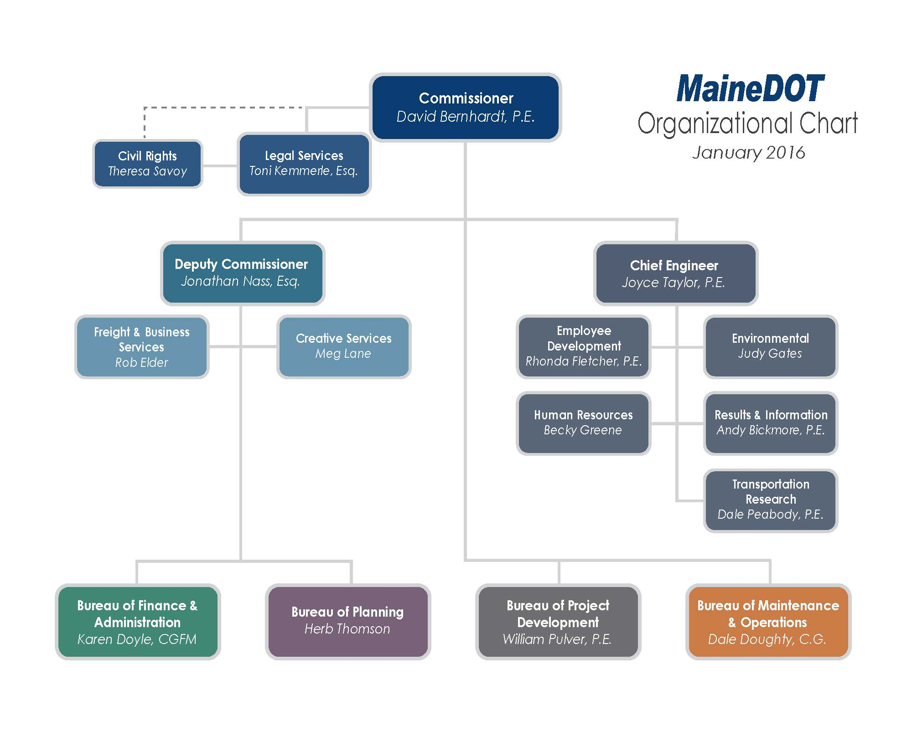
Attachment 2

Bidder’s List Survey Form

Page ____ of ____
MaineDOT BIDDER INFORMATION

Prime Contractor: Contact Person: EEO Officer:

List all DBE and Non-DBE Subcontractors and Suppliers that provided quotes to you for MaineDOT federal-aid projects between April 1, 20__ and March 30, 20__.

Return Report by: Friday, April , 20 _ @ 4:00 P.M.___

List alphabetically Duplicate if Necessary
Subcontractor Name | Address (Town/State) | DBE | Non-  DBE | Business Age (Yrs) | Annual Gross Business Receipts
Less than $500,000;
$500,000 - $1,000,000;
$1,000,000 - $2,000,000;
$2,000,000 - $5,000,000; Over $5,000,000
Less than $500,000;
$500,000 - $1,000,000;
$1,000,000 - $2,000,000; $2,000,000 - $5,000,000; Over $5,000,000
Less than $500,000;
$500,000 - $1,000,000;
$1,000,000 - $2,000,000; $2,000,000 - $5,000,000; Over $5,000,000
Less than $500,000;
$500,000 - $1,000,000;
$1,000,000 - $2,000,000; $2,000,000 - $5,000,000; Over $5,000,000
Less than $500,000;
$500,000 - $1,000,000;
$1,000,000 - $2,000,000; $2,000,000 - $5,000,000; Over $5,000,000
Use Additional Sheets as Necessary

Attachment 3

DBE Special Provision

SPECIAL PROVISION 105.10.1-6
GENERAL SCOPE OF WORK
Equal Opportunity and Civil Rights
(Disadvantaged Business Enterprises Program)
105.10.1.1 Disadvantaged Business Enterprises Program. The Maine Department of Transportation (MaineDOT) has established a Disadvantaged Business Enterprise (DBE) program in accordance with regulations of the United States Department of Transportation (USDOT), 49 CFR Part 26. The MaineDOT receives federal financial assistance from USDOT, and as a condition of receiving this assistance, the Department has signed an assurance that it will comply with 49 CFR Part 26.The MaineDOT is responsible for determining the eligibility of and certifying DBE firms in Maine.

A DBE is defined as a for-profit business that is owned and controlled by one or more socially and economically disadvantaged person(s). For the purpose of this definition:

1. “Socially and economically disadvantaged person” means an individual who is a citizen or lawful permanent resident of the United States and who is Black, Hispanic, Native American, Asian, Female; or a member of another group or an individual found to be disadvantaged by the Small Business Administration pursuant to Section 3 of the Small Business Act.2. “Owned and controlled” means a business which is:
a. A sole proprietorship legitimately owned and controlled by an individual who is a disadvantaged person.
b. A partnership or limited liability company in which at least 51% of the beneficial ownership interests legitimately are held by a disadvantaged person(s).
c. A corporation or other entity in which at least 51% of the voting interest and 51%of the beneficial ownership interests legitimately are held by a disadvantaged person(s).

The disadvantaged group owner(s) or stockholder(s) must possess control over management, interest in capital, and interest in earnings commensurate with the percentage of ownership. If the disadvantaged group ownership interests are real, substantial and continuing and not created solely to meet the requirements of this program, a firm is considered a bona fide DBE.

105.10.1.2 Commercially Useful Function. MaineDOT will count expenditures of a DBE contractor toward DBE goals only if the DBE is performing a commercially useful function on that contract. A DBE performs a commercially useful function when it is responsible for execution of the work of the contract and is carrying out its responsibilities by actually performing, managing, and supervising the work involved. Credit will only be given when the DBE meets all conditions for a CUF. Credit for labor will be in accordance with the responsibilities outlined in the contract. To perform a commercially useful function, the DBE must also be responsible, with respect to materials and supplies used on the Contract, for negotiating price, determining quality and quantity, ordering the materials, and installing (where applicable) and paying for the material itself. To determine whether a DBE is performing a commercially useful function, MaineDOT will evaluate the amount of work subcontracted, industry practices, whether the amount the firm is to be paid under the Contract is commensurate with the work it is actually performing and DBE credit claimed for its performance of the work, and other relevant factors. Rented equipment used by the DBE must not be rented from the Prime Contractor on a job that the DBE is subcontracted with that Prime Contractor for regular course of business.
A current listing of certified DBEs that may wish to participate in the highway construction program and the scope of work for which they are certified can be found at http://www.maine.gov/mdot/civilrights/dbe. Credit will be given for the value described by a DBE performing as:

A. A prime contractor; 100% of actual value of work performed by own workforces.
B. An approved subcontractor; 100% of work performed by own workforces.
C. An owner-operator of construction equipment; 100% of expenditures committed.
D. A manufacturer; 100% of expenditures committed. The manufacturer must be a firm that operates or maintains a factory or establishment that produces on the premises the materials or supplies obtained by the Contractor. Brokers and packagers shall not be regarded as manufacturers.
E. A regular dealer; 60% of expenditures committed. A regular dealer is defined as a firm that owns, operates, or maintains a store, warehouse or other establishment in which the materials or supplies required for the performance of the contract are bought, kept in stock, and regularly sold to the public. For purposes of this provision a “Broker” is a DBE that has entered into a legally binding relationship to provide goods or services delivered or performed by a third party. Brokers and packagers shall not be regarded as regular dealers.
F. A bona fide service provider; 100% of reasonable fees or commissions. Eligible services include professional, technical, consultant, or managerial, services and assistance in the procurement of essential personnel, facilities, equipment, materials or supplies required for the performance of the contract. Eligible services also include agencies providing bonding and insurance specifically required for the performance of the contract.
G. A trucking, hauling or delivery operation. 100% of expenditures committed when trucks are owned, operated, licensed and insured by the DBE and used on the contract and, if applicable, includes the cost of the self-supplied materials and supplies.100% of expenditures committed when the DBE leases trucks from another DBE firm including an owner-operator. 100% of reasonable fees or commissions the DBE receives as a result of a lease arrangement for trucks from a non-DBE, including an owner-operator.
H. Any combination of the above.

105.10.1.3 Race-neutral Goals. The Maine DOT is required to set an annual goal (approved on a three year basis) for DBE participation in Federal-aid projects. In order to fulfill that goal, bidders are encouraged to utilize DBE businesses certified by the MaineDOT. MaineDOT seeks to meet the established DBE goal solely through race-neutral means. Race-neutral DBE participation occurs when a DBE is awarded a prime contract through customary competitive procurement procedures is awarded a subcontract on a contract that does not carry a DBE contract goal, or wins a subcontract from a prime contractor that did not consider its DBE status in making the award. A DBE/subcontractor Utilization Proposed Form is required to be included in bid documents.

MaineDOT will analyze each project and create a Project Availability Target (PAT), based on a number of factors including project scope, available DBE firms, firms certified in particular project work, etc. Each bid will request that the contractor attempt to meet the PAT. This PAT is developed to assist contractors to better understand what the MaineDOT expectations are for a specific project. The PAT is NOT a mandate but an assessment of what this particular project can bear for DBE participation. The Department anticipates that each contractor will make the best effort to reach or exceed this PAT for the project.

105.10.1.4 Race-conscious Project Goals. If it is determined by the Department that the annual DBE goal will not be met through race-neutral means, the Department may implement race-conscious contract goals on some projects. Race-conscious contract goals are goals that are enforceable by the Department and require that the prime contractor use good faith effort to achieve the goal set by the Department for that particular project. If race conscious means are implemented on a project, the Prime must comply with the requirements of 49 CFR.

At the time of the bid opening, all Bidders shall submit with their bid a Disadvantaged Business Enterprise (DBE) Commitment Form provided by the Department. This form will list the DBE and non-DBE firms that are proposed to be used during the execution of the Work. The list shall show the name of the firm, the item/material/type of work involved and the dollar amount of work to be performed. The dollar total of each commitment shall be totaled and a percentage determined.

If the project goal is not met, acceptable documentation showing all good faith efforts made to obtain participation may be required in order to award the project. Failure to provide the required listing with the dollar participation total or acceptable documentation of good faith efforts to obtain DBE participation within 3 days after the bid opening date will be considered a lack of responsiveness on the part of the low bidder. Rejection of the low bid under these circumstances will require the low bidder to surrender the Proposal Guaranty to the Department.

The submission and approval of the above forms does not constitute a formal subcontract. If for any reason during the progress of the Work the Contractor finds that DBEs included on the list are unable to perform the proposed work, the Contractor, with written release by the committed DBE or approval of the Department, may substitute other DBE firms for those named on the list. If the Contractor is able to clearly document their inability to find qualified substitute firms to meet the project goal, the Contractor may request in writing approval to substitute the DBE with a non-DBE firm. If at any time during the life of the Contract it is determined that the Contractor is not fulfilling the goal or commitment(s) and is not making a good faith effort to fulfill the DBE requirement, the Department may withhold progress payments. If good faith effort is determined by the Department, failure to meet the DBE contract goal will not be a detriment to the bid award. Fulfillment of the goal percentage shall be determined by dividing the dollars committed to the DBEs by the actual contract dollars. These requirements are in addition to all other Equal Employment Opportunity requirements on Federal-aid contracts.

105.10.1.5 Certification of DBE Attainment on Contracts. The MaineDOT must certify that it has conducted post-award monitoring of all contracts to ensure that DBEs had done the work for which credit was claimed. The certification is for the purpose of ensuring accountability for monitoring which the regulation already requires. The MaineDOT will certify these contracts through review of CUF forms, Elations sub-contract payment tracking as well as occasional onsite reviews of projects and through the project’s final closeout documentation provided by our Contracts Section.

105.10.1.6 Bidders’ List Survey. Pursuant to 49 CFR 26.11 the MaineDOT is required to “create and maintain” a bidders list and gather bidder information on our construction/consultant projects, Contractors will maintain information on all subcontract bids submitted by DBE and Non-DBE firms and provide that information to the Department. The Following information is required:

Firm Name
Firm Address
Firm status (DBE or non-DBE)
Age of firm (years)
And the annual gross receipts amount as indicated by defined brackets, i.e. $500,000 to $800,000, rather than requesting exact figures.

Not only is this information critical in determining the availability of DBE businesses relative to other businesses that do similar work, but the Federal Highway Administration requires that we obtain this information.

Attachment 4

MaineDOT DBE Utilization Forms

- Contractor DBE Utilization Form (Race- neutral)
- Consultant DBE Utilization Form (Race-Neutral)
- Contractor DBE Utilization Form (Race Conscious contract goals)
- Consultant DBE Utilization Form (Race Conscious contract goals)

Page ___ of ___

MaineDOT CONTRACTOR’S DBE/SUBCONTRACTOR
PROPOSED UTILIZATION FORM
All Bidders must furnish this form with their bid on Bid Opening day

Contractor: ______________________________ Telephone: __________________ Ext _________

Contact Person: ____________________________ Fax: _____________________

E-mail: ________________________________

BID DATE: ______________________

FEDERAL PROJECT PIN # _______________ PROJECT LOCATION: ___________________________________

TOTAL ANTICIPATED DBE ____ % PARTICIPATION FOR THIS CONTRACT

W  B  E | D  B  E | Non DBE | Firm Name | Item Number & Description of Work | Quantity | Cost Per Unit/Item | Anticipated $ Value
Subcontractor
Total>
 |  |  |  |  |  | DBE Total >

NOTE: THIS INFORMATION IS USED TO TRACK AND REPORT ANTICIPATED DBE PARTICIPATION IN ALL FEDERALLY FUNDED MAINE DOT CONTRACTS. THE ANTICIPATED DBE AMOUNT IS VOLUNTARY AND WILL NOT BECOME A PART OF THE CONTRACTUAL TERMS.
Equal Opportunity Use:
Form received: ___/___/___ Verified by: ___________________________________________
FHWA  FTA  FAA

For a complete list of certified firms and company designation (WBE/DBE) go to http://www.maine.gov/mdot/civilrights/

Rev. 01/15
Original Contract
Modification
MaineDOT CONSULTANT’S DBE/SUBCONSULTANT
PROPOSED UTILIZATION FORM
Must be provided by the Consultant as an attachment to Technical Proposals for New Contracts
and Contract Modifications

Consultant Firm: | DBE: Yes No
Contact Person: | Tele: Fax:
E-mail:
Contract/Modification Amount: | Date of Execution:  (For Department Use Only)
Federal Project PIN # | Project Location:

TOTAL ANTICIPATED DBE % PARTICIPATION FOR THIS CONTRACT

W  B  E• | D  B  E• | Non DBE | Firm Name | Description of Work | Anticipated $ Value
Subconsultant
Total >
 |  |  |  | DBE Total >
*Note: this information is used to track and report anticipated dbe participation in all federally funded maine dot contracts. The anticipated DBE amount is voluntary and will not become a part of the contractual terms.
(MAINEDOT INTERNAL USE ONLY)
Form received: ___/___/___ Verified by: __________________________________________________
Civil Rights Office Representative
FHWA FTA FAA
For a complete list of certified firms and company designation (WBE/DBE) go to http://www.maine.gov/mdot/civilrights/dbe/

Rev. 05/06/15
____ Original Submission Page ___ of ___
____ Revision # ________

MaineDOT CONTRACTOR’S DBE/SUBCONTRACTOR UTILIZATION FORM
ONLY FOR PROJECTS WITH CONTRACT GOAL ASSIGNED

All Bidders must furnish this form with their bid on Bid Opening day

Contractor: _______________________________________ Telephone: _________________ Ext. ______

Prepared by:____________________________________ Fax: ______________________________

BID DATE: ______/________/________

FEDERAL PROJECT PIN # _______________________ PROJECT LOCATION: ______________________________

TOTAL DBE ________ % PARTICIPATION FOR THIS SUBMISSION

W  B  E• | D  B  E• | Non DBE | Firm Name | Unit/Item Cost | Unit # | Description of Work & Item Number | Actual $ Value
 |  |  |  |  |  | Total ›

Contractors must make a good faith effort to include Certified DBE firms in all aspects of the project. If no DBE firms are to be part of this project, a detailed explanation is required. Attach supporting evidence to the maximum participation of DBEs on this project. This is a requirement. This evidence must include name of firm(s) contacted, date contacted, and outcome of solicitation.

Equal Opportunity Use:
Form received: ___/___/___ Verified by: ______________________________
____ Accepted ____ Rejected ___________________________________________________
cc:  Contracts  Other ___________________________

For a complete list of certified firms go to http://www.maine.gov/mdot

Rev. 5/12
____ Original Submission Page ___ of ___
____ Revision # ________

MaineDOT CONSULTANT’S DBE/SUBCONSULTANTUTILIZATION FORM
ONLY FOR CONTRACTS WITH CONTRACT GOAL ASSIGNED

Must be provided as an attachment to each New or Revised Technical Proposal

Consultant: __________________________________________ Telephone:________________ Ext ______

Prepared by:______________________________________ Fax: _______________________________

DATE OF EXECUTION: ____/________/_______
(For Department Use Only)

FEDERAL PROJECT PIN # ________________________ PROJECT LOCATION: __________________________

TOTAL DBE ________ % PARTICIPATION FOR THIS SUBMISSION

W  B  E• | D  B  E• | Non DBE | Firm Name | Description of Work & Item Number | Actual $ Value
 |  |  |  | Total ›

Consultants must make a good faith effort to include Certified DBE firms in all aspects of the project. If no DBE firms are to be part of this project team, a detailed explanation is required. ____________________________________________________________________________________________
___________________________________________________________________________________________
___________________________________________________________________________________________
Equal Opportunity Use:
Form received: ___/___/___ Verified by: ______________________________
____ Accepted ____ Rejected ___________________________________________________
cc:  Contracts  Other ___________________________

For a complete list of certified firms go to http://www.maine.gov/mdot
Rev. 2/11

Attachment 5

Certification of Final DBE Payment Forms

- Contractor
- Consultant
CERTIFICATION OF FINAL DBE PAYMENT

Contractor submit to: MaineDOT, Capitol Resources Contract Section with final Project documentation.

Complete one form for each DBE Participant

Project Number and Location: ____________________________________________________________

Total DBE Participation $ __________________________________ % ________________________

In connection with the above referenced contract we the undersigned, jointly certify and attest the following information to be true.

1. DBE Firm: _________________________________________________________________

2. Describe work performed by DBE on this project: ___________________________________

______________________________________________________________________________

3. Total amount paid to DBE to date: $ _____________________________________________

4. Total amount remaining to be paid to DBE $ ______________________________________

5. Is amount paid to DBE expected to increase when final invoice is submitted?

Yes ____ No _____

6. If yes, approximately how much? $ _________________________________________________

Attest:

CONTRACTOR/CONSULTANT DBE

___________________________________ _______________________________________
(Firm’s Name) (Firm’s Name)

___________________________________ _______________________________________
(Signature) (Signature)

___________________________________ _______________________________________
(Title) (Title)

___________________________________ _______________________________________
(Date Signed) (Date Signed)
CERTIFICATION OF FINAL DBE CONSULTANT PAYMENT

Complete one form for each DBE Participant

Project Number and Location: ____________________________________________________________

Total DBE Participation $ _________________________________ % _________________________

In connection with the above referenced contract we the undersigned, jointly certify and attest the following information to be true.

1. DBE Firm’s Name: _____________________________________________________________

2. Describe work performed by DBE on this project: ___________________________________

______________________________________________________________________________

3. Total amount paid to DBE to date: $ _____________________________________________

Consultant submit to: ________________________________
(Contract Specialist)
________________________________
(Program)
Maine Department of Transportation
#16 State House Station
Augusta, Maine 04333-0016

Attest:

PRIME CONSULTANT DBE

___________________________________ _______________________________________
(Firm’s Name) (Firm’s Name)

___________________________________ _______________________________________
(Signature) (Signature)

___________________________________ _______________________________________
(Title) (Title)

___________________________________ _______________________________________
(Date Signed) (Date Signed)

Rev/ 10/08

Attachment 6

Commercially Useful Function

On Site Review Form

 Maine Department of Transportation
DBE On-Site Review for CUF
Prime Contractor |  | Federal Aid Number
Subcontractor |  | Contract Number
Project Engineer | Project Location |  MBE  DBE  WBE(for Headquarters Use Only)

- DBE Date - Initially on site review _____________ Mid-Way/Peak review ____________ Final Review ______________

2. % of DBE work Completed ______ | 3. DBE Anticipated Completion Date __________ |  |  |  |  | 4. Total Contract % Completed ___________ Anticipated Project Completion Date ______ ______
5. DBE Interviewed  Site Superintendent  Foreman  Employee (Name) |  |  |  |  | 6. Is Employee Exclusively Employed by the DBE Contractor  Yes  No
6a. If No, Please Explain
- Is Superintendent/Foreman/employees Shown on DBE Payroll?  Yes  No |  |  | 8. Is Superintendent/Foreman shown on any other On-Site Contractor’s Payroll?  Yes  No
8a. If Yes, Please Explain
9. If Known, to Whom does the DBE’s Superintendent/Foreman Directly Report to Within His/Her Own Organization?
Name: Title:
- List Names and Crafts of DBE’s Crew as Observed (Use additional sheets, if needed).

11. Are any of the Prime Employees on any other Project Subcontractor’s Payroll(s)?  Yes  No |  |  |  | 11a. If yes, Please Indicate
12. List DBE’s Major (Self-Propelled) Equipment Used
13. Is the source of materials being used by the DBE from their own facility?
14. Does the Equipment have DBE’s Markings or Emblems?  Yes  No |  | 14a. If No, Please Indicate |  |  |  |  | 15. Is DBE Equipment  Owned  Leased
Has any other Contractor performed, on behalf of the DBE, any amount of work designated to be DBE?  Yes  No
16a. If Yes, Please Explain
17. Has the DBE owner been present on the Job Site?  Yes  No If so, what % _________
18. Are Personnel and Equipment Under Direct Supervision of the DBE Subcontractor?  Yes  No |  |  |  | 19. Does the DBE Subcontractor appear to have control over methods of work in its items?  Yes  No
Comments
Note: Attach any documents pertinent to the review, i.e., Invoices, Photographs, Daily Reports, Correspondence, etc.
Review Conducted By _______________________________________________ Date of this Review ________________________
Rev. 5/15
Attachment 7

Prompt Payment Provision
Standard Specifications

104.5.5 Prompt Payment of Subcontractors
A. Pay When Paid: The Contractor shall pay Subcontractors in full for all Work satisfactorily performed and Invoiced by the Subcontractor no later than 30 Days from the date the Contractor receives payment from the Department for such Subcontractor’s Work. Contractor will insure that its Subcontractors pay all Sub-Subcontractors, including suppliers 1-47 and material men, no later than 30 days from the date that they receive payment from the Contractor.
B. Retainage: The Contractor shall return to the Subcontractor all retainage withheld from the Subcontractor within 30 Days after the date the Subcontractor's Work is satisfactorily completed. If there is a Delay in such return of retainage, the Subcontractor may pursue all rights it may have under the claims procedure referenced in Section 104.5.6 - Subcontractor Claims for Payment.

104.5.6 Subcontractor Claims for Payment: The Contractor agrees to notify all Subcontractors of the claim filing procedure of Payment and Performance bonds required by 110.2.1. The Department may use retainage and other remaining project funds to pay outstanding claims for Accepted Work.

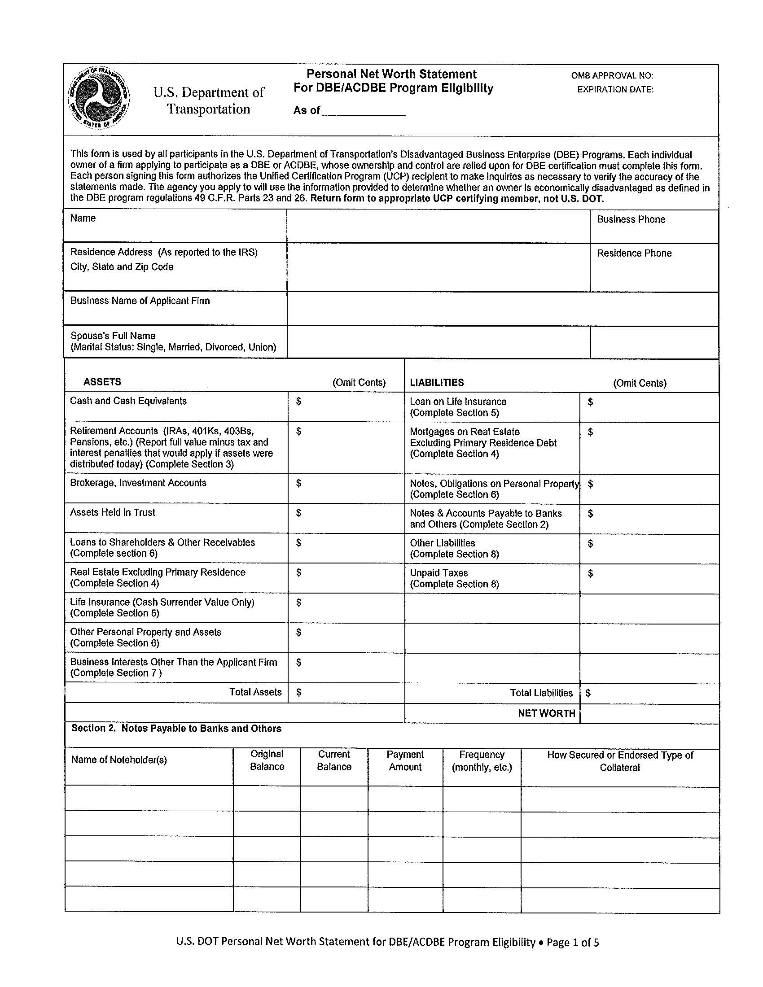
Attachment 8
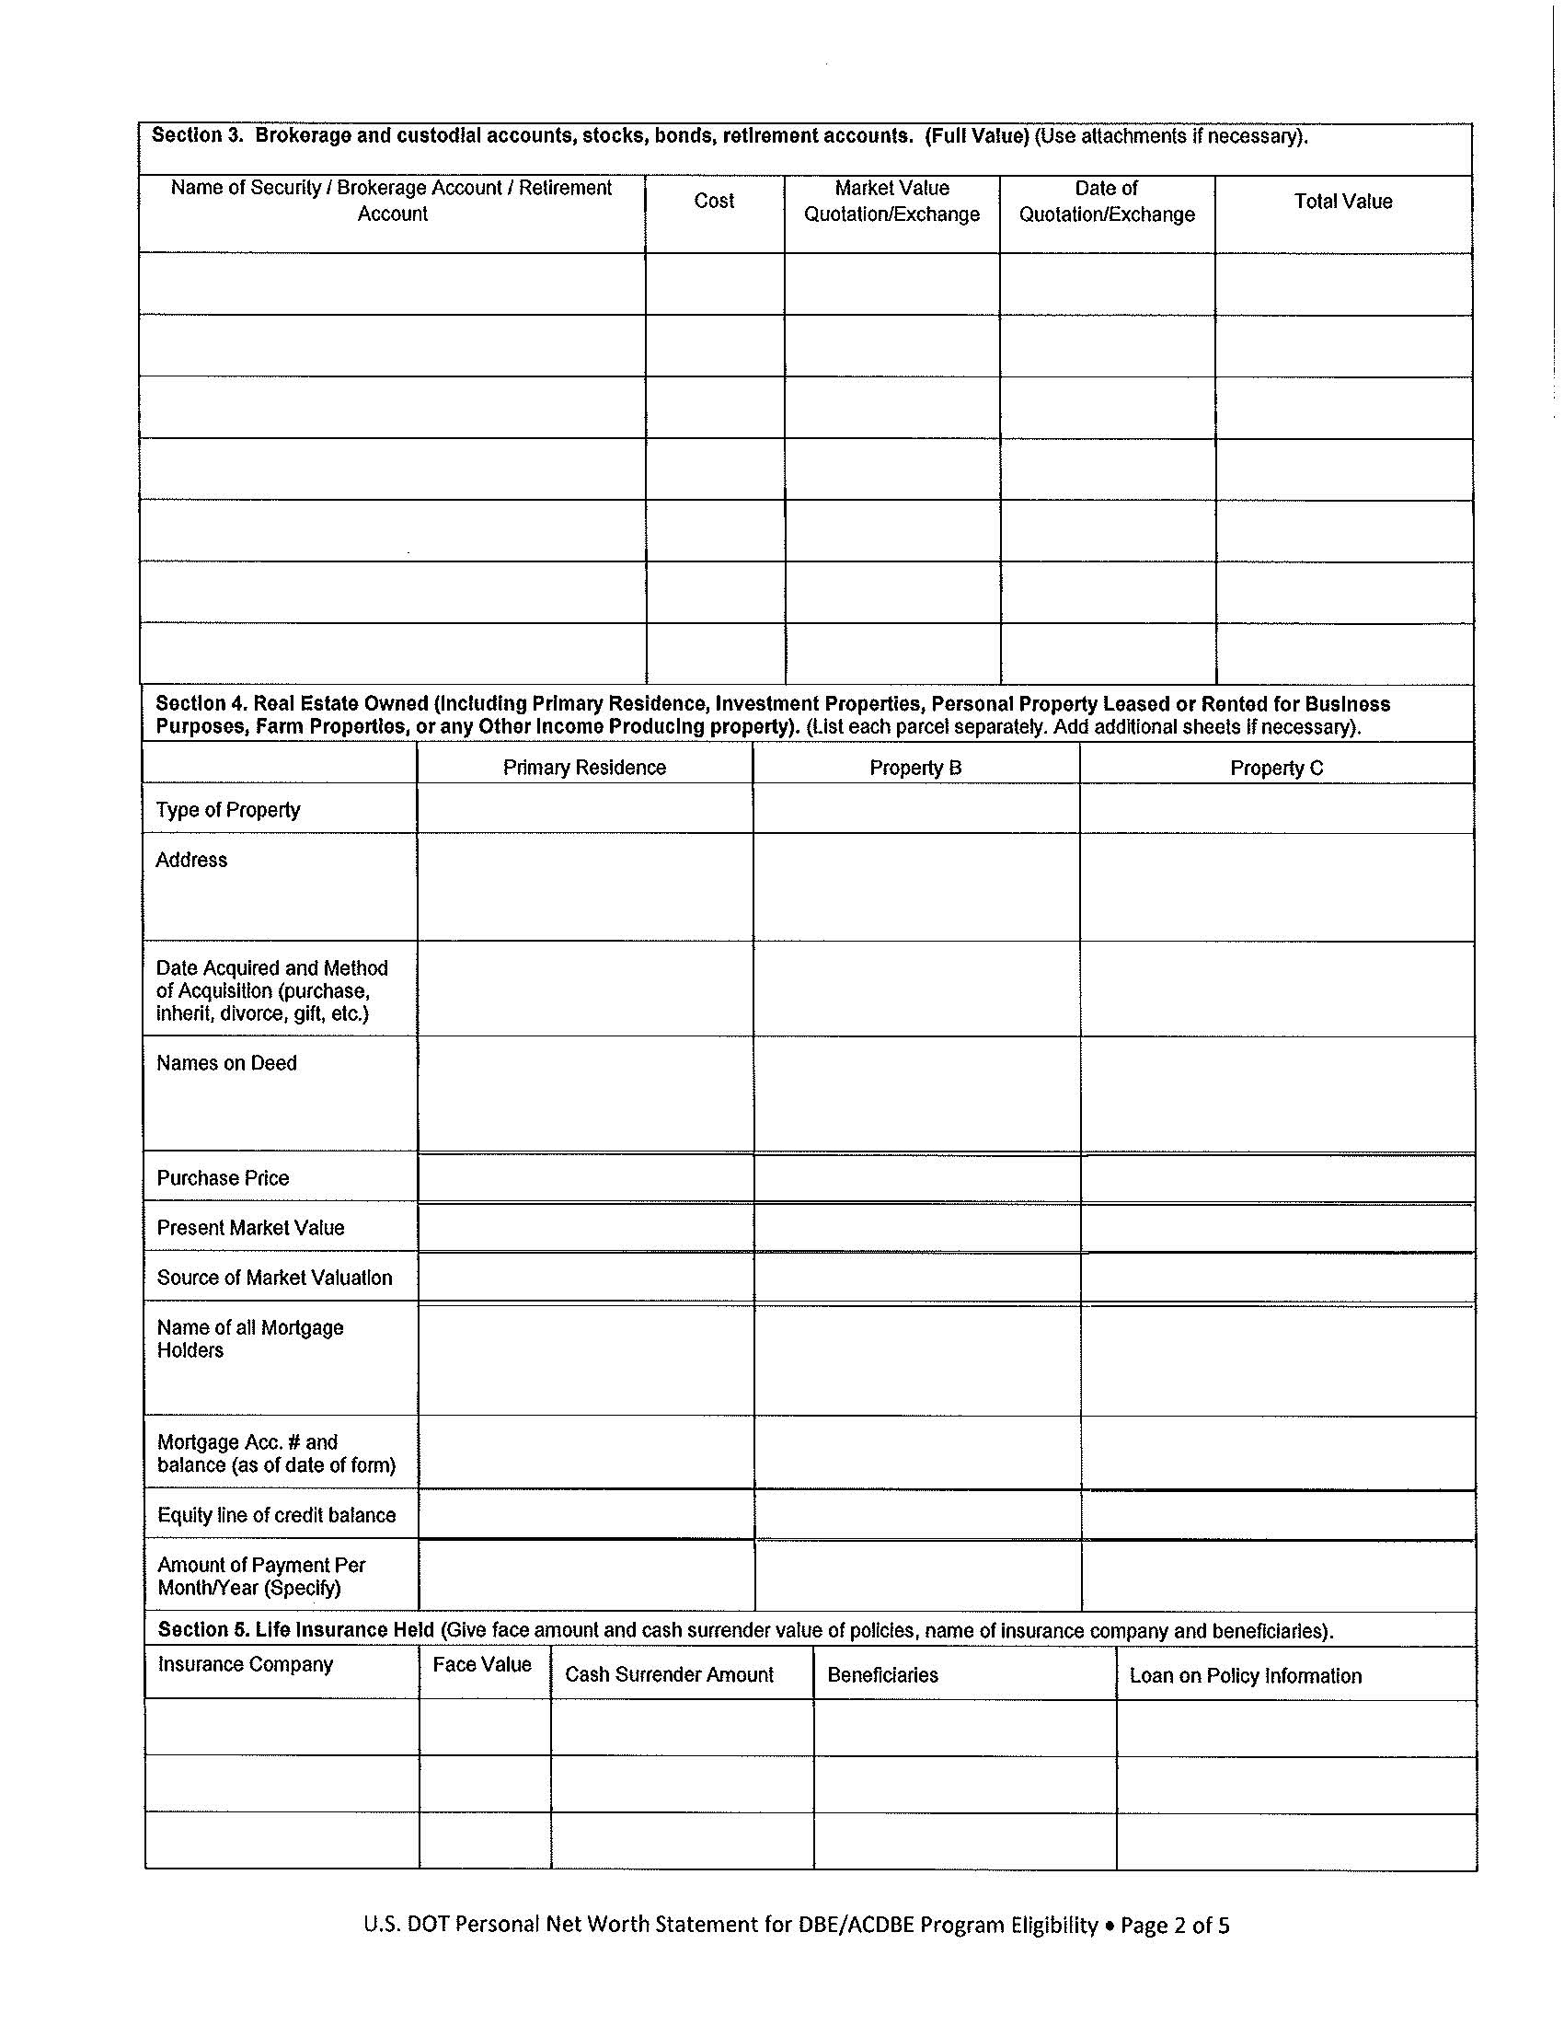
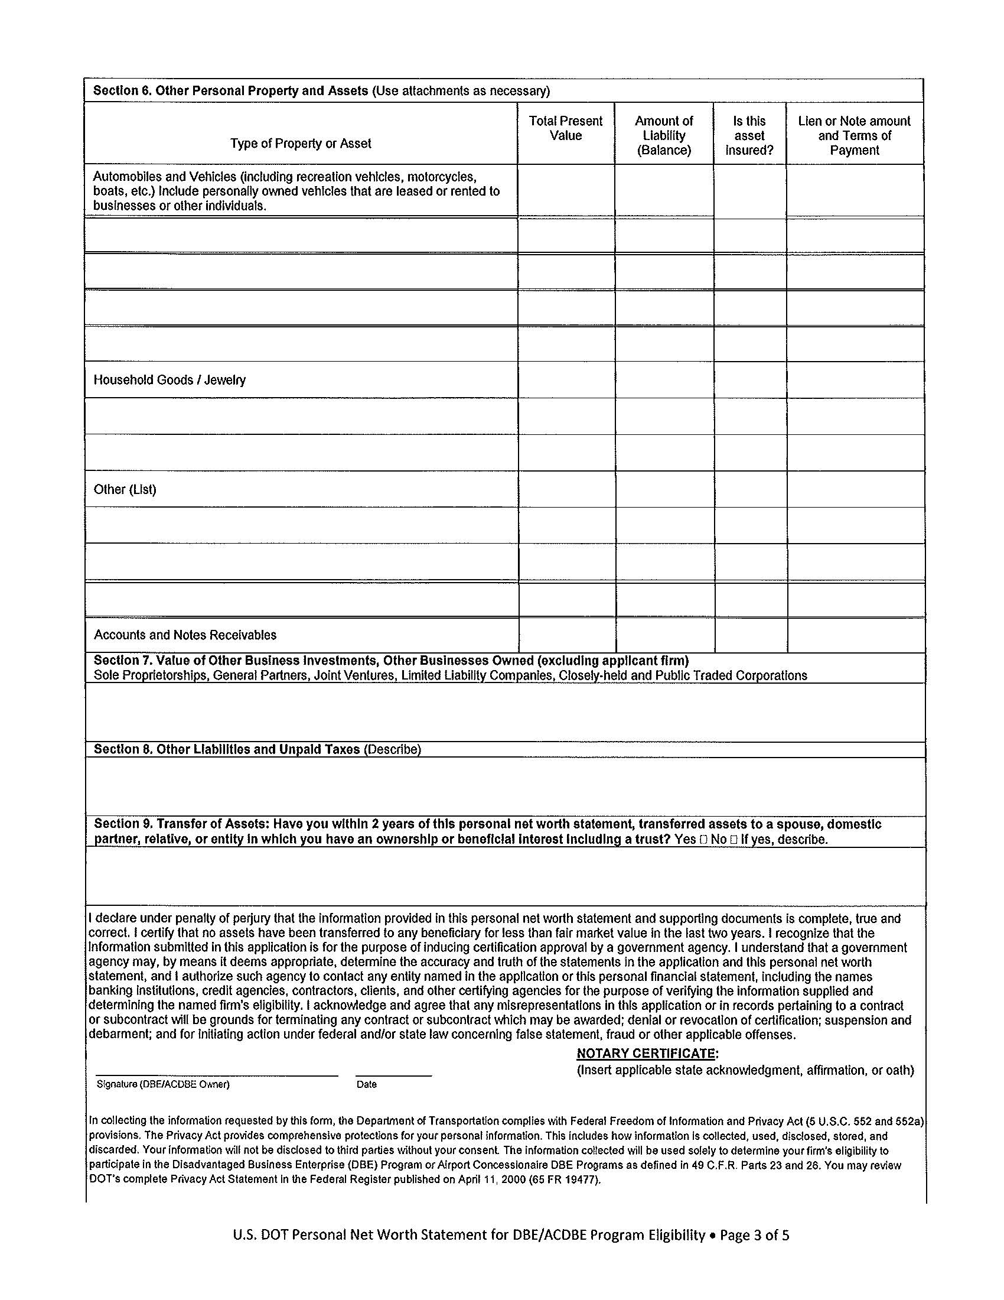
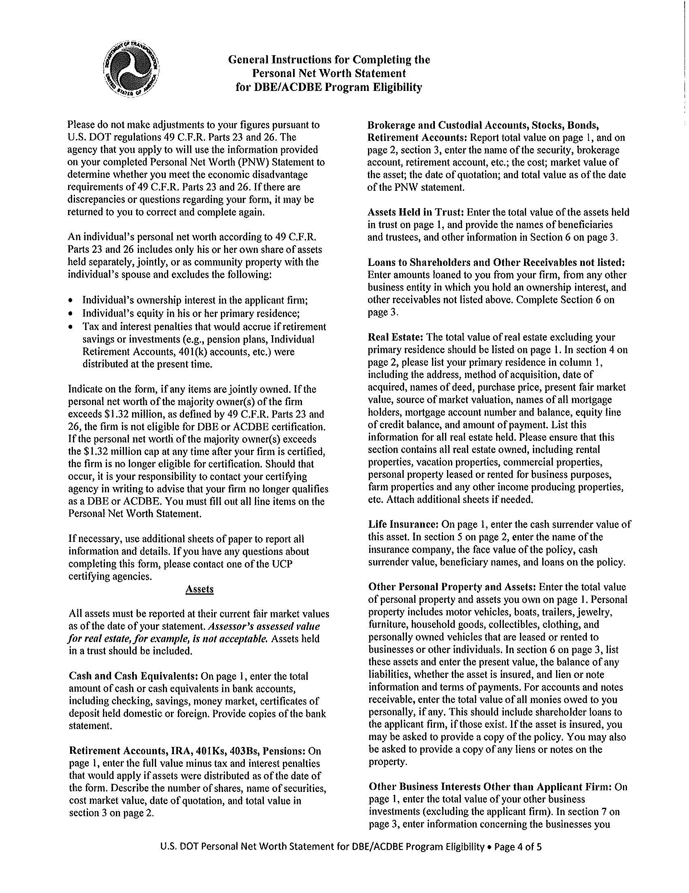
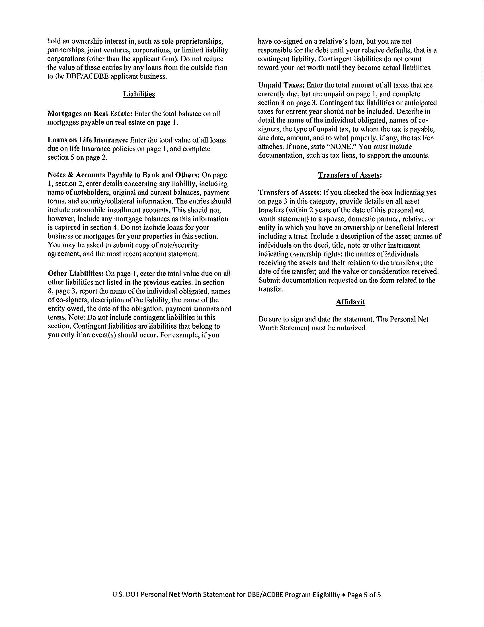

Attachment 9

Maine Freedom of Information Act and Confidentiality of DBE Records

TITLE 5: ADMINISTRATIVE PROCEDURES AND SERVICES

PART 2: CIVIL SERVICE

CHAPTER 65: CODE OF FAIR PRACTICES AND AFFIRMATIVE ACTION (HEADING: PL 1975, c. 153, @1 (new))
§ 791. Records confidential

§ 791. Records confidential
Records and correspondence utilized by state agencies in the certification of minority business enterprises, women's business enterprises and disadvantaged business enterprises which pertain to the applicant's financial or tax status, to private contracts made by the applicant, to the applicant's trade secrets or to any other matter customarily regarded as confidential business information shall be confidential and shall not be open for public inspection. [1985, c. 587 (new).]
Nothing in this section prevents the disclosure of any records, correspondence or other materials to authorized officers and employees of the State Government and Federal Government. [1985, c. 587 (new).]
Section History: 1985, c. 587 (NEW).

Attachment 10

AGREEMENT BETWEEN THE
MAINE DEPARTMENT OF TRANSPORTATION
AND
___________________________________________

THIS AGREEMENT is made this ____ day of _______________, 20__, by and between the State of Maine, through the Department of Transportation (MaineDOT), with an address of 16 State House Station, Augusta, Maine and ___________________
____________________, with an address of _________________________________, Maine.

- AGREEMENT

MaineDOT and the named party hereby agree as follows:

- The named party agrees that as a recipient of the USDOT financial assistance it will cooperate fully with the Maine Department of Transportation in the certification of Disadvantaged Business Enterprises.
- The named party agrees that it shall utilize the MaineDOT Disadvantaged Business Enterprise Certification Program.
- The named party agrees to refer potential applicants for DBE Certification to MaineDOT.
- The named party agrees to honor the decisions made by MaineDOT with respect to certification decisions made in accordance with 49 CFR Parts 23 and 26 Subpart E, Certification Procedures
- MaineDot will accept, review and make determinations about DBE Certification for those entities referred to it by the named party.

- TERMS

This Agreement remains in place indefinitely.

SEEN AND AGREED TO BY:

MAINE DEPARTMENT OF TRANSPORTATION

_____________________________ __________________
By: Amy Hughes Date
Its: Director, Civil Rights Office

__________________________________

______________________________ __________________
By: Date
Its:

Attachment 11

MaineDOT Regulation Regarding Debarment

DEPARTMENT OF TRANSPORTATION -- 17

OFFICE OF THE COMMISSIONER -- 229

CHAPTER -- 102 -- RULES REGARDING DEBARMENT OF CONTRACTORS

SUMMARY: Chapter 102 sets forth the rules used by the Department of Transportation for considering debarment of contractors.

102.01 DEFINITIONS

1. Person shall mean any individual, corporation, partnership or other business entity and shall include affiliates and subsidiaries of any such entity, and shall also include directors and officers of any entity which are closely connected to or associated with such and entity so as to control or have the power or authority to control such and entity in any business dealings.

2. Debarment shall mean disqualification from bidding on or subcontracting for any project administered by the Maine Department of Transportation.

3. Bidding Crime shall mean any act prohibited by the state or federal law committed in any jurisdiction involving fraud, conspiracy, collusion, perjury or material misrepresentation with respect to bidding on any public or private contract, and shall include violations of state anti-trust laws, federal anti-trust laws, the Racketeer Influence and Corrupt Organizations Act (RICO), 18 U.S.C. §1961, et seq., and the Mail Fraud Act, 18 U.S.C. §1341, et seq.

102.02 AUTHORITY FOR DEBARMENT

The Commissioner of the Department of Transportation shall have the authority to debar any person for the following reasons:

A. Conviction of a bidding crime resulting from either a jury or bench trial; any plea of guilty or nolo contendere to a charge of a bidding crime; any public admission by any person of a bidding crime; or any testimony under oath by an unidicted co-conspirator indicating a person’s involvement in a bidding crime.

B. Conviction of any offense indicating a lack of moral or ethical business integrity as may reasonably be perceived to relate to or reflect upon the business practices of the person.

C. Debarment by any other State or Federal agency for substantially any of the reasons listed in this Section.

D. Making false, deceptive, or fraudulent statements on any documents submitted to the Department.

E. Any other cause affecting a person’s responsibility as a contractor of such serious and compelling nature so as to consider said person for disbarment.

102.03 NOTIFICATION AND RIGHT TO HEARING

Any person considered for debarment shall be sent written notice by certified mail and allowed the opportunity for a hearing to determine whether debarment is appropriate. The notice shall state that debarment is being considered, the reasons underlying the consideration of debarment, and that the person under consideration shall be afforded an opportunity for a hearing on a specified date.

With respect to any hearing of a person under consideration for debarment:

A. Hearings shall be before a Debarment Committee consisting of five (5) individuals appointed by the Commissioner.

B. Findings of the Committee are to be determined by a preponderance of the evidence.

C. Such findings shall be agreed upon by a majority of the members of the Committee.

D. The Debarment Committee shall submit a written report to the Commissioner and each person under consideration for debarment.

E. The Commissioner shall render a final decision after review of the report of the Committee, any evidence contained in the record of the Hearing and any information related to the public interest. The Commissioner shall provide a copy of said decision to each person under consideration for debarment.

F. The Commissioner shall have the authority, in the best interest of the public, to suspend or otherwise delay inquiry into possible debarment in the event that such inquiry might impede any State or Federal investigation.

102.04 TERMS OF DEBARMENT

If a person is debarred, the term of debarment shall be for a period commensurate with the seriousness of the causes but shall not exceed twenty-four (24) months except as provided herein.

The Commissioner shall have the authority to lift, suspend or shorten the term of the debarment, or in the alternative, extend the term of debarment for any mitigating circumstances he may consider appropriate, an may include but shall not be limited to:

A. The degree of culpability of the debarred person;

B. Whether under the facts and circumstances of a debarred person’s case a lengthy debarment is necessary to protect the best interest of the State;

C. A debarred person’s disassociation from individual and business entities that have been involved in bidding crimes;

D. Cooperation by a debarred person with State, Federal or other governmental investigations of bidding crimes, including a complete and full account of the involvement of the debarred person therein;

E. Restitution by the debarred person of damages to the State.

Any debarred person may request a hearing to show that mitigating circumstances exist to lift, suspend or shorten the term of debarment.

102.05 AFFIRMATIVE DUTY TO NOTIFY THE DEPARTMENT

Every person submitting a bid or proposal to the Department of Transportation on any project shall be under the duty to notify the Department in writing and with each bid or proposal whether said person is under debarment in Maine or any other State, has been debarred by any Federal agency, or has been convicted of or pled guilty or nolo contendere to any bidding crime. Any person’s failure to furnish such notification shall constitute a reason for considering debarment.

102.06 OBLIGATIONS OF A DEBARRED PERSON

Debarment by the Commissioner of any person shall in no way affect the obligations of that person to complete services already under contract.

102.07 EFFECTS OF DEBARMENT

Any debarred person shall not be employed in any capacity on any project administered by the Department during the term of debarment, except as specifically detailed by the Commissioner.

BASIS STATEMENT: This rule was enacted to protect public funds from contractors who have engaged or are engaged in anti-trust, collusive and other irresponsible activities. A public hearing was held on July 31, 1985 at the Department of Transportation. The only comment recommending any changes to this rule was to add the word “knowingly” as the first work of Section 102.02(D). The Commissioner has determined that this change is not advisable, since the addition of the word would render this section unenforceable.

The Commissioner determined that this rule would not have significant economic impacts on a substantial number of small entities in accordance with Executive Order 12 FY 84/85.

AUTHORITY: 23 M.R.S.A. §§4204, 4206

EFFECTIVE DATE: OCT 2 1985
TITLE 23: HIGHWAYS
PART 1: STATE HIGHWAY LAW
CHAPTER 13: CONSTRUCTION, MAINTENANCE AND REPAIRS
SUBCHAPTER II: STATE HIGHWAYS
§ 753. Contracts for construction
The department shall have full power in the letting of all contracts for the construction of all state highways and other work under its jurisdiction, except as otherwise provided. The department shall make all surveys, plans, estimates, specifications and contracts for all proposed work and shall, except as otherwise provided in chapters 1 to 19, advertise for bids for the same in 2 or more public newspapers printed wholly or in part in the State, and in one public newspaper printed wholly or in part in the county where the proposed work is to be done, if any such newspaper is so printed in such county. Such advertisement shall state the place where the bidders may examine the plans and specifications, and the time and place where the bids for such work will be received by the department. Each bidder must accompany his bid with a deposit of a good and sufficient bid bond in favor of the State for the benefit of the department, executed by a corporate surety authorized to do business in the State, or certain securities, as defined in Title 14, section 871, subsection 3, payable to the Treasurer of State, for an amount which the department considers sufficient to guarantee that if the work is awarded to him, he will contract with the department for its due execution. All bids so submitted shall be publicly opened and read at the time and place stated in such advertisement. The department shall have the right to reject any and all bids, if in its opinion good cause exists, but otherwise it shall award the contract to the lowest responsible bidder. Any town may submit bids for state highway construction within its limits, and shall be subject to all requirements prescribed for other contractors, except that no bond need be required of it. The department may construct state highways by day labor without advertising for bids; and may, with the approval of the Governor, award contracts for state highways without advertising for bids, if the same shall be for the best interest of the State. [1985, c. 554, § 4 (amd).]
The department may adopt its own standard contract specifications. Notwithstanding any other federal or state law, the department's standard specifications shall be utilized in lieu of federally mandated contract clauses. [1989, c. 208, §§20, 21 (new).]
Section History: 1969, c. 322, § 2 (AMD). 1971, c. 593, § 22 (AMD). 1975, c. 771, § 252 (AMD). 1985, c. 554, § 4 (AMD). 1985, c. 86, § 2 (AMD). 1989, c. 208, § 20 (AMD).
§ 752. Expense of construction
The department shall be sole arbiter of the designation of state highways, but shall, after reasonable notice by publication, give all parties interested an opportunity to be heard thereon before such designation is made. [1971, c. 593, § 22 (amd).]
The expense of constructing such state highways shall be borne wholly by the State, except as otherwise provided in chapters 1 to 19. [1971, c. 593, § 22 (amd).]
Section History: 1971, c. 593, § 22 (AMD).
17-229 DEPARTMENT OF TRANSPORTATION

OFFICE OF THE COMMISSIONER

Chapter 105: RULES REGARDING SUSPENSION FROM BIDDING

SUMMARY: Chapter 105 sets forth the rules used by the Maine Department of Transportation to suspend a contractor’s right to bid on Construction Contracts.
105.01 Definitions
For purposes of this chapter, the following words have the following meanings unless the context indicates otherwise.

Construction Contract. A contract between the Department and at least one other party with a scope of work that encompasses the construction or maintenance of on-the-ground improvements including roads, bridges, paths, wharves, piers, buildings, other transportation infrastructure, and related improvements such as landscaping. Construction Contracts do not include planning, appraisal, design, survey or other preconstruction services unless such services are to be provided by the Contractor and are specifically within the scope of work.

Predecessor Entity. Any individual or entity that was in existence at any time within five years of the conduct allegedly justifying the suspension and that was owned, operated, or controlled to a significant degree by a Contractor or that Contractor’s owners or officers.

Unless the context clearly indicates otherwise, all other words, phrases or terms shall have the meanings contained in the latest version of the Department’s Standard Specifications, Highways and Bridges, as revised by Supplemental Specifications.

105.02 Suspension Authorized
The Department may suspend the right of a Contractor to submit bids on Construction Contracts for a term of not less than 90 days, but not more than two years. In setting the period of suspension, the Department will consider the degree to which the Contractor has violated the grounds for suspension set forth in è 105.03 as well as the gravity of the attendant consequences of such violation. Suspension does not affect the suspended Contractor’s right to perform Work as a subcontractor on Construction Contracts provided that the suspended Contractor does not work as a subcontractor for its Predecessor Entity or its Related Entity.

Suspension is distinguishable from debarment in that the suspended Contractor is only prohibited from bidding on Construction Contracts, but the suspended Contractor can work as a subcontractor. In the case of suspension, the maximum period of suspension under this rule is two years. Compare the “Rules Regarding Debarment of Contractors”, Me. Dept. of Trans. Reg. 17-229, Chap. 102.

105.03 Grounds for Suspension

The Department may suspend a Contractor if the Contractor, its predecessor entity, or a related entity:

A. Defaults or terminates on past or current Contracts;

B. Fails to pay or settle any bills for labor, materials or services on past or current Contracts;

C. Fails to provide Closeout Documentation in a timely way on past or current Contracts;
D. Fails to fulfill warranty obligations of past or current Contracts;

E. Engages in "Below Standard" performance as determined by the Department’s Contractor’s Performance Rating process;

F. Is unable to obtain or retain performance or payment bonds meeting the Department’s requirements;

G. Fails to accept an award of a Contract made by the Department;

H. Makes false, deceptive, or misleading statements or omissions, whether or not under oath, on the Contractor’s Prequalification Application, in connection with a claim on prior Contracts or in connection with bidding or performance on a Construction Contract;

I. Fails to provide information requested by the Department pursuant to this Chapter 105;

J. Engages in activity that constitutes grounds for debarment under section 102.02 of the “Rules Regarding Debarment of Contractors”, Me. Dept. of Trans. Reg. 17-229, Chap. 102 (Oct. 2, 1985);

K. Is debarred or suspended by any federal, state or local governmental procurement agency or agrees to refrain from bidding as part of a settlement with any such agencies.

L. Engages in serious misconduct that the Department reasonably determines will substantially and adversely affect the cost, quality or timeliness of Work or the safety of workers or the public.

105.04 Notice of Possible Suspension

The Department must provide written notice to the Contractor that the Department is considering suspending the Contractor from bidding on Construction Contracts. The notice must include the apparent grounds for suspension and a copy of these Rules Regarding Suspension from Bidding (Chapter 105).

105.05 Investigation

The Department may require the Contractor to provide any information that the Department determines is necessary or convenient to evaluate possible suspension including all information requested in the Contractor’s Prequalification Application form adopted by the Department. The Department may conduct such other investigation as it determines is necessary to evaluate possible suspension of the Contractor including gathering information from other published sources of industry information, information from other state transportation departments, the Federal Highway Administration, and any other relevant information. The Department may issue subpoenas to compel the attendance and testimony of witnesses and the production of evidence relating to any material issue in accordance with Maine Administrative Procedure Act, 5 M.R.S.A. Section 9060.

Based upon this investigation, the Department will determine whether there exist reasonable grounds to proceed with suspension. The Department must provide written notice to the Contractor of this determination. Said notice must include a provision that the Contractor has the right within 10 days of receipt of said notice to request a hearing. Such notice may also include a provision that the Department, in its discretion, has scheduled a hearing.

105.06 Hearing

If a hearing is scheduled due to a request by the Contractor or due to an exercise of the Department’s discretion, the Department will provide the Contractor with at least 10 days prior written notice of the date, time and place of the hearing unless waived by the Contractor. All hearings shall be adjudicatory proceedings held in accordance with the Maine Administrative Procedure Act, 5 M.R.S.A. Section 9051, et seq.

105.07 Decision

After investigation and hearing (if any), the Department will make its decision through its Chief Engineer and notify the Contractor in writing of its determination. If a Contractor is suspended, then the term of the suspension shall not be less than 90 days and not more than two years.

Upon receipt of the Department’s notice of suspension, the Contractor is disqualified from bidding on Construction Contracts for the suspension period in the notice.

105.08 Delay of Bid Openings Pending Appeal

Within two days of receipt of a notice of suspension, the Contractor or the Department may request a postponement of bid openings on which the Contractor intends to bid until after the appeal process provided in subsection 105.09 below. Such requests will be granted unless the Department in its discretion determines that delay is likely to cause substantial harm to the interests of the State. If a request for postponement is denied, the Contractor is not eligible to bid pending appeal.

105.09 Appeal to Commissioner

To appeal a suspension by the Chief Engineer, the Contractor must, within 10 days of receipt of the notice of suspension, deliver to the Commissioner a written appeal notice and any additional written information or arguments that the Contractor wants considered.

Within 20 days of receipt of the appeal notice, the Commissioner or his designee(s) will notify the Contractor in writing that the suspension is affirmed, modified or reversed, that additional information is required or that the Commissioner elects to submit the issue to binding or non-binding alternative dispute resolution.

105.10 Final Agency Action

Any such written affirmation, modification, or reversal by the Commissioner or his designee(s) pursuant to è 105.9 of these rules shall be final agency action as of the date of receipt by the Contractor. In cases of binding alternative dispute resolution, the 20-day appeal period shall not begin to run until the day after the Commissioner mails written notice to the Contractor that the Commissioner has adopted the decision. In cases of non-binding alternative dispute resolution, the 20-day appeal period shall not begin to run until the day after the Commissioner mails to the Contractor written notice adopting, modifying or reversing the non-binding decision.

105.11 Judicial Review

Any petition for review shall be in accordance with the Maine Administrative Procedure Act, 5 M.R.S.A. §11001, et seq. and Rule 80C of the Maine Rules of Civil Procedure.

STATUTORY AUTHORITY: 23 M.R.S.A. èè 52, 753, 4206 (5).

EFFECTIVE DATE: September 26, 2001

Attachment 12

DEFINITIONS
Definitions of terms used in 49 CFR 26.5:
Affiliation has the same meaning the term has in the Small Business Administration (SBA) regulations, 13 CFR part 121.
(1) Except as otherwise provided in 13 CFR part 121, concerns are affiliates of each other when, either directly or indirectly:
(i) One concern controls or has the power to control the other; or
(ii) A third party or parties controls or has the power to control both; or
(iii) An identity of interest between or among parties exists such that affiliation may be found.
(2) In determining whether affiliation exists, it is necessary to consider all appropriate factors, including common ownership, common management, and contractual relationships. Affiliates must be considered together in determining whether a concern meets small business size criteria and the statutory cap on the participation of firms in the DBE program.
Alaska Native means a citizen of the United States who is a person of one-fourth degree or more Alaskan Indian (including Tsimshian Indians not enrolled in the Metlaktla Indian Community), Eskimo, or Aleut blood, or a combination of those bloodlines. The term includes, in the absence of proof of a minimum blood quantum, any citizen whom a Native village or Native group regards as an Alaska Native if their father or mother is regarded as an Alaska Native.
Alaska Native Corporation (ANC) means any Regional Corporation, Village Corporation, Urban Corporation, or Group Corporation organized under the laws of the State of Alaska in accordance with the Alaska Native Claims Settlement Act, as amended (43 U.S.C. 1601, et seq.).
Assets mean all the property of a person available for paying debts or for distribution, including one's respective share of jointly held assets. This includes, but is not limited to, cash on hand and in banks, savings accounts, IRA or other retirement accounts, accounts receivable, life insurance, stocks and bonds, real estate, and personal property.
Business, business concern or business enterprise means an entity organized for profit with a place of business located in the United States, and which operates primarily within the United States or which makes a significant contribution to the United States economy through payment of taxes or use of American products, materials, or labor.
Compliance means that a recipient has correctly implemented the requirements of this part.
Contingent Liability means a liability that depends on the occurrence of a future and uncertain event. This includes, but is not limited to, guaranty for debts owed by the applicant concern, legal claims and judgments, and provisions for federal income tax.
Contract means a legally binding relationship obligating a seller to furnish supplies or services (including, but not limited to, construction and professional services) and the buyer to pay for them. For purposes of this part, a lease is considered to be a contract.
Contractor means one who participates, through a contract or subcontract (at any tier), in a DOT-assisted highway, transit, or airport program.
Days mean calendar days. In computing any period of time described in this part, the day from which the period begins to run is not counted, and when the last day of the period is a Saturday, Sunday, or Federal holiday, the period extends to the next day that is not a Saturday, Sunday, or Federal holiday. Similarly, in circumstances where the recipient's offices are closed for all or part of the last day, the period extends to the next day on which the agency is open.
Department or DOT means the U.S. Department of Transportation, including the Office of the Secretary, the Federal Highway Administration (FHWA), the Federal Transit Administration (FTA), and the Federal Aviation Administration (FAA).
Disadvantaged business enterprise or DBE means a for-profit small business concern—
(1) That is at least 51 percent owned by one or more individuals who are both socially and economically disadvantaged or, in the case of a corporation, in which 51 percent of the stock is owned by one or more such individuals; and
(2) Whose management and daily business operations are controlled by one or more of the socially and economically disadvantaged individuals who own it.
DOT-assisted contract means any contract between a recipient and a contractor (at any tier) funded in whole or in part with DOT financial assistance, including letters of credit or loan guarantees, except a contract solely for the purchase of land.
Good faith efforts means efforts to achieve a DBE goal or other requirement of this part which, by their scope, intensity, and appropriateness to the objective, can reasonably be expected to fulfill the program requirement.
Home state means the state in which a DBE firm or applicant for DBE certification maintains its principal place of business.
Immediate family member means father, mother, husband, wife, son, daughter, brother, sister, grandfather, grandmother, father-in-law, mother-in-law, sister-in-law, brother-in-law, and domestic partner and civil unions recognized under State law.
Indian tribe means any Indian tribe, band, nation, or other organized group or community of Indians, including any ANC, which is recognized as eligible for the special programs and services provided by the United States to Indians because of their status as Indians, or is recognized as such by the State in which the tribe, band, nation, group, or community resides. See definition of “tribally-owned concern” in this section.
Joint venture means an association of a DBE firm and one or more other firms to carry out a single, for-profit business enterprise, for which the parties combine their property, capital, efforts, skills and knowledge, and in which the DBE is responsible for a distinct, clearly defined portion of the work of the contract and whose share in the capital contribution, control, management, risks, and profits of the joint venture are commensurate with its ownership interest.
Liabilities mean financial or pecuniary obligations. This includes, but is not limited to, accounts payable, notes payable to bank or others, installment accounts, mortgages on real estate, and unpaid taxes.
Native Hawaiian means any individual whose ancestors were natives, prior to 1778, of the area which now comprises the State of Hawaii.
Native Hawaiian Organization means any community service organization serving Native Hawaiians in the State of Hawaii which is a not-for-profit organization chartered by the State of Hawaii, is controlled by Native Hawaiians, and whose business activities will principally benefit such Native Hawaiians.
Noncompliance means that a recipient has not correctly implemented the requirements of this part.
Operating Administration or OA means any of the following parts of DOT: the Federal Aviation Administration (FAA), Federal Highway Administration (FHWA), and Federal Transit Administration (FTA). The “Administrator” of an operating administration includes his or her designees.
Personal net worth means the net value of the assets of an individual remaining after total liabilities are deducted. An individual's personal net worth does not include: The individual's ownership interest in an applicant or participating DBE firm; or the individual's equity in his or her primary place of residence. An individual's personal net worth includes only his or her own share of assets held jointly or as community property with the individual's spouse.
Primary industry classification means the most current North American Industry Classification System (NAICS) designation which best describes the primary business of a firm. The NAICS is described in the North American Industry Classification Manual—United States, which is available on the Internet at the U.S. Census Bureau Web site: http://www.census.gov/eos/www/naics/.
Primary recipient means a recipient which receives DOT financial assistance and passes some or all of it on to another recipient.
Principal place of business means the business location where the individuals who manage the firm's day-to-day operations spend most working hours. If the offices from which management is directed and where the business records are kept are in different locations, the recipient will determine the principal place of business.
Program means any undertaking on a recipient's part to use DOT financial assistance, authorized by the laws to which this part applies.
Race-conscious measure or program is one that is focused specifically on assisting only DBEs, including women-owned DBEs.
Race-neutral measure or program is one that is, or can be, used to assist all small businesses. For the purposes of this part, race-neutral includes gender-neutrality.
Recipient is any entity, public or private, to which DOT financial assistance is extended, whether directly or through another recipient, through the programs of the FAA, FHWA, or FTA, or who has applied for such assistance.
Secretary means the Secretary of Transportation or his/her designee.
Set-aside means a contracting practice restricting eligibility for the competitive award of a contract solely to DBE firms.
Small Business Administration or SBA means the United States Small Business Administration.
SBA certified firm refers to firms that have a current, valid certification from or recognized by the SBA under the 8(a) BD or SDB programs.
Small business concern means, with respect to firms seeking to participate as DBEs in DOT-assisted contracts, a small business concern as defined pursuant to section 3 of the Small Business Act and Small Business Administration regulations implementing it (13 CFR part 121) that also does not exceed the cap on average annual gross receipts specified in §26.65(b).
Socially and economically disadvantaged individual means any individual who is a citizen (or lawfully admitted permanent resident) of the United States and who has been subjected to racial or ethnic prejudice or cultural bias within American society because of his or her identity as a members of groups and without regard to his or her individual qualities. The social disadvantage must stem from circumstances beyond the individual's control.
(1) Any individual who a recipient finds to be a socially and economically disadvantaged individual on a case-by-case basis. An individual must demonstrate that he or she has held himself or herself out, as a member of a designated group if you require it.
(2) Any individual in the following groups, members of which are rebuttably presumed to be socially and economically disadvantaged:
(i) “Black Americans,” which includes persons having origins in any of the Black racial groups of Africa;
(ii) “Hispanic Americans,” which includes persons of Mexican, Puerto Rican, Cuban, Dominican, Central or South American, or other Spanish or Portuguese culture or origin, regardless of race;
(iii) “Native Americans,” which includes persons who are enrolled members of a federally or State recognized Indian tribe, Alaska Natives, or Native Hawaiians;
(iv) “Asian-Pacific Americans,” which includes persons whose origins are from Japan, China, Taiwan, Korea, Burma (Myanmar), Vietnam, Laos, Cambodia (Kampuchea), Thailand, Malaysia, Indonesia, the Philippines, Brunei, Samoa, Guam, the U.S. Trust Territories of the Pacific Islands (Republic of Palau), Republic of the Northern Marianas Islands, Samoa, Macao, Fiji, Tonga, Kirbati, Tuvalu, Nauru, Federated States of Micronesia, or Hong Kong;
(v) “Subcontinent Asian Americans,” which includes persons whose origins are from India, Pakistan, Bangladesh, Bhutan, the Maldives Islands, Nepal or Sri Lanka;
(vi) Women;
(vii) Any additional groups whose members are designated as socially and economically disadvantaged by the SBA, at such time as the SBA designation becomes effective.
(3) Being born in a particular country does not, standing alone, mean that a person is necessarily a member of one of the groups listed in this definition.
Spouse means a married person, including a person in a domestic partnership or a civil union recognized under State law.
Transit vehicle manufacturer means any manufacturer whose primary business purpose is to manufacture vehicles specifically built for public mass transportation. Such vehicles include, but are not limited to: Buses, rail cars, trolleys, ferries, and vehicles manufactured specifically for paratransit purposes. Producers of vehicles that receive post-production alterations or retrofitting to be used for public transportation purposes (e.g., so-called cutaway vehicles, vans customized for service to people with disabilities) are also considered transit vehicle manufacturers. Businesses that manufacture, mass-produce, or distribute vehicles solely for personal use and for sale “off the lot” are not considered transit vehicle manufacturers.
Tribally-owned concern means any concern at least 51 percent owned by an Indian tribe as defined in this section.
You refers to a recipient, unless a statement in the text of this part or the context requires otherwise (i.e., ‘You must do XYZ’ means that recipients must do XYZ).
[64 FR 5126, Feb. 2, 1999, as amended at 64 FR 34570, June 28, 1999; 68 FR 35553, June 16, 2003; 76 FR 5096, Jan. 28, 2011; 79 FR 59592, Oct. 2, 2014]

