My Stress Bucket
MDOT Lunch and Learn

Top 3 Things That Contribute to My Stress:
- ___________________________
- ___________________________
- ___________________________
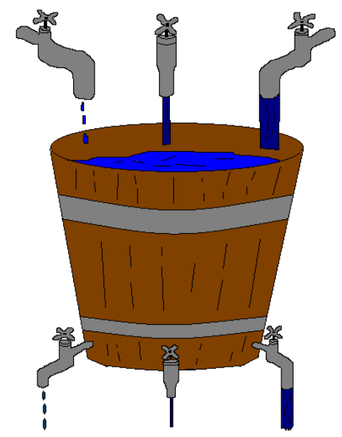

3 Things I Do To Relieve My Stress:
- ___________________________
- ___________________________
- ___________________________
How Will I Maintain This Or How Can I Change This:
- __________________________
- __________________________
- __________________________
Comments About My Stress:
_____________________________________________________________________________________________________________________________________________________________________________________________________________________________________________________________________________________________________________

* FMI Or to set up a health coaching appointment please contact Health Coach Hester Kohl at 624-3597 or Hester.Kohl@maine.gov.

