STATE OF MAINE – CALL TRANSFER POLICY TEMPLATE

SUBJECT: CALL TRANSFER PROCEDURE |  | NUMBER:
RESCINDS: | EFFECTIVE DATE:
DISTRIBUTION: | REVIEW DATE:
STANDARD:

- PURPOSE

The purpose of this policy is to establish call transfer procedures for PSAPs.

- POLICY

It is the policy of this agency to provide the highest quality response to all emergency calls and to ensure that calls requiring transfer to another PSAP or dispatch facility are processed efficiently and in accordance with the procedures established by this directive. This policy, which has been created and approved by the State of Maine, is intended to standardize and streamline the call transfer process, as well as define areas of responsibility. It is also designed to ensure that call transfers are done as seamlessly as possible, while also allowing the ETC to provide necessary instructions to the caller.

- DEFINITIONS

- Emergency Services Communication Bureau (ESCB): The Bureau within the Maine Public Utilities Commission overseeing the 9-1-1 system in Maine.

- Emergency Communications Specialist (ECS)

- Emergency Communications Specialist Supervisor (ECSS)

- Emergency Telecommunicator (ETC)

- Public Safety Answering Point (PSAP): A place where 9-1-1 calls are received and transferred to the appropriate dispatch center for the emergency services requested.

- Automatic Number Identification (ANI): The ability of the 9-1-1 system to display the phone number of the incoming 9-1-1 call.

- Automatic Location Identification (ALI): The ability of the 9-1-1 system to display the subscriber address information of the incoming 9-1-1 call.

- Dispatch Agency: An agency responsible for dispatching police, fire, and/or EMS units.

- GENERAL

  - Ownership - When a call arrives at (PSAP name), it is considered to be owned by this PSAP, and we are therefore obligated to take charge of the call, take immediate action, and provide all necessary assistance to the caller.
  - Non-Jurisdictional Calls - In the event that an emergency call is received by this agency that is not within the jurisdiction in which we provide police, fire or emergency medical dispatch service, this call transfer procedure shall be used to process the call.

  - Caller Management - In order to effectively manage the caller, as well as minimize caller frustration, ETCs need to preface repeated questions with a reason. Refer to Exhibit A – Call Transfer Procedure - for examples of suggested language.

  - Quality Assurance – Rules regarding quality assurance (QA) have been established to ensure the highest level of care for our citizens. For clarification purposes, QA starts when the receiving PSAP begins caller interrogation.

  - ETC Orientation - It is recommended that ETCs thoroughly review the chart, and become familiar with its content. It is also recommended that ETCs use role playing techniques (with typical call examples) to practice and become familiar with this procedure.

  - Feedback – All PSAP staff are encouraged to report any issues regarding this policy to their immediate supervisor. Feedback includes suggestions for improvement as well as any problematic issues that may surface with its use. Please forward feedback on this policy to info911@maine.gov

- PROCEDURE

  - Verification of Address – Location of the emergency is crucial to the “where” emergency responders are required to attend. For every call, including each incident of call transfer, the case entry question “What is the address of the emergency?” shall be posed to the caller. Verification of the address shall be consistent with agency procedures.
    - In order to ensure that complete address verification occurs, and that “location of the event” dispatch errors are minimized, callers shall always be asked to verify their complete address including, where appropriate the following:
      - House number
      - Apartment number
      - Business name
      - Intersection
      - Landmarks
      - Jurisdiction
      - GPS coordinates
      - City, town or village

  - Verification of Call-Back Number – Verification of the call-back number is crucial to the reestablishment of contact with the caller. For every call, including each incident of call transfer, the case entry question “What’s the phone number you are calling from?” shall be posed to the caller. Verification of the call back number shall be consistent with agency procedures.
    - In order to ensure that call-back number verification occurs, and that call-back number errors are minimized, callers shall always be asked to verify their call back number.

  - Determination of Chief Complaint – Determination of the chief complaint is crucial to the dispatch of the correct emergency resources, as well as the level of response. For every call, including each incident of call transfer, the case entry question “Okay, tell me exactly what happened?” shall be posed to the caller. Determination of the chief complaint shall be consistent with agency procedures.
    - In order to ensure that the ETC establishes exactly what has happened, and that all scene safety issues have been addressed, and the appropriate response is initiated, callers shall always be asked to describe exactly what has happened.
      - In most cases, callers do not accurately report all of the facts pertaining to an emergency call. For example, a request for an ambulance may be the result of an assault with a weapon, or some other crime against a person that requires a law enforcement response.
        - Under no circumstance shall the question, “Do you need police, fire or ambulance?” be posed to a caller.

  - Unable to Transfer - If for some reason the line is not transferable, the dispatcher will obtain all necessary details including the caller’s name and call back number, and relay all pertinent information to the responsible PSAP as soon as possible. This ensures little or no delay in dispatching help to the caller. Non-transferable medical emergency calls will be processed using the EMD protocol, and another dispatcher shall relay information to the appropriate agency for medical dispatch.
    - Examples of Unable to Transfer situations may include phone system outages, 9-1-1 selective router system failures, or problems with the 9-1-1 equipment at the PSAP.

  - Incorrect Transfer - In the event that a PSAP transfers an emergency call to (your PSAP) that is not within your jurisdiction:
    - An ‘Incorrect Xfer’ event (call) shall be created in CAD,
    - The transferring agency shall become the complainant, and
    - The receiving ETC becomes the ‘Responsible Officer’.
The same procedure shall be taken with emergency calls received on business lines or non-emergency trunk lines. A brief narrative should also be included as to the nature of the call, the agency that it should have gone to, and any further pertinent information.

  - EMD Centers – EMD Centers are licensed by the Maine State Board of Emergency Medical Services. All Public Safety Answering Points (PSAPs) must be licensed as EMD Centers. In addition, Dispatch Only Centers (DOCs) may be licensed as EMD Centers.
    - Refer to Exhibit B - Licensed EMD Centers – for a complete list of Maine licensed EMD centers.

  - EFD Centers – EFD Centers are certified through a protocol vendor and maintain a Quality Assurance program. All Public Safety Answering Points (PSAPs) must be certified in the use of EFD protocols. In addition, Dispatch Only Centers (DOCs) may be certified as EFD Centers.
    - Refer to Exhibit C – Certified EFD Centers – for a complete list of Maine certified EFD centers.

- EFFECTIVE DATE:

This Directive is effective immediately, as approved by (your policy authority) on ________day of ________, 20___.

________________, Director
(PSAP name)
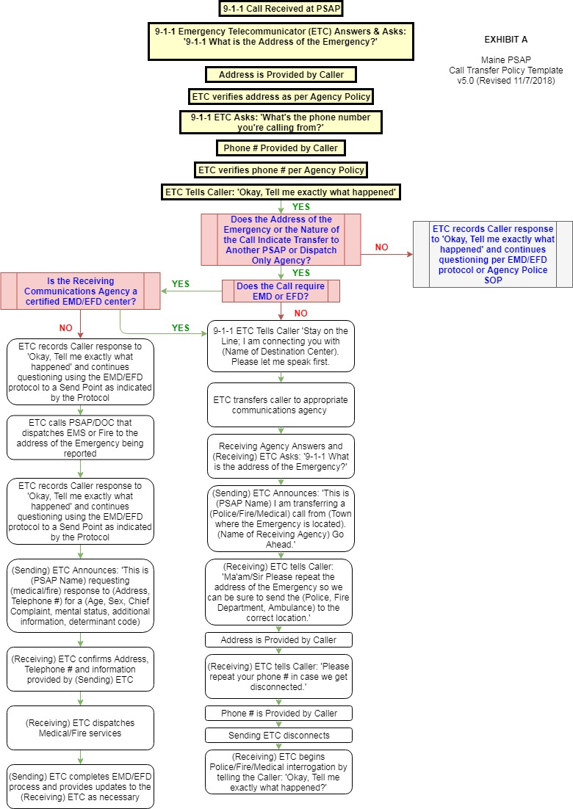
Exhibit B – Licensed EMD Centers

SERVICE NAME | EMD STATUS | PSAP STATUS | STREET ADDRESS | CITY | ZIP
Androscoggin County Sheriff Department | Licensed | PSAP | 2 Turner Street | Auburn | 04210
Biddeford Public Safety Communications Center | Licensed | PSAP | 39 Alfred Street | Biddeford | 04005
Brunswick Police Department Communications Division | Licensed | PSAP | 85 Pleasant Street | Brunswick | 04011
Central Maine Consolidated Emer Comm Bureau | Licensed | PSAP | 45 Commerce Drive | Augusta | 04333
Cumberland County Regional Communications Center | Licensed | PSAP | 22B High Street | Windham | 04062
Dept. of Public Safety - Bangor | Licensed | PSAP | 198 Maine Avenue | Bangor | 04401
Dept. of Public Safety - Houlton | Licensed | PSAP | 1 Darcie Drive | Houlton | 04730
Franklin County RCC | Licensed | PSAP | 124 County Way | Farmington | 04938
Hancock County RCC / 9-1-1 | Licensed | PSAP | 50 State Street | Ellsworth | 04605
Kittery Police Department | Licensed |  | 200 Rogers Rd | Kittery | 03904
Knox Regional Communications Center | Licensed | PSAP | 301 Park Street | Rockland | 04841
Lewiston/Auburn 9-1-1 | Licensed | PSAP | 552 Minot Avenue | Auburn | 04210
Lincoln County 9-1-1 | Licensed | PSAP | 34 Bath Road | Wiscasset | 04578
Oxford County Regional Communications Center | Licensed | PSAP | 26 Western Avenue | South Paris | 04281
Penobscot Regional Communications Center | Licensed | PSAP | 97 Hammond Street | Bangor | 04401
Piscataquis County Sheriff's Dept. | Licensed | PSAP | 52 Court Street | Dover Foxcroft | 04426
Portland Police & Fire Department | Licensed | PSAP | 109 Middle Street | Portland | 04101
Saco Police Department | Licensed |  | 20 Storer Street | Saco | 04072
Sagadahoc County Communications | Licensed | PSAP | 752 High Street | Bath | 04530
Sanford Regional Communications Center | Licensed | PSAP | 935 Main Street | Sanford | 04073
Scarborough Public Safety | Licensed | PSAP | 246 US Route 1 | Scarborough | 04074
Somerset County Communications Center | Licensed | PSAP | 8 County Drive | Skowhegan | 04976
Waldo County RCC | Licensed | PSAP | 2 Public Safety Way | Belfast | 04915
Washington County Regional Communications Center | Licensed | PSAP | 28 Center Street | Machias | 04654
Waterville Police Dept. | Licensed |  | 10 Colby Street | Waterville | 04901
Wells Police Dept. | Licensed |  | 1563 Post Rd | Wells | 04090
Westbrook Communications | Licensed | PSAP | 570 Main Street | Westbrook | 04092
York Police Department | Licensed | PSAP | 9 Hannaford Drive | York | 03909

Exhibit C – Certified EFD Centers

SERVICE NAME | EFD STATUS | PSAP STATUS | STREET ADDRESS | CITY | ZIP
Androscoggin County Sheriff Department | Certified | PSAP | 2 Turner Street | Auburn | 04210
Biddeford Public Safety Communications Center | Certified | PSAP | 39 Alfred Street | Biddeford | 04005
Brunswick Police Department Communications Division | Certified | PSAP | 85 Pleasant Street | Brunswick | 04011
Central Maine Consolidated Emer Comm Bureau | Certified | PSAP | 45 Commerce Drive | Augusta | 04333
Cumberland County Regional Communications Center | Certified | PSAP | 22B High Street | Windham | 04062
Dept. of Public Safety - Bangor | Certified | PSAP | 198 Maine Avenue | Bangor | 04401
Dept. of Public Safety - Houlton | Certified | PSAP | 1 Darcie Drive | Houlton | 04730
Franklin County RCC | Certified | PSAP | 124 County Way | Farmington | 04938
Hancock County RCC / 9-1-1 | Certified | PSAP | 50 State Street | Ellsworth | 04605
Kittery Police Department | Certified |  | 200 Rogers Rd | Kittery | 03904
Knox Regional Communications Center | Certified | PSAP | 301 Park Street | Rockland | 04841
Lewiston/Auburn 9-1-1 | Certified | PSAP | 552 Minot Avenue | Auburn | 04210
Lincoln County 9-1-1 | Certified | PSAP | 34 Bath Road | Wiscasset | 04578
Oxford County Regional Communications Center | Certified | PSAP | 26 Western Avenue | South Paris | 04281
Penobscot Regional Communications Center | Certified | PSAP | 97 Hammond Street | Bangor | 04401
Piscataquis County Sheriff's Dept. | Certified | PSAP | 52 Court Street | Dover Foxcroft | 04426
Portland Police & Fire Department | Certified | PSAP | 109 Middle Street | Portland | 04101
Saco Police Department | Certified |  | 20 Storer Street | Saco | 04072
Sagadahoc County Communications | Certified | PSAP | 752 High Street | Bath | 04530
Sanford Regional Communications Center | Certified | PSAP | 935 Main Street | Sanford | 04073
Scarborough Public Safety | Certified | PSAP | 246 US Route 1 | Scarborough | 04074
Somerset County Communications Center | Certified | PSAP | 8 County Drive | Skowhegan | 04976
Waldo County RCC | Certified | PSAP | 2 Public Safety Way | Belfast | 04915
Washington County Regional Communications Center | Certified | PSAP | 28 Center Street | Machias | 04654
Waterville Police Dept. | Certified |  | 10 Colby Street | Waterville | 04901
Wells Police Dept. | Certified |  | 1563 Post Rd | Wells | 04090
Westbrook Communications | Certified | PSAP | 570 Main Street | Westbrook | 04092
York Police Department | Certified | PSAP | 9 Hannaford Drive | York | 03909

