EMPLOYER ATTITUDES TOWARD
SUBSTANCE ABUSE AND
SUBSTANCE ABUSE TESTING PROGRAMS
IN MAINE

This study is an attempt to determine the perceptions of Maine employers as to whether and how substance abuse affects their business. The study also examines employer attitudes toward employer substance abuse testing programs.

Methods and Limitations
The method devised to collect this information was a one-page questionnaire (Exhibit A). Time constraints dictated that it be administered as a mail-out to a sample of Maine employers. The questionnaire was accompanied by a cover letter (Exhibit B) and by a postage-paid return envelope. Faxing instructions were provided on the questionnaire.

The sample must, however, be large enough to get a return that would provide a reasonable error rate. This was achieved as follows. There were 39,868 private-sector employers in the state of Maine who paid wages subject to Unemployment Insurance in 2003. Of these, 12,768 employers had an annual average employment of 5 or more in 2003. These 12,786 were defined as the population to be sampled and we mailed questionnaires to 5,973 employers randomly selected from that population. Of the 5,973 questionnaires mailed out, 586 were returned with invalid addresses. We received 42 questionnaires that were unusable and those returns received after October 4 were not entered.

We entered 2,565 usable returns into the sample data set. Analysis was done using SPSS software. The proportions of returns are close to those of the population in terms of both the SIC Divisions and the size classes, meaning that the returns are representative of the population as judged by those criteria. The error rate on our proportion estimates is + 2%.

Employer Expressions of Concern
Of 2,565 employers in the sample data set, only 613, or 24% of all respondents, believed that substance abuse in their area and among their employees had an effect on their businesses: 1,876, or 73%, felt it did not. The larger the number of its employees, the more likely the business was to say substance abuse had an effect (Figure 1). Where only 17% of businesses with 10 employees or less saw an effect, 54% of businesses with 250 or more employees did so. There was some variation by industry as well (Figure 2). Most major industrial divisions posted around 30% as the proportion that saw an effect. The highest proportion was 34% reported for the wholesale trade. However, of those divisions with significant returns, the division of finance, insurance and real estate indicated that only 9% of its employers saw an effect. The division of agriculture, forestry and fishing and the division of services both were at about 20% affected.

In rating the effect on a five-point scale where five equaled “very significant,” only 98 employers reporting themselves as affected by substance abuse responded with a rating of five, just 16% of employers who believed they were affected. Of employers reporting themselves as affected, 413 (68%) rated the level of effect at three or less. Business size made little difference except that, just as smaller businesses saw themselves as less likely to be affected, there also was a tendency for them to see a greater proportion of the effect as minor (Table 1). This tendency of the perceived level of effect to mirror the general level of concern also seems to hold industry-by-industry, with one exception. In the major industrial division of transportation and utilities, 30% of responses rated the effect at level five, or “very significant,” the first choice for that division (Table 2). This proportion is two to three times as high as in any other major industrial division.

TABLE 1. Significance of effect by business size

Number of employees | Significance of effect (5 highest)
Number of employees | 1 | 2 | 3 | 4 | 5
5-10 | 47.8% | 13.3% | 15.4% | 8.7% | 14.8%
11-49 | 34.9% | 20.2% | 24.4% | 11.8% | 8.7%
50-249 | 25.8% | 21.2% | 25.0% | 13.6% | 14.4%
250+ | 20.8% | 29.2% | 29.2% | 8.3% | 12.5%
1 = minor, 5 = very significant, percent of total response for category

Two specific effects were indicated notably more than all others (Table 3). 400 employers who considered themselves affected by substance abuse indicated “increased absenteeism” as an effect. This amounts to 65% of affected employers. 388 affected employers (63% of affected employers) indicated “decreased productivity” as an effect. Two other specific effects stood out above the others to a lesser extent. “Decrease in employee morale” (selected by 39.0%) and “Increase in employee conflict” (34.9%) were selected at levels approximately three times those of the remaining options. “Increased work related accidents” was the least-indicated actual effect, selected by only 68 employers, 11% of affected employers. There were 78 varied responses to “other” effect. These have not been formally analyzed, but some repeating themes are: theft, high turnover, difficulty recruiting, and low employee motivation.

TABLE 2. Significance of effect by major industrial division

Major industrial division | Significance of effect (5 highest)
Major industrial division | 1 | 2 | 3 | 4 | 5
Agriculture, forestry & fishing | 46.9% | 15.6% | 18.8% | 6.3% | 12.5%
Mining | 100.0% | 0.0% | 0.0% | 0.0% | 0.0%
Construction | 37.4% | 17.7% | 22.4% | 12.9% | 9.5%
Manufacturing | 32.4% | 16.7% | 25.9% | 10.2% | 14.8%
Transportation & utilities | 20.0% | 20.0% | 12.0% | 18.0% | 30.0%
Wholesale trade | 30.6% | 22.2% | 25.0% | 11.1% | 11.1%
Retail trade | 36.4% | 19.4% | 22.7% | 11.7% | 9.7%
Finance, insurance & real estate | 69.7% | 3.0% | 18.2% | 0.0% | 9.1%
Services | 41.7% | 19.6% | 18.3% | 9.4% | 11.1%
1 = minor, 5 = very significant, percent of total response for category

TABLE 3. Effects according to affected employers (n = 613)

Effect | Resp. | %
Increased absenteeism | 400 | 65.3
Increased accidents | 68 | 11.1
Decreased productivity | 388 | 63.3
Increased health costs | 82 | 13.4
Increased workers' comp | 83 | 13.5
Increased employee conflict | 214 | 34.9
Decreased morale | 239 | 39.0
No negative effect | 59 | 9.6
Other | 78 | 12.7

Employer Responses to Substance Abuse
Despite the low level of effect reported, 1,026, or 40%, of the employers in the sample reported that they had a written drug-free workplace policy. However, only 282 (11% of employers with policies) reported that they had involved employees in drafting that policy. 411 employers (16% of the sample) reported that they had some kind of self-disclosure policy.

Only 358 employers, or 14% of the sample, reported having a substance abuse testing policy. Only 21% (129) of those who indicated they were affected by substance abuse had such policies. Of employers with testing policies, 141 (39% of those with testing) were both federally mandated and state approved, 138 (39%) federally mandated only, and 68 (19%), state approved only. Apparently, 11 (3.0% of those testing) were without either state or federal sanction as confirmed by remarks on some questionnaires. These numbers may not give a reliable picture of the application of such programs; notes on several questionnaires indicated that the testing programs involved only certain motor vehicle operators, not all employees. Only 60 employers (just 17% of those with testing programs) indicated that they had involved employees in drafting their testing policies. Notation on at least one questionnaire suggests that this may due to use of federal or state provided model policies.

Coincidentally, 358 employers, 14% of the sample, reported having employee assistance programs. These were not the exact same 358 with testing programs. From notes and formal comments on the questionnaires, some of these programs were services provided under the employers’ health insurance package.

Reasons for Not Testing
Overall, the reason most often cited for not having a substance abuse testing program was “not seen as needed,” given by 1821 employers, or 71% of the entire sample (Table 4). Of these, 1659, or 91%, rated it as the most significant reason. This reason was cited more often than all others combined. The other reasons provided by the questionnaire (Exhibit A) all were given a significant proportion of their ratings as secondary reasons for not having a substance abuse testing policy. “State law requirements too complicated” was cited least as a reason for not having a testing program.

TABLE 4. Reasons for not testing among all employers (n = 2,565)

Reasons | Significance (1 highest)
Reasons | 1 | 2 | 3 | 4 | 5+ | Total
Not needed | 64.7% | 2.2% | 1.9% | 1.2% | 0.9% | 70.9%
Don't know how | 7.4% | 5.8% | 4.5% | 3.2% | 2.0% | 22.9%
Costly | 6.9% | 7.6% | 4.1% | 2.3% | 1.9% | 22.8%
Law too complicated | 5.4% | 4.6% | 3.5% | 3.7% | 1.6% | 18.8%
Other 1 | 3.7% | 0.9% | 0.2% | 0.0% | 0.1% | 4.9%
Other 2 | 0.2% | 0.0% | 0.1% | 0.0% | 0.0% | 0.3%
Percent of total sample

Among employers who indicated they were affected by substance abuse, “not seen as needed” rated a full order of magnitude less. Only 181 of these employers cited it as the most significant reason for not having a testing program, although this still made it first choice (Table 5). The other reasons followed fairly closely in the following order:

Don’t know how to start such a program
Costs outweigh benefits
State law requirements too complicated

The latter two were close together and below the first, putting lack of knowledge in second place as a reason for not having a testing program among employers who felt the were affected by substance abuse. That this was a concern was affirmed by written comments requesting information.

TABLE 5. Reasons for not testing among affected employers (n = 613)
.
Reasons | Significance (1 highest)
Reasons | 1 | 2 | 3 | 4 | 5+ | Total
Not needed | 29.5% | 3.3% | 2.9% | 3.8% | 1.8% | 41.3%
Don't know how | 17.6% | 6.0% | 4.2% | 3.3% | 2.2% | 33.3%
Costly | 14.5% | 7.8% | 4.6% | 1.1% | 1.8% | 29.8%
Law too complicated | 13.4% | 8.0% | 4.1% | 1.3% | 1.4% | 28.2%
Other 1 | 8.8% | 1.5% | 0.7% | 0.0% | 0.2% | 11.2%
Other 2 | 0.8% | 0.0% | 0.3% | 0.0% | 0.0% | 1.1%
Percent of employers who identified themselves as affected by substance abuse.

Two opportunities for giving “other” reasons for not testing were given. There was a total of 139 responses to the two combined. 112, or 81%, of these indicated the “other” reason to be the most significant reason. The verbal responses have not been formally analyzed, but many are variations of the reasons provided on the questionnaire. Other points occurring more than once are concerns about employee privacy, recruitment problems, and added employer responsibility. It was also repeatedly pointed out here that employees in very small businesses are often well known to their employers, removing the need for substance abuse testing.

Written Comments
There were only 344 questionnaires (13% of the total sample) with comments written in the space provided for them. These comments have not been formally analyzed. Some repeating themes were:

Complaints about government, particularly placing further burdens on small businesses,
Concerns about increased employer liability,
Concerns about employee privacy,
Concerns about increased employer expense,
Concerns about employer vs. employee responsibilities,
Concerns about recruitment,
Experience with workplace substance abuse,
Discussion of existing/past policies,
Requests for additional information,
Explanation of why a small/family business doesn’t need a substance abuse testing policy

And, in general, expansions on each of the reasons provided on the questionnaire for not having a substance abuse testing policy.

Conclusions
In general, Maine employers are not strongly concerned about the effect of substance abuse on their worksites. The level of concern does increase with the size of the business, however. Still, very few consider that effect to be “very significant.” As might be expected from the level of concern, few employers have substance abuse testing programs, even among those expressing concern. The dominant reason for not testing is that testing is not seen as needed, followed by lack of knowledge about such programs. The least cited reason for not testing is that state law requirements are too complicated.

Exhibit A
Maine Department of Labor
Bureau of Labor Standards
45 State House Station, Augusta, Maine 04330-0045
Telephone (207) 624-6400 FAX (207) 624-6449
Worksite Substance Abuse Prevention and Training Survey

Please answer all questions that apply. The back may be used for additional comments.

1. How many employees do you have in Maine?
a. | □ | 1 - 10
b. | □ | 11 - 49
c. | □ | 50 - 249
d. | □ | 250 - 999
e. | □ | 1000+

2. How many worksite locations does your company have in Maine? __________

3. What type of business are you? ___________________

4. Do you as an employer feel that substance abuse in your area and among your workers has an effect on your business? If no, skip to question 7.
Yes | No
□ | □

5. On a scale of 1 to 5, where 5 is very significant and 1 is minor, how would you rate this effect?
1 □ 2 □ 3 □ 4 □ 5 □

6. How is substance abuse affecting your company (check all that apply)?
a. | □ | Increased Absenteeism
b. | □ | Increased Work Related Accidents
c. | □ | Decreased Productivity
d. | □ | Increase in Health Benefit Costs
e. | □ | Increase in Workers’ Compensation
f. | □ | Increase in Employee Conflict
g. | □ | Decrease in Employee Morale
h. | □ | Not a problem, no negative effect
i. | □ | Other____________________________

7. Do you have a written Drug Free Workplace Policy?
If no, skip to question 9.
Yes | No
□ | □

8. Did you involve employees in drafting your policy?
Yes | No
□ | □

9. Do you have a self-disclosure policy (what to do if an employee self discloses that he/she has a substance abuse problem and is seeking assistance)?
Yes | No
□ | □

10. Do you have a Substance Abuse testing policy? If no, skip to question 13.
Yes | No
□ | □

11. Is your substance abuse testing policy?
a. | □ | Federally mandated
b. | □ | State approved
c. | □ | Both

12. Did you involve employees in drafting your policy?
Yes | No
□ | □

13. If you do not have a substance abuse testing program, rate as many of the reasons below as apply, with 1 being the most significant reason (skip this question if you answered “yes” to question 10):
a. | _______ | Not seen as needed
b. | _______ | Costs outweigh benefits
c. | _______ | Don’t know how to start such a program
d. | _______ | State law requirements too complicated
e. | _______ | Other: ____________________________
f. | _______ | Other: ____________________________

14. Do you have an Employee Assistance Program?
Yes | No
□ | □

Please feel free to give us any additional comments on this issue (use back if necessary).
____________________________________________________________________________________________________________________________________________________________________________________________________________________________________________________________________________________________________________________________________________________________________________________________________________________________________________________________________________________________________________________________________________________________________________________________________________________________________________________________________________________________________________________________________________________________________________________________________________________________________________________________________________________________________________________________________________________________________________

If we may contact you for further discussion, please provide the following contact information:
Name: __________________________ Phone: _________
Address: ________________________________________
_______________________________________________
E-mail: _________________________________________

Thank you for completing this survey. Please return the survey by Friday, September 24th, 2004 in the enclosed self-addressed, prepaid envelope or mail or FAX to the Maine Bureau of Labor Standards using the information at the top.

Exhibit B
 | Department of Labor  Bureau of Labor Standards  45 state house station  augusta, maine  04333-0045 | LAURA A. FORTMAN  COMMISSIONER
JOHN ELIAS BALDACCI |  | WILLIAM A. PEABODY
GOVERNOR |  | DIRECTOR
September 10, 2004

«Name1»
«Name2»
«Address1»
«Address2»
«City», «State» «Zip»

Dear Maine Employer:

The Maine Department of Labor, in collaboration with the Maine Office of Substance Abuse, is conducting a survey of employers in Maine to determine the extent and nature of problems associated with substance abuse and substance abuse testing in the workplace. The responses will be tabulated and analyzed for use in determining public policy. We have selected employers in a variety of industries and sizes to try to get a representative sample. Every response is therefore important to the validity of the study. Answering and returning the survey should take less than ten minutes of your time and we will appreciate your effort.

We ask that you answer the questions on the enclosed form and return it by September 24th, 2004. We apologize for the very short deadline but we were given a very short timeline for this study so our need for your immediate response is urgent. A pre-addressed, postage-paid envelope is enclosed for the return of the completed form. Note that there are no identifiers on the survey form that you return unless you place them there voluntarily. Your response is therefore completely anonymous unless you choose otherwise.

If you have any questions regarding the completion of the survey form, call Ted Bradstreet at (207) 624-6434. Thank you very much for your attention to this questionnaire,

Sincerely,
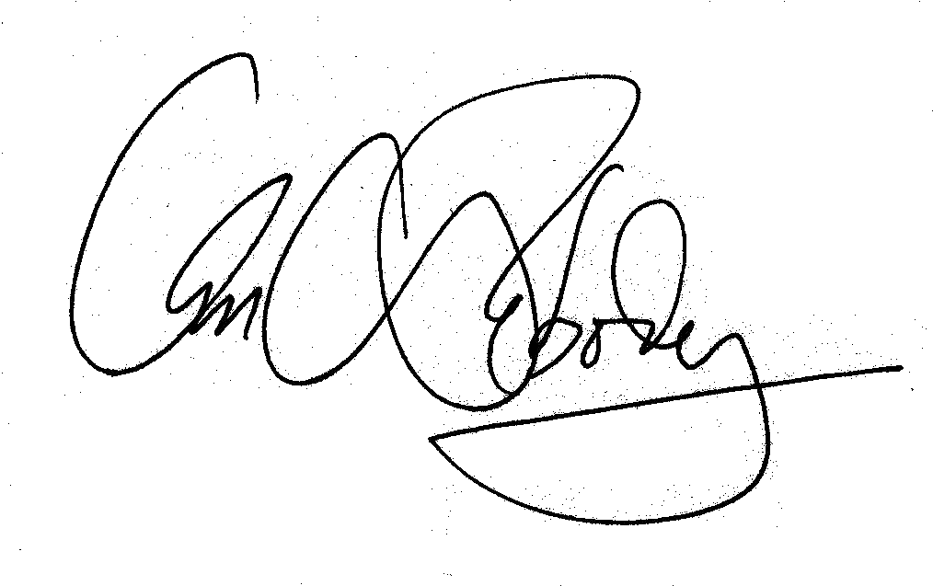
William A. Peabody, Director
Bureau of Labor Standards

Enc. SASurvey Form

