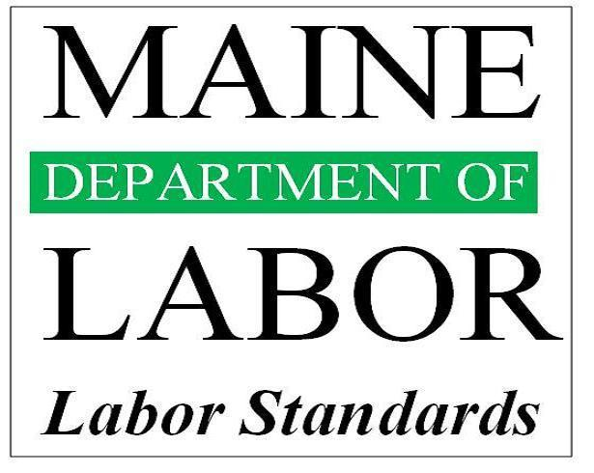

Lyme Disease in the Workplace
A Thirteen-year Retrospective
1999–2011

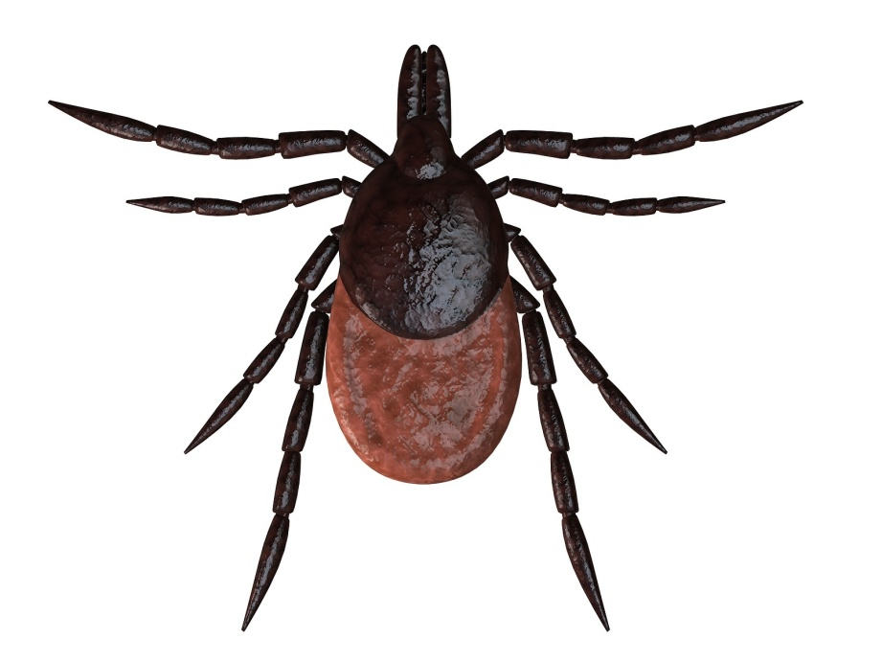

For more information, you are welcome to contact:

Kirk Duplessis, Planning and Research Analyst
Department of Labor
Bureau of Labor Standards
Research and Statistics Unit
45 State House Station
Augusta, ME 04333

207-623-7900

This short report is based on instances of Lyme Disease contracted at work and resulting in one or more days off from work.

- The Maine State Workers’ Compensation database was queried for Lyme Disease, from 1992–2011. (Nature code 237)
- 276 cases were discovered.
- However, all cases in the database occurred in 1999 or later.
- Most occurred primarily in Cumberland and York counties, in the southern part of the state.
- The largest number of incidents was reported in 2006. The number of cases by year appears to be highest when accompanied by a relatively warm winter.
- The most frequently reported occupation was, unsurprisingly, Landscaping and Grounds-keeping Workers (Standard Occupation Code 37-3011).

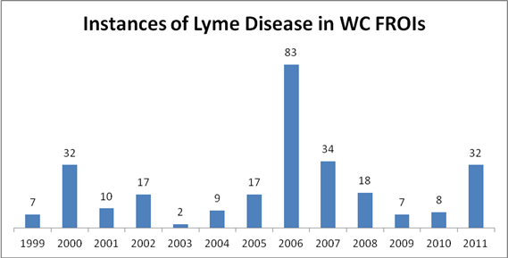
Cases by Year

