Maine Department of Labor
Occupational Safety & Health Surveillance 2005-2011

May 2012

Maine Total Disabling Cases by Sector, 2005-2011
Year | State Govt. | Local Govt. | Private Sector | Total
2005 | 795 | 1407 | 12473 | 14680
2006 | 784 | 1366 | 12091 | 14241
2007 | 786 | 1396 | 12215 | 14397
2008 | 766 | 1344 | 11415 | 13526
2009 | 781 | 1381 | 10677 | 12846
2010 | 910 | 1396 | 11568 | 13887

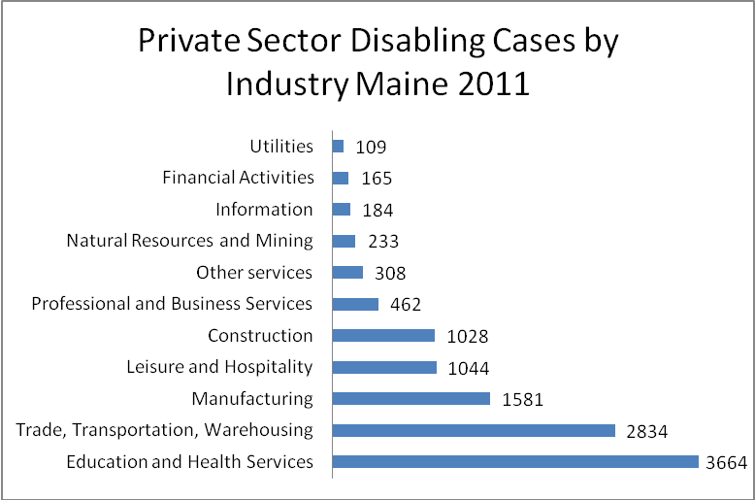

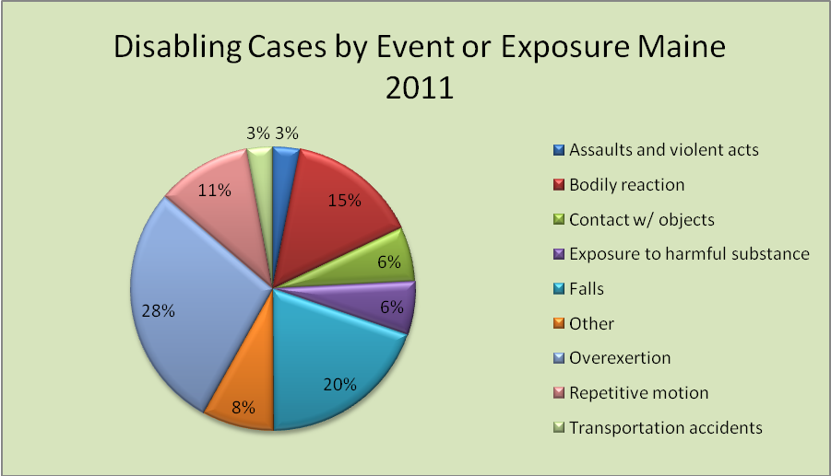

Occupational Safety and Health Surveillance
The Research and Statistics Unit within the Maine Department of Labor collects and compiles work-related injury and illness statistics. It provides annual counts, case characteristics and incidence rates of fatal and nonfatal injury and illness.
The annual counts and case characteristics data are generated from the Employer’s First Report of Occupational Injury or Disease submitted to the Maine Workers' Compensation Board (WCB) while incidence rates and fatal cases are derived from the Federal Bureau of Labor Statistics Survey of Occupational Injury and Illness (SOII) and the Census of Fatal Occupational Injuries (CFOI) respectively.

How can the data be used?

- Analyze injury trends
- Analyze lost time due to work-related injuries
- Identify common causes of injuries
- Develop accident prevention activities
- Develop training programs and material
- Support grant applications
- Support contract bids
- Assess company and community health needs
- Evaluate effectiveness of safety and health programs
- Conduct safety and health walkthroughs
- Advocate for safety and health policy and legislation

What types of data are available?
- An easy-to-use profile of your company Workers’ Compensation claims that provides details such as types and causes of injuries involving cases resulting in one or more days away from work.
- State and National injury profile for your industry.
- Special profiles of different types of injuries and fatalities.
To request an injury profile, call 207-623-7903 or e-mail steven.p.laundrie@Maine.gov To ensure confidentiality, we only provide company profiles to officials of the company.

Occupational Injuries and Illnesses Data Sources
The Maine Department of Labor (MDOL) collaborates with two federal agencies and the Maine Workers’ Compensation Board (Maine WCB) to produce data on work-related injuries and illnesses. The MDOL administers the U.S. Bureau of Labor Statistics annual Survey of Occupational Injuries and Illnesses Survey (SOII) and the Census of Fatal Occupational Injuries Program (CFOI). In addition, the MDOL assists federal Occupational Safety and Health Administration (OSHA) to collect data under its OSHA Data Initiative program (ODI).

Survey of Occupational Injuries and Illnesses (SOII)
The SOII gathers information on work-related injuries and illnesses from the OSHA data log. The summary results of this survey are available at: http://stats.bls.gov/iif/oshstate.htm#ME

Census of Fatal Occupational Injuries Program (CFOI)
The CFOI Program tracks the number of work-related fatalities through the news media, Worker’s Compensation Board and federal OSHA. The summary results of this program are available at: www.maine.gov/labor/labor_stats/publications/cfoi/index.html

Occupational Safety & Health Administration Data Initiative (ODI)
The MDOL collaborates with the federal OSHA to collect injury and illness data to identify employers and industries with higher-than-average incidence rates of days away from work for safety interventions. The results of this survey are available at: http://www.osha.gov/as/opa/foia/hot_13.html

Maine Workers’ Compensation Board (WCB)
The MDOL generates injury data from the first reports of injury submitted to the Maine Workers’ Compensation Board. The results are published in an annual report, which is available at www.maine.gov/labor/labor_stats/publications/charwork/index.html

Additional Data Sources:

Occupational Fatality Report
Occupational Fatality Reports identify events and sources contributing to work-related fatalities. In addition, each report provides data on similar fatalitiesnationwide, pertinent safety and health regulations and
prevention resources.

Substance Abuse Testing Survey
All companies with approved Substance Abuse Testing Policies are required to participate in this survey. The survey report lists all companies with approved testing policies, laboratories licensed by the State to test and outcomes of these tests as reported by the employers.

The Prevailing Wage Rate Survey on Construction Projects
Results of an annual survey of construction contractors are used to set prevailing wage and benefit rates that all contractors must pay their employees while working on state-funded contracts of $50,000 or more.

For more information
Online: www.maine.gov/labor/labor_stats/research.html
Telephone: (207) 623-7900
Maine Department of Labor
Bureau of Labor Standards
45 State House Station
Augusta, ME 04333-0045
The Maine Department of Labor provides equal opportunity in employment and programs. Auxiliary aids and services are available to individuals with disabilities upon request.

