2012 Annual Census of
Maine’s Fatal Occupational Injuries
A Report Provided to the U.S. Department of Labor:
Statistical Factors Regarding Maine’s 2012 Work Related Fatalities

Nineteen Maine Workers Died from

Occupational/Work-Related Injuries in 2012.

The Bureau of Labor Standards of the Maine Department of Labor annually participates in the Census of Fatal Occupational Injuries (CFOI) conducted by the Bureau of Labor Statistics of the U.S. Department of Labor (US DOL). This informational report provides statistical data and charts derived from the 2012 Census. It also presents 2012 occupational fatality rates for the United States and Maine and key data points pertaining to Maine’s fatalities.
Maine’s participation in the CFOI is funded by the U.S. Bureau of Labor Statistics and the Safety Education and Training Fund (SETF) in Maine.

States collect data by conducting research, verifying occupational fatalities with supporting documentation and submitting case data to the Bureau of Labor Statistics for review and compilation.

The CFOI program limits counting occupational fatalities to those resulting from injuries; the latency period of many occupational illnesses and the resulting difficulty of linking illnesses to work makes it difficult to compile a complete count of all fatal illnesses in a given year.

2004—2012 Occupational Fatalities
Table 1 lists Maine’s annual totals of occupational fatalities for the years 2004 to 2012. There were 177 occupational fatalities in that period, averaging 20 fatalities per year. The largest annual total of fatalities during this period, 26, occurred in 2011.

Table 1: Maine’s Occupational Fatalities from 2004 – 2012
Year | 2012 | 2011 | 2010 | 2009 | 2008 | 2007 | 2006 | 2005 | 2004
Total  Fatalities | 19 | 26 | 20 | 16 | 24 | 21 | 20 | 15 | 16

Fatalities within Occupational Categories
Figure 1 illustrates reportable data for Maine’s 2012 occupational fatalities in three occupational categories. The Farming, Fishing and Forestry occupations accounted for 8 fatalities, or 42 percent of 2012’s occupational fatalities. Among Transportation and Material Moving occupations, there were 5 fatalities, accounting for 26 percent of 2012’s occupational fatalities. Installation, Maintenance, and Repair occupations accounted for 3 fatalities, or 16 percent of the total for 2012. Three additional fatalities occurred within a broad range of occupational categories or were not reportable.

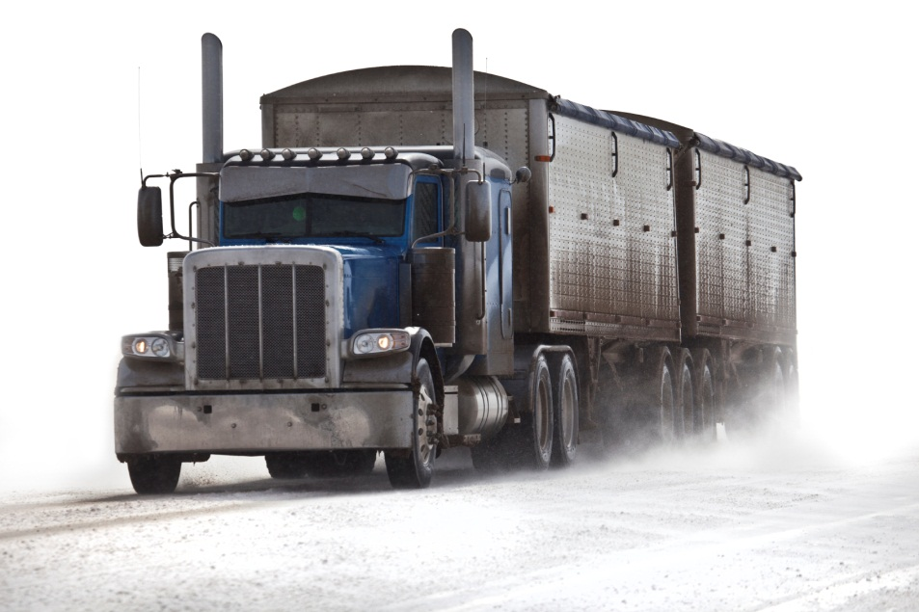

Types of Fatal Events
Figure 2 provides reportable data from Maine’s 2012 types of fatal events. Transportation Incidents accounted for eight fatalities, 42 percent of all 2012 occupational fatalities. Falls, Slips and Trips as well as Contact with Objects and Equipment accounted for four fatalities in each category (21 percent) and Exposure to Harmful Substances or Environments accounted for three fatalities, 16 percent.

Primary Sources Causing Fatalities
Figure 3 provides reportable data for four primary sources that contributed to Maine’s 2012 occupational fatalities. Highway Vehicles, Motorized, were involved in seven fatalities, 37 percent of all 2012 fatalities. Persons, Plants, Animals and Minerals were involved in three fatalities and Structures and Surfaces were also involved in three. Machinery was involved in 2 fatalities, 10 percent of all 2012 fatalities. These 15 fatalities accounted for 79 percent of all 2012 occupational fatalities.

Secondary Sources

Vehicles were secondary sources in five occupational fatalities and Plants, Trees, and Vegetation were secondary sources in three occupational fatalities.

Age Categories
Figure 4 provides reportable data regarding age categories for Maine’s 2012 occupational fatalities. Workers who were age 45 and older accounted for 15 fatalities, or 79 percent of the total. Of those 15 workers, five of them, or 33 percent were in the age 45-to-54 range; four of them, or 27 percent were in the age 55-to-64 range; and six of them, or 40 percent, were age 65 and older. Five of the injuries that occurred in the 65 and older range, 83 percent, occurred in the Agricultural, Forestry, Fishing and Hunting industry.

The U.S. 2012 occupational fatality age data reflects that 58 percent were over age 45, with 25 percent in the age 45-to-54 range, 20 percent in the age 55-to-64 range and 13 percent were age 65 and older. One hundred fifty-six of the injuries that occurred in the 65 and older range, 30 percent, occurred in the Agricultural, Forestry, Fishing and Hunting Industry.

2012 U.S. Fatality Rate and Maine Fatality Rate
In 2012, there were 4,628 occupational fatalities in the United States.¹ The national occupational fatality rate per 100,000 employed persons was 3.4.¹ Maine’s rate of occupational fatalities during 2012 was 3.2.² This represents a decrease of 1.0 in Maine’s occupational fatality rate from 4.2 in 2011.²

Other Key Points:
- Eighteen (95 percent) of Maine’s 2012 occupational fatalities involved male workers.
- Fatalities in Goods Producing industries accounted for 15 of Maine’s 2012 occupational fatalities, or 79 percent of the total.
- Maine’s 2012 fatalities in Agriculture, Forestry, Fishing and Hunting industries accounted for 53 percent of total fatalities in the state. U.S. occupational fatalities in this category accounted for 11 percent of fatalities nationally.
- Eight of Maine’s 2012 occupational fatalities, 42 percent, were to self-employed workers in the Forestry and Logging or Fishing, Hunting and Trapping industries. For more information please see Maine Department of Labor Occupational Fatality Report # 1301 “Dying Alone On the Job”. http://www.maine.gov/labor/labor_stats/research.html

Sources:
Except for numbered references, data for this report was extracted from the Census of Fatal Occupational Injuries (CFOI), Maine Department of Labor, 2012. CFOI is a federal program that, in most cases, is administered by the states.

- See the national CFOI website: (http://www.bls.gov/iif/oshcfoi1.htm)
2. See the Fatal Injury Rates documents on the BLS CFOI Website for Maine (http://www.bls.gov/iif/oshstate.htm#ME) for detailed information on the calculation of fatal injury rates and limitations on the comparability of state and national rates.

Research for this report was prepared by Eliza Galella
Research and Statistics Unit, Division of Technical Services
Bureau of Labor Standards
Maine State Department of Labor

For more information on fatal occupational injuries, contact
Eliza Galella, 207-623-7907
TTY users call Maine Relay 711.

Maine Department of Labor provides equal opportunity in employment and programs.
Auxiliary aids and services are available to individuals with disabilities upon request.

