Maine Department of Labor
2010 Annual Census of Maine’s Fatal Occupational Injuries

A Report Provided to the US Department of Labor: Statistical Factors Regarding Maine’s 2010 Work Related Fatalities

May 2012

Twenty Maine Workers Died from Occupational/Work-Related Injuries in 2010.
The State of Maine’s Department of Labor, Bureau of Labor Standards, annually participates in the United States’ Bureau of Labor Statistics’ Census of Fatal Occupational Injuries (CFOI). Provided in this informational report are statistical data and charts derived from the 2010 Census.

Also presented are the United States’ and Maine’s 2010 occupational fatality rates and key data points pertaining to Maine’s fatalities.

In addition, a perspective on improvements in Maine’s logging industry appears at the end of this report.

2003 – 2010 Occupational Fatalities:
Table 1 below provides Maine’s annual totals of occupational fatalities for the years 2003 to 2010.
For that eight year period, there were 155 occupational fatalities with an average rate of 19 fatalities per year.

Table 1: Occupational Fatalities, Maine 2003-2010
Year | 2010 | 2009 | 2008 | 2007 | 2006 | 2005 | 2004 | 2003
Total Fatalities | 20 | 16 | 24 | 21 | 20 | 15 | 16 | 23

Occupational Fatalities from Industry Categories:
Figure 1 provides reportable data for Maine’s 2010 occupational fatalities in five industry categories. Two industries, Natural Resources and Mining and Trade, Transportation and Utilities, each had four fatalities. The eight fatalities from these industry categories account for 40% of all 2010 occupational fatalities. Three industries, Manufacturing, Construction and Education and Health Services, each had three fatalities. The nine fatalities from these industry categories account for 45% of all 2010 occupational fatalities. Three fatalities fell under Other industry categories or were not reportable.
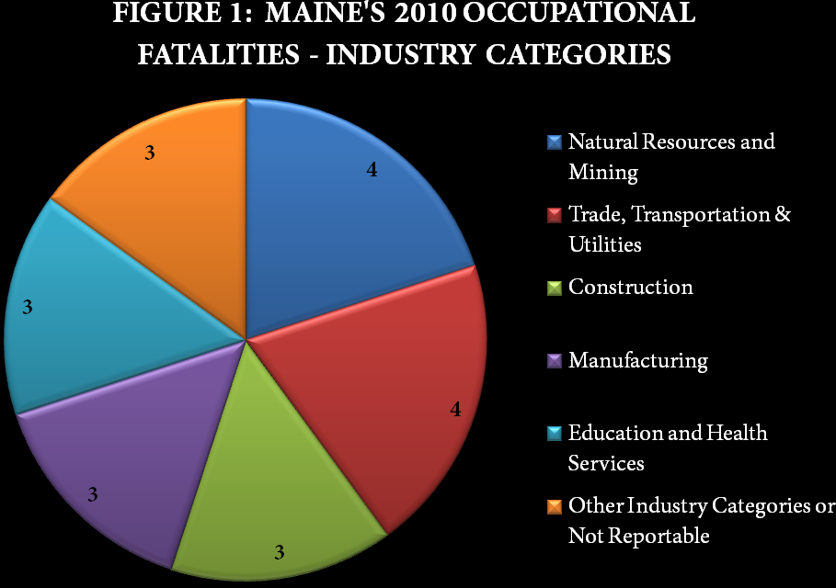

Types of Fatal Events:
Figure 2 provides reportable data from Maine’s 2010 types of fatal events. Thirteen fatalities (65% of all 2010 occupational fatalities) were attributed to Transportation Incidents. Ten of those transportation incidents were attributed to the fatal event subcategory of Highway Incidents. Six fatalities were attributed to two types of fatal events, three from Contact with Objects and Equipment and three from Falls, accounting for 30% of all 2010 occupational fatalities. One fatality (5%) fell under the fatal event category of Other or was not reportable.
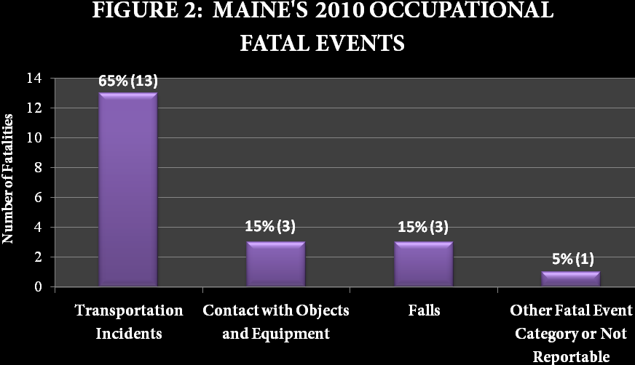

Primary Sources Causing Fatalities:
Figure 3 provides reportable data for primary sources causing Maine’s 2010 occupational fatalities. Three primary sources, Automobiles, Pickup Trucks and Semitrailer, Tractor Trailer, Trailer Trucks, account for nine occupational fatalities, with three fatalities resulting from each primary source category. These nine fatalities account for 45% of all 2010 occupational fatalities.
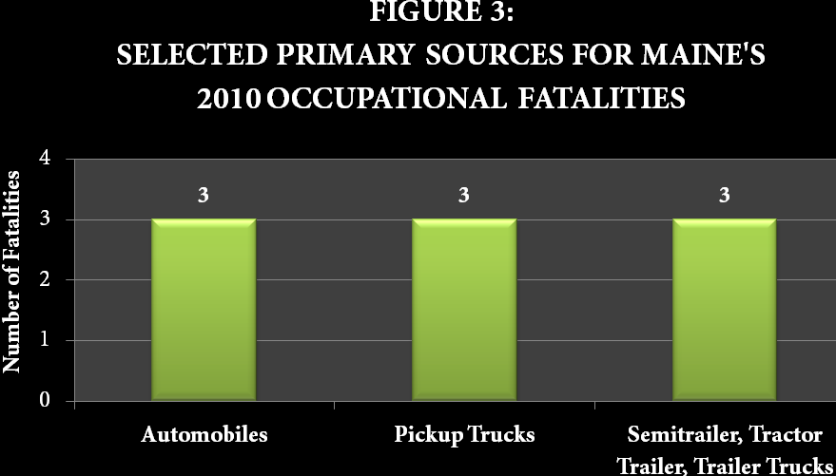

Age Categories:
Figure 4 provides reportable data regarding age categories for Maine’s 2010 occupational fatalities. Fourteen (70%) of the fatalities occurred to workers who were age 45 and above. Of those fourteen workers, five (25%) were in the age 45 to age 54 range, four (20%) were in the age 55 to age 64 range and five (25%) were age 65 and above.

Three (15%) worker fatalities were in the age 25 to age 34 range and three (15%) were not reportable or no data was available.
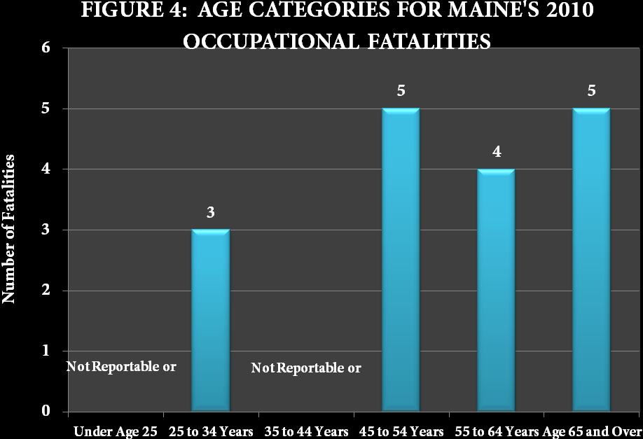

2010 U.S. Fatality Rate and Maine Fatality Rate:
In 2010 there were 4,690 occupational fatalities in the United States.¹ The national occupational fatality rate per 100,000 employed persons was 3.6.¹ Maine’s rate of occupational fatalities during 2010 was 3.3.
Although 2010 occupational fatalities in Maine were twenty percent higher than in 2009, there is no evidence of a long-term upward trend.

Other Key Points:
- Nineteen (95%) of Maine’s 2010 occupational fatalities occurred to male workers.
- Eighty percent (16) of the fatalities occurred in five counties. Fifty percent (10) occurred in Penobscot and Aroostook counties and thirty percent (6) occurred in Cumberland, Kennebec and Hancock counties.
- The average age of workers who died in Maine in 2010 was 52.

Focus on Logging:
Although the purpose of the present report is to provide data and information, it is difficult to avoid some interpretation when it comes to what has happened in the logging industry in the past two decades. The introduction of the Certified Logging Professional program in 1991² and the growth in the number of persons who have been certified as loggers (5,778) has helped to greatly reduce injuries and deaths in the state’s forests. The other important factor is the introduction of mechanized logging. These two variables are dramatically illustrated in Table 2 below. Note that there are substantial reductions in workers compensation insurance rates between non-mechanized and mechanized logging systems. Likewise, there are substantial reductions between certified and non-certified loggers, but only with respect to mechanized logging.

Table 2: Workers Compensation Rates in 2012 for Loggers in Maine³
Logging Classification | Certified | Not Certified
Mechanized | $ 4.83 | $ 10.77
Non-mechanized | $ 23.00 | $ 23.00

The combination of being certified and working in a mechanized environment is clearly the safest way to pursue this occupation.

The measurement of the effectiveness of improved logging practices rests mostly with non-fatal injuries. In a separate report produced by the Department of Labor, the past two decades shows a gradual but definite reduction in injuries. This report is summarized in the Certified Logging Professionals website, http://clploggers.com.²

Sources:
Except for numbered references, data for this report was extracted from the Census of Fatal Occupational Injuries (CFOI), Maine Department of Labor, 2010. CFOI is a federal program that, in most cases, is administered by the states.

See the national CFOI website: http://www.bls.gov/iif/oshcfoi1.htm
Certified Logging Professionals, Jackman, Maine. See http://clploggers.com
B.W. Cawley, Department of Professional and Financial Regulation, Maine Bureau of In-surance, Casualty and Technical Services Division.

Research for this report was prepared by Barbara A. Spillane
Research and Statistics Unit, Division of Technical Services
Bureau of Labor Standards
Maine State Department of Labor

For more information of occupational illnesses and injuries, contact
Steven P. Laundrie, 207-623-7903

For more information of fatal occupational injuries, contact
Barbara A. Spillane, 207-623-7905

The Maine Department of Labor provides equal opportunity in employment and programs.
Auxiliary aids and services are available to individuals with disabilities upon request.

