Fatal

Occupational

Injuries

In Maine

2008

Ann M. Beaulieu, Statistician

In cooperation with

U.S. Department of Labor
Bureau of Labor Statistics

Grant No. W9J981239P

September 2009 Augusta, Maine

Material in this publication is in the public domain and may,
with appropriate credit, be reproduced without permission.

The Maine Department of Labor provides equal opportunity employment and programs.
Auxiliary aids and services are available to individuals with disabilities upon request.
Telephone (207) 623-7900 TTY (207) 1-800-794-1110 FAX (207) 623-7938

This publication is available online at: www.Maine.gov/labor/
Acknowledgements

We would like to thank the following agencies for their cooperation and assistance in providing source documents which made it possible to publish this Census of Fatal Occupational Injuries:

U.S. Department of Labor, Bureau of Labor Statistics

U.S. Department of Labor, Occupational Safety and Health Administration (OSHA)

U.S. Coast Guard

Maine Department of Health and Human Services

Maine Workers’ Compensation Board

Maine State Medical Examiner’s Office

Maine Department of Marine Resources

Maine State Police

Maine Bureau of Motor Vehicles
Contents

Introduction 1
Scope of Fatality Data 2
Worker Characteristics
Worker Characteristics 5
Industry 6
Occupation 7
Incident Characteristics
Nature 11
Part of Body 12
Source 13
Event/Exposure 14
Secondary Source 14
Work Activity 15
Work Location 15
Composite Data, Maine 17
U.S. Fatality Data 23

Tables

1. Fatal Occupational Injuries by Characteristic, Maine, 2008 5
2. Fatal Occupational Injuries by Industry, Maine, 2008 6
3. Fatal Occupational Injuries by Occupation, Maine, 2008 7
4. Fatal Occupational Injuries by Nature, Maine, 2008 11
5. Fatal Occupational Injuries by Part of Body, Maine, 2008 12
6. Fatal Occupational Injuries by Source, Maine, 2008 13
7. Fatal Occupational Injuries by Event/Exposure, Maine, 2008 14
8. Fatal Occupational Injuries by Secondary Source, Maine, 2008 14
9. Fatal Occupational Injuries by Work Activity, Maine, 2008 15
10. Fatal Occupational Injuries by Work Location, Maine, 2008 15
11. Fatal Occupational Injuries by Industry Division, Maine, 1992-2008 19
12. Fatal Occupational Injuries by Age Group, Maine, 1992-2008 20
13. Fatal Occupational Injuries by Industry and Event/Exposure, Maine, 1992-2008 21
14. U.S. Fatal Occupational Injuries by State and Event/Exposure, 2008 25

Contents (cont.)

Figures

1. Fatal Occupational Injuries by Industry, Maine, 2008 6
2. Fatal Occupational Injuries by Occupation, Maine, 2008 7
3. Fatal Occupational Injuries by Nature, Maine, 2008 11
4. Fatal Occupational Injuries by Part of Body, Maine, 2008 12
5. Fatal Occupational Injuries by Source, Maine, 2008 13
6. Fatal Occupational Injuries by Age Group, Maine, 1992-2008 20
7. Fatal Occupational Injuries by Event/Exposure, Maine, 1992-2008 21
8. Fatal Occupational Injuries by County of Incident, Maine, 1992-2008 22
Introduction

The Census of Fatal Occupational Injuries (CFOI) program is a Federal/State cooperative program, created in 1990 by the U.S. Department of Labor, Bureau of Labor Statistics. All 50 states and the District of Columbia participate in the program. The CFOI program was established to determine a true count of work-related fatal injuries in the United States. Prior to CFOI, estimates of work-related fatalities varied because of differing definitions and reporting sources. The CFOI program collects and compiles workplace fatality data based on guidelines established by the U.S. Bureau of Labor Statistics which are consistent for all states.

The CFOI program provides data on all fatal workplace injuries in all industries and for all ages. To be included in CFOI, a fatality must be the result of an incident that occurs while the employee is in work status.

For questions regarding the data in this publication please contact:

Ann Beaulieu
Maine Department of Labor
Bureau of Labor Standards
45 State House Station
Augusta, ME 04333-0045
Tel. (207) 623-7907
E-mail: Ann.M.Beaulieu@maine.gov

Internet Addresses:

State of Maine:
www.Maine.gov/

Bureau of Labor Standards: www.Maine.gov/labor/bls

Federal Bureau of Labor Statistics:
www.bls.gov/iif/oshcfoi1.htm

Occupational Safety & Health Administration:
www.osha.gov

Scope of Fatality Data

All deaths due to work-related injuries in 2008 are included in the Census of Fatal Occupational Injuries (CFOI). A case is considered work- related if an event or exposure resulted in a fatality while an employee is in work status, whether at an on-site or off-site location.

Fatalities must be confirmed by two independent sources before inclusion in CFOI. Sources include death certificates, first reports of injury for workers’ compensation, medical examiner’s reports, Department of Marine Resources reports, Maine State Police reports, Bureau of Motor Vehicles fatality records, Coast Guard reports, OSHA reports, and news media.

Fatal occupational illnesses are excluded from this report since many fatalities due to an illness or disease may not be diagnosed until years later or the work relationship may not be known.

Heart attacks and strokes are generally considered illnesses and are excluded from the count.

However, heart attacks and strokes are considered
an injury if a traumatic work injury or event was listed as a contributing or underlying cause of death on the death certificate or other medical report.

Fatal injuries that occurred in international waters or airspace surrounding the U.S. are in-scope if a U.S. death certificate was issued and the case meets the CFOI criteria for work relationship. Injuries that occurred in another country are out-of-scope even if a U.S. death certificate was issued. For example, a death in the U.S. that occurred from an injury sustained in Canada would be considered out-of-scope. A state will be responsible for compiling data for an out of state death, if the incident occurred in its own state. Also an injury that occurred in 1996 for example that resulted in a death in 2005 will be counted in the year 2005.

Each fatality is coded according to the Bureau of Labor Statistics Occupational Injury and Illness Classification System. Each fatality is classified in seven categories: Nature, Part, Source, Secondary Source (if applicable), Event or Exposure, Activity, and Location of the incident.

Worker Characteristics

Worker Characteristics

Table 1 lists the general characteristics of the 24 workers who were fatally injured in Maine in 2008. The list includes the ownership, employment status, gender and race.
___________________________________________________________________________________

Table 1. Fatal Occupational Injuries by Characteristic, Maine, 2008

Characteristic Number Percent

Total 24 100.0

Ownership

Private Industry 22 91.7
Public Industry 2 8.3

Employment Status

Working for Wage or Salary 14 58.3
Self-Employed 8 33.3
Other 1 4.2
Unknown 1 4.2
Gender

Male 19 79.2
Female 5 20.8

Race

White 23 95.8
Other 1 4.2

Industry

Table 2 lists the number and percent distribution of fatal workplace injuries by the industry in which the worker was working when the incident occurred (See Figure 1).
____________________________________________________________________________________

Table 2. Fatal Occupational Injuries by Industry, Maine, 2008

Industry Number Percent

Total 24 100.0

Services 6 25.0

Transportation 5 20.8

Agriculture, Forestry, and Fishing 4 16.7

Manufacturing 3 12.5

Other 6 25.0

Figure 1. Fatal Occupational Injuries by Industry, Maine, 2008

Occupation

Table 3 lists the number and percent distribution of fatal workplace injuries by the worker’s occupation when the incident occurred (See Figure 2).
____________________________________________________________________________________

Table 3. Fatal Occupational Injuries by Occupation, Maine, 2008

Occupation Number Percent

Total 24 100.0

Transportation & Material Moving 9 37.5

Farming, Forestry, and Fishing 6 25.0

Managerial & Professional Specialties 4 16.7

Services 3 12.5

Other 2 8.3

Figure 2. Fatal Occupational Injuries by Occupation, Maine, 2008

Incident Characteristics

Nature

The Nature identifies the initial injury which led to the fatality. If an injury led to further complications, the initial injury is coded as the nature (e.g., for a cut leading to infection, the cut is the nature of the injury even though the death was from infection). Table 4 lists the number and percent distribution of the fatal injuries by the Nature of injury that resulted in the fatality.
____________________________________________________________________________________

Table 4. Fatal Occupational Injuries by Nature, Maine, 2008

Nature Number Percent

Total 24 100.0

Intracranial Injuries, Unspecified 7 29.2 Internal Injuries to Organs & Blood Vessels of the Trunk 4 16.7
Multiple Traumatic Injuries & Disorders, Unspecified 4 16.7 Drownings 3 12.5
Other 6 25.0

____________________________________________________________________________________
Figure 3. Fatal Occupational Injuries by Nature, Maine, 2008

Part of Body

The Part of Body identifies the injured person’s body part directly affected by the injury. Table 5 lists the number and percent distribution of the fatal injuries by the body part directly affected by the injury which led to the fatality.
____________________________________________________________________________________

Table 5. Fatal Occupational Injuries by Part of Body, Maine, 2008

Part of Body Number Percent

Total 24 100.0

Head 8 33.3

Multiple Body Parts 7 29.2

Trunk 4 16.7

Body Systems 3 12.5

Other 2 8.3

____________________________________________________________________________________

Figure 4. Fatal Occupational Injuries by Part of Body, Maine, 2008
Source

The Source of the injury identifies the object, substance, exposure, or bodily motion which directly produced the injury. Table 6 lists the number and percent distribution of the fatal injuries by the Source of the injury which led to the fatality.
____________________________________________________________________________________

Table 6. Fatal Occupational Injuries by Source, Maine, 2008

Source Number Percent

Total 24 100.0

Vehicles 15 62.5
Highway Trucks 3 12.5
Highway Cars 3 12.5 Other 9 37.5

Construction Logging & Mining Machinery 3 12.5

Other Sources 3 12.5

Other 3 12.5

_________________________________________________________________________

Figure 5. Fatal Occupational Injuries by Source, Maine, 2008
Event/Exposure

The Event/Exposure identifies the actual event which directly led to the fatality. Table 7 lists the number and percent distribution of the fatal injuries by the Event/Exposure.
___________________________________________________________________________________

Table 7. Fatal Occupational Injuries by Event/Exposure, Maine, 2008

Event/Exposure Number Percent

Total 24 100.0

Transportation Accidents 16 66.7

Contact with Objects & Equipment 4 16.7

Other 4 16.7

___________________________________________________________________________________

Secondary Source

The Secondary Source identifies the object, substance, or person that generated the source of the injury or contributed to the event or exposure. Table 8 lists the number and percent distribution of the fatal injuries by the Secondary Source.

Table 8. Fatal Occupational Injuries by Secondary Source, Maine, 2008

Secondary Source Number Percent

Total 16 100.0

Highway Vehicles 7 43.8

Persons, Plants, Animals & Minerals 5 31.3

Other Sources 4 25.0

A fatal event may or may not involve a secondary source. In 2008, 16 fatal events involved a secondary source.
Work Activity

The Work Activity describes what the worker was doing at the time of an incident. Table 9 lists the number and percent distribution of the fatal injuries by the Work Activity.
____________________________________________________________________________________

Table 9. Fatal Occupational Injuries by Work Activity, Maine, 2007

Work Activity Total Percent

Total 24 100.0

Vehicle and Transportation Operations 14 58.3
Physical Activities 3 12.5
Other 7 29.2

____________________________________________________________________________________

Work Location

The Work Location describes where the employee was working at the time of an incident. Table 10 lists the number and percent distribution of the fatal injuries by the Work Location.

Table 10. Fatal Occupational Injuries by Work Location, Maine, 2008

Location Total Percent

Total 24 100.0

Street or Highway 12 50.0
Other Places 8 33.3
Other Locations 4 16.7

Composite Data
Fatal Occupational Injuries, by Industry*, Maine, 1992-2008
_____________________________________________________________________________

Table 11. Fatal Occupational Injuries by Industry Division, Maine, 1992 – 2008

Industry 1992 1993 1994 1995 1996 1997 1998 1999 2000 2001 2002 2003 2004 2005 2006 2007 2008 Total
Total 21 24 21 18 23 19 26 32 26 23 30 23 16 15 20 21 24 382
Agriculture, Forestry
&Fishing 6 8 4 -- 3 3 8 5 8 7 17 6 3 3 4 7 4 96
Transportation -- 4 3 7 4 5 8 4 4 -- -- 3 4 3 3 5 5 62
Manufacturing 7 -- 6 3 3 6 4 6 4 -- 3 4 3 -- 4 -- 3 56
Construction -- 3 4 -- 6 -- -- 4 6 4 -- 5 -- 3 -- 5 -- 40
Services -- 4 -- 3 4 -- -- 6 -- -- -- -- -- -- 3 -- 6 26
Retail -- -- -- -- -- -- -- -- -- 6 4 -- -- -- -- -- -- 10
Public Admin. -- -- -- -- -- -- -- 3 -- -- -- -- -- -- -- -- -- 3
Finance -- -- -- -- -- -- -- -- -- -- -- -- -- -- -- -- -- 0
Wholesale -- -- -- -- -- -- -- -- -- -- -- -- -- -- -- -- -- 0
Non-classifiable -- -- -- -- -- -- -- -- -- -- -- -- -- -- -- -- -- 0
Mining -- -- -- -- -- -- -- -- -- -- -- -- -- -- -- -- -- 0
Unpublishable 8 5 4 5 3 5 6 4 4 6 6 5 6 6 6 4 6 89
_____________________________________________________________________________
Dashes indicate data that does not meet publication criteria or more within a category or no data reported.
*Industry classification as defined by the Standard Industrial Classification Manual (SIC).

Table 12. Fatal Occupational Injuries by Age Group, Maine, 1992- 2008

Age Group Number Percent

under 20 9 2.4
20-24 28 7.3
25-34 77 20.2
35-44 84 22.0
45-54 93 24.3
55-64 57 14.9
over 64 34 8.9
Total = 382
_________________________________________________________________________________

Figure 6. Fatal Occupational Injuries by Age Group, Maine, 1992- 2008

Table 13. Fatal Occupational Injuries by Industry and Event/Exposure, Maine, 1992-2008

Transportation
Accidents Contact with Exposure to
Highway or Objects or Harmful Assaults Fire or
Industry Division Total Non-highway Equipment Substances Falls Suicides Explosions

Total 382 192 78 38 48 19 7

Agriculture
Forestry and Fishing 96 66 6 19 5 -- --

Manufacturing 57 15 32 -- 10 -- --

Transportation and
Public Utilities 63 47 7 5 4 -- --

Construction 49 10 11 9 16 -- 3

Services 39 15 13 -- 6 5 --

Retail 23 11 -- -- 6 6 --

Government 20 12 3 -- -- 5 --

Wholesale 14 14 -- -- -- -- --

Other Industry
and Non Publishable
or Unknown 21 2 6 5 1 3 4
Dashes indicate data that does not meet publication criteria of 3 or more within a category or no data reported.

Figure 7. Fatal Occupational Injuries by Event/Exposure, Maine, 1992- 2008

Figure 8. Fatal Occupational Injuries by County of Incident, Maine, 1992-2008

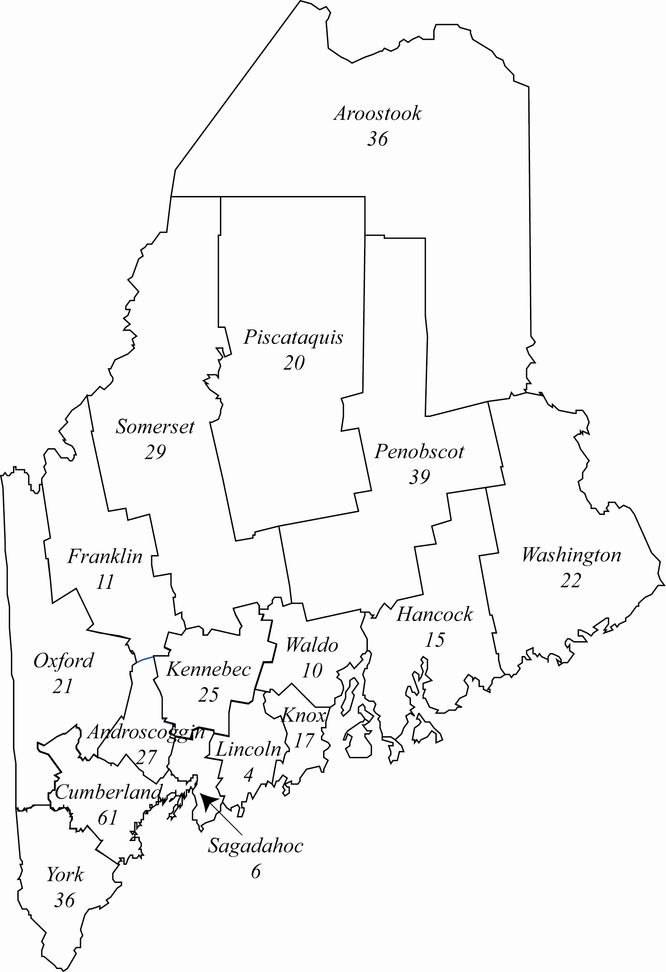

U.S. Fatality Data

Table 14. U.S. Fatal Occupational Injuries by State and Event/Exposure,2008
State of Injury | Fatalities | Event/Exposure
State of Injury | Fatalities | Transportation Incidents | Assaults or Violent Acts | Contact with Objects or Equipment | Falls | Exposure to Harmful Substances or Environments | Fires or Explosions
Alabama | 97 | 48 | 8 | 22 | 3 | 14 | --
Alaska | 33 | 23 | -- | 4 | -- | 3 | --
Arizona | 86 | 37 | 14 | 7 | 16 | 11 | --
Arkansas | 85 | 40 | 12 | 13 | 5 | 10 | 5
California | 404 | 153 | 84 | 63 | 56 | 42 | 6
Colorado | 102 | 47 | 13 | 17 | 11 | 10 | 4
Connecticut | 28 | 9 | 6 | 6 | 4 | 3 | --
Delaware | 11 | 5 | -- | -- | -- | -- | --
District of Columbia | 9 | -- | -- | -- | 5 | -- | --
Florida | 290 | 107 | 56 | 41 | 39 | 38 | 6
Georgia | 171 | 62 | 26 | 28 | 28 | 11 | 16
Hawaii | 18 | 7 | -- | 5 | -- | -- | --
Idaho | 36 | 23 | -- | 7 | 3 | -- | --
Illinois | 193 | 62 | 38 | 34 | 29 | 23 | 7
Indiana | 132 | 61 | 12 | 34 | 12 | 10 | --
Iowa | 93 | 47 | 6 | 23 | 10 | 5 | --
Kansas | 73 | 38 | 9 | 12 | 7 | 6 | --
Kentucky | 105 | 45 | 19 | 22 | 9 | 8 | --
Louisiana | 134 | 77 | 9 | 23 | 11 | 13 | --
Maine | 24 | 16 | -- | 4 | -- | -- | --
Maryland | 59 | 17 | 9 | 10 | 12 | 10 | --
Massachusetts | 61 | 18 | 8 | 8 | 15 | 10 | --
Michigan | 123 | 43 | 22 | 21 | 23 | 8 | 6
Minnesota | 65 | 28 | 3 | 26 | 3 | 4 | --
Mississippi | 80 | 34 | 7 | 17 | 13 | 4 | 5
Missouri | 147 | 58 | 34 | 23 | 18 | 8 | 5
Montana | 39 | 18 | 5 | 7 | 6 | 3 | --
Nebraska | 53 | 21 | 8 | 12 | 9 | -- | 3
Nevada | 40 | 14 | 4 | 12 | 5 | 3 | --
New Hampshire | 7 | 3 | -- | -- | -- | -- | --
New Jersey | 91 | 39 | 14 | 15 | 14 | 6 | 3
New Mexico | 31 | 15 | 5 | -- | 5 | -- | --
New York | 212 | 38 | 48 | 51 | 47 | 18 | 9
North Carolina | 160 | 63 | 34 | 28 | 22 | 7 | 6
North Dakota | 27 | 12 | -- | 8 | 3 | -- | --
Ohio | 167 | 65 | 31 | 24 | 25 | 11 | 10
Oklahoma | 102 | 55 | 5 | 18 | 5 | 9 | 10
Oregon | 54 | 23 | 9 | 13 | -- | 5 | 3
Pennsylvania | 240 | 83 | 37 | 50 | 36 | 23 | 8
Rhode Island | 6 | -- | -- | -- | -- | -- | --
South Carolina | 85 | 36 | 14 | 12 | 11 | 11 | --
South Dakota | 30 | 14 | -- | 6 | 6 | -- | --
Tennessee | 134 | 51 | 22 | 27 | 24 | 6 | 4
Texas | 457 | 200 | 76 | 69 | 57 | 32 | 23
Utah | 65 | 34 | 7 | 6 | 9 | 8 | --
Vermont | 10 | 3 | -- | 4 | -- | -- | --
Virginia | 154 | 52 | 37 | 27 | 20 | 14 | 4
Washington | 83 | 33 | 13 | 20 | 12 | 3 | --
West Virginia | 53 | 22 | 5 | 12 | 6 | 5 | --
Wisconsin | 77 | 33 | 6 | 18 | 11 | 3 | 5
Wyoming | 33 | 17 | 4 | 7 | 3 | -- | --
Dashes indicate no data reported or data that do not meet publication criteria.

