Heat Illness Prevention Plan
COMPANY NAME
PURPOSE
The purpose of this plan is to protect our employees from the hazards of hot working environments. Work activities that could potentially expose our employees to these hazards include:
SCOPE
This plan implements efficient and safe work practices that will prevent both indoor and outdoor heat-related illnesses among employees at our workplace. It will be used for training new employees and for the annual refresher training of employees. All employees potentially exposed to hot working environments are subject to this plan.
BACKGROUND
Heat-related illnesses can happen if workplace activities in a hot environment overwhelm the body’s ability to cool itself. This becomes more likely if any of the risk factors are present. Examples include working in a hot environment without adequate access to water for rehydration, working in protective gear that does not allow air circulation across the skin, or working where the humidity is too high for sweat to evaporate.
RISK FACTORS
The following are environmental risk factors for heat illness (see heat index on Page 6):
- Air temperature above 90 degrees F.
- Relative humidity above 40 percent
- Radiant heat from the sun and other sources
- Conductive heat sources such as dark-colored work surfaces
- Lack of air movement
- Physical effort needed for the work
- Use of nonbreathable protective clothing and other personal protective equipment
The following are personal risk factors for heat illness:
- Lack of acclimation to warmer temperatures
- Poor general health
- Dehydration
- Alcohol consumption
- Caffeine consumption
- Previous heat-related illness
- Use of prescription medications that affect the body’s water retention or other physiological responses to heat such as beta blockers, diuretics, antihistamines, tranquilizers, and antipsychotics.
NIOSH HEAT STRESS APP

HEAT-RELATED ILLNESSES
- Heat rash is the most common health problem in hot work environments. It is caused by sweating and looks like a red cluster of pimples or small blisters. Heat rash usually appears on parts of the body that overlap or rub other parts of the body, such as in the groin area, under the arms or breasts, and in knee or elbow creases. If an employee has symptoms of heat rash, provide a cooler, less humid work environment, if possible. Advise the employee to keep the area dry and not to use ointments and creams that make the skin warm or moist, which can make the rash worse.
- Heat exhaustion can best be prevented by being aware of one’s physical limits in hazardous environment on hot, humid days. The most important factor is to drink enough clear fluids (especially water, not alcohol or caffeine) to replace those lost to perspiration. Signs and symptoms of heat exhaustion typically include:
  - Profuse sweating
  - Weakness and fatigue
  - Nausea and vomiting
  - Muscle cramps (associated with dehydration)
  - Headache
  - Light-headedness or fainting; fainting or loss of consciousness is potentially serious and should be treated as a medical emergency.
When you recognize heat exhaustion symptoms in an employee, you must intervene; stop the activity, and move the employee to a cooler environment. Cooling off and rehydrating with water (or electrolyte-replacing sports drinks) is the cornerstone of treatment for heat exhaustion. If the employee resumes work before their core temperature returns to normal levels, symptoms may quickly return.
If there is no intervention and the body’s temperature regulation fails, heat exhaustion can rapidly progress to heat stroke, a life-threatening condition!
- Heat stroke requires an immediate emergency medical response. The person may stop sweating, become confused or lethargic, and may even have a seizure! The internal body temperature may exceed 106 degrees F. Signs and symptoms of heat stroke typically include:
  - Absence of sweating
  - Dry skin
  - Agitation or strange behavior
  - Dizziness, disorientation, or lethargy
  - Seizures or signs that mimic those of a heart attack
Ensure that emergency responders are summoned immediately if heat stroke is suspected. While waiting for emergency responders to arrive, cool the employee; move the employee to an airconditioned environment or a cool, shady area; and help the employee remove any unnecessary clothing. Do not leave the employee unattended. Heat stroke requires immediate medical attention to
prevent permanent damage to the brain and other vital organs that can result in death.
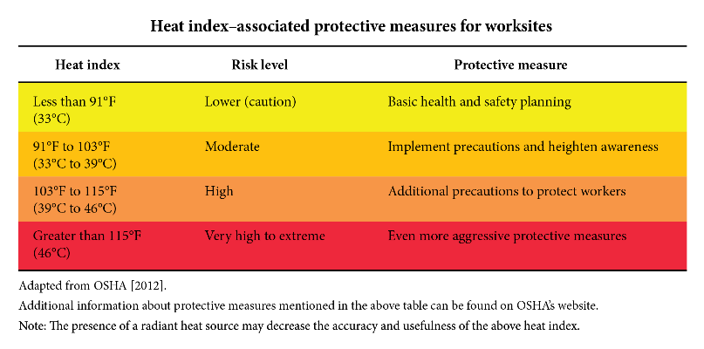
PREVENTING HEAT-RELATED ILLNESSES
- Gradually increase workloads and allow more frequent breaks during the first week of work so that employees become acclimatized to higher temperatures, especially those who are new to working in the heat or have been away from that work for a week or more.
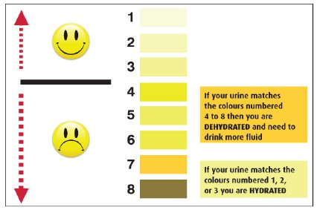
- Encourage employees to frequently drink small amounts of water before they become thirsty to stay hydrated. During moderate activity, in moderately hot conditions, employees should drink about 8 ounces of liquid every 15 to 20 minutes. Employees can monitor their hydration with a urine chart. Urine should be clear or slightly colored; dark urine is a warning sign! See urine color chart.
- Encourage employees to eat regular meals and snacks as they provide enough salt and electrolytes to replace those lost through sweating as long as enough water is consumed.
- Provide a buddy system where employees encourage each other to drink water, use shade to stay cool, and to watch each other for symptoms of heat-related illness.
- Educate employees that drinking extreme amounts of water can also be harmful (more than 12 quarts in a 24-hour period).
- Schedule frequent rest periods with water breaks in shaded or air- conditioned recovery areas. Note that air conditioning does not result in loss of heat tolerance.
- Ensure employees are aware of the signs of heat-related illnesses and encourage them to report immediately they or their co-workers show symptoms.
- Monitor weather reports daily and reschedule jobs with high heat exposure to cooler times of the day, if possible. Be extra vigilant when air temperatures rise quickly. When possible, schedule routine maintenance and repair projects for the cooler parts of the year.
- Provide shade or cool areas for breaks.
Water is located throughout the work area. Locations include:

Shade or cooling areas are located:

Other measures we will follow to prevent heat-related illness at our workplace are:

Our company is serious about preventing heat-related illness and we have adopted the following best practices from Appendix A:

RESPONSIBILITIES:
All employees are responsible for protecting themselves from heat illnesses by following these guidelines for prevention and immediately reporting any signs or symptoms to his or her supervisor.

______________________________________ is responsible for conducting initial training with new employees and for the annual refresher training.

______________________________________ is responsible for administering the provisions of this plan.

HEAT INDEX
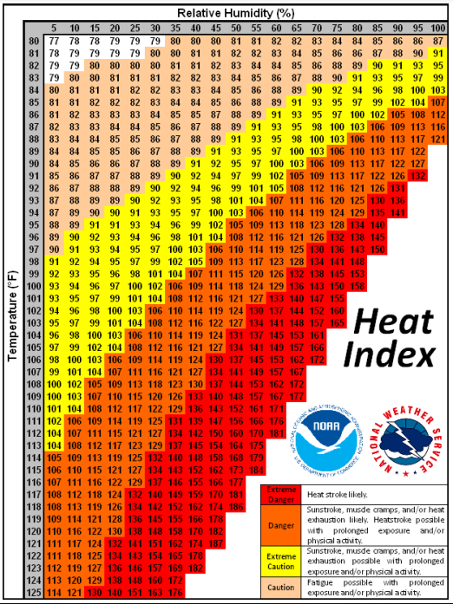

APPENDIX A
BEST PRACTICES COULD INCLUDE PROVIDING EMPLOYEES WITH:
- Containers that hold ice or otherwise keep drinking water and other beverages cold.
- Chilled beverages such as electrolyte type sports drinks. Discourage caffeine consumption.
- Cold treats at break time such as popsicles, ice cream, or fruit with high water content (watermelon, grapes, oranges).
- A cooling trailer with conditioned air and cold water to consume.
- Cooling tents with mist, fan, and cold water to consume.
- Heat-reflective work clothing such as light-colored, breathable uniforms.
- Evaporative accessories (cooling neck wraps, head bands)
- Cooling vests designed to safely use ice packs.
- Ventilated PPE (high-visibility garments or powered air purifying respirators, if appropriate)
- Cell phone text orders from supervisor to stop and rest in shade and drink.

