Daily Inspection Checklist: Walking Pallet Truck
- The vehicle inspection  - Forks  - Battery  - Hand guards  - The operations inspection  - Check the drive operations  - Test the brakes  - Check the horn  - Inspect the load-handling attachment operations | 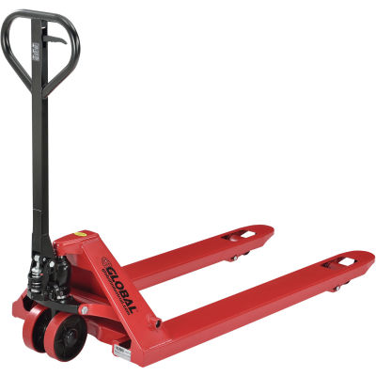
Daily Inspection Checklist: Full Electric Pallet Jack Truck
- The vehicle inspection
  - Forks
  - Battery
  - Hand guards
- The operations inspection
  - Check the drive operations
  - Test the brakes
  - Check the horn
  - Inspect the load-handling attachment operations

