Wire Rope Sling Inspection Record
Model: | Serial Number: |  |  | Reach: |  |  | Capacity:
COMPONENT UNIT OR PART | PROBLEM | SAT | ADJ |  | REP | ACTION NOTES:  SAT=SATISFACTORY  ADJ=ADJUST  REP=REPAIR
Missing or illegible sling identification
Evidence of heat damage
Broken Wires
Severe localized abrasion or scraping
Kinking, crushing, bird caging
Any other damage resulting in damage to the rope structure
End attachments that are cracked, deformed, or worn
Severe corrosion of the rope, end attachments, or fittings
Stretching in length
Eye distortion
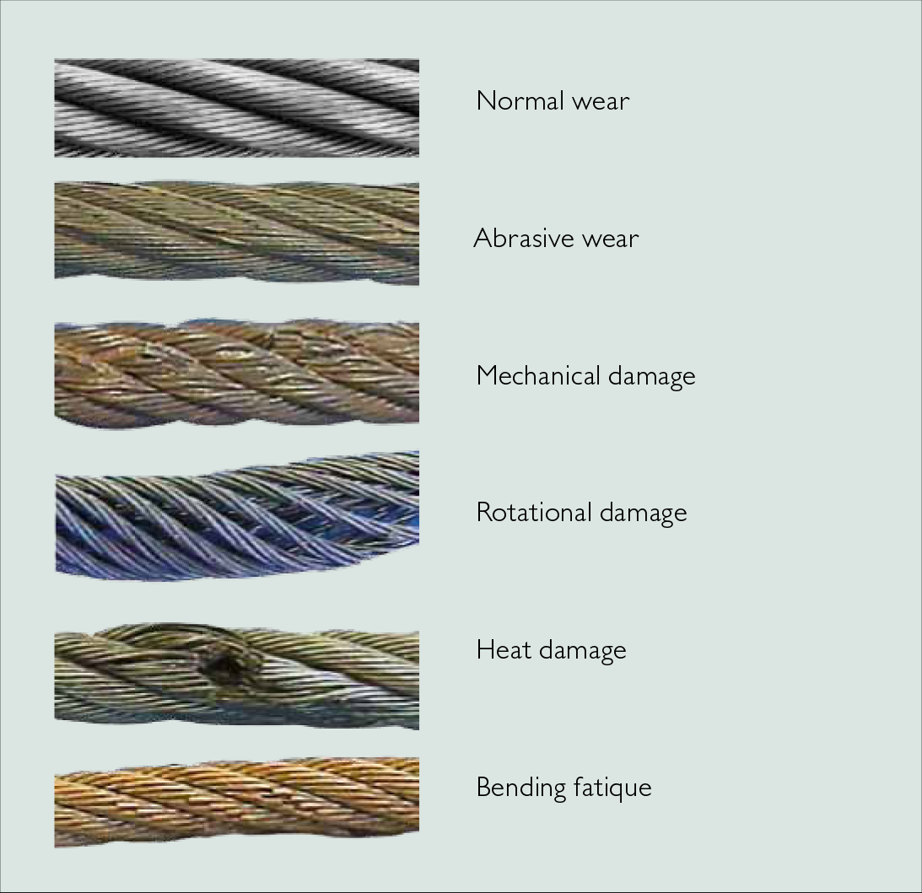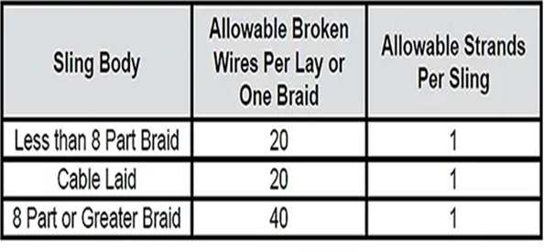
How to Inspect your Slings
- First, it is necessary that all parts of the sling are readily visible. The sling should be laid out, so every part is accessible.
- Next, the sling should be sufficiently cleaned of dirt and grease, so wires and fittings are easily seen. This can usually be accomplished with a wire brush or rags.
- The sling should then be given a thorough, systematic examination throughout its entire length, paying particular attention to sections showing the most wear.
- Special attention should also be paid to fittings and end attachments, and areas of the sling adjacent to these fittings.
- When the worst section of a sling has been located, this area should then be carefully checked against the OSHA and ASME criteria.
- Keep records of inspections that include dates and corresponding conditions of slings.
- Immediately dispose of slings that are rejected.
  - The best lifting and rigging inspection program is of no value if slings, which are worn out and have been retired, are not properly disposed of.
  - When it is determined by the inspector that a sling is worn out or damaged beyond use, it should be tagged immediately DO NOT USE.
  - If it’s determined that the wire rope will be removed from service, we suggest cutting it down into more manageable sizes before discarding. Cut into approximately 3’ to 4’ sections
  - Use a chop saw or torch to cut, or destroy, the eyes of the wire rope sling to prevent any further use of the sling
  - If the sling body is long enough to allow for an eye to be reformed by other means, the wire should be cut down to shorter lengths
  - Use proper PPE when handling the pieces of cut wire—cut or frayed ends of the wire rope will be sharp
  - Remove, or separate, any tags and labels from the sling

