Synthetic Sling Inspection Record
Manufacturer: | Model: |  | Serial Number: | Reach: |  |  |  |  | Capacity:
COMPONENT UNIT OR PART |  | PROBLEM |  |  | SAT | ADJ | REP | ACTION NOTES:  SAT=SATISFACTORY  ADJ=ADJUST  REP=REPAIR
Missing or illegible sling identification
Acid/caustic burns
Evidence of heat damage.
Holes, tears, cuts, abrasive wear or snags that expose the core yarns
Broken or damaged core yarns.
Weld splatter that exposes core yarns.
Knots in the round sling, except for core yarns inside the cover.
Fittings that are pitted, corroded, cracked, bent twisted, gouged, or broken.
Other conditions, including visible damage, that cause doubt as to the continued use of the sling

Damage to the Surface and Edge - It is important to realize that all of the fibers in slings contribute to the strength of the web sling. When there have been a significant number of fibers broken in a nylon web sling, as shown here, that sling should be taken out of service.
What to Inspect: During your hoist inspection checklist, look for broken fibers. Broken fibers of equal length indicate that the sling has been cut by an edge. Red core warning yarns may or may not be visible with cuts and are not required to show before removing slings from service.
How to Prevent: Always protect synthetic slings from being cut by corners and edges by using wear pads or other devices.

Sling Damage: Holes, Snags, and Pulls
What to Inspect: Punctures or areas where fibers stand out from the rest of the sling surface.
How to Prevent: Avoid sling contact with protrusions, both during lifts and while transporting or storing.
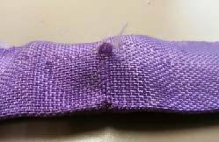

Sling Damage: Abrasion
What To Inspect: Areas of the sling that look and feel fuzzy indicate that the fibers have been broken by being subject to contact and movement against a rough surface. Affected areas are usually stained.
How to Prevent: Never drag slings along the ground. Never pull slings from under loads that are resting on the sling. Use wear pads between slings and rough surface loads.
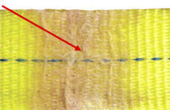

Sling Damage: Heat and Chemical
What To Inspect: Melted or charred fibers anywhere along the sling. Heat and chemical damage can look similar and they both have the effect of damaging sling fibers and compromising the sling's strength. Look for discoloration and/or fibers that have been fused together and often feel hard or crunchy.
How to Prevent: Never use nylon or polyester slings where they can be exposed to temperatures in excess of 200° F. Never use nylon or polyester slings in or around chemicals without confirming that the sling material is compatible with the chemicals being used.
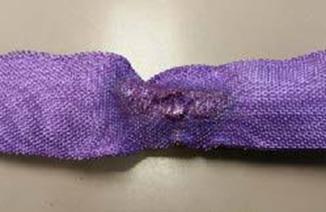

Sling Damage: Knots These compromise the strength of all slings by not allowing all fibers to contribute to the lift as designed. Knots may reduce sling strength by up to 50%.
What To Inspect: Knots are rather obvious problems as shown below.
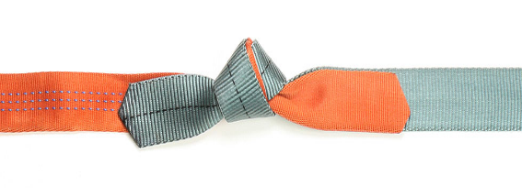
How to Prevent: Never tie knots in slings and never use slings that are knotted.

Sling Damage: Broken/Worn Stitching The main stitch patterns of web slings has a direct adverse effect on the strength of a sling. The stitch patterns in web slings have been engineered to produce the most strength out of the webbing. If the stitching is not fully intact, the strength of the sling may be affected.
What to Inspect: Loose or broken threads in the main stitch patterns.
How to Prevent: Never pull slings from beneath loads where stitch patterns can get hung up or snagged. Never overload the slings or allow the load edge to directly contact the stitch pattern while lifting. Never place a sling eye over a hook or other attachment whose width/diameter exceeds 1/3 the eye length.
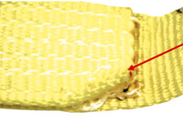

Sling Damage: The manufactures tags show the Rated Capacity for vertical, choker and a 90-degree basket hitches in lbs. and kgs, the type of fiber material and the sling length. Some manufacturer’s attach supplemental warning tag with valuable information for the sling user. The combination of these tags provides the user with the most complete and descriptive information.
What to Inspect: The information provided on the sling tag is important for knowing what sling to use and how it will function. If you cannot find or read all of the information on a sling tag, the sling must be taken out of service.
How to Prevent: Never set loads down on top of slings or pull slings from beneath loads if there is any resistance. Load edges should never contact sling tags during the lift. Avoid paint or chemical contact with tags.
All slings shall be tagged in accordance to ASME B390-2014 which include the following: name or manufacturers trademark, code or stock number, rated loads for types of hitch (es) used and the angle upon which it is used, In addition, tag will have individualized serial number and integrated caution/warning section. ALWAYS follow manufacturers suggested care, use, and maintenance recommended guidelines.
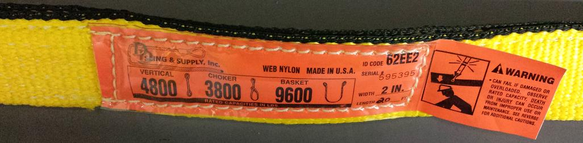

** What is the difference between nylon and polyester web slings? **
At rated capacity, a treated nylon sling stretches approximately 10%, whereas a treated polyester sling will stretch approximately 7%. Nylon's extra stretch helps to avoid shock loading. The lesser stretch of polyester makes load control easier by reducing bounce. In a chemical environment, nylon should not be used around acids or bleaching agents while polyester should not be used near aldehydes. (LiftAll)

