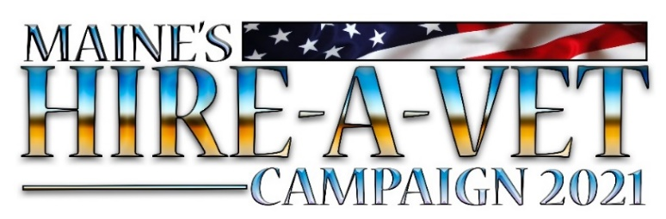
Maine Hire A Vet 2021
Memorandum of Agreement

As an employer participant in the Maine Hire-A-Vet Campaign for 2021, we agree to the following terms and conditions.
We Pledge To:
- Attempt to hire at least one qualified veteran or military family member over the 100-day period.
- Consider military education, training, and experience of veterans in hiring consideration.
- Consider qualified veterans referred by Maine Hire A Vet staff and partners.
- Share campaign success stories without revealing personally-identifiable hiring information of veterans and military families.
- Provide a company logo and a desired clickable “careers” link to the Campaign.
- Participate in at least one, one-hour, veteran related virtual training session provided by the campaign.
- Use the hashtag #mainehiresvets as applicable in our social media postings.

Maine Hire-A-Vet Campaign commits to the following terms and conditions.
MHAV Pledges To:
- Provide employers with as many qualified veteran candidates as possible
- Provide related virtual training opportunities to educate employers about hiring veterans, military culture, and other topics of interest
- Make available Campaign Veterans’ Representatives to communicate by phone, email, or virtual platform (in a timely manner) about the campaign and the hiring of veterans.
- Connect Campaign Employers with Maine CareerCenter resources, including Maine JobLink, employment, training, and placement services.
- Assist Campaign Employers with creating employer accounts on Maine JobLink and in posting your jobs.
- Execute an aggressive social media and public relations effort to promote the Campaign, its participating employers and publicize job postings.
- Acknowledge your participation in the Campaign through digital media and communications.
- Recognize participating employers for their participation in the campaign and their successful hires of veterans and military families.
________________________________________ ____________________________
Representative Signature Date

