

Guide to Updating Your Profile in
Maine JobLink (MJL) for
Apprentices with existing JobLink accounts



As a registered apprentice (RA) with the Maine Apprenticeship Program, all apprentices are required to be registered as an apprentice in the Maine Job Link (MJL) for federal funding purposes and case management.
MJL is a free and easy cloud-based job board that features improved job search and job matching functions, notifications of job match by email, a professional resume builder, support for more than 60 languages using Google Translate and a mobile-friendly design for smartphones and tablets.
The MJL website strives to comply with the best practices and standards as defined by Section 508 of the U.S. Rehabilitation Act and Level AA of the World Wide Web Consortium (WC3) Web Content Accessibility Guidelines 2.0. These guidelines outline how to make web content more accessible for people with disabilities.
 The Maine Department of Labor provides equal opportunity in employment and programs. Auxiliary aids and services are available to individuals with disabilities upon request. This program is provided in partnership with the American Job Center network.
Before you begin, you must know your Registered Apprentice Number (if you do not know your apprentice number contact your employer or the Maine Apprenticeship Program at 623-7969). You can also find your apprenticeship number on the printed Apprenticeship Registration Form that was sent to you in your welcome packet.
To access the Maine JobLink website: https://joblink.maine.gov
Step 1: Sign in to your account



Step 2: Click on My Profile on the left-hand side of the web page

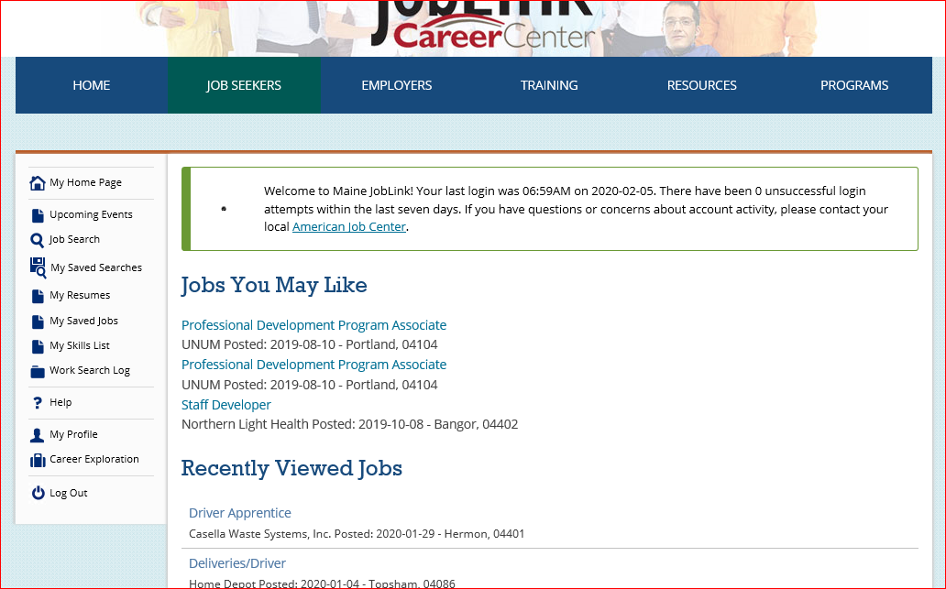

Step 3: Scroll down and click on Personal Information

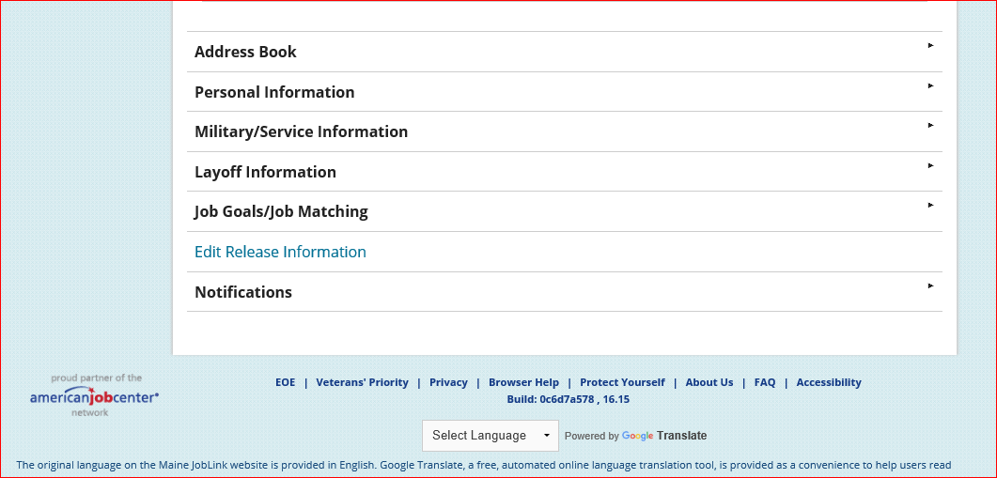

Step 4: Click on Edit Personal Information

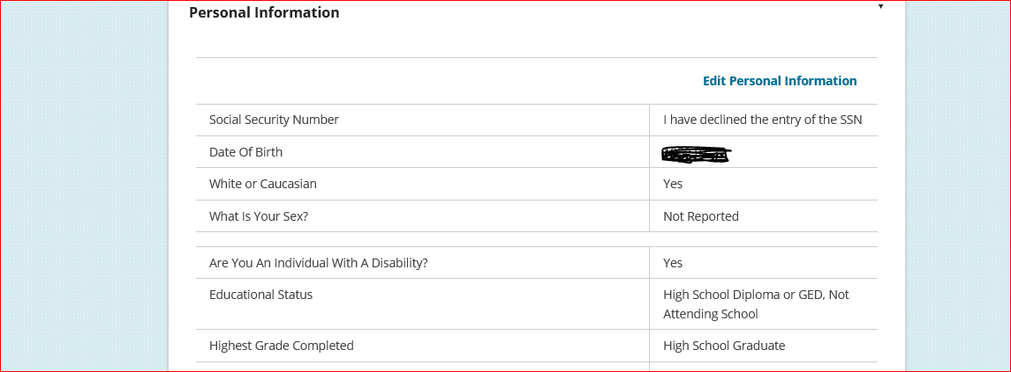

Step 5: Click on Registration Information

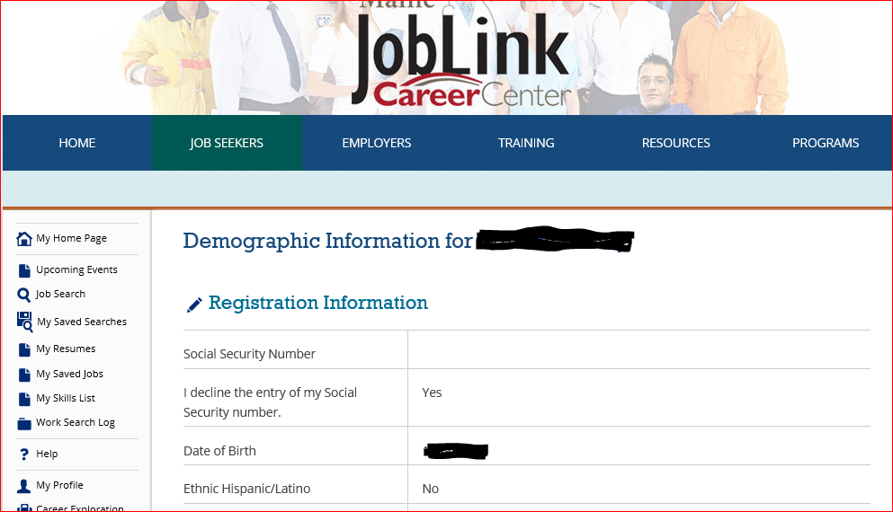

Step 6: Scroll down until you see the question “Are you a Registered Apprentice?”
-Select Yes.
-Enter your Registered Apprentice Number in the next box (if you do not know your apprentice number contact your employer or the Maine Apprenticeship Program at 623-7969).
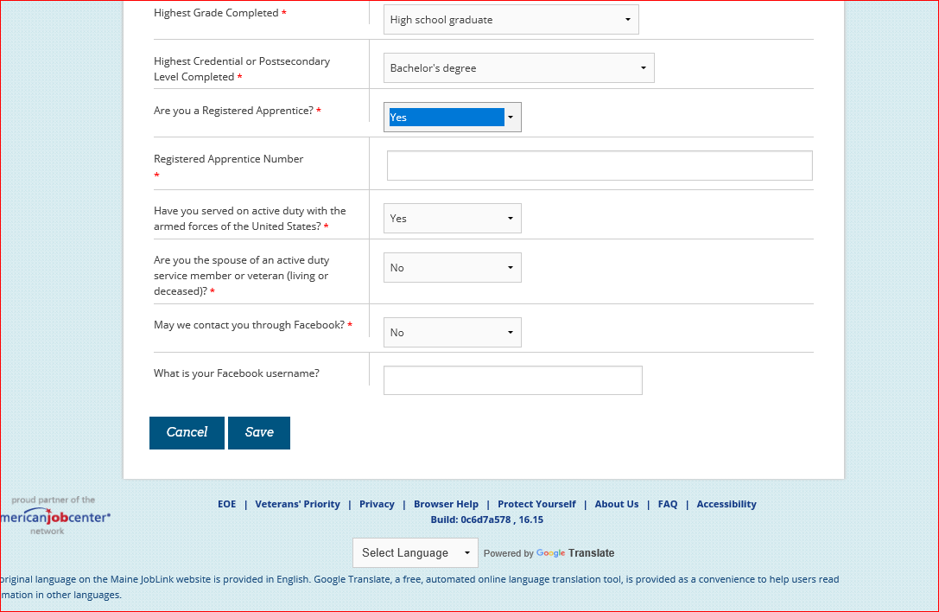
-You can also find your apprenticeship number on the printed Apprenticeship Registration Form that was sent to you in your welcome packet.
-Finally, you must click the “Save” button at the bottom of the page.

-You are done!

