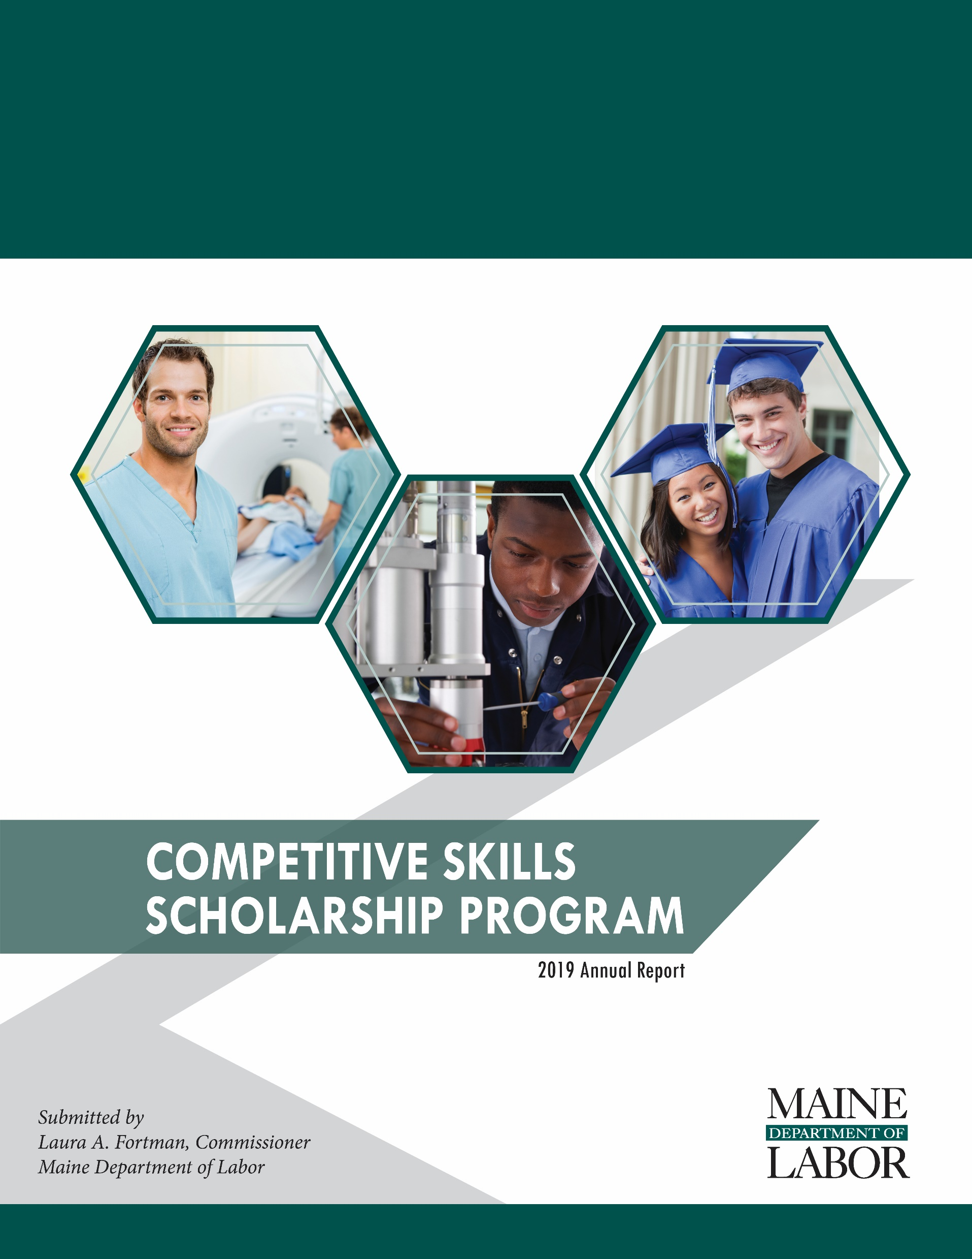

# 2019 Report of the Competitive Skills Scholarship Program

Transmitted to:

Joint Standing Committee on Labor and Housing

by:

Laura A. Fortman, Commissioner

Maine Department of Labor

February 2020

The information in this report is provided in accordance with Title 26 §2033 sub-§10 of Maine statute.

# Introduction

The success of Maine’s economy is tied directly to the skill of our workforce and the creativity and innovation of our employers. The Competitive Skills Scholarship Program (CSSP) was established to positively affect the skill of people in the workforce and to support employers’ success. In order to do so, the CSSP provides: postsecondary education; training for industry-recognized credentials; and, other support that leads to good-paying in-demand jobs.

2019 represented CSSP’s twelfth year, and since inception it has helped 3,107 low-income Mainers attain the skills necessary in order to thrive in our state’s economy. Supporting individuals in continuing their education and skill development increases an individual’s ability to support themselves and their family, and subsequently reduces the potential need for unemployment benefits in the future. By reducing the need for future unemployment benefit payments, the unemployment trust fund is more likely to maintain a healthy balance, and the employer taxes for unemployment benefits are potentially reduced. Because of this connection, the CSSP is funded through assessments on Maine employers that also contribute to the unemployment trust fund. An employer’s unemployment tax is reduced by the amount paid into the CSSP, as required by [Title 26 §1221 sub-§4-A](http://legislature.maine.gov/legis/statutes/26/title26sec1221.html) of Maine statute.

Demand for the CSSP continues to remain high. Enrollment in the program peaked in the fall, resulting in the Department’s need to temporarily freeze the program to new enrollments in November 2019. Funding for the CSSP will continue to support those currently enrolled. The Department will monitor available funding through the Spring of 2020 in order to determine when the program can reopen to new participants.

CSSP contributes to the goals of the State’s economic plan. The 10-year vision of the plan is to:

1. grow the average annual wage by 10%;
2. increase the value of what we sell per worker by 10%; and,
3. attract 75,000 people to Maine’s talent pool.

By encouraging continued learning and credential attainment, CSSP increases an individual’s ability to participate fully in Maine’s workforce, to earn family-supporting wages, and to contribute more robustly to Maine’s economy.

Summary of Program Outcomes

The Competitive Skills Scholarship Program (CSSP) is successfully moving our workforce and economy forward. Highlights of the 2019 CSSP are:

**Improved wage earnings.** Of those completing the program between April 2018 and March 2019, participants’ average quarterly wage earnings after completion increased by 75.12%.

**Continued demand.** CSSP served 1,140 individuals during calendar year 2019. Between April 2018 and March 2019 (the most recent period that captures wage earnings of those exited), a total of 362 individuals completed the program and   
77% entered employment in Maine.

**Relevant training for employers.** CSSP trains individuals for in-demand jobs available in Maine. According to Maine’s Occupational Employment Outlook to 20261, the largest job gains are expected in Health Practitioner and Technician and Healthcare Support occupations. Twenty-six percent of CSSP trainees choose healthcare occupations.

1 https://cwri1.blogspot.com/2018/09/occupationalemployment-outlook-to-2026.html

**Positive credential attainment rate**. In the most recent year, 346 individuals completed CSSP with 67% successfully earning their degree or industry recognized credential. Of those who exited in 2019, 35 earned associate degrees, 34 earned bachelor’s degrees, and 162 earned post-secondary occupational skills certificates or credentials of value.

**High school students enrolled in Career and Technical Education programs pursuing degrees**. CSSP Bridge Year students can graduate from Maine’s Career and Technical Education High Schools with up to 24 credits completed. At the end of 2019, 100 students were actively enrolled in the CSSP Bridge program; 38 in high school and 62 enrolled in college. A significant percentage, 78%, of CSSP Bridge’s students, who are economically disadvantaged, remained enrolled in college or have graduated. In comparison, the 2019 Educate Maine report indicates that only 50% of economically disadvantaged students enroll in college, and of those only 74% return for a second year. 2

**CSSP aligns with the goals of the Maine Economic Development Strategy 2020-2029.**3CSSP provides low-income Maine people with the financial resources and support services necessary to earn a post-secondary certificate of value. By gaining the knowledge, skills and abilities necessary to be successful in Maine’s high-demand industries, successful CSSP participants ultimately participate more fully in Maine’s workforce and improve their wage earnings allowing them and their families to thrive in Maine.

2 <http://www.educatemaine.org/docs/2019_IndicatorsReport-FNL-WEB.pdf>

3 <https://www.maine.gov/decd/sites/maine.gov.decd/files/inline-files/DECD_120919_sm.pdf>

# CSSP’s Three Paths

The CSSP is broken down into three components:

* CSSP for Individuals
* CSSP for Business
* CSSP Bridge

Each component has a slightly different focus, described below. Eligibility for each component is the same and is dependent on the individual. Each participant must:

* not already have a marketable post-secondary degree;
* have an income lower than 200% of the federal poverty level for their applicable family size;
* be working toward a job in a high-demand high-wage occupation; and,
* have the aptitude and ability to complete the desired educational program.

Competitive Skills Scholarship Program for Individuals

Established in 2007, CSSP for Individuals provides funding to individuals for education, training and necessary support services that lead to good-paying jobs. Eligible education and training must be universally recognized and accepted by the trade or industry in which the participant intends to seek employment, and must provide opportunity for employment in high-wage, in-demand jobs in Maine that lead to a substantial improvement in earnings and benefits.

Many individuals enrolled in CSSP also receive federal Pell Grants that typically cover most if not all tuition costs associated with attending college. Although Pell may cover tuition costs, low-income individuals often struggle to stay in school due to the high-cost of childcare, transportation, books, supplies and unanticipated situations that require money to resolve. CSSP provides support services to assist individuals with these costs of attending college that go beyond tuition. CSSP participants benefit from the combination of these support services along with the career counseling, guidance and support provided through their case managers at Maine’s CareerCenters.

In 2019, 70% of CSSP participants were enrolled in CSSP for Individuals. Of the 201 individuals exiting CSSP for Individuals this year, 61% (123) earned a credential of value. Fifty-six earned college degrees and 67 earned industry recognized credentials.

Competitive Skills Scholarship Program for Business

First piloted in 2014, the CSSP Business Program (CSSP-B) helps businesses train their employees to take on hard-to-fill, high-wage occupations within their organization. CSSP Business Program participants are either CSSP income-eligible incumbent employees in entry-level jobs or income-eligible individuals recruited directly through the CareerCenter. At the conclusion of training, successful trainees earn an industry-recognized certificate or degree, leading to a new job and increased wages, while businesses have access to individuals trained for their industry.

In 2019, a total of 99 new trainees were enrolled in CSSP-B. During 2019, 73% of those who finished CSSP-B successfully earned a degree or credential. Ten college degrees and 75 industry recognized credentials were obtained.

Competitive Skills Scholarship Program - Bridge

Beginning in 2016, the CSSP Bridge Program was added to support high school students who are at least 16 years-old and enrolled in a Career and Technical Education (CTE) school. Students are dually enrolled in high school and college courses while attending their regional CTE school. CSSP Bridge students can obtain 24 or more college credits by high school graduation through dual enrollment. These credits are offered at a reduced rate of $40 per credit hour and are transferable to all University of Maine System schools, all Maine Community College System schools, and may be transferable to other public and private post-secondary institutions. Students enrolled in CSSP Bridge can graduate from high school and enter college with nearly a full year of college courses behind them. CSSP funding and CareerCenter consultants will support them as they pursue an associate degree and/or complete a bachelor’s degree. A total of 159 students have been enrolled in CSSP Bridge since its inception in 2016.

During 2019, a total of 34 new students were enrolled in the CSSP Bridge Program. To date, six CSSP Bridge students have earned associate degrees and 27 are upper classmen in four-year degree programs.

Individual Success Stories

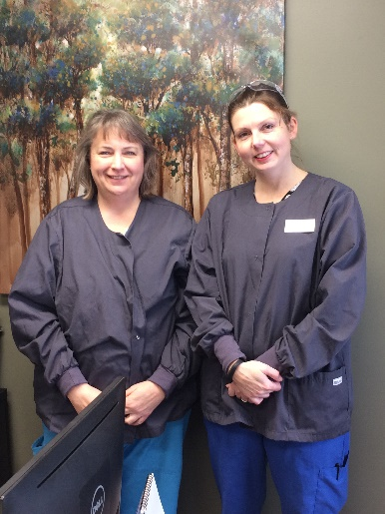Jolene came to the CareerCenter while working survival jobs in health care and retail fields. Jolene has three children and a fiancée who works on a farm earning low wages. At the time of her enrollment in CSSP, the family was eligible for and received benefits from the Supplemental Nutrition Assistance Program (SNAP).  Jolene wanted to become a dental assistant and completed an online dental assistant course through Lawrence Adult Education. The certificate she earned didn’t give her the radiology training and job experience that dental assistants are required to have.  Jolene worked with a CareerCenter consultant to find a job placement and develop a six-month On-the-Job training contract which provided the business with a 50% reimbursement of Jolene’s wages for six months. Jolene then passed her radiology exam, earned a nationally recognized dental assistant certification, and become employed full-time in the dental office where she had learned her trade.

**“My name is Landry Kwizera. I am from Rwanda, Africa. When I was 23 years old, I fled my country due to political instabilities and came to live in the U.S. Alone in a new country with no friends or family, I didn’t know how I would survive. Luckily, I obtained a work permit and started working at Embassy Suites as a shuttle driver. In 2013, I met my wife Larissa and had my first child. With additional responsibilities, I found the courage to pursue my dreams to be able to provide a better future for my children. I wanted to go back to school but I didn’t have the finances to cover my tuition. I heard about a program through the CareerCenter that offered scholarships. In 2014, I applied and received the Competitive Skills Scholarship through the CareerCenter which covered 100% of my tuition to enroll in the nursing program at University of Southern Maine. CSSP also provided monthly stipends to help cover my bills as working more hours while studying full-time wasn’t possible. When I talk about the CareerCenter scholarship with my family, we are sure it is a blessing from above, that has greatly changed our lives. I worked hard and was able to succeed because I didn’t have to worry about working more hours or taking debts to pay for my tuition. I graduated from University of Southern Maine nursing program with a job offer to work at Spring Harbor as soon as I passed my NCLEX nursing licensing exam. The CareerCenter supported me throughout the entire process including paying the exam registration fees.”

# Continued Development of Maine’s Workforce

Workforce is a key component of the ongoing success of Maine’s economy. Maine businesses need talented workers in order to succeed. Maine people need the skills that are in demand so that they can thrive. Through CSSP, the needs of both business and workers are supported.

The Department is committed to a workforce development plan that:

* partners and responds to the talent needs of Maine employers;
* creates a system of lifelong learning and employment connection for Maine residents; and,
* builds an integrated workforce development infrastructure accountable to residents and businesses.

CSSP delivers on each of these components. By ensuring that participants are pursuing occupations that are in demand, CSSP is responding to the talent needs of Maine employers. By supporting individuals who are economically disadvantaged, CSSP is encouraging learning into adulthood and increasing connection to the workforce for those who might otherwise struggle. By supporting program participants through their educational attainment, CSSP ensures effective outcomes that benefit the Maine economy, and both residents and businesses alike.

The Department coordinates the CSSP program with other agencies that offer workforce programs. Programs and funding are provided through many agencies in Maine, including the: Department of Health and Human Services, Local Workforce Investment Boards, Maine Community College System, Department of Education, as well as other Department of Labor programs. CSSP staff work collaboratively with other agencies to leverage the funding and supports available throughout the state.

# Competitive Skills Scholarship Program— 2019 By the Numbers

Total Trainees in 2019 1,140

Trainees served during calendar year increased by 7.73% from 2018.

Expense Summary 2019

Training $2,223,088

Support Services and Stipends $1,673,128

Case Management, Counseling and Administration $1,607,642

Total Expenditures in 2019 $5,503,858

Revenue Balance as of December 31, 2019 $1,290,139

These funds are obligated for the expected costs for current CSSP participants. Expected costs for Calendar Year 2020 are $3.8 million. The additional funds will come from Calendar Year 2020 revenue.

|  |  |  |  |  |
| --- | --- | --- | --- | --- |
| **AVERAGE ANNUAL COST PER PERSON** | **All CSSP** | **Individual** | **Business** | **Bridge** |
| Number of Trainees Served in 2019 | 1,136 | 800 | 206 | 130 |
| Training | $1,950 | $1,988 | $1,889 | $1,874 |
| Support and Stipends | $1,468 | $1,813 | $1,029 | $56 |
| Case management, Counseling, Admin. | $1,410 | $1,453 | $905 | $1,727 |
| Average Annual Cost Per Person | $4,828 | $5,255 | $3,823 | $3,657 |

Demographics

Supplemental Nutrition Assistance Program (SNAP) Recipients 34%

Income at or below Federal poverty line 74%

While participants must be at 200% or less than the federal poverty level, most participants’ income falls below the federal poverty level.

Published by the Maine Department of Labor

February 2020

