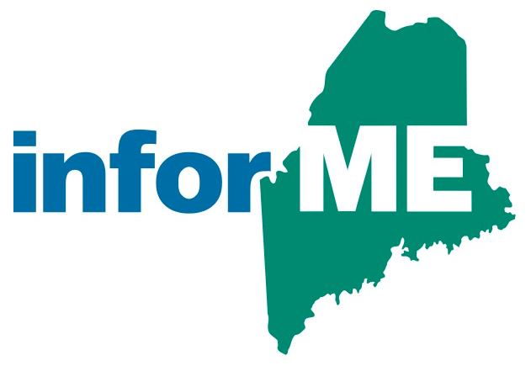

InforME Board Meeting Minutes

**Meeting Date:** October 26, 2023

**Meeting Time:** 1:00 PM - 3:00 PM

**Meeting Location:** Virtual Meeting

**Attendees**

**Board Members Present:**

Shenna Bellows

Jeremy Cluchey

Adam Fisher

Anne Head

Sam Foster (non-voting member)

**Guests and State Agency Members:**

Dawnna Pease

**InforME Staff:**

Kimberly Duplisea

Tony Brodie

**The meeting was started at 1:05 PM.**

* 1. **Welcome & Introductions**
  2. **Adoption of Minutes**

Adoption of the meeting minutes was tabled due to lack of quorum.

* 1. **Third Quarter General Manager’s Report**

Sam Foster provided a summary of the third quarter General Manager’s report. Sam provided service updates including that the rapid renewal service processed its 3 millionth transaction online, that several projects are in testing in the project queue, and that Engagement Builder platform has allowed us to spin up new digital services in record-time. Sam also provided an update on the Maine Data Center migration. Several services have been migrated, and several are in testing.

Sam also provided Tyler company-wide updates including details about Prompt Pay, a service that allows agencies to send a text message containing links to secure payment pages, about Data Collect Mobile, which is being used to unify inspections across divisions, and Managed Detection and Response Services, which is a suite of services that monitor partner networks 24/7 for behavior that could pose risks to an environment.

* 1. **Net Promoter Score (NPS) Survey Results**

Sam Foster gave an overview that the Net Promoter survey is designed to gauge customer satisfaction with Tyler Maine. This tool asked 72 users across state agencies a series of questions. Of those 72 users, 31 users responded to the survey. The survey showed us that agencies need to have more educational opportunities, timely communication, and a feeling that we truly understand needs.

* 1. **Next Board Meeting Dates**

TBD