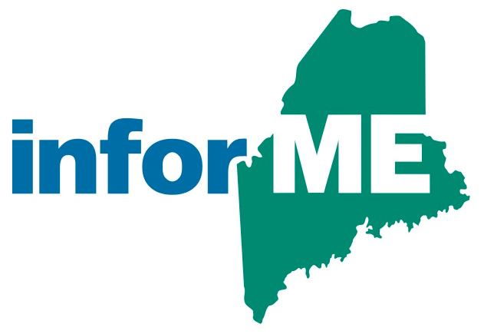

InforME Board Meeting Minutes

**Meeting Date:** August 24, 2023

**Meeting Time:** 1:00 PM - 3:00 PM

**Meeting Location:** Virtual Meeting

**Attendees**

**Board Members Present:**

Nicholas Marquis

Shenna Bellows

Michael Cyr

Kathy Montejo

Chris Pinkham

Jeremy Cluchey

David Simsarian

Adam Fisher

Anne Head

Sam Foster (non-voting member)

**Guests and State Agency Members:**

Dawnna Pease

**InforME Staff:**

Kimberly Duplisea

**The meeting was called to order at 1:02 PM.**

* 1. **Welcome & Introductions**
  2. **Adoption of Minutes**

Motion: Chris PInkham motioned to adopt the minutes.  
Second: Shenna Bellows

Vote: Unanimous

* 1. **Strategic Plan Discussion**

Nick Marquis introduced the strategic plan. Some of the dates must be updated on the plan, and assignments should be made for tasks within the plan. The board action item will be to create a work session to reacquaint members with the plan contents as well as to assign out new dates and priorities.

* 1. **Disaster Recovery Plan Update**

Sam Foster provided an update on the disaster recovery plans in place for InforME’s primary Virginia Data Center. A full data center disaster recovery exercise will be scheduled for September. More details will be provided as the exercise is scheduled, as well as details of the exercise.

* 1. **Award Highlight**

Tyler Technologies was awarded one of the best places to work in Maine for 2023. An award ceremony will be held in October at the Augusta Civic Center.

* 1. **Adjournment**

Motion: Shenna Bellows motioned to adjourn the meeting.  
Second: Nicholas Marquis

Vote: Unanimous

* 1. **Next Board Meeting Dates**

Sam Foster will poll the board regarding the date and time for the September board meeting.