Beech-Oak Mast Management
By Rich Hoppe, Region G Wildlife Biologist

The word “mast” may conger up a thought of sailing ships out on the ocean or to those individuals who are inclined to think of wildlife or forestry understands what a critical seasonal component this food source is for wildlife. Mast is a broad term that refers to the various nuts and fruits produced by woody plants and subdivided into hard mast (nuts) and soft mast (fleshy fruits). In Maine our main mast strictly based on volume and nutritional value would be composed of hard mast, beech, and oak while soft mast would be raspberry. Of the more than 350 species of woody plants native to Maine, only about a dozen produce nuts, and more than 80 produce fruits or berries (Fernald 1950). In New England over 170 species are known to use hard mast including amphibians, reptiles, birds, and mammals.

Primary hard mast in Maine includes American beech, red, white, and black oaks. What few managers understand about hard mast is the nutritional value (Figure A) they offer to wildlife consuming them. Although oaks are more abundant in central to southern Maine, beechnuts and beaked hazelnuts are plentiful throughout the state and offer an abundance of protein, fat, and calories. Not hard to understand why these nuts are so important to wildlife species especially to deer and bear trying to put on extra fat reserves to get them through the winter. Where once another important mast tree, the American chestnut existed in southern Maine it succumbed to the chestnut blight and no longer exists in any great numbers. Hard mast production generally begins between 20-40 years of age, is greatest at mid age and size, and tapers off between 100-200 years. The three oaks differ in nut production frequency with red producing heavy crops every 2-5 years, white every 4-10 years, and black every 2-3 years. The acorns of white oak contain less tannin than those of the red and black and are more palatable to wildlife. Beech trees begin nut production at about 40 years of age and produce heavy crops every 2-8 years. Beech trees are particularly important to northern Maine where oaks are uncommon, and wildlife species are particularly dependent physiologically to nut production. Of interest to wildlife managers in northern Maine is the demise of mature beech trees due to the beech bark disease which has killed large numbers of nut producing trees obviously impacting numerous wildlife species dependent on this nut.

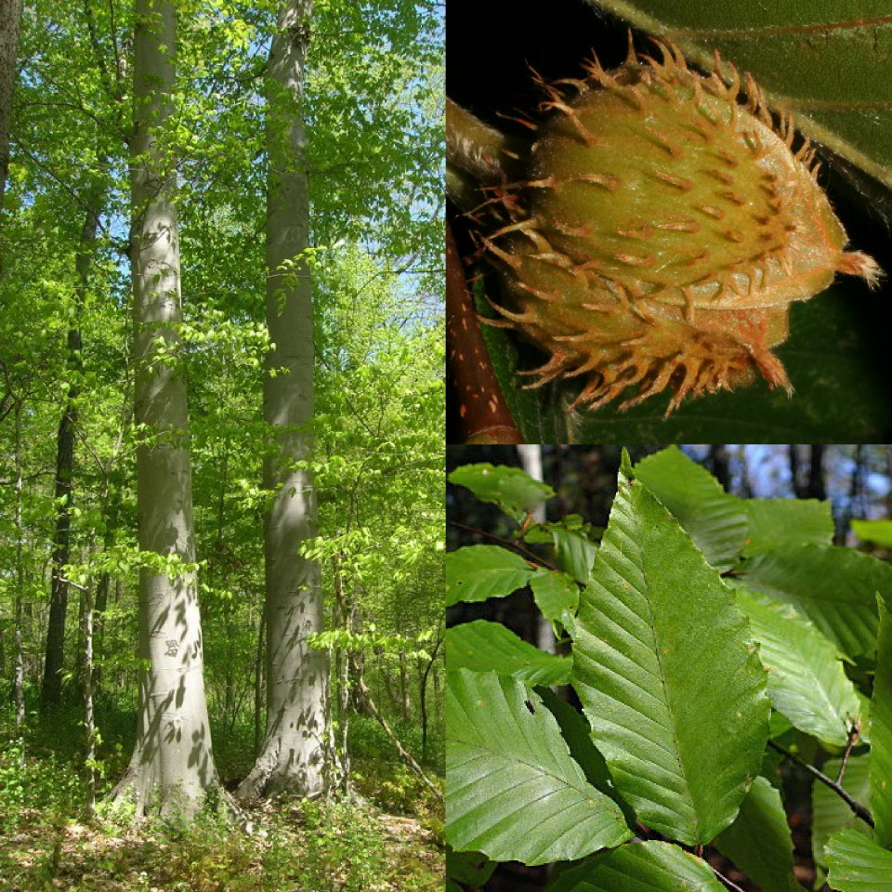

American Beech

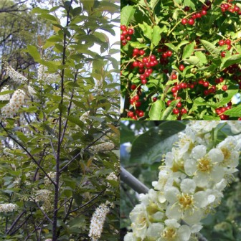

Choke Cherry

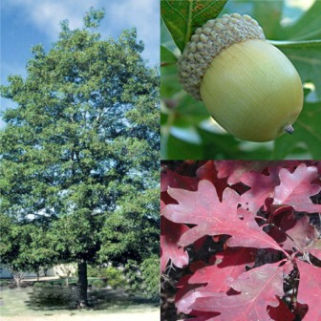

White Oak
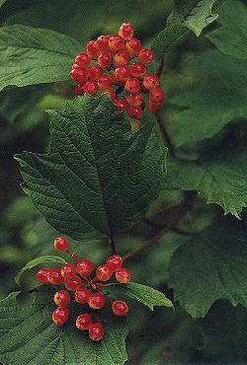

Highbush cranberry

Black cherry is the only canopy tree in Maine that produces soft mast while the common chokecherry and highbush cranberry along hedgerows, pastures, secondary roads, and disturbed areas produce a significant about of fruit which is consumed by a myriad of wildlife species. Other abundant and widespread shrub species offering an array of seasonal foods in Maine include mountain ash, serviceberries, blueberry, and pin cherry. More than 30 species of herbaceous plants in Maine forests produce soft mast. The largest and most prolific are the “brambles” which include raspberries, blackberries, and black raspberries and tend to be utilized primarily by birds and mammals. Berries of species such as wild strawberry, wild sarsaparilla, and painted and red trilliums disappear quickly after ripening suggesting intense use by many species.

Management considerations:

- Manage for multiple species of mast producing trees and shrubs to maintain diversity and production of mast.
- Manage oak stands on long rotations to maximize acorn production.
- Retain beech trees with bear scars from prior use, and retain smooth bark beech trees perhaps resistant to beech bark disease. Note: Dying beech often produce significant nut biomass multiple years.
- Retain beech and oak trees when they occur as single or scattered trees amongst other species.
- Retain wild apple trees and maintain by pruning and releasing them from competitive species.
- Maintain highbush cranberry and chokecherry around perimeters of fields and hedgerows.
- Maintain a percentage of openings dominated by “brambles” on the landscape. On disturbed sites this will happen naturally in most cases in Maine due to early plant succession of flora.

Figure A:

Nut | Protein (gr) | Fat (gr) | Calories
Acorns (mixed species) | 3.5 | 2.5 | 260
Beechnuts | 19.4 | 50.5 | 568
Butternuts | 23.7 | 61.2 | 629
Chestnuts | 2.9 | 1.5 | 194
Hazelnuts | 12.6 | 66.9 | 634
Hickory nuts | 13.2 | 68.7 | 673

Nutritional value of selected hard mast/ 100 gram edible portion
(Krochmal and Krochmal 1982)

