Janet T. Mills
GOVERNOR
STATE OF MAINE OFFICE OF THE GOVERNOR
1 STATE HOUSE STATION
AUGUSTA, MAINE
04333-0001

April 26, 2022

The 130th Legislature of the State of Maine State House
Augusta, Maine

Dear Honorable Members of the 130th Legislature:

By the authority conferred by Article IV, Part Third, Section 2 of the Constitution of the State of Maine, I am hereby vetoing L.D. 1820, An Act to Strengthen the Governance of the University of Maine System.

The perspective of faculty, staff, and the public is certainly important to the work of the Board of Trustees of the University of Maine System. I encourage the Board to develop better methods for obtaining input from current faculty and staff at its Board and subcommittee meetings to ensure that they have ample opportunity for involvement in significant decisions impacting the System. However, I believe this can and should be done without adding to the membership of the Board individual faculty and staff who are currently employed by the System.

L.D. 1820 is very similar to L.D. 1253 from last year, except that it adds a member and it makes the new member non-voting. But it has the same flaws. This proposal, once again, contravenes longstanding policy and law that guard against members of public boards having real or perceived conflicts of interest in matters in which they benefit financially or otherwise from board action. , Title 17 M.R.S. § 3104 prohibits any "trustee, superintendent, treasurer or other person holding a place of trust in any state office or public institution of the State" from being "pecuniarily interested directly or indirectly in any contracts made in behalf of the State or of the institution in which he holds such place of trust, and any contract made in violation hereof is void." This bill purports to "notwithstand" that longstanding law, without articulating any reason for doing so. This same common sense conflict rule is the reason why current employees are not permitted to serve on any school board, on the Maine Maritime Academy board, the Maine Community College System board or on other public governing boards.

University of Maine policy goes further than state law and prohibits trustees from being employed by the System during their service and for one full year following service on the Board. This prohibition does not just prevent trustees from voting on contracts in which they have a direct or indirect pecuniary interest; it prohibits them from serving at all. The same policy voids any contracts made while persons with such conflicts serve as trustees. Simply put, as I wrote in my June 23, 2021, veto message on L.D. 1253, it is bad public policy to authorize active employees to serve on a board that sets their salaries, governs the budget, and otherwise makes decisions that directly impact them.

PRINTED ON RECYCLED PAPER

PHONE: (207) 287-3531 (Yo1cE) TTY USERS CALL 711
www.maine.gov

FAX: (207) 287-1034

L.D. 1820 differs from L.D. 1253 by adding three current employees to the Board instead of two, and by making these employee trustees non-voting members. However, the law and policy cited above apply whether or not the person with a conflict is a voting member, and the same risk to the validity of contracts exists. Both perceived and actual conflicts remain.

Current University Board policy states that trustees cannot participate in discussions about agenda items which may benefit them or their family more than the average Maine person. Employee compensation makes up more than two-thirds of the University's budget, and budgetary matters are at the heart of the Board's work. Allowing trustees who are current employees to participate in deliberations on matters in which they have a direct financial interest, regardless of whether they vote, would create a distinct conflict of interest and undermine the decision-making process of the Board.

During the committee process, the University proposed an alternative to L.D. 1820 that would have avoided the conflict of interest problem while creating more opportunity for faculty and staff to provide input, including a standing coordinating committee established in statute and co-chaired by a trustee and faculty member with regular reporting to the Legislature. Unfortunately, this proposal was rejected and was not incorporated into this bill. The bill remains as flawed as L.D. 1253 before it.

For all these reasons, and for the reasons articulated in my veto message last year, I return L.D. 1820 unsigned and vetoed and I strongly urge the Legislature to sustain this veto.

Sincerely,
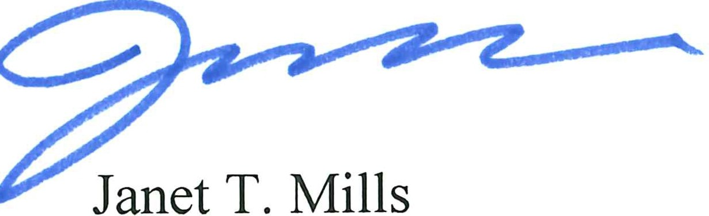
Governor

PRINTED ON RECYCLED PAPER

PHONE: (207) 287-3531 (Vo1cE) TTY USERS CALL 711
www.maine.gov

FAX: (207) 287-1034

