Reviewing/Editing Documents Instructions
One of the best features of this tracking system is the ability for multiple people to review, comment on, and edit an existing document in real time, and with version tracking. Provided these documents are attached to a case, anyone who is a reviewer/interested party to a case can access the documents and do what needs to be done inside them, while never worrying about deleting or replying to the wrong version.
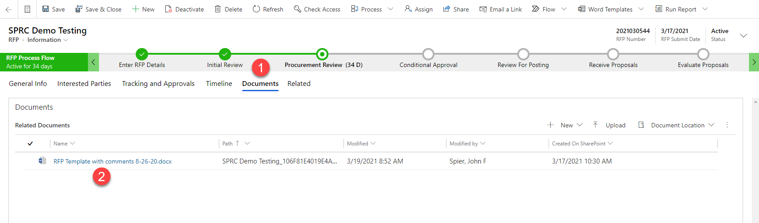
- While inside the case, click on “Documents” in order to see all documents that are attached to this case
- Clicking on an individual document’s linked title will open it immediately in the Word browser app which is basic, but not ideal, so you will want to open it in the desktop app asap
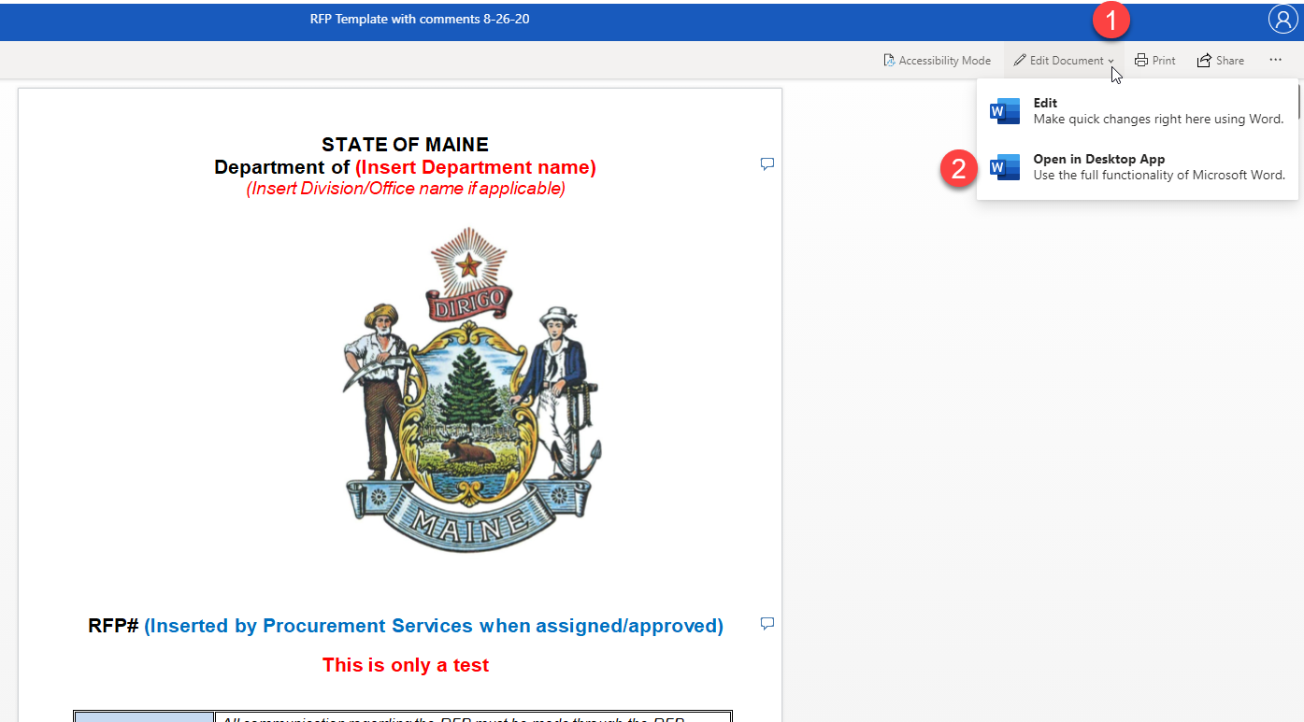
- By clicking on “Edit Document” you will see a dropdown menu
- Clicking “Open in Desktop App” will then open the document in that app and allow you to edit it as you normally would, as well as see all other edits and notes

Document FAQs
Can’t I just edit the document right in my browser? | Yes, technically you can, though we have found through years of trial and error that the browser-based editing is very limited, simplistic, and not always ideal, so we strongly recommend you edit in the desktop app
If I use the desktop app, won’t I just be saving the document to my desktop? How do I then upload the document back to Dynamics? | No, that’s the beauty of this system. Because it is integrated with SharePoint, by clicking through Dynamics, the version you open in your desktop app is tied directly to the SharePoint file. So when you hit “Save” or have Auto Save turned on, everything gets saved back to SharePoint automatically
If I save a version of the document with my edits, will I be overwriting everyone else’s edits/comments? | No. SharePoint has “Versioning Control” enabled, which means every time a document is updated in any way, a version of it is saved separately. Anyone can go back to any older version and see what it looked like in that moment. In this way, it’s also safer than normal document retention, as there is always a backup (or several)
Can I see real-time updates as I am editing if someone else is also editing at the same time? | Yes! Because of the SharePoint integration, you will see indications as to which people are currently looking at the document you are reviewing, and as they add text, comments, or make changes, you will see it all happen in real time! (Pretty neat stuff, huh?)

