STATEMENT OF SOURCES OF INCOME (SOSOI) FILING INSTRUCTIONS
FOR EXECUTIVE BRANCH EMPLOYEES
STATEMENT DUE BY APRIL 18, 2023

- GO TO WWW.MAINECAMPAIGNFINANCE.COM AND CLICK ON THE BUTTON IN THE UPPER RIGHT-HAND CORNER OF THE SCREEN AND SIGN IN WITH YOUR SOSOI USERNAME AND PASSWORD.

2. CLICK “FILE STATEMENT” TO START YOUR REPORT
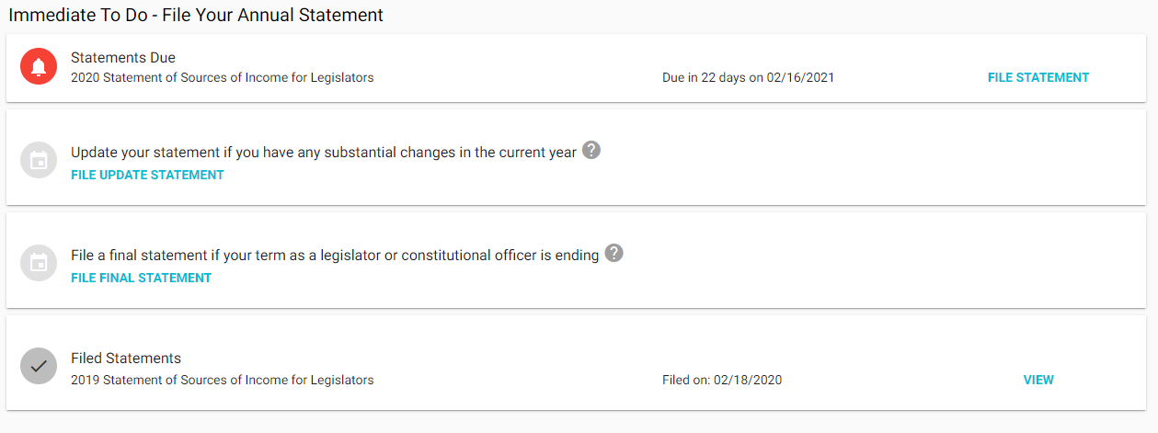
3. CLICK HERE TO COPY YOUR DATA FROM THE PREVIOUS REPORT AND SAVE DATA ENTRY TIME!
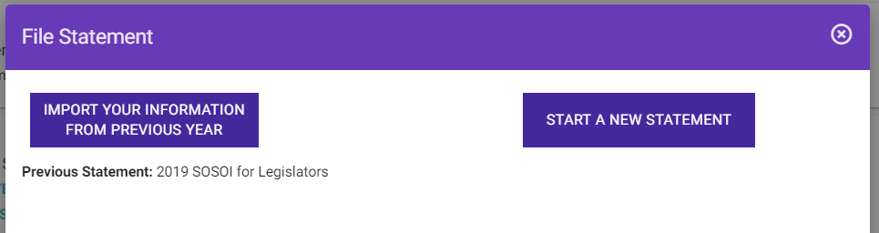

4. CLICK THROUGH EACH SECTION TO ADD OR REMOVE DATA PERTINENT TO THIS REPORTING PERIOD.
Note – you must have a GREEN checkmark next to each section before you can file the report.
5. WHEN YOU HAVE FINISHED MAKING NECESSARY CHANGES, CLICK THE CERTIFICATION CHECK BOX
AND THEN CLICK TO GET A MESSAGE CONFIRMING YOUR SUBMISSION.
