ANGUS S. KING, JR. 04330 JAY BRADSHAW
state of maine
Department of Public Safety
Maine Emergency Medical Services
16 Edison Drive
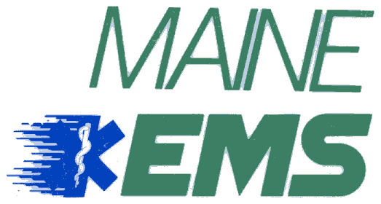
state of maine
Department of Public Safety
Maine Emergency Medical Services
152 State House Station
Augusta, Maine
04333

Paul R. LePage
governor
John E. Morris
Commissioner

Jay Bradshaw
director

Practical Skills Evaluation (PSE) Scheduling Form – April 1, 2013
Training Centers:
A. Complete §§ 1 – 23, below. (Note: When field is selected, instructions appear at bottom left of screen)
B. Send the completed form to: Maine EMS, 152 State House Station, Augusta, ME 04333-0152 and attach a
check for the PSE Evaluator fee made payable to: Treasurer of State.
C. Complete the online Maine EMS Testing Opportunity Form for the PSE and submit it to the Maine EMS online Testing Calendar.

Training Center Information
1. Name: |  |  |  |  |  |  |  |  |  |  |  |  |  |  |  |  |  | 2. Contact Name:
3. Telephone: |  |  |  |  |  |  |  |  |  |  | 4. E-Mail:
Instructor Coordinator Information
5a. Name: |  |  |  |  |  |  |  |  |  |  |  |  |  |  |  |  |  |  |  |  | Tel.#:
 | Email: |  |  |  |  |  |  |  |  |  |  |  |  |  |  |  |  |  |  |  | Course#:
5b. Name: |  |  |  |  |  |  |  |  |  |  |  |  |  |  |  |  |  |  |  |  |  | Tel.#:
 | Email: |  |  |  |  |  |  |  |  |  |  |  |  |  |  |  |  |  |  |  |  | Course#:
5c. Name: |  |  |  |  |  |  |  |  |  |  |  |  |  |  |  |  |  |  |  |  |  | Tel.#:
 | Email: |  |  |  |  |  |  |  |  |  |  |  |  |  |  |  |  |  |  |  |  |  | Course#:
6. IC Contact/PSE Location Tel# on PSE Day: |  |  |  |  |  |  |  |  |  |  |  |  |  |  |  |  |  |  |  |  |  |  |  |  | Alt Tel.#:

PSE Information
7. PSE Level: |  |  |  |  |  |  |  |  |  |  |  |  |  |  |  |  |  |  |  |  |  |  | 8. (Estimated) Participant #:
9. PSE Location:
10. PSE Address: |  |  |  |  |  |  |  |  |  |  |  |  |  |  |  |  |  |  | 11. PSE City:
12. PSE Date: |  |  |  |  |  |  |  |  | 18. PSE Day:
18. Start Time: |  |  |  |  |  |  |  |  |  |  |  |  |  | 19. Estimated End Time:
20. I have confirmed the following State Evaluator to monitor the PSE:
21. Enclosed is a check made payable to
Treasurer of State in the amount of:
22. (For NREMT AEMT and Paramedic Level Examinations Only) TC elects  to secure and reimburse NREMT representative directly: |  |  |  |  |  |  |  |  |  |  |  |  |  |  |  |  |  |  |  |  |  |  |  |  |  |  |  |  |  |  | (Check if statement is applicable)
23. Certification

I certify that the aforementioned Practical Skills Evaluation will be conducted in accordance with Maine EMS Standards
___________________________________________ ___________________
Program Director or Program Coordinator Signature Date
Maine EMS Use Only: |  |  |  |  |  |  |  | Amount Rec’d: |  |  |  |  |  |  |  | Check #: |  |  |  |  |  |  |  | Acknowledgement sent:
Comments:

