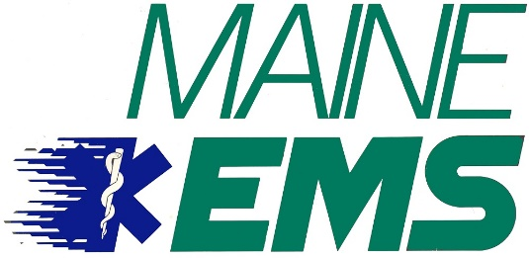

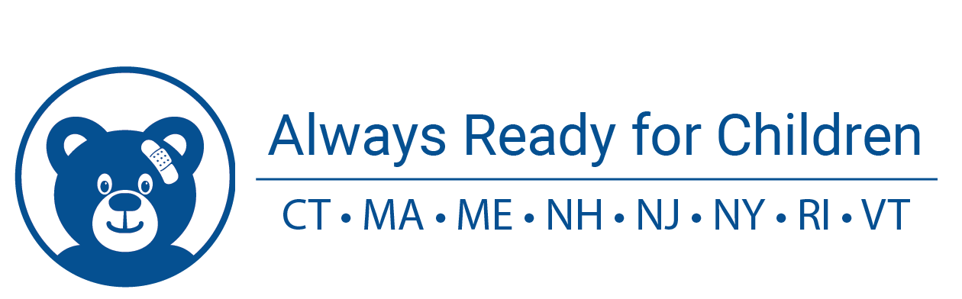
ARC Commitment Letter

TO: Maine Emergency Medical Services for Children
Marc Minkler, Program Manager
Marc.A.Minkler@maine.gov

FROM: ______________________________________________________
(Emergency Department Leader’s Name and Title)

SUBJECT: Hospital Commitment Letter
Participation in the Always Ready for Children Program

We commit to joining Emergency Medical Services for Children (EMSC) in Maine and the region in participating in the Always Ready for Children (ARC) improvement project. This project is an opportunity for our hospital to collaborate with EMSC and other regional institutions on a program that will help ensure we are prepared to care for ill and injured children.

We as an organization are committed to providing appropriate time and resources for our Emergency Department team to assess and improve our pediatric readiness, including participation in quality improvement initiatives such as the assignment of a Pediatric Emergency Care Coordinator and data collection activities.

Hospital Name:
Emergency Department PECC (Pediatric Emergency Care Coordinator): | Email address:
Emergency Department Medical Director: | Email address:
Emergency Department Nurse Director/Manager: | Email address:

_______________________________________________ Date: ______________
(Signature of authorizing leader)

Printed Name:
Title within organization:
Email:
Phone:

Always Ready for Children
Facility Demographic Information
Hospital Information
(Note – if multiple campuses, please submit a form for each campus)
Hospital Name:
Hospital Address:
Hospital Contact Name:
Contact Email Address:
Hospital Readiness Score (if known, contact us for assistance):

Pediatric Emergency Care Coordinator
(if more than 1, please include additional contact info)
Name:
Level of Licensure:
PECC Email Address:

Specify the level of Recognition that your hospital is applying for:
  - Pediatric Engaged
  - Pediatric Ready
  - Pediatric Innovator

