Board of Trustees
MAINE CRIMINAL JUSTICE ACADEMY

BASIC CORRECTIONS TRAINING PROGRAM

Specification S-3

The following requirements are specific for the certification of Basic Corrections Training Program (BCTP):

Requirements:

- Prior to admission to the BCTP, the applicant must successfully pass the MCJA ALERT TEST with a minimum score of 37.

- The applicant will be subject to a background investigation by their employing agency, revealing no disqualifying convictions/conduct as defined by 25 M.R.S. §2806-A.

- The applicant will submit to a medical evaluation by a licensed medical professional to determine if the applicant is medically suitable for training.

- Upon admission to the BCTP the applicant/student will attend a minimum of 90% of the BCTP.

- In addition to the requirements set forth in Requirements, section D above to be certified, students will attend at least 90% of the following “Critical Components” of the training and fully participate in all aspects:
- Mechanics of Effective Restraint and Control.
- Interactive Use of Force.
- Constitutional Law.
- Interpersonal Behavior and Skills.
- Mental Health First-Aid.

- The student must successfully pass the BCTP Certification Exam with a minimum score of 75%.

- The BCTP will consist of a minimum of 208 hours.

- Upon successful completion of the BCTP, and within the first year of employment, each student will be field trained by their agency for a minimum of 80 hours. This training must include all otherwise required state and agency training (i.e. emergency fire procedures, agency policy, CPR, etc.) and complete a Board defined probationary period that lasts for at least 1 year after graduation from the BCTP or the date the Board waives the basic training requirement. This training will be documented on a MCJA approved form and submitted to the Academy for review.

Procedures:

- The employing agency on behalf of the applicant will forward the following forms to the Maine Criminal Justice Academy:
  - MCJA Notice of Employment.
  - MCJA Application to attend training.
  - MCJA Medical Form signed by a licensed medical professional.
  - MCJA Background Form signed and notarized.

Certification

- All corrections officers who attend the BCTP will be given a provisional Certificate of Eligibility to act as a corrections officer in the State of Maine upon being hired. Certification as a corrections officer will remain in effect, if this individual who holds the Certificate of Eligibility as a correction officer in the State of Maine, maintains employment in this capacity and remains in good standing with the Board, per M.R.S. 25 §2806-A, regardless of job title.
- The corrections officer must successfully pass the BCTP Certification Exam with a minimum score of 75%.
- A corrections officer who completes a Field Training Officer program (Phase III), which consists of a minimum of 80 hours and includes other required state and agency training, i.e.: emergency fire procedures, agency policy and CPR within the first year of probation, shall receive a Certificate of Eligibility to act as a corrections officer in the State of Maine.
- A corrections officer who has completed equivalent corrections training may have the hiring agency apply for a MCJA training waiver certification utilizing the process set out in MCJA Specification S-43.

Recertification

- To maintain a Certificate of Eligibility to act as a corrections officer in the State of Maine, a corrections officer must complete the annual mandatory in-service training, per 25 M.R.S. 2804-F by December 31st of each calendar year.

Adopted: 05/09/2014
Revised: 09/13-2019
Review Date: 09/13/2022

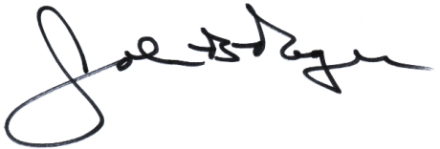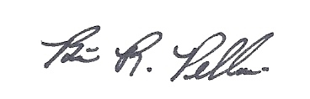
____________________________ __________________________
John B. Rogers, Director Brian R. Pellerin, Chair
Maine Criminal Justice Academy MCJA Board of Trustees

