Board of Trustees
MAINE CRIMINAL JUSTICE ACADEMY

JUDICIAL MARSHAL CERTIFICATION

Specification S-12

The following requirements are specified for the certification of Judicial Marshals. This specialized training course is for personnel specifically and regularly assigned to judicial marshal services. Such certified personnel will be able to accept assignment to judicial marshal duties at any court locations.

This special certification empowers personnel to perform judicial marshal duties, which includes; general law enforcement authority within this limited scope of duty granted as a judicial marshal.

Requirements for Training and Certification:

- Be employed by a criminal justice agency with the MCJA Notice of Employment upon application.

- Meet the required admission, medical and background standards as prescribed by the Board and the Office of the State Judicial Marshal or the Sheriff’s Office that the Judicial Marshal is employed.

- Successful completion of the Law Enforcement Pre-Service Program or the Basic Law Enforcement Training Program upon application.

- MCJA Background upon application.

- Polygraph Exam within the first year of employment.

- Successful completion of the Judicial Marshal Training Program as approved by the Board, within the first year of employment. Each student will be required to attend all sessions of the school except for absences approved by the academy staff. No judicial marshal will be certified when his/her absences exceed ten (10) percent of the total hours of the instruction time.

- As a requirement for certification as a judicial marshal, each judicial marshal must demonstrate competency in the use of their agency approved firearm using the MCJA law enforcement firearms qualification course of fire upon application and each year thereafter.

- The Academy Director will review the documentation and make a recommendation to the Board for certification as a Judicial Marshal if everything has been successfully completed.

Recertification:

A. To maintain a Certificate of Eligibility to act as a judicial marshal in the State of Maine, a judicial marshal must complete the annual mandatory law enforcement in-service training, per 25 M.R.S. §2804-E by December 31st of each calendar year.

Adopted: 05/12/2017
Amended: 09/13/2019
Review Date: 09/13/2022
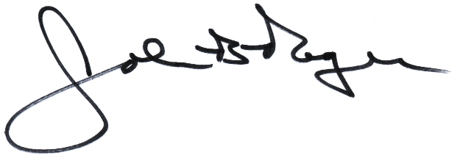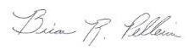
____________________________ __________________________
John B. Rogers, Director Brian R. Pellerin, Chair
Maine Criminal Justice Academy MCJA Board of Trustees

