Board of Trustees
MAINE CRIMINAL JUSTICE ACADEMY

MECHANICS OF ARREST, RESTRAINT and CONTROL (MARC) INSTRUCTOR CERTIFICATION

Specification S-10

Purpose:

To establish certification requirements and procedures for Mechanics of Arrest, Restraint & Control (MARC) instructors.

Certification:

  - The applicant shall have the following minimum employment qualifications:
- Must be a certified full-time law enforcement officer in the state of Maine with at least three years of full-time experience and be designated by their employing agency as an agency MARC Instructor
a. NOTE: The requirement of years of service may be waived by the Director upon submission of evidence that the applicant has extensive experience as a MARC Instructor, or

- Must be a certified part time law enforcement officer in the state of Maine with at least five years of part time experience and be designated by their employing agency as an agency MARC Instructor
a. NOTE: The requirement of years of service may be waived by the Director upon submission of evidence that the applicant has extensive experience as a MARC Instructor, or

- Must be a retired full-time law enforcement officer sponsored by the Director or an Academy Staff member sponsored by the Director.

  - Applicants must successfully complete the MCJA Methods of Instruction course, or a comparable course of instruction as determined by Staff review.

  - Applicants must successfully complete the Mechanics of Arrest, Restraint, and Control (MARC) Instructor Development Program or a comparable course of instruction as determined by Staff review.

  - The applicant will be monitored instructing during an Academy approved unit of instruction in a Mechanics of Arrest, Restraint, and Control topic. A MARC Lead Instructor assigned by the Academy Director will evaluate the applicant as to form, content, and competency during this instruction and will make a recommendation (on an approved form) as to whether the applicant demonstrates proficiency worthy of certification as MARC Instructor.

Recertification:

- The applicant shall have the following minimum employment qualifications:
- Must be a certified full-time law enforcement officer in the State of Maine and be designated by their employing agency as an agency MARC Instructor, or

- Must be a certified part time law enforcement officer in the State of Maine and be designated by their employing agency as an agency MARC Instructor, or

- Must be a retired full-time law enforcement officer sponsored by the Director or an Academy Staff member sponsored by the Director.

- During the 2yearr certification, assist for a minimum of an aggregate twenty-five (25) hours as an instructor in the current MARC training for the:
- Basic Law Enforcement Training Program, and / or

- MARC Instructor Development Course, and / or

- Law Enforcement Pre-service Course (Phase 2 training).

Procedures:

  - The candidate will apply on approved forms submitted with required supporting documentation to the Academy.

  - The application and supporting documentation shall be reviewed by the Academy staff for compliance with standards and consideration for certification recommendation to the Board of Trustees.
1. The applicant shall be advised of the nature of the staff’s recommendation.

- The applicant may appeal the Academy staff’s findings to the Academy Director.

- The MCJA Board of Trustees shall have the final decision making authority as to certification.

- Successful candidates seeking initial certification who maintain the employment criteria
enumerated above under Requirement for certification, A 1-3 above will receive certification for a period of two years.

- Successful candidates seeking recertification who maintain the employment criteria enumerated above under Requirement for recertification, A 1-3 above will receive certification for a period of two years.

- Certified MARC Instructors who fail to meet recertification standards shall be placed in an inactive status by the Academy Director.

- Certified MARC Instructors who fail to comply with the instruction of Academy approved techniques and tactics or deviate from approved instruction are subject to suspension of their certification as a MARC Instructor by the Academy Director.
  - The applicant may appeal the Academy Directors findings to the Board of Trustees.

  - The MCJA Board of Trustees shall have the final decision making authority as to certification status.

Adopted: 07/11/2014
Amended: 11/08/2019
Review Date: 11/08/2022

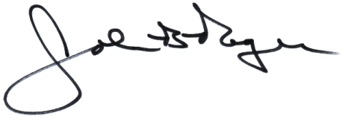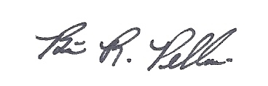

John B. Rogers, Director Brian R. Pellerin, Chair
Maine Criminal Justice Academy MCJA Board of Trustees

