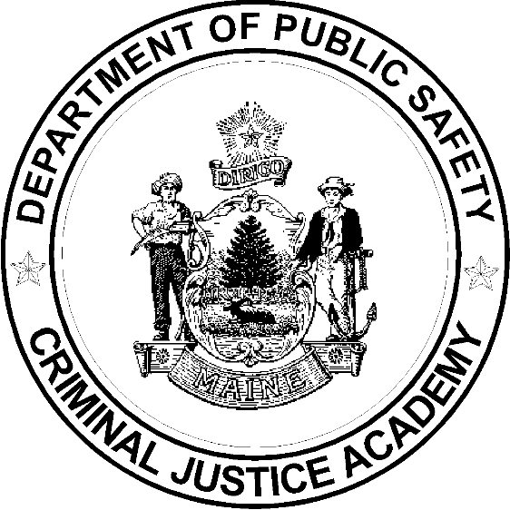

Name: _________________________________________
Print last name (print) first name

Date: ________________________________________

Date certification expires: __________________________

Training Year Activity Hours Completed
20
Option A. Minimum 40 hrs. BLETP Range
OR
Option B. 40 hrs.of approved firearms training that must include: low-light drills, multiple target drills, re-loading drills, use of cover, use of force decision making, scenario based training

20
Minimum 40 hrs. BLETP Range
OR
Option B listed below
20
Minimum 40 hrs. BLETP Range
OR
Option B listed below
The certification period is for three (3) years. During this 3- year period you must A. assist a lead instructor on a BLETP range for a minimum of 40 hours OR B. document a minimum of 40 hours of approved firearms training within the three year period. These 40 hours MUST include: low-light drills, multiple target drills, re-loading drills, use of cover, use of force decision making and scenario based training. See MCJA Specification S-7 for additional information. (Now available on the MCJA web site).

My signature attests that I have met the minimum standards for re-cert as outlined in MCJA Specification S-7 and am employed as either a full or part-time law enforcement officer or full time corrections officer with ____________________________________.
(Agency)

______________________________________________________
(Signature / Date)

I certify that the above training is true and accurate in accordance with MCJA Specification S-7 fulfilling requirements for firearms instructor re-certification.

____________________________________________________________________
Chief Administrator/Dept. Designee/Firearms Instructor - Date

