Suspected meth lab raided
Mark LaFlamme, Staff Writer
Feb 04, 2010 12:00 am
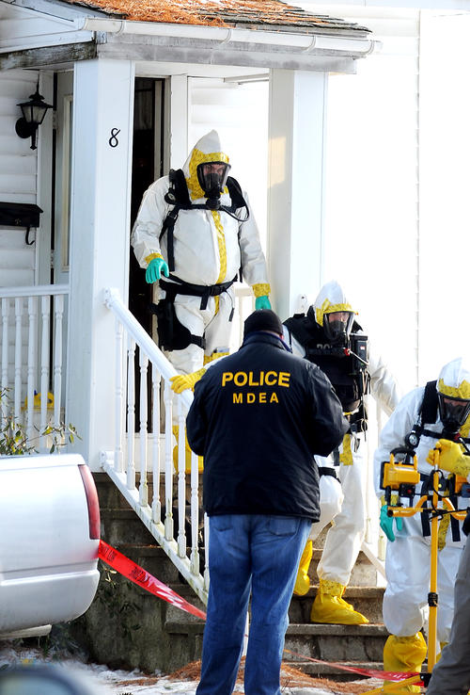
Amber Waterman/Sun Journal
State and local police officers in hazardous materials gear leave 8 Omer St. in Lewiston after a search warrant was served on a possible methamphetamine lab at the multi-unit building Wednesday afternoon.
- Amber Waterman/Sun Journal

LEWISTON — One man was arrested and a variety of substances were seized Wednesday when police and drug agents raided a suspected methamphetamine lab on Omer Street. James Ludlow, 35, of 8 Omer St., was charged with possession of methamphetamine after police found evidence of the drug inside his apartment. Ludlow was arrested while he was working at a nearby business, police said. He was taken to the Androscoggin County Jail in Auburn where he remained later Wednesday night. At about 3 p.m., dozens of Maine Drug Enforcement agents, police officers and others went to the two-family home at the corner of Omer and Baril streets. Since last year, agents had been investigating reports that meth was being used and possibly manufactured at an apartment there.
For the next four hours, drug agents in chemical-resistant suits and ventilators carried a variety of substances and other items out of the building. They examined and tested those items at the scene and bagged several as evidence.
Investigators said there was ample evidence of the presence of meth inside the house. In coming days, police and drug agents will attempt to learn more about where the drug came from.
"Whether or not that meth production took place here or somewhere else, we're not prepared to confirm that," said MDEA Division Commander Darrell O. Crandall.
When the team first went to Omer Street, their presence was heavy. Police, drug and environmental officials were joined by firefighters, rescue crews and others. Crandall said the first part of the response was to make sure the building was clear, that everyone was removed from the building and that obvious safety hazards were identified.
"We let them work at a safe pace," Crandall said.
When drug agents first arrived, with a search warrant, there was one young woman inside the apartment, police said. She was taken out and placed in an MDEA mobile crime van. The woman was not arrested.
Neighbors said they had no idea that anything like an illegal drug operation was going on at the neat, two-story house.
"We never would have thought this was going on," said Adam Carlton, who lives on the dead-end portion of Omer Street. "They're really friendly people. They have friends that were over but no more than you or I would have."
Crandall said he did not know how many people lived in the apartment. Carlton said there were occasional poker games there, but he did not know specifically how many people lived their, either.
He had not heard anything about the possibility of drugs being used in the apartment.
"I don't want it on my street. Nobody wants it on their street," Carlton said. "With drugs come violence. Anything could go wrong."
The neighborhood is a quiet one, with few complaints of crime or other matters, said Deputy Chief James Minkowsky of the Lewiston Police Department. But that is not always an indication that a neighborhood is drug-free.
"It's a good neighborhood. It's certainly not a high crime area," Minkowsky said. "But there is really no typical area for this kind of thing."
Ludlow was being held without bail Wednesday night, charged with meth possession and violating bail from an earlier, unrelated arrest.
Another neighbor on Omer Street said he hadn't suspected drug trafficking at the house being searched. However, he did say he had noticed an inordinate number of people coming and going.
Investigators said they had been monitoring activity at the house for months. They did not say what kind of information led them there but stressed that it was part of an ongoing investigation.
"We have got a fair amount of evidence that was seized," said Crandall, the MDEA commander. "There was a lot to go through. The team did a great job under cold and miserable circumstances."
MDEA officials did not specify what they had seized from the house. Crandall said that by the time the teams left, there were no obvious dangers to concern neighbors.
"We have no fears of explosives or fire based on what we've seen in the residence," Crandall said.
Once the police phase of the search was over, three specialists from the Department of Environmental Protection went in to clean up. Police took some substances as evidence, but the rest was left behind for the DEP.
"We'll go in and collect the waste," said Stephen G. Brezinski, an oil and hazardous waste specialist. "We'll clean it up or call in a contractor if it's significant enough."
Brezinski could not speculate on what materials they would be removing from the apartment. In similar cases, they have been asked by police to clean up certain ammonias, potential phosphorus, acetone and other solvents, he said.
While the investigators examined potential evidence taken out of the building, sections of both Omer and Baril streets were cordoned off.
That meant some Omer Street residents could not drive to their homes during the raid, although police did allow two men to walk beneath the crime scene tape to get to their houses.
Carlton was one of them, although he didn't mind the intrusion.
"They're doing their jobs," he said of the police teams. "And I'm glad they

