MEDIA RELEASE: Maine Drug Enforcement Agency (MDEA)

October 31, 2009

Direct questions to: Division Commander Darrell Crandall @ 207-557-0510

- Drugs valued at over $100,000 seized in two MDEA investigations late last week -

At the end of last week, MDEA Agents in two District Task Force groups were busy collecting evidence of large scale trafficking in prescription drugs.

On Thursday evening, MDEA Agents assigned to the Down East District Task Force executed a search warrant at the home of William McManus on the Cove Road in Otis. McManus, 52, had been under investigation by MDEA since August in response to reports that he was selling large quantities of prescription drugs. Agents were able to buy Oxycodone from McManus in recent weeks, and used that as a basis to obtain a search warrant for his home. Agents seized over 1,500 tablets of various prescription drugs to include nearly 500 Oxycodone and over 800 Xanax. Agents also seized $20,794 in US currency which is believed to be proceeds from the sale of drugs. About four ounces of marijuana and drug ledgers were also seized. McManus is charged with Aggravated Trafficking in Scheduled Drugs - a Class A offense. Lawrence Peters, 29, of Madison was also found in the home, and is charged with Possession of Scheduled Drugs. Both men are scheduled to appear in Hancock County Superior Court on December 18.The drugs seized from the home have a retail street value of more than $25,000.
The following evening, MDEA Agents assigned to the North Central District Task Force culminated an unrelated investigation with the execution of a search warrant at the home of Mackenzie Kelley on Broadway in Bangor. Since the summer, Agents had been investigating reports that Kelley was selling large quantities of prescription drugs. On Friday, their investigation prompted them to follow Kelley to a business in Bangor, where she was stopped. Agents seized thirty, 80mg OxyContin and $3,000 in cash from Kelley and they then obtained a search warrant for Kelley's home. There, they seized approximately eight-hundred (800) 80 mg OxyContin and another $3,000 in cash. The street value of the drugs seized in this case exceeds $80,000. Kelley is charged with Trafficking in Scheduled Drugs and is scheduled to appear in Penobscot Superior Court on December 4.

A number of area law enforcement agencies assisted MDEA Agents with the execution of the search warrants and arrests. Those agencies include the Bangor and Brewer Police Departments, Hancock County Sheriff's Office and the Maine State Police.

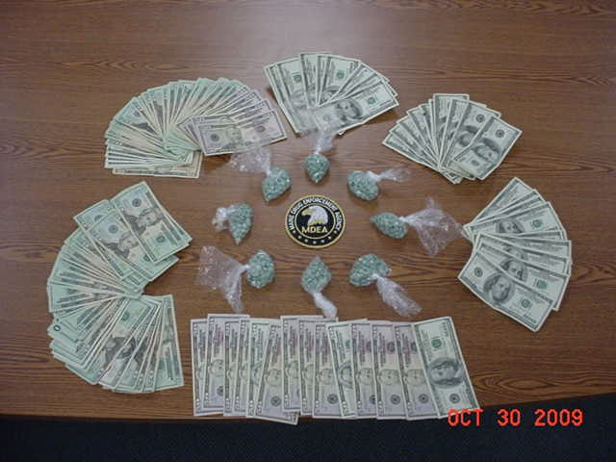

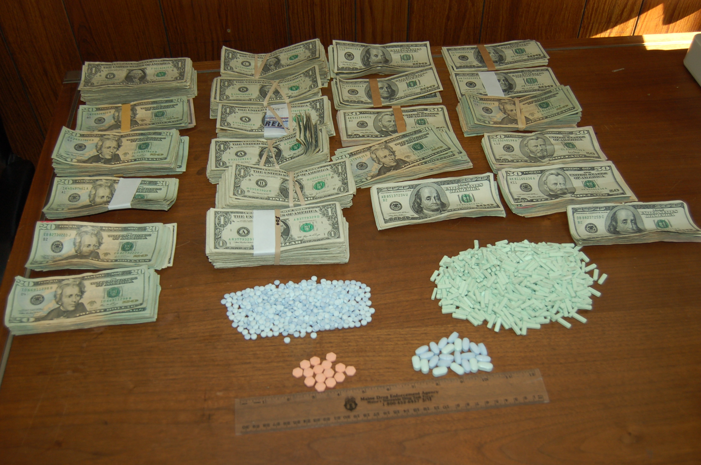
"These cases are a striking reminder of the illicit demand for prescription drugs in Maine." "They also illustrate MDEA's continuing resolve to pursue those who seek to profit from the unfortunate circumstances of others."

If anyone has information on drug trafficking in Maine, they may call MDEA toll free at 1-800-452-6457 or leave a tip on the MDEA website at http://www.maine.gov/dps/mdea/drugtip.html

