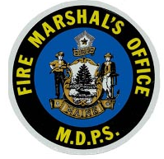
Maine Department of Public Safety
Office of the State Fire Marshal
52 State House Station
Augusta, Maine 04333-0052
Tel. (207) 626-3880 Fax (207) 287-6251

April 11, 2022

ImageTrend has released its long-awaited inspections module WITH AN NFPA Codes feature for fire departments. The current locations, occupants, inspections module has always allowed departments to record data in a cloud-based system. You can create, update and reference records from virtually anywhere with an internet connection or with an optional offline tool.
The new update to the inspections module incorporates the National Fire Protection Association codes to assist a department in recording, citing, and monitoring code violations anywhere as well. The Fire Marshal’s Office will be administering the program. At this time preparations are being made to begin registering new participants.
The number of registered users that each department chooses to have access to the NFPA Code feature for NFPA 1 & 101 will be a local decision between the local department and the vendor ImageTrend.
For more information, contact Richard Taylor at (207) 626-3873 or by e-mail at Richard.e.taylor@maine.gov.

