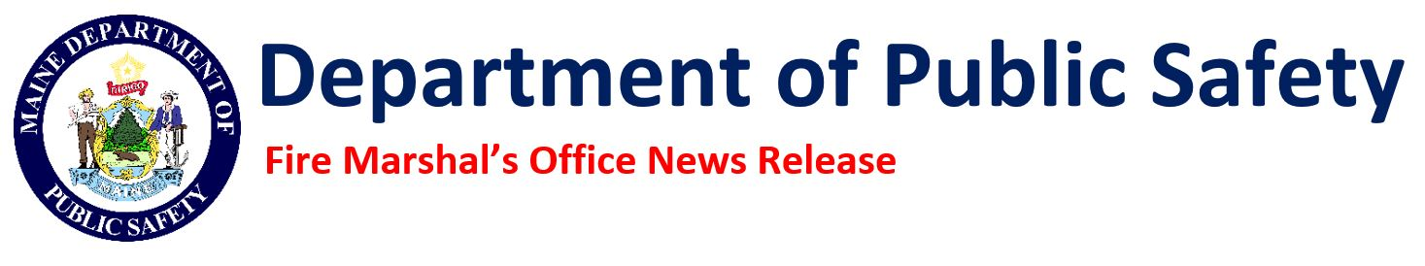

Press Conference to Highlight Community Risk Reduction Efforts Across Maine

The Maine Fire Marshal’s Office and the Maine Forest Service invite members of the media to a news conference on Wednesday, January 29, 2025, at 10:30 am, to announce and discuss Maine’s innovative Community Risk Reduction (CRR) efforts.

Community Risk Reduction is a proactive, all-hazards approach to identifying, prioritizing, and mitigating risks within communities. By addressing issues such as fires, falls, car accidents, and medical emergencies, CRR helps reduce injuries, fatalities, property losses, and the costs associated with emergency responses. Governor Janet Mills has recognized the significance of this initiative by proclaiming the week of January 26–February 1, 2025, as Community Risk Reduction Week, emphasizing Maine’s commitment to public safety.

Speakers at the press conference will include representatives from Maine’s fire service. This new effort is supported by the Community Risk Reduction Collaborative, which includes members from the Department of Public Safety, the Department of Education, the Department of Transportation, older adult advocacy organizations, Maine EMS, the Maine Fire Service, Maine County Emergency Management Agencies, and the Bureau of Alcohol, Tobacco, Firearms and Explosives (ATF).

Maine is leading New England in CRR innovation, with successful programs already in place. These include community paramedicine programs connecting EMS with seniors to reduce hazards in the home, fall prevention programs offering safety resources for older adults and people with disabilities, and wildfire risk assessments for homeowners in forested areas. These efforts protect residents, reduce risks to first responders, and lower long-term costs for municipalities.

Media are encouraged to attend to learn more about these initiatives and hear directly from officials and experts driving this important work.

Community Risk Reduction News Conference
Wednesday, January 29, 2025, at 10:30 am
Department of Public Safety
45 Commerce Drive, Augusta

Shannon Moss
Public Information Officer
Maine Department of Public Safety
45 Commerce Drive. Augusta, ME 04333
Cell 207.530.3602

