State of Maine
Youth Fire Safety & Intervention
Protocol

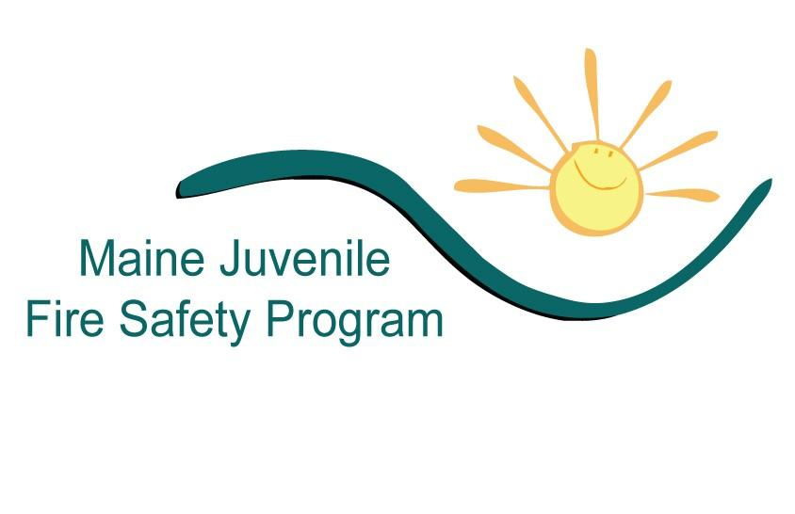

Office of State Fire Marshal

Department of Public Safety

TABLE OF CONTENTS

Statement of Purpose………………………………………………… 4
Goals and Objectives………………………………………………… 4
Foreword…………………………………………………………….. 5
Regional Concept……………………………………………………. 6
Mission Statement…………………………………………………… 6
Acknowledgments………………………………………………….. 7

SECTION ONE – YOUTH FIRESETTERS AND THEIR FAMILIES

Fire Behavior…………………………………………………….. 9
Typologies of Firesetting…………………………………………….. 9
Summary………………………………………………………… 13

SECTION TWO – IDENTIFICATION AND SCREENING

Referral and Release Information……………………………… 14
Intake-Screening………………………………………………… 14
Summary………………………………………………………… 16

SECTION THREE – YOUTH AND FAMILY INTERVIEW

Risk Determination………………………………………………… 17
The Interview………………………………………………………. 17
Target Populations…………………………………………………. 17
The Interview Format……………………………………………… 17
Recording the Interview…………………………………………… 17
Interview Style……………………………………………………… 18
The Interviewer……………………………………………………. 18
Special Situations………………………………………………….. 18
Confidentiality……………………………………………………… 19

SECTION FOUR – PROGRAM COMPONENTS AND INTERVENTION

Continuum of Care………………………………………………… 20
Identification……………………………………………………….. 21
Referral/Intake/Release of Information………………………….. 21
Screening and Safety Implementation……………………………. 23
Multi-disciplinary Team (MDT) Review…………………………. 23
Interventions……………………………………………………….. 24
Exit and Follow-Up………………………………………………… 24
Additional Components…………………………………………… 25
Summary…………………………………………………………… 25

SECTION FIVE – THE OPTIMAL COMMUNITY/REGIONAL NETWORK

Optimal Continuum of Care……………………………………… 26
Prevention…………………………………………………………. 26
Early Identification……………………………………………….. 27
Immediate Treatment…………………………………………….. 27
Graduated Sanctions……………………………………………… 27
Summary………………………………………………………….. 27

SECTION SIX– PROGRAM OPERATIONS AND MANAGEMENT

Program Planning………………………………………………… 28
Program Development……………………………………………. 29
Program Implementation………………………………………… 30
Program Maintenance……………………………………………. 31
Summary…………………………………………………………… 34

SECTION SEVEN – PROGRAM EDUCATIONAL COMPONENT

Designing a Program Educational Component…………………. 35
Who Participates in the Education?............................................... 35
Educational Intervention Not Appropriate……………………… 36
When Educational Intervention Is Appropriate………………… 37

SECTION EIGHT– REGIONAL/LOCAL PROGRAM COMPONENTS

Staff………………………………………………………………… 39
Referral System…………………………………………………… 39
Screening Interview………………………………………………. 39
Multi-Disciplinary Team…………………………………………. 40
Data Collection……………………………………………………. 40
Treatment Interventions…………………………………………. 40

APPENDIX ONE

Program Documents and Forms

APPENDIX TWO

Program Resources
STATEMENT OF PURPOSE

This Protocol document is designed as a resource and guide to assist communities and regional organizations in creating effective Youth Fire Safety and Intervention programs. The protocol is divided into eight major elements that are considered essential in creating successful programs. They are:
- Division One -- Youth Firesetters and their Families
- Division Two -- Identification and Screening
- Division Three -- Youth and Family Interview
- Division Four -- Program Components and Intervention
- Division Five -- The Optimal Community / Regional Network
- Division Six -- Program Operations and Management
- Division Severn -- Program Educational Component
- Division Eight -- Regional/Local Program Components

Individuals engaged in the prevention and mitigation of youth-set fires must understand the personality profiles of youth firesetters and their families. This understanding leads to identifying at-risk children and youth for intervention practices. Once a youth firesetter is identified, they are referred to an intervention program where the process of helping to correct the problem behavior begins. Following referral, the child is screened, and a report is generated. The results of that screening report are reviewed by a multi-disciplinary team (MDT) who provide specific direction toward appropriate interventions. A youth firesetting intervention program must be part of a community or regionally based network that offers a continuum of care designed to provide a range of intervention services including prevention, education, immediate treatment, and graduated sanctions, to youths and their families. The Maine Youth Fire Safety and Intervention Program offers a specific set of programmatic tasks that will ensure the delivery of the swift and effective intervention to this at-risk population and their families.

Community and regional youth firesetter intervention programs must be diverse in composition and include multiple disciplines that continually have contact with youths. They include public and private school systems, fire service professionals, mental health professionals, school social workers and counselors, children and youth social service workers, youth justice probation officers, law enforcement, and other like team members. All of these and other professionals should be part of the planned and coordinated effort to reduce child set fires. This protocol is designed to provide those who seek to establish a youth firesetting program in their area with the necessary tools to accomplish that goal.

YOUTH FIRESETTER PROGRAM GOALS AND OBJECTIVES
To educate the public regarding the dangers of children and fire.

To provide fire science, fire prevention, burn awareness, and decision-making education to families participating in the program.

To see that needed behavioral health services are provided to individuals and families in the program.

To develop and maintain a network of inter-agency cooperation, jointly addressing the problem and relieving the risk associated with youth firesetting behavior.

FOREWARD

The occurrence of youth set fires is both pervasive and an incredibly destructive event. Each year, fires set by youths account for a large percentage of injuries, property damage and deaths in the United States. According to the National Fire Protection Association (NFPA), children “playing” with fire start 100,000 fires that are reported to fire departments annually. On a yearly basis, fires set by youths cause an estimated 350 deaths and 2,800 injuries. The cost of providing protection from these fires and the property loss attributed to youth fire setters easily exceeds $280 million annually. And it is a fact that more than 50% of persons arrested for the crime of arson are under the age of 18 years, while a far greater number of youth firesetting behaviors never attain that status of criminal arson.

For clarification, the term firesetter is used to identify any child, youth, or adolescent who: engages in the act of burning/melting anything, regardless of its value and regardless of their intent, or who; plays with fire for any given reason. There are only two types of fires started by youths, intentional and accidental. Children’s interest in fire is almost universal and there is a tendency to dismiss fire play of children under the adage that “kids will be kids.” As a result, families, law enforcement administrators, fire service officials, and other professional agencies are often reluctant to take a proactive position. Studies show that large portions of those children who engage in fire play are acting on motives other than simple curiosity as is often suspected with children who play with fire. Additionally, statistics demonstrate that child fire play can be a deadly and costly activity, that it is in fact, the leading cause of fire deaths among preschoolers. The youth firesetting problem encompasses the realm of many youth-related professional and technical disciplines and is a statewide problem that must be addressed by programs involving those disciplines. Such disciplines may include agencies and individuals trained and experienced in dealing with the myriad of psychological, social, and legal aspects associated with these children and youth.

The prevalence of youth-set fires warrants serious consideration. It is this consideration that was the driving force causing the State of Maine Commissioner of Public Safety and Office of State Fire Marshal to recruit and empower the Maine Youth Fire Safety and Intervention Task Force to address the problem. The Task Force was charged with the responsibility of establishing intervention efforts to address the problem associated with youth firesetting within the State of Maine, and in developing and implementing statewide youth firesetter intervention programs. Task Force members were carefully selected based on their knowledge, experience and interest in the subject and represent the disciplines needed to successfully deal with the problem of children setting fires.

Joseph E. Thomas
State Fire Marshal

STATE OF MAINE
YOUTH FIRE SAFETY AND INTERVENTION REGIONAL CONCEPT FOR
YOUTH FIRESETTER
INTERVENTION PROGRAMS

STATEWIDE REGIONAL PROGRAM DEVELOPMENT

The statewide regional concept is based on the premise that numerous community-based programs across the state would be cost-prohibitive and unnecessary duplication of effort. Regionally based or County programs would better serve the individual communities throughout the state to address the youth firesetting problem. A region is defined as a combination of population, geography, and socio-economic demographics. Youth-related agencies and professionals within a delineated region must be sought and encouraged to work within the program and to execute the principles applied to intervention strategies. A special emphasis would be placed on developing programs to learn how to interview, screen, evaluate and apply the appropriate interventions through the multi-disciplinary team concept.

REGIONAL OR COUNTY STRATEGY

To promote a statewide program with the goals and objectives outlined in this protocol document, a cadre of experienced and trained personnel should be recruited for each established region or county. These persons should receive training recommended in the protocol developed by the Maine Youth Fire Safety and Intervention Task Force. The training of these persons will enable them to develop, implement and maintain a youth firesetter intervention program within their region or county utilizing the state’s protocol. Data collected by a regional or county program would be forwarded to the Office of the State Fire Marshal for compiling, analysis, and submittal to national data collection agencies. The data collected would be used to improve, expand, and revise regional programs to ensure statewide success.

MISSION STATEMENT
ACKNOWLEDGEMENTS/RESOURCES
To address the problem of youth firesetting behavior within the State of Maine and to reduce the risk of fire-related loss of life, personal injury, and property destruction. The goals and objectives of the statewide program will be accomplished through interventions including fire science, fire prevention, burn awareness, and decision-making education and professional mental health counseling, working cooperatively with those agencies and individuals serving the youth population.

REFERENCES

The concept of this Protocol was derived from information and material widely circulated within the arena that focuses on the problem of youth firesetting in our society. Some information may reflect those agencies listed below as they relate to this topic and can be utilized as a sound resource and reference in managing Youth Firesetter Intervention programs.

- “YOUTH FIRESETTER INTERVENTION RESEARCH PROJECT: FINAL REPORT”, 03/30/2001, Phase I
National Association of State Fire Marshals (NASFM)
A semi-annual report submitted to the Department of Justice’s Office of Youth Justice and Delinquency Prevention. July 2000

- “SOCIOECONOMIC FACTORS AND THE INCIDENCE OF FIRE”, JUNE 1997
Federal Emergency Management Agency (FEMA), United States Fire Administration (USFA)
National Fire Data Center
FA 170 / June 1997

- “USER’S GUIDE”
The National Youth Firesetter/Arson Control and Prevention Program, November 1993
FEMA, USFA
FA-145/June 1994

- “FIRE SERVICE GUIDE TO A YOUTH FIRESETTER EARLY INTERVENTION PROGRAM”
The National Youth Firesetter/Arson Control and Prevention Program, November 1993
FEMA, USFA
FA-146/June 1994

- “GUIDELINES FOR IMPLEMENTATION”
The National Youth Firesetter/Arson Control and Prevention Program, November 1993
FEMA, USFA
FA-147/June 1994

- “EXECUTIVE SUMMARY”
The National Youth Firesetter/Arson Control and Prevention Program, November 1993
FEMA, USFA
FA-148/June 1994

- “TRAINER’S GUIDE”
The National Youth Firesetter/Arson Control and Prevention Program, July 1993
FEMA, USFA
FA-149/June 1994

- “YOUTH FIRESETTER INTERVENTION HANDBOOK”
FEMA, USFA
FA-210/June 2002

- “ARSON AND YOUTHS: RESPONDING TO THE VIOLENCE”
Special Report. A review of teen Firesetting and interventions.
FEMA, USFA
Technical Report Series, Report 095 of the Major Fires Investigation Project

- “HANDBOOK ON FIRESETTING IN CHILDREN AND YOUTH”
Edited by David J. Kolko
University of Pittsburgh School of Medicine
Western Psychiatric Institute and Clinic
Copyright © 2002 by Academic Press

- MASSACHUSETTS COALITION FOR YOUTH FIRESETTER INTERVENTION PROGRAMS
Irene Pinsonneault, coordinator
P.O. Box 416
Westport, MA 02791

- “CHILDREN AND FIRE”
2000 Report
Massachusetts Coalition for Youth Firesetter Programs

- “THE CYCLES OF FIRESETTING: AN OREGON MODEL”
The Oregon Youth Firesetter Treatment Strategies Task Force &
The Oregon Office of State Fire Marshal
©1996 revised edition

- BUCKS COUNTY FIRE MARSHAL DEPARTMENT
FIRE PROFESSIONALS AIDING CHILDREN ≈ BUCKS COUNTY FIRE P-A-C
A Youth Firesetter Intervention Program
Nicholas E. Rafferty, CFI
Assistant Fire Marshal
Director, Bucks County FIRE P-A-C Program

- “YOUTH FIRESETTER INTERVENTION PROGRAM”
Urban Services Division
Corporate Communications, Publication Section
City of Phoenix, Arizona Fire department
January 2001

- “PARENT GUIDE”
Youth Firesetter Intervention Program
City of Phoenix, Arizona Fire Department
2001

SECTION ONE

YOUTH FIRESETTERS AND THEIR FAMILIES

FIRE BEHAVIOR

Youth firesetting behavior is a growing and largely unaddressed problem in our nation today. The act of fire play, as a fire behavior may seem non-threatening, but can create havoc and produce devastation in seconds. The beginning of this dangerous behavior may be viewed in numerous ways including playing with lighters, matches, BBQ lighters, BBQ -grills, stove, and the burning of candles, paper, and brush. Young people at times may also express a strong interest in fire through watching movies, television, videos, or social media that portray fire, and by repetitiously talking about fire. Firesetting is both a learned and progressive behavior that commonly does not go away on its own. It is often hidden from the parent’s view and yet maybe a “cry for help” for underlying problems. Firesetting behavior is often found to continue and worsen in time, if not appropriately addressed.

There has been considerable debate as to whether fire behavior generally follows a naturally occurring developmental sequence in children and whether there are specific subtypes of child/youth firesetters. Although there are no clear-cut profiles or subtypes based on research studies, professionals working with this population have often described several important characteristics, some of which are described below, to consider in an evaluation which may help to identify an appropriate intervention for a particular child or youth. These characteristics can be influenced by other psychological and social factors that can cause a certain percentage of children to become involved in fire risk behavior or to continue engaging in the behavior.

Although we recognize that the characteristics of firesetters and their behavior have not been subject to scientific examination, we offer a few general ideas about some of the types of children who present for firesetting behavior and their key characteristics.

TYPOLOGIES OF YOUTH FIRESETTING

To better identify and understand the progressive nature of firesetting behavior, the Maine Youth Fire Safety and Intervention Task Force acknowledge five general subgroups of firesetters.

- Curiosity / Experimentation
- Crisis / Troubled / Cry for Help
- Thrill-Seeking / Risk-Taking Behavior
- Delinquent / Criminal / Strategic
- Pathological / Severely Disturbed / Cognitively Impaired / Thought Disordered

These types of activities or levels may, at times, represent a chronological and increasing development in the child’s involvement with fire, although a child’s firesetting may not necessarily have progressed in this fashion. It is important to understand the social and psychological factors such as emotional disorders, family dysfunction, and chronic stressors that influence fire behavior and can lead to a progressive unsupervised fire starting, intentional, and malicious firesetting.

CURIOSITY / EXPERIMENTATION

According to the United States Fire Administration (USFA), some children may experience fire curiosity between the ages of three and five; however, it is not limited to these ages alone. This interest can be expressed in many ways. Children may question the physical properties of fire such as how hot a fire is or what makes a fire burn. This interest is seen as a natural curiosity in the development of a child.

Unfortunately, a majority of these children engage in at least one unsupervised fire motivated by curiosity. Fires resulting from these incidents are often accidental or unintentional and generally not a significant fire event. Young children will often attempt to put these fires out or go for help but may also be likely to hide or run away.

Curiosity / Experimentation Fireplay in the form of curiosity and experimentation is perhaps the most common motive of children involved in unsupervised fire starting. If these children are identified and evaluated at an early age, and receive proper supervision and educational intervention, there should be little concern for future fire incidents and continued firesetting behavior. At the same time, some young children may exhibit more serious psychological problems or be exposed to stressful circumstances that increase their likelihood of using fire repeatedly. Such children may therefore require additional clinical assessment and intervention.

CRISIS / TROUBLED / CRY FOR HELP

Fire-use/burning can occur when children experiment with ignition sources such as matches and lighters. Young boys of school age may experiment at least once with fire, although some children and even adolescents may go beyond experimentation to include their use of fire attributed to other motives. Consider the influence of today’s electronic age wherein children are exposed to vast amounts of the negative aspects of fire; those aspects as seen on TV, in commercials, and in the movies can portray detrimental meanings that include power, control, revenge, and rage, as well as inappropriate problem-solving.

Such inappropriate fire-use / burning can provide a child with feelings of warmth and happiness as well as a sense of power and control over their lives and others. Fire use/burning may be a form of communication where verbal skills are lacking, an avenue to gain attention, express anger, and possibly even as a weapon for revenge.

When young youths progress to repeated intentional firesetting activity, underlying psychological or social problems and issues may influence it. These fires are deliberate and may include the gathering of fuels and the possible selection of a target to be affected by the fire. They may be set for different reasons including anger, revenge, attention-getting, malicious mischief, crime concealment, problem-solving, the intent to harm people or destroy property, or simply to make something or someone go away when they have no other solution. Children setting these fires rarely attempt to put them out and will often retreat from the fire but may remain close enough to watch its effect.

This emotionally motivated firesetting can serve as a “cry for help.” Fire safety and prevention education may help these youngsters but once identify and evaluated, they should be referred to the appropriate mental health services for intervention. With help, in a timely fashion, these youth and their families have a reasonably good chance the firesetting behavior will be halted with minimal risk for future incidents.

NOTE: If at any time a child or youth can be petitioned to youth court for offenses relating to their firesetting behavior it should be done to assure services would be administered. This is due to the fact that parents of these children with serious firesetting behavior issues are often reluctant to pursue any service once the immediate incident has passed and time spans the gap between the initial incident and practical intervention services. Keep in mind that intervention is an inclusive approach, one that commonly needs the involvement of the parents. Often the only guarantee of intervention is the court system itself.

THRILL-SEEKING / RISK-TAKING BEHAVIOR

While adolescence frequently model behavior, with the advances in technology some adolescence try to duplicate dangerous fire setting behaviors that are seen in media or on internet platforms. Thrill-seeking/risk-taking behaviors are different from curiosity firesetting, as youth take risks without thinking that could result in injury, death, property damage, or criminal sanctions. Though adolescents are consistently searching for an adrenaline rush through experiential learning, the influence of peers is often a contributing factor to thrill-seeking/risk-taking behaviors.

Many parents are often surprised to learn of their youth’s behavior, often only being aware of the situation following contact with public officials. This typology of youth firesetting may oppose authority figures, often lying or making up stories when confronted about the behaviors. Despite this opposition, thrill-seeking/risk-taking youth are often afraid of legal consequences and often admit to indiscretions when approached in a respectful manner. While much of this behavior is often associated with peer influence, many youths who fall within this typology enjoy attention-getting behaviors.

While most thrill-seeking/risk-taking firesetting behaviors occur outside, this typology is responsible for the greatest number of school fires and firework-related incidents. Though fires set by youth demonstrating thrill-seeking /risk-taking behaviors are usually created with easily accessible materials, cognitive challenges to include learning disabilities and ADHD may contribute to poor decision making or spontaneous behaviors.

DELINQUENT / CRIMINAL / STRATEGIC

Delinquent / Criminal / Strategic firesetters may reflect those same aspects listed above. They also can present a successively more severe form of firesetting behavior that may be influenced by psychological and social factors of individual traits, social circumstances, and firesetting scenarios. These youth generally reflect a small subgroup of firesetters, but they are often considered at-risk for engaging in future firesetting incidents.

Delinquent youths can exhibit certain patterns of aggressive, deviant, and criminal behavior that occur with greater frequency as the youth matures. The longer the delinquent behavior continues, the harder it is to reverse; therefore, early identification and intervention is critical but not always possible. Fire safety education may impact but not reverse their behavior. Dependent on their histories and how they come to the attention of the fire and other professional services, these youths can be referred to mental health, social services, other community agencies, or if the firesetting is classified as arson, they should be referred to the youth justice system.

NOTE: If at any time a child or youth can be petitioned to youth court for offenses relating to their firesetting behavior it should be done to assure services would be administered. This is due to the fact that parents of these children with serious firesetting behavior issues are often reluctant to pursue any service once the immediate incident has passed and time spans the gap between the initial incident and practical intervention services. Keep in mind that intervention is an inclusive approach, one that commonly needs the involvement of the parents. Often the only guarantee of intervention is the court system itself.

It is important to recognize that these individuals may suffer from significant mental health dysfunctions or disorders. These include psychotic disturbances of schizophrenia and affective disorders as well as organically impaired disturbances of mental retardation and fetal alcohol syndrome. These severely disturbed children and adolescents are beyond most fire safety and prevention programs and may in fact be a significant danger to themselves or others. Local mental health agencies should be contacted immediately if these individuals are encountered.

NOTE: In general, the mental health community, like that of the fire services, may not be well acquainted with the various aspects of firesetting behavior and the children who set them. Both systems should seek and respect the knowledge of the other in their respective fields, while at the same time working together to better develop the remedy for this behavior, a process aided using a multi-disciplinary team approach.

PATHOLOGICAL / SEVERELY DISTURBED / COGNITIVELY IMPAIRED / THOUGHT DISORDERED

Pathological fire setting is disconcerting as individuals may use fire as a means of receiving gratification with willful disregard for others. When pathological fire setting is left unaddressed it may transcend into a pathology of continued fire setting behaviors. Though pathological fire setting is not a disease itself, the behavior is a response to some level be it problem-driven, or criminal intent.

While the behavioral health community often reserves the term “pyromaniac” for adult offenders, youth firesetting left unchecked can transcend into pathological firesetting. It is common for a pathological firesetter to have started multiple fires for a multitude of reasons, often having a ritualistic nature to the behavior. When confronted a pathological firesetter is likely to deny involvement, as he or she believes they are smarter than police officers and or fire investigators. While some pathological firesetters may demonstrate a high IQ, they may often interject themselves within the investigation process.

While pathological fire setting is often related to a long history of emotional, physical, and or psychological disorders, these individuals often have difficulty with peer or family relationships. Pathological Firesetters may also have an unstructured home environment, that may place them at risk for substance abuse, neglectful, abusive, or even incestuous behaviors. Pathological firesetting is divided into disorder coping, pathological, severely disturbed, or thought disordered. Regardless of these individual pathological typologies, a pathological firesetter is an extreme danger to themselves, community, and public safety. If a pathological firesetter is identified, immediate multidisciplinary intervention is required.

SUMMARY

Fire interest often may emerge in children around the age of three. If guided by parents, caregivers, schools, and the fire service, most children learn how to properly respect and utilize fire in their environment. However, because of the impact of various psychological and social factors, a certain percentage of children become involved in fire risk behaviors that include unsupervised fire starting and intentional firesetting. Additionally, the characteristics of any single child / youth may or may not correspond to the characteristics described in each of the three general categories of firesetters described above. You may see very young children with serious clinical problems and an extensive history of firesetting; likewise, you could encounter an adolescent with a recent interest in fire but very few problems and no prior history of firesetting. In either case, it is important to conduct a careful and comprehensive screening and evaluation with each child in order to determine the nature of the child’s firesetting problem, the presence of key psychological and social problems, and any other relevant details of the child’s history, family environment, and service needs.
SECTION TWO

IDENTIFICATION AND SCREENING

The heart of Maine’s youth firesetter intervention program lies in its ability to identify and screen at-risk youth and their families with the intent of providing intervention services in an effort to deter firesetting behavior and reduce or eliminate the potential risk of fire. When a youth is suspected of firesetting behavior and/or a fire result from the actions of a youth, intake procedures are initiated. Those procedures begin with the referral process and are then followed by the screening of the individual and family to determine the threat or severity for fire concern, along with a path for intervention.

IDENTIFICATION, REFERRAL and RELEASE OF INFORMATION

Typically, youths can be referred from any source including: the fire service, parents, caregivers, and schools, community agencies such as law enforcement, mental health, child protective services, and youth aid programs.

Observations by fire service personnel during fire suppression and investigation procedures can lead to the identification of youth firesetters. Persons and agencies outside of the fire service may identify these youths by the personal observation of telltale signs such as burned items found in the youth’s bedroom, or in or around the home. The individual’s fire related activities may be made known through reported fire incidents and/or the youth’s own admission.

Once a firesetter is identified, referral can be initiated by either direct application to a firesetter intervention program or via the youth justice system. These steps depend on a number of factors including the nature and severity of the fire, violations of local or state laws, and the amount of evidence from the origin and cause investigation, local fire service operating procedures, and the age and history of the youth.

When a referral is made, the parent and/or legal guardian is required to sign a Release of Information form permitting the program the legal rights to release information to those parties who need to be involved, and which will serve the goal of implementing appropriate interventions for a successful outcome of the case.

INTAKE – SCREENING

A youth firesetter program must have an intake process that includes the following five basic procedures.
- Points of Entry – where the youth make initial contact with the program.
- Reasonable Response Time – the best window of opportunity is immediately after the fire.
- Contact Person(s) – intake personnel and their availability.
- Record of Contact - Referral Form – written or automated record of contact established for all cases. A Fire Incident form and Contact Referral Form are recommended.
- Prioritization of Cases – methods for responding to urgent cases that require more rapid intervention.

The screening process of youths and their families is always completed immediately following their referral to a youth firesetter intervention program. Referrals can be the result of either a legal action initiated by law enforcement and/or the youth justice system, or voluntarily when the parent is cooperative in seeking help for their child. In any case, screening should not be used as a determining factor for legal action, only for purposes of intervention efforts for the sake of prevention. It is for this reason that law enforcement professionals should be a part of the multi-disciplinary team working as part of the intervention effort.

NOTE: It is always best (whenever possible) to have a child petitioned to youth court for offenses relating to their firesetting behavior in an effort to assure the parent will administer services. Often parents of children with serious firesetting behavior problems are reluctant to pursue services when offered through a normal course of programming. Youth court action guarantees the parent, thus serving to prevent the risk of potential future fires, will administer the services of intervention.

Initiating legal action is a serious matter and mandates compliance with all jurisdictional requirements, including recognizing and honoring defendant’s civil rights. Because policies and procedures can vary from jurisdiction to jurisdiction regarding the youth code, it is imperative that each youth firesetter intervention program consults with the local district attorney regarding protecting the legal rights of the youth. Local law enforcement and the district attorney are responsible for how a case is conducted and can involve the following actions after a youth arrest.

- Citation – Youth can be issued a citation to appear before the probation officer at youth court and may be subject to release, remanded to custody, or released to the family under house arrest. The case will be investigated for further action.
- Diversion – A decision is made to not take legal action but to refer to alternative interventions such as a youth firesetter program.
- Probation – An option of sentencing if legal action is taken wherein the youth is put on probation. Conditions of probation may include the following:
  - The child may be released to the custody of his or her parents with conditions of probation including such measures as fire safety training, mental health services, drug/alcohol services, or community service.
  - The child may be remanded to a residential treatment program to aid in the removal of stressful conditions and the provision of more intensive mental health services.
  - The child may be remanded to a specialized approved residential youth firesetter program to provide in-depth rehabilitation for youths with firesetting behaviors.
- Detention – The harshest form of legal action if the youth is in immediate personal danger or could cause immediate harm to someone else.
- As soon as possible after a fire incident involving youths, a referral should be made to a youth firesetter intervention program for screening procedures to get the youth involved with the appropriate interventions.

SUMMARY

Parents, schools, community agencies, social services, mental health professionals, fire services, law enforcement and youth justice professionals represent avenues for referral to youth firesetter intervention programs. Programs are designed and equipped to initiate the mechanisms for proper identification and intervention of referred youths. The application of a multi-disciplinary team approach is critical for successful outcome of any given case.

SECTION THREE

YOUTH AND FAMILY INTERVIEW

The success of a youth firesetter intervention program is in its ability to accurately gather information, deliver it to the multi-disciplinary team for their evaluation, and apply proven interventions.

RISK DETERMINATION

No given screening or assessment tool can unequivocally determine the future behavior of any child or youth regarding fire, as that depends entirely on the response of the individual themselves, the attention given the case by the program leaders, and the success of the interventions directed toward each child and family. Likewise, the level of concern is often dependent upon the degree and severity of firesetting behavior reported in each case, which most often is obvious from the information received in the referral and discovered during the screening process. Even though a scoring system is incorporated in the screening tool, it is simply designed as a mechanism to assure the need for review by the multi-disciplinary team, for purposes of accurate intervention in each case.

THE INTERVIEW

A structured interview consists of a series of questions and answers designed to gather information that will yield facts and circumstances concerning the fire incident(s), as well as attitudes, behaviors, and levels of understanding of those being interviewed. The Maine Youth Fire Safety and Intervention Task Force has adopted a proven screening tool that provides the structure for accurately accomplishing the goal of interviewing youths and their parents. This tool is to be used in sync with the six essential elements that comprise a structured interview and include the target population, the interview format, the interview style, special situations, confidentiality, supplementary interviews, and legal issues.

TARGET POPULATIONS

Three target populations – the young child, the preadolescent, and the adolescent – are primarily distinguished by age and often require different considerations when conducting a structured interview.

THE INTERVIEW FORMAT

The interview format consists of those factors that influence how the interview is conducted including location, setting, scheduled time, and the sequence of the interview. Each must be considered and planned prior to the start of the interview.

RECORDING THE INTERVIEW

The practical means for recording the interview is to use the screening tool provided in this protocol. The actual recording of information can be done either by conventional handwritten notes or audio recorder. Note: The interviewer should reference local laws regarding audio recordings.

INTERVIEW STYLE

The purpose of a structured interview is to learn as much as possible about the youth and family so that the interviewer and multi-disciplinary team can make an informed decision regarding intervention for the youth. The interviewer’s style may impact the quality and amount of information gathered. This interview should be an informational event where questions and answers lead to resolving problematic firesetting behavior, not an interrogation that would normally lead to legal action. The interview can be conducted with one or two people; however, two Individuals are recommended but not necessary. The benefit of a second person is two-fold. First, to serve as an observer looking for those things that may go unnoticed by the interviewer (due to their concentration) that would give hint to the firesetting problem with the youth and in the home. The second, is to serve as support to the key interviewer, and a witness of good faith while conducting business in an individual’s home.

THE INTERVIEWER

The State of Maine Youth Fire Safety and Intervention Protocol highly recommends all interviewers acquire the knowledge consistent with the FEMA/USFA Youth Firesetter Specialist Level I course, which is based on professional qualification standards in NFPA 1035, Standard for Professional Qualifications for Public Fire and Life Safety Educators.

Individuals responsible for conducting interviews should have previous experience in dealing directly with the public in difficult situations, possess an ability to comfortably communicate critical information, and be able to relate to youths and parents. The dress code for interviewers may vary, with some wearing uniforms due to departmental policy, while others wear semi-casual attire. The uniformed look may tend to portray a strong adversarial posture and thereby deter the youth and parent from divulging information critical to the case. The semi-casual appearance may help to place the person(s) more at ease and open doors of communication. Yet above all, it is what the interviewer does and says that’s critical in building rapport and communication with the youth and parent(s). Although the Child and Parent Screening Tools present a set of structured questions with the objective of scoring responses to questions, many questions may require further explanation or lead to other questions or topics of importance and should be pursued and recorded.

SPECIAL SITUATIONS

Although the interviewer cannot be prepared for every situation during the interview process, some can be anticipated and handled effectively. During interviews, several special situations can occur such as dealing with very young children, language barriers, resistance on the part of the youth or parent, physical or sexual abuse, severe mental disorder, and criminal behavior. It is important to determine the level of understanding (age-dependent) of the child.

If English is not the first language of the youth and family, an interpreter should be present to speak during the interview. It may also be useful to have identified a sign language interpreter in the community who can help during interviews.

Resistance, or the lack of cooperation on the part of the youth or family, may be encountered at any time and can take several forms. Resistance may be expressed by refusal to talk, lying, sarcasm, hostility, anger, and rudeness, cracking jokes, or trying to divert attention to another subject. Parents may resist by making it difficult to schedule an interview, skipping the appointment, or not talking during the exercise. Interviewers should be prepared to work through these difficult situations.

State laws regarding reporting physical and sexual abuse to child welfare agencies should be in all cases immediately complied with. Having representatives from the child welfare agency on the program multi-disciplinary team serves well in handling such situations.

Interviewers may encounter rare situations wherein signs of severe mental disorder are identified. The three major types of severe mental disorder are psychosis, depression, and suicide risk. Interviewers should be cognizant of the signs and symptoms of these disorders and make an immediate referral of the youth and family to mental health services.

Situations can occur during interviews wherein the youth or family discloses that they have or intend to commit arson or another criminal act. The community, regional or county youth firesetter intervention program guidelines should include the mechanism, based on state and local jurisdiction legal code, and the qualification or background of the interviewer, for handling this problem. Disclosure of criminal activity or of the intent to commit arson or any other crime must be taken seriously, and the interviewer must move to prevent the occurrence of criminal activity.

CONFIDENTIALITY

The nature of the relationship between the interviewer, the youth, and the family is one of trust. However, youths and family members may want to share information in confidence. Such information may be critical to the case, therefore, it is important for the youth and family to understand that any and all information may be recorded as deemed necessary Additionally, it needs to be understood that by signing the release of information document prior to the interview, they have agreed to permit such information to be shared with the multi-disciplinary team and others as is necessary for the handling of the case in the best interest of the child.

SECTION FOUR

PROGRAM COMPONENTS and INTERVENTION

CONTINUUM OF CARE

Youth Firesetter Intervention Programs must build a comprehensive network designed to intervene and prevent child firesetting occurrences within their sphere of influence and jurisdiction. The focal point of this approach is a “continuum of care” network designed to provide consistent intervention for all youth and children. The continuum of care network provides a range of interventions based on the screening process and recommendations of the multi-disciplinary team. The following graph depicts elements of the continuum of care for a youth entered into a program.

Continuum of Care Network – Youth Firesetter Intervention Program

Identification
And
Referral

Intake
And
Screening

Interventions:
Fire Safety/Science/Prevention Education
Counseling Services
Other Alternative Interventions

Multi-Disciplinary Team Review
and
Intervention Directives

Exit
And
Follow-Up

Note: See Division 8 for Program Coalition Site components.

THE YOUTH FIRESETTER
INTERVENTION PROGRAM COMPONENTS

There are six components to any youth firesetter intervention program. They are:

- Identification
- Referral / Intake / Release of Information
- Screening and Safety Considerations
- Multi-Disciplinary Team (MDT) Review
- Interventions
- Exit and Follow-up

IDENTIFICATION

The point of entry into a firesetter intervention program follows the identification of at-risk youth and children. The earlier the identification is initiated the better are the chances of successful intervention. Typically, any community agency or service that can or does have contact with youths may serve as an initial point of contact for at-risk youth and children to enter a program by means of an established referral system.

REFERRAL/INTAKE/RELEASE OF INFORMATION

A firesetter intervention program must have an in-take / referral system established for receiving cases.
- A Referral needs to be made using an established form that provides the information necessary to initiate the case. (A “Referral Form” for this purpose is included in the appendices of this document). The referral system must make provision for a specific contact person(s) to receive and record all new incoming cases and arrange for the screening of the referred youth.
- When a referral form is submitted it must be accompanied by a “Release of Information” form signed by the parent(s), or legal guardians, and the youth if they are age 12 or above. (A “Release of Information form” for this purpose can be found in the appendices of this document).
- The “Release of Information form” is absolutely critical to the success of the case. It provides the program officials the right to release information received to those persons and/or agencies necessary for intervention. Without it no information may exchange hands, thereby preventing any intervention from taking place and thus wasting the time and energy of the program.

*See “Referral Network” diagram on the following page.

YOUTH FIRESETTER REFERRAL NETWORK

The following diagram of a typical referral system depicts the flow of intake procedures, screening, and pathways to intervention.

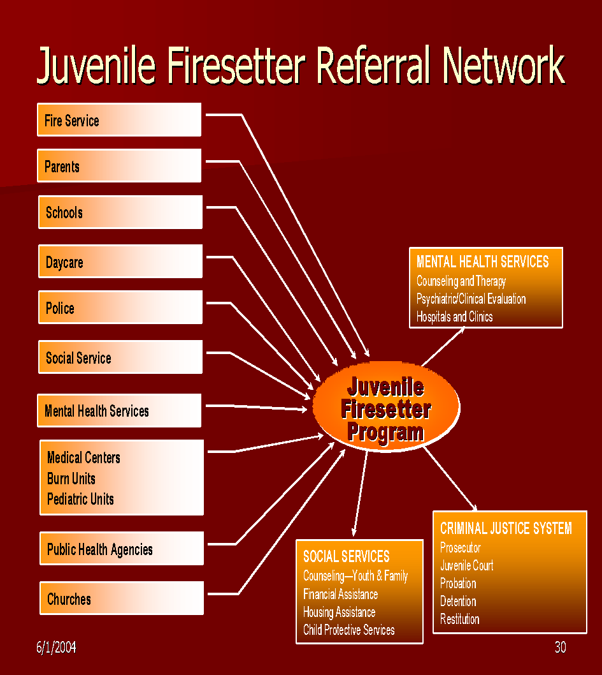
SCREENING AND SAFETY CONSIDERATIONS

Screening: The main component of the intervention process is screening. The purpose of a screening interview is primarily to gain information for the multi-disciplinary team (MDT) to use in making their determination regarding the type(s) of intervention needed for a favorable outcome in each case. The interview should be conducted in the home of the referred family so that the interviewer(s) have an opportunity to experience the usual environment (living conditions) of the family. It will also help the individuals being interviewed feel more comfortable and thereby potentially provide more information.

The use of the structured screening tool often produces an understanding as to why the youth engages in the use of fire (firesetting behavior) and may provide an indication of the likelihood or risk of continued firesetting behavior. Additionally, this too is helpful in determining the course of action for intervention. The structured screening interview should be the only method of fact finding employed by any program for gaining information that will lead to appropriate intervention strategies established and initiated by the MDT.

Safety: At the time of the screening interview a home fire safety inspection should be conducted to assure a safe environment. The inspection should ensure the installation and proper operation of smoke detectors in each room of the home (except bath and kitchen), clear exit ways, and the reduction and elimination of obvious fire hazards. It can address replacing incandescent light bulbs with fluorescent tube-bulbs, removal of combustible clutter, and such fire prevention aspects as securing matches and lighters.

MULTI-DISCIPLINARY TEAM (MDT) REVIEW

The multi-disciplinary team is comprised of professionals who are involved with those agencies and departments that are concerned with and/or may provide services to youths. It is the MDT’s responsibility to periodically meet to review and evaluate each case Screening Interview Report and matters related to the case; and to identify the level of concern for each case and the best type of intervention(s) necessary to address the behavior. Multi-disciplinary team composition should consist of representatives of the fire services, law enforcement, youth court system, mental health services, school systems, and a county or local children and youth social service agency.

INTERVENTIONS

Interventions are decided upon by the multi-disciplinary team and delivered by those departments and agencies designated for that function. Interventions consist of any method and/or means of breaking the cycle that causes and/or results in firesetting behavior. Most common interventions are:

- Fire Safety/Science/Prevention Education
- Mental Health Services
  - Individual and/or family counseling
  - Behavior modification
  - Prescription drug adjustment and/or implementation
  - Residential treatment
- Social Services
  - Parenting classes
  - Medical
  - Abuse intervention
  - Foster care

EXIT AND FOLLOW-UP

Exit from a firesetter intervention program follows the completion and/or adequate implementation of intervention(s) as directed by the MDT. Anyone who exits the program prior to the completion and/or adequate implementation of any intervention(s) fails the program. However, the most typical exit for youths is after education and/or referral to an appropriate intervention.

Once a person exits a program it is important that follow-up procedures take place. Follow-up is established so the youth and families understand that the firesetter intervention program will continue to be concerned about their welfare. Follow-ups generally occur:

- Four to six weeks after exit
- A secondary follow-up between six and twelve months after exit.

Follow-ups can be conducted in several different ways including telephone calls (most cost-effective and least time-consuming), written contacts, and visits. The content of the follow-up needs also to be considered and may include a standard set of questions. (Note: For children less than 6 years old, a one or two-year follow-up may be appropriate. These children will be entering the primary age of firesetting behaviors.)

ADDITIONAL COMPONENTS

There are two additional components that may be used when working with youths. They include:

- Community Service
- Restitution

Both components are commonly derived from and should remain in the direction of the court system. Community service, typically employed for older youths, can be used as a consequence of firesetting and might include such activities as food and clothing drives, senior citizen assistance work, and community clean-up. Community service at a fire station should be avoided, as the excitement of the fire service may have been a contributing factor in the original development of the firesetting behavior. However, the MDT may permit community service at a fire station only after careful consideration of and approval. It should then be limited strictly to fire prevention activities outside of the station and under the direct guidance of a fire officer or appointed senior firefighter.

Restitution programs require youths and parents to be responsible for dollar damage caused by firesetting and in some cases, the cost to suppress fires. Restitution may be mandated by the court system; a youth firesetter intervention program may arrange for some agreement with the local court to hold youths and parents responsible and to assess restitution.

SUMMARY

The continuum of care for youth firesetting strategy dictates six components. They include identification, Referral/Intake/Release of Information, Screening and Safety Considerations, Multi-Disciplinary Team (MDT) Review, Interventions, and Exit and Follow-up. Other program components could involve community service and restitution as ordered by the courts. Intervention strategies result from the review by the multi-disciplinary team. Fire safety/science/prevention education benefits everyone who enters the program with the exception of those rare cases where the child lacks the ability for true remorse and only seeks to harm others. In such cases, education may only serve to enhance the child’s endeavors to do harm. Follow-up will let youths and their families know there is a continued concern for their welfare and that of the public.

SECTION FIVE

THE OPTIMAL COMMUNITY, REGIONAL, OR COUNTY NETWORK

OPTIMAL CONTINUUM OF CARE

The Optimal Continuum of Care for any community, regional, or county network represents a way to organize programs designed to prevent and control child and youthful firesetting-related activities. The three major elements for a continuum of care include prevention, early identification, and immediate treatment through an approved Youth Firesetter Intervention Program. Each of the three represents a distinct level of community/regional intervention.

- Prevention is designed to inhibit the firesetting activity and can be implemented by special education programs through the local school systems.
- Early identification can be achieved through the education of parents and youth related agencies that may encounter children with firesetting behavior. Providing parents and agencies with the level of awareness necessary to identify this unwanted behavior in children and youth will greatly enhance the prevention of youth set fires. One should understand that the earlier a problem is identified, the better the chance for resolution.
- Immediate treatment can be achieved through an approved Youth Firesetter Intervention Program that would provide rapid access to appropriate care and therapy.

PREVENTION

Youth firesetting does not have to occur. Prevention efforts using education, support, and protection focus on a broad base of the community, regional, or county programs that are available to serve all children and their parents.

Specialized fire education can include such programs as the Prevent Arson Loss in Schools (P.A.L.S.) program, the National Fire Protection Association’s (NFPA) Risk Watch Child Injury Prevention Curriculum, the NFPA Learn Not to Burn program, and other national, state, and local programs that are designed to increase fire safety awareness, which in turn will deter firesetting activity.

The fire service has a long history of providing communities with fire safety education. Other organizations such as the American Red Cross, many burn centers, the YMCA, community centers, Big Brothers and Sisters, church groups, recreational athletic programs, and other supervised school programs support programs that help improve the quality of life for children, offer safety education, and can help prevent youth involvement in firesetting behavior.

EARLY IDENTIFICATION

Early identification focuses on recognizing at-risk youth and preventing their further involvement in firesetting. A community, regional or county youth firesetter intervention program is the major access point for early intervention to a network of community/regional services. The community, regional, or county program refers youth into the system and provides screening, evaluation by a multi-disciplinary team and intervention. Each community, regional, or county program will develop its own specific links to referral services and associated agencies and maintain an effective working relationship with them. It is critically necessary to educate the referral agencies about the services of a youth firesetter program. Referral agencies need to understand the types of problems they can expect to encounter. Key people in the referral agencies must be identified, especially those who will be working directly with the firesetter program. Those who will approve the working agreements between the agency and the program must also be identified.

IMMEDIATE TREATMENT

Swift and effective help is imperative for youths having active firesetting behavior. Referral to one or both of the two major types of immediate treatment format – mental health and social services – depends on the directives of the MDT. This is an example of where the firesetter program must have a strong link with these immediate treatment formats.

GRADUATED SANCTIONS

Graduated sanctions components – rehabilitation and corrections – are commonly the product of the youth justice system and consist of sub-levels or graduations that provide an integrated approach to interrupt the progression of delinquent and criminal activity. Rehabilitation encompasses immediate therapy and intermediate sanctions whereas corrections include community confinement, training schools, and aftercare. For rehabilitation efforts to be effective, they must be swift, certain, consistent, and incorporate increasing sanctions, including loss of freedom.

First-time offenders are likely to be placed in diversion including accountability, making amends to the victim and the community, and exiting the youth justice system as a more productive and responsible citizens. If a youth continues firesetting, he/she will be subjected to more severe sanctions and could ultimately be confined in a secure setting. Firesetters who are not first-time offenders or who fail to respond to rehabilitation are likely to be subject to intermediate sanctions including intensive supervision programs, short-term confinement, day treatment, outreach, twenty-four hour residential and/or secured specialized youth firesetting programs, and discharge and follow-up.

SUMMARY POINTS

An organized network of community, regional, or county services is the key to effective prevention and mitigation of youth firesetting. Within any program, fire safety education is essential for everyone and is important in improving the quality of family life and protecting the community. Immediate treatment for those involved in youth firesetting and their families include mental health and social services. However, youths repeatedly arrested for firesetting and arson will face increasingly severe methods of sanctions, including the loss of freedom, to be imposed by the youth justice system.
SECTION SIX

PROGRAM OPERATIONS AND MANAGEMENT

PROGRAM PLANNING

Once a consensus has been reached to address a youth firesetting problem on a community, regional or county basis, an organized approach (plan) should be developed to resolve the problems. The plan may address bolstering existing programs or adding new features to current activities. In some cases, a program may be required to be built ‘from the ground up.’ In any case, the following chart summarizes three elements that would comprise program planning.

Program Planning
Activity | Description
Leadership | The selection of someone responsible for running the program.
Location | The identification of the primary location to house the program.
Site | The determination of the program’s geographic boundaries and jurisdiction of service delivery.

Typically the program leader will be associated with the fire service although law enforcement, youth justice, social services, and mental health professionals can also assume the leadership role. Within the Maine community, regional or county concept, it would be beneficial for the program leader (coordinator) to complete or attain certification (if available) as a Youth Firesetter Specialist Level II. Additionally, state-run training programs may be available along with direct coalition assistance in training persons needed for the implementation and operation of any youth firesetter intervention program within the state.

The location for a program is generally the local fire service, which may be the best choice to help in identifying children and youthful firesetters. If a local or regional fire service does not have the resources to house a program, there are other options including county-owned and operated facilities, state-owned and operated facilities, private agencies, non-profit organizations (such as the YMCA), mental health, and counseling agencies.

Many child/youth firesetter intervention programs operate within a fire service area of jurisdiction or basically within community boundaries. However, the Maine approach involves a regional or county concept that would operate over a larger geographical area, or involve several counties and is based on a population basis. This coordinated and widespread approach would encourage more referral agencies such as mental health, social services, and youth justice to be involved thus providing more opportunities for larger numbers of individuals to receive the needed program interventions.

PROGRAM DEVELOPMENT

Once a program is in place, it is ready to begin work within its area of jurisdiction or geographical area. Program development involves six steps that are outlined below.

The first step in program development is to establish a multi-disciplinary team that includes representatives from key youth-related agencies, departments, and schools, headed by a program coordinator. The program coordinator should have certification as a Youth Firesetter Specialist Level II or receive or maintain the equivalent thereof.

The MDT with the coordinator needs to identify and establish links with the type of services necessary for the intervention of youths referred to the program. Services need to include fire safety/science/prevention education, social service agencies, mental health services, and any other community-based service that may be applicable to the needs of the youths and families referred to the program.

Budgeting will also vary within a community, regional or county programs with some common categories. The major category is personnel costs and budgeting will reflect the level of service provided.

PROGRAM DEVELOPMENT

Program Development
Activity | Description
Management Team | The selection of a team to support the work of the program leader. Team members should be certified at Youth Firesetter Specialist Level II or the equivalent thereof.
Service Delivery System | Specify the program components – identification, referral, screening, MDT evaluation, education and related interventions, and follow-up that will be offered by the program.
Budget | Estimate the costs of the program’s services.
Funding | Establish a funding team to develop sources of financial support, donations, grants, and contributions to the program.
Organizational Chart | Specify in writing, the various organizational relationships within the MDT and with program intervention agencies.
Interagency Linkages | Establish and maintain an effective, multi-agency community, regional, or county network of services for the program.

PROGRAM IMPLEMENTATION

After all the planning and development for youth, the firesetter program has been completed, it is time to put the program into action. However, certain implementation steps will need to be accomplished before the first intake is undertaken. Those steps, extracted from the United States Fire Administration’s Youth Firesetter Intervention Handbook publication are summarized as follows:

Program Implementation
Activity | Description
Training | The development of a training program for all new management and staff.
Documentation | Setting up a written or automated record-keeping system for all cases entering the program.
Confidentiality | Program policies must be established regarding the privacy of written and verbal communications, access to and sharing of records, and media involvement.
Liability | The program must be protected from potential legal action because of the behavior of firesetters and their families.

The size of the staff will depend on the size of the program and the selection process will vary by community/region based on available resources.

Regardless of their background, all staff should receive standardized training. A number of training venues and opportunities are available throughout the country and within the state. At a minimum, it is advisable that program staff should have completed the National Fire Academy “Extinguishing Youth Firesetters” classes or comparable training. Training of all staff can ensure a coordinated, standardized program for all program providers and may include such topics as the following:

  - National, state, and local statistics on child firesetting and youth arson.
  - Personality profiles of child firesetters/youth arsonists and their families.
  - How to interview individuals.
  - How to screen and interview individuals and their families using the Child and Parent Screening Tools.
  - How to properly read and interpret screening reports and interviews.
  - Special case studies.
  - Educational programs for individuals and their families.
  - How to build an effective network of community/regional services.
  - Problem-solving.

All programs must develop policies and procedures to document their work with youth firesetters. Each youth and their family should have a case record and assigned identification number that can move through the program. Such components as screening documents and their related reports, education intervention summaries, fire incident reports, and referrals should be documented.

Documentation along with individual and family identification must be kept confidential. Case records can be written or automated. Written records must be kept in locked files and automated files must be password protected. Access to such records must be strictly limited to only authorized individuals. Where legal issues apply to these situations, access to records must be in compliance with applicable local and state legal rules, regulations, laws, and other statutes.

The liability factor of legal action against the program and its associates must be considered because of the behavior of firesetters and their families. Programs must be protected from being held liable for the actions of youths. This protection may involve the use of liability waivers that release programs from responsibility and should be developed in consultation with the local district attorney. Additionally, liability insurance for a program should be strongly considered for its protection and that of its associates.

PROGRAM MAINTENANCE

Program maintenance is the final component of Program Operations and Management and involves certain activities that will help sustain and strengthen the program. These activities that affect the day-to-day operation of the program as well as providing continued service to the community/region are outlined in the following tables.

COMMUNITY, REGIONAL, OR COUNTY MAINTENANCE
Activity | Description
Information Acquisition | Collect, organize, and evaluate fire incidence data to determine the scope of the community youth firesetting problem.
Consensus Building | Harnessing the support of key community decision-makers to reach an agreement regarding the need and support of a firesetter intervention program to address the youth firesetting concern.

PROGRAM MAINTENANCE
Activity | Description
Operations Handbook | This handbook establishes the specifics regarding the program and how it regularly operates.
Resource Directory | This directory lists the names, street addresses, phone numbers, and e-mail addresses of all agencies that work with youth firesetters and their families in the geographic area serviced by the youth firesetter intervention program.
Record keeping | Record keeping of a firesetter intervention program allows management to monitor the level and volume of the caseload as well as the quality of interventions
Public Awareness | A publicity and outreach effort educates the public as well as specific target populations about the problem of youth firesetting and informs them about the availability of the program.
Continuing Education | Continuing education opportunities for management and staff will ensure that the program operates with the most current knowledge and information and maintains a high standard for performance.

Community, regional or county programs need to establish their own handbook of operations and procedures. The content of the handbook will vary between programs, but the average should include means and procedures for identification, referral, screening, MDT evaluation, intervention(s), and follow-up. All program managers and staff should receive their own copy of the handbook. Handbooks may also serve as a primary training tool.

Resource directories should include contact data of local, regional, state, and national resource agencies, which can be useful for both daily operations as well as when referring youth and their families to services outside the program.

Monitoring and Evaluation will involve having current and accurate program data. There are several ways to collect and analyze information using two types of information systems – a Management Information System (MIS) and an Evaluation System (ES). The MIS summarizes the program’s caseload, tracks, and reporting of the number and type of program activities, and provides data for the annual reports, funding agencies, and evaluations. Those MIS categories can consist of a myriad of aspects concerning the children and youth referred to the program. Some are listed in the following table.

Management Information System (MIS) Data Collection
Data Category | Information
Case Characteristics | - Referral Source  - Age, Sex, Race  - Family Status  - Details of Current Fire Incident  - Details of All Past fire Incidents
Services | - Educational Services  - Referrals  - Mental Health Services  - Social Services  - Youth Justice  - Other Referrals
Case Disposition | - Outcomes of Services  - Youth Justice Status
Program Activities | - Education and Prevention  - Training  - Resource Material Development  - Media

Evaluation System data is an extension of the MIS data and contains information on follow-ups, recidivism, and other events such as school or family problems, arrests, comparisons and trends, dollar losses, etc. The table below lists data collected in an ES.

Evaluation System (ES) Data Collection
Data Category | Information
Firesetting Recidivism | Recurrence of Firesetting
Delinquency | - Arrests  - Probation  - Conviction  - Incarceration
School | - Academic Problems  - Disciplinary Problems  - Truancy  - Expulsion
Mental Health | Contacts
Social Services | Contacts
Family Environment | Discipline
Personal | Functioning
Costs | Average Dollar Loss Per Youth Firesetter

SUMMARY POINTS

This division addresses Program Operations and Management. It includes careful and detailed planning in selecting a site for the firesetter intervention program, naming a program leader, and specifying the geographic areas to be serviced by the program. Following this, the program builds on its plans and sets into motion all the necessary program operations. It begins with establishing an MDT staff and their training, along with establishing documentation procedures and addressing issues related to confidentiality and liability. The success and longevity of the program depend on the commitment of the program personnel, coupled with short and long-range planning, creating a monitoring and evaluation system for the program itself, mounting a public awareness campaign, and providing continuing related educational opportunities.

SECTION SEVEN

PROGRAM EDUCATIONAL COMPONENT

DESIGNING A PROGRAM EDUCATIONAL COMPONENT

Education is a key component in the treatment and prevention aspect of firesetting intervention programs and provides a path for change. In order for the community, regional or county programs to be effective they must utilize a professional and proven fire safety/science/prevention education curriculum that specifically addresses the concerns of fire as it relates to those youths referred to the program; as well as the aspects of accountability and responsibility as it relates to these youths in particular.

There are numerous educational resources available, some of which are listed in Appendix Two of this Protocol. They are specially designed to address this behavior in youths and carefully laid out so that any level of professional can employ them.

WHO PARTICIPATES IN THE EDUCATION?

Fire safety/science/prevention education is a mechanism for empowering the child with knowledge and self-esteem. Education is simply one of many other interventions in this process of breaking the dangerous cycle of children connected with fire. Yet the success of these interventions rests fully on the parent(s) and their ability to implement these interventions in the home and life of the child. The responsibility is not that of the educators, intervention specialists, or program leaders, but of the parent(s) alone. Parents are the only ones who can effectively make these changes in the child’s life by their constant personal contact, discipline, attention, and love.

The parent(s)/guardian/caregiver is a key component to the solution and is required to attend and participate with the child in all phases of the educational program. In understanding the dynamics of family responsibilities, it’s acknowledged that in some cases only one parent can attend. Often children who engage in firesetting behavior lack any personal involvement from either parent, fathers in particular. Hence, the parent(s) involvement and support of the child are crucial to the child’s change and development. In this action, the parent(s) presence should demonstrate to the child a mutual concern and effort to stop and prevent firesetting behavior. In addition, parents often learn as much as their children and can be a focal point within the family to enforce safety awareness. Siblings should not attend the education with the subject child as this may cause rivalry between siblings that may have been one of the underlying causes originally leading to the firesetting behavior.

The first respondent to a family crisis has a unique opportunity in many cases to make an unusually strong connection and to make a special impression. Fire service personnel may therefore be the best choice for educators or educational program providers. However, other educated individuals from various disciplines associated with youth firesetting may also effectively serve as educators. In any case, educators must be trained in the dynamics of the program, which includes understanding child firesetting behaviors, child development, and elements of fire safety/science/prevention education and be able to deliver a level of excellence that will spell success for the educational process.

EDUCATIONAL INTERVENTION NOT APPROPRIATE

The United States Fire Administration suggests that there will be times when educational intervention should be delayed or only presented to parents/caregivers. Those times may include when:
- The child and/or his family need to be referred immediately to a mental health professional for further assessment.
- The child’s ability to concentrate or comprehend is impaired to the degree that the usefulness of the material presented will be minimal or misunderstood in a way that will be counterproductive.
- The child’s fascination or excitement with fire will only be further enhanced by fire education material. Referral to a mental health professional and fire safety education for parents is indicated,
- The very young child is better served with education and/or counseling for the parents.
- The situation involves a chronic youth offender. Hence, the screening report and education intervention should be discussed with the child’s probation officer, youth diversion, District Attorney, etc., in connection with the MDT to void reinforcing the behavior you are attempting to eliminate.

WHEN EDUCATION INTERVENTION IS APPROPRIATE

With the exception of the previously mentioned situations, educational intervention is almost always appropriate at some level. Education intervention equips the child with an understanding of the nature of fire and helps resolve issues of power and control in an external, concrete process that creates a positive feeling. The educational intervention creates a balance and establishes a safe context within which to examine unsafe fire behaviors and to learn safety through creative learning.

The primary concern is that the information delivered is age-appropriate both in content and context for each child and family. The following are considerations for each age group extracted in part from the United States Fire Administration’s (USFA) Youth Firesetter Intervention Handbook.

The Very Young Child (Ages 2 and 3)

There is a growing concern about the number of very young children who are injured or killed as a result of fireplay and firesetting. This is a particularly troublesome age group due to the child’s limited ability to:

…understand the consequences of his behavior,
…problem solve, and
…appropriately respond once materials have ignited.

Firesetting and fireplay in this age group is usually a direct result of inadequate supervision or of the caregiver’s failure to provide a safe environment. Education intervention for this age group is primarily focused on educating parents about the basics of fire safety, such as:

…fire tools and combustible materials should not be accessible to young children,
…child needs constant adult supervision, and
…children are sensitive to environmental stress.

Children (Ages 3 - 5)

Primarily, children engaging in fireplay in this young age group may be doing so out of experimentation, curiosity, and a drive to learn and imitate adult behavior. Children learn best from material that is presented to them from curricula that involve auditory and visual learning modalities in increments of twenty minutes or less. Parents should be educated on the proper storage and use of ignition sources. In cases where there is a concern that the child’s environment in the home is not safe, a referral to protective services is in order.

Children (Ages 6 - 9)

This age group of children is capable of participating in the fire safety/science/prevention educational curriculum and should be entered in the basic phase of education from that curriculum.

Children (Ages 10 -12)
This age group of children is recommended for fire safety/science/prevention educational curriculum and should be entered in the intermediate phase of education from that curriculum.

Adolescents (Ages 12 - 18)

This age group of children is recommended for fire safety/science/prevention educational curriculum and should be entered in the advanced phase of education from that curriculum.

Note: Any educational resource may be utilized provided it is comparable with the minimum educational curriculum recommended by this Protocol.
SECTION EIGHT

COMMUNITY, REGIONAL, OR COUNTY
PROGRAM COMPONENTS

Community, regional, or county program sites should include the following components:

  - STAFF
  - REFERRAL SYSTEM
  - SCREENING INTERVIEW TOOL
  - MULTI-DISCIPLINARY TEAM (MDT)
  - DATA COLLECTION
  - TREATMENT INTERVENTIONS

STAFF

Coalition/team staffing should include the following elements: Coordinator, Investigator, Educator, Case Manager, and Secretary. At a minimum, it is recommended that Coordinators have attained a level of competency equivalent to FEMA/USFA Youth Firesetter Specialist Level II. Investigators and Educators should have attained a level of competency equivalent to FEMA/USFA Youth Firesetter Specialist Level I.

REFERRAL SYSTEM

When a child is suspected of firesetting behavior, as evidenced by some form of fire involvement, he or she should then be referred by the agency/individual identifying the suspect behavior to a child/youth firesetting intervention program. Referrals should be made by completing and submitting a form with detailed information regarding the incident and/or behavior, accompanied by a release of information form signed by the parent and/or caregiver of the youth.

SCREENING INTERVIEW

Trained professionals who possess minimum qualifications recommended by the Maine Youth Fire Safety and Intervention Protocol should conduct screening interviews. Those qualifications should be consistent with the standards of NFPA Youth Firesetter Specialist Levels I or II. Any screening tool may be implemented. However, the recommended screening tool suggested by the State Protocol can be found in the appendix of this protocol.

MULTI-DISCIPLINARY TEAM (MDT)

An MDT is commonly composed of varied youth-related disciplines within a program’s operating jurisdiction that will be involved in the intervention, mitigation, and prevention of child firesetting and youth arson. These disciplines include but are not limited to: government and private mental health services, public and private school officials, public and private children and youth social services, District Attorney’s Office, Youth Court representatives, fire service representatives, and law enforcement officials. MDTs should meet monthly to review, deliberate, and satisfy the needs and other aspects of intervention for children referred to programs, as well as to help in the development of the program.

DATA COLLECTION

It is imperative that data collection be an integral component of all firesetting intervention programs. The types, use, and maintenance of data collected are presented in the Maine Youth Fire Safety and Intervention Protocol.

TREATMENT INTERVENTIONS

Treatment interventions usually consist of two components:

- Fire Safety/Science/Prevention Education
- Mental Health Counseling

At times additional support intervention may be necessary to resolve the firesetting behavior. They include but are not limited to family housing, parental employment, alternative schooling, re-establishing parental visitation, food concerns, drug and alcohol issues, etc. Such interventions require the cooperation and assistance of multiple disciplines. (MDTs)

State of Maine
Youth Fire Safety & Intervention Protocol

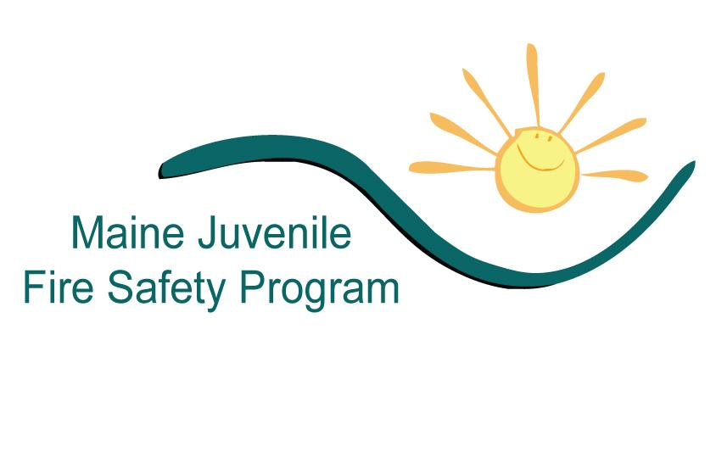

Supplement for the
Prevention and Mitigation
of Youth Fire Behaviors

PROGRAM MANAGEMENT FORMS

Documentation of program policy, practices, and procedures is an important component of all youth firesetting prevention and mitigation programs. The following forms have been developed to assist community, regional or county youth firesetting program practitioners to manage the various elements of their program.

The forms contained herein are templates and suggested formats. None of the provided forms are required by any state statute to manage a community, regional, or county program. The forms are provided as a courtesy and adoption of any or all forms is voluntary. Community, regional, or county program practitioners may adopt the forms as developed or may modify the forms and their content to suit their own program guidelines. Any modification of forms should be evaluated by proper authorities to ensure compliance with applicable legal and confidentiality requirements.

The following forms are provided:

- ADVISEMENT OF RIGHTS FORM
- FIRE INCIDENT REFERRAL AND CONTACT FORM
- CONTACT RECORD FORM
- PARTICIPATION RELEASE FORM
- RELEASE OF LIABILITY FORM
- RELEASE OF CONFIDENTIAL INFORMATION
- RISK ADVISEMENT FORM
- RESTITUTION AGREEMENT
- REFERRAL CLIENT FOLLOW-UP FORM
- DEMOGRAPHIC CLIENT FOLLOW-UP FORM
- EVALUATION POSTCARD
- YFIRES INTAKE FORM
MAINE YOUTH FIRE SAFETY AND INTERVENTION PROGRAM
ADVISEMENT OF RIGHTS FORM

Name of Person to be Advised ______________________Date Advised ____________

Place of Advisement _____________________________ Time Advised ____________

Incident Tracking Identification (if applicable) _________________________________

I am a(n) (Fire) Investigator. Before you are asked any questions by an Investigator about any potential crimes involving you, you must understand your rights.

- You don’t have to talk to us or answer our questions if you don’t want to.
- If you decide to talk with us, you must understand that anything you say can be used against you.
- You have the right to talk with a lawyer before you are questioned, and to have him/her present with you during any questioning.
- If you want a lawyer, but cannot afford to hire a lawyer, a lawyer will be appointed by a court to represent you before you are questioned, and be with you during any questioning, at no charge to you.
- If you decide to start answering questions, you will still have the right to stop answering questions, and the right to talk to a lawyer at any time.

My rights have been read to me and I have read this statement of my rights. I understand what my rights are.

_________________________________________ Signature of Person Advised

I have read this Advisement of Rights to the person who signed his/her name above, and I witnessed the making of the above signature.

_________________________________________ Signature of Advising Investigator

WAIVER OF RIGHTS

I understand my above rights, and I know what I am doing. I agree to answer questions. I do not want a lawyer currently.

____________________________________
Signature of Person Waiving Rights

Waiver Signature Witnessed by:

___________________________________________
MAINE YOUTH FIRE SAFETY AND INTERVENTION PROGRAM

Referral- Name:

Date of Referral: ___________ Name: _____________________Organization: ___________

Notes: ______________________________________________________________________________________________________________________________________________________

Interview / Intake Process

Date of Interview: __________Location: ____________Interviewers: _______________

Interview Completed • Rescheduled Date: __________Notes: ____________________

• Authorization to Interview / Release of Liability • Parent Checklist
• Authorization of Release (s) • Parent Interview
• Fire Safety Education Agreement • Child / Youth Interview
• Child / Youth Fire Safety Contract • Screening Repo
• Maine Juvenile Fire Safety Intervention Intake Form • Fire Report / Police Report

Disposition

• Comprehensive Fire Safety Education • Information Only
• Referred to Intervention Services (Non-Fire Safety) • Youth Not Seen by Program

Education

• Fire Behavior Module Date: __________ • Pre-Test ________
• Fire Prevention Module Date: __________ • Post-Test ________
• Burn Management Module Date: __________
• Decision Making Module Date: __________ • Objectives Form

Graduation

• Certificate of Completion • Exit Interview
• Vocational Introduction • Yes • No

Follow up

• 6-month Date: __________ Response • Yes • No
• 12-month Date: __________ Response • Yes • No

Notes:____________________________________________________________________________________________________________________________________________________________________________________________________________________________
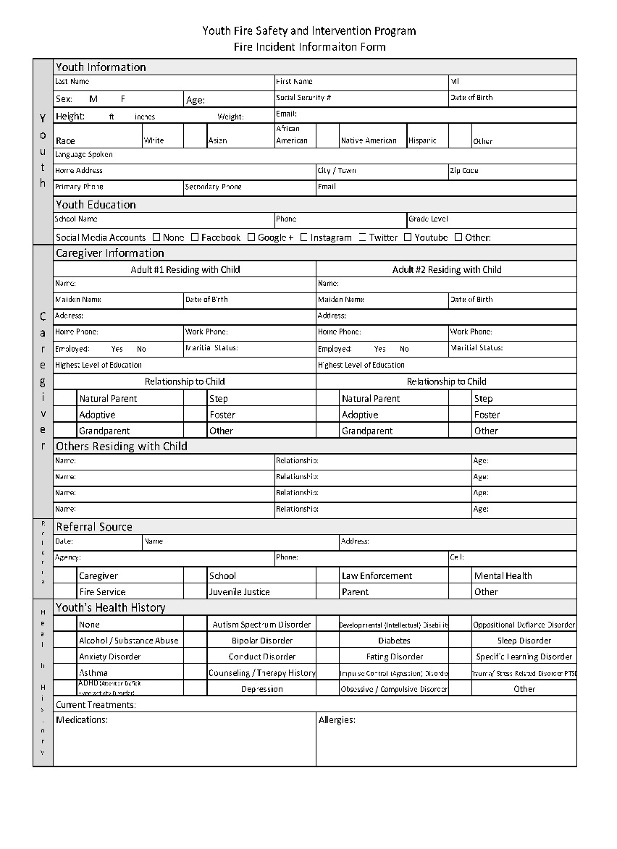
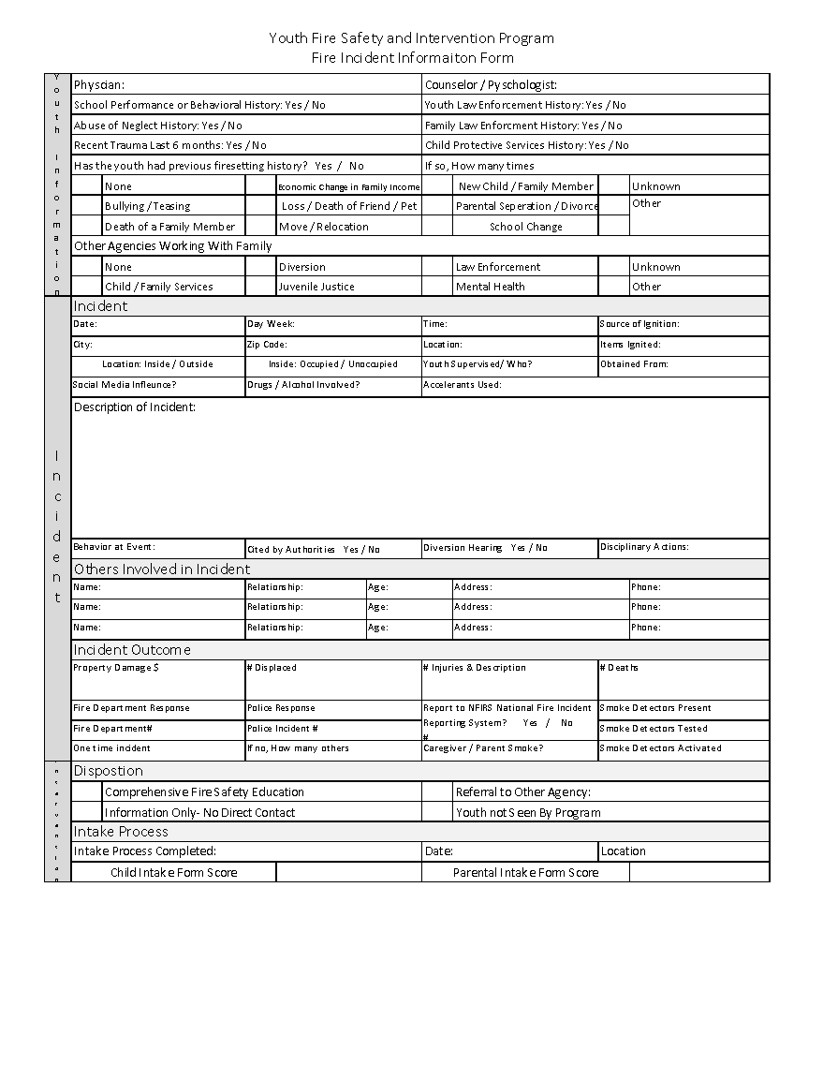

MAINE YOUTH FIRE SAFETY AND INTERVENTION PROGRAM

Date | Time | Medium | Person | Topic | Interventionist

MAINE YOUTH FIRE SAFETY AND INTERVENTION PROGRAM

Authorization to Interview and Release of Liability Form Notice of Mandated Reported Status
Youth’s Name__________________________________ Date of Birth ____________
Authorization to Interview
I, ____________________________ (parent / legal guardian) hereby authorize the MAINE YOUTH FIRE SAFETY AND INTERVENTION PROGRAM to interview the above-named youth for the purpose of program intervention, educational planning, and fire setting category determination. I understand that I have the right to be present at any interview, although I may waive this right and allow all or a portion of the interview to occur without my presence.
Release of Liability
I do hereby release, indemnify, and hold harmless the MAINE YOUTH FIRE SAFETY AND INTERVENTION PROGRAM and its employees, volunteers, officers, officials, affiliated fire departments and duly authorized agents, from all legal responsibility and liability and from any claims, actions, cause of action, related to:
- The receipt of information from or the release of information to the persons, entities, or agencies specified above.
- To the interviewing of the above-named youth as part of the program
- To any injuries from participation in this program.
Mandated Reporter Status
I understand that Maine statute law requires that certain people (those conducting this interview) must report to the Department of Health and Human Services (DHHS) if it is known or there is reasonable cause to suspect that a child has been or is likely to be abused or neglected. (Maine Child and Family Services Protection Act Title 22 Chapter 1071 § 4011-A)
Signature of Parent / Legal Guardian _____________________________________________
Printed Name__________________________________________ Date _________________
Signature of Witness ____________________________________ Date _________________
Printed Name of Witness ________________________________ Date _________________
MAINE YOUTH FIRE SAFETY AND INTERVENTION PROGRAM
Authorization for Release of Confidential Information
Youth’s Name__________________________________ Date of Birth _______________
I, ____________________________ (parent / legal guardian) do hereby request and authorize the MAINE YOUTH FIRE SAFETY AND INTERVENTION PROGRAM to have contact with the following persons, entities or agencies I have identified below to for the purpose of planning, education, intervention, referral and coordination of services.
Information can be: ____ Disclosed To ____ Obtained From
This information may be shared by:
___ Telephone ____ Fax ____ Email ___ In Person
Name of Organization/Individual ____________________________________________________ Address: _______________________________________________________________________ Phone_________________________________ Fax_____________________________________
For the purpose of:
__ Educational Plan/Records ___Probation Reports __ Police Reports
__ Diagnostic Evaluations ___Progress reports ___ Treatment plans
__ Fire Reports ___ Medical Reports __ Consultations
__ Medical Information __Other Specify__________________
I understand that:
- According to Code 42 of Federal Regulations, Part 2, Confidentiality of Alcohol and Drug Abuse Treatment patient records, further disclosure of the information may not be made without my written consent or as otherwise restricted by Federal Regulations
- Information released with this authorization will not be given, sold, transferred, or in any way be relayed to any other person or agency not specified above without written consent or otherwise required by law.
- I understand that I may revoke this consent at any future time by submitting a written request to the MAINE YOUTH FIRE SAFETY AND INTERVENTION PROGRAM
- I understand this release will expire one year from date signed
Youth’s Signature________________________________ Date________________
Guardian’s Signature_____________________________ Date_______________
If the youth listed above is a minor or is unable to sign and you are the parent, legal guardian or personal representative signing on behalf of this youth please complete the following:
Print Name: ____________________________ Relationship to Youth_________________________
Witness Signature: _______________________________ Date______________________________
MAINE YOUTH FIRE SAFETY AND INTERVENTION PROGRAM
RISK ADVISEMENT / FIRE SAFETY AGREEMENT FORM

Your child has been involved in a fire setting incident or shown a fascination with fire play. Firesetting is a serious matter and should be addressed as soon as possible. When a child sets a fire and receives no intervention, there is a better than 50% chance that he/she will set a second fire. If, in fact, the child does set a second fire, the chances are better than 80% that their firesetting will continue. Fire Safety School is specifically designed for children who have set fires, been involved with fire play, or have shown interest in fire play to decrease the potential risk of future fire setting and/or fire play. The fire safety school is made up of four modules that consist of fire behavior, fire prevention, burns, and decision-making. The modules are broken up into 2-3 learning sessions that consist of 1-2 hours of education each and are adjusted based on your child’s needs.
Program Responsibilities
- Staff will act in a professional manner and be familiar with youth fire safety interventions.
- Staff will be prompt and adhere to agreed time allocations.
- Staff will send one reminder 24 to 48 hours prior to the start of the learning session.
- Staff will attempt to contact participants three separate times over a 30-day period to initiate education. *If there is no response the case will be filed until services are requested.
- Staff will utilize the preferred communication selected by the parent to schedule education.
- Staff will evaluate the student following the completion of education and make further recommendations as required.
Parent Responsibilities
- Parent will determine the preferred means of communication ___Text ___Email ___ Phone
- Parents will notify staff 24 hours in advance if they are unable to attend the session.
- Parents will arrive on time to the session and actively participate as directed by staff.
- Parents will be respectful, responsible, and safe during all educational sessions.
- Parent will assist the student with assigned homework as required.
Student Responsibilities
- Student will be respectful, responsible, and safe during all educational sessions.
- Student will complete all homework assigned, with assistance from the parent as needed.

I, ________________________ parent / legal guardian of ________________________ agree
to cooperate with the youth fire safety program. I agree that my child and I will attend the Fire Safety School beginning on ____________ and continuing until ___________.

My signature below indicates that I have read the conditions and provisions of the Fire Safety
School agreement and agree with them in total.

________________________ ________________________ _________
Parent / Legal Guardian Printed Name Parent / Legal Guardian Signature Date

________________________ ________________________ _________
Child’s Printed Name Child’s Signature Date

________________________ ________________________ _________
Staff’s Printed Name Staff’s Signature Date

MAINE YOUTH FIRE SAFETY AND INTERVENTION PROGRAM

RESTITUTION AGREEMENT

I, ________________________________ agree to pay restitution to the victim(s) of my fire in the amount of $ ___________. I will pay $ ___________ per ________________________ until it is paid in full.

Restitution will be paid to:

Name: _________________________________________

Address: _____________________________________________________________________

Name: _________________________________________

Address: _____________________________________________________________________

Name: _________________________________________

Address: _____________________________________________________________________

___________________________________ __________________________
Parent/Guardian Date / time

__________________________________
Youth

__________________________________
Witness

MAINE YOUTH FIRE SAFETY AND INTERVENTION PROGRAM

REFERRAL CLIENT, 3-AND 6-MONTH FOLLOW-UP

Youth’s Name: ____________________________________ Case #_______________

Person Conducting 3-month Follow-up: ____________________________ Date: _________

Person Conducting 6-month follow-up: ____________________________ Date: _________

The child was referred to another agency. Did he/she go? _____ Yes _____ No

Please circle the appropriate number.

Is there continued use of fire? |  |  | Yes |  |  |  |  |  | No
[THREE MONTH FOLLOW-UP How would you rate the improvement (if any) in the child’s behavior since involvement with this program?
 |  | POOR |  |  |  | FAIR |  |  | EXCELLENT
Emotionally? |  | 1 |  | 2 | 3 |  |  | 4 |  | 5 | NA
Overall? |  | 1 |  | 2 | 3 |  |  | 4 |  | 5 | NA
How consistent has your family been in keeping matches/lighters out of the child’s environment? |  | 1 |  | 2 | 3 |  |  | 4 |  | 5 | NA
As a parent/guardian, how satisfied were you with:
- Fire safety education provided in counseling? |  | 1 |  | 2 | 3 |  |  | 4 |  | 5 | NA
- Counselor’s skills/rapport with the child and family? |  | 1 |  | 2 | 3 |  |  | 4 |  | 5 | NA
The overall counseling process? |  | 1 |  | 2 | 3 |  |  | 4 |  | 5 | NA
[6 MONTH FOLLOW-UP How would you rate the improvement (if any) in the child’s behavior since the last follow-up 3 months ago?
Emotionally? |  | 1 |  | 2 | 3 |  |  | 4 |  | 5 | NA
Continued use of fire? |  | 1 |  | 2 | 3 |  |  | 4 |  | 5 | NA
Overall? |  | 1 |  | 2 | 3 |  |  | 4 |  | 5 | NA
Does your family employ the fire safety education received in this program (i.e., test smoke alarms, escape plans, etc.) |  | 1 |  | 2 | 3 |  |  | 4 |  | 5 | NA

Any additional comments or suggestions regarding this program: _________________________________________________________________________________________________________________________________________________________________________________________________________________________________
MAINE YOUTH FIRE SAFETY AND INTERVENTION PROGRAM

DEMOGRAPHIC CLIENT, 3-MONTH FOLLOW-UP

Youth’s Name: ____________________________________ Case #_______________

Person Conducting 3-month Follow-up: ____________________________ Date: _________

Person Conducting 6-month follow-up: ____________________________ Date: _________

The child was referred to another agency. Did he/she go? _____ Yes _____ No

Please circle the appropriate number.

Is there continued use of fire? |  |  | Yes |  |  |  |  |  | No
How would you rate the improvement (if any) in the child’s behavior since involvement with this program?
 |  | POOR |  |  |  | FAIR |  |  | EXCELLENT
Emotionally? |  | 1 |  | 2 | 3 |  |  | 4 |  | 5 | NA
Overall? |  | 1 |  | 2 | 3 |  |  | 4 |  | 5 | NA
How consistent has your family been in keeping matches/lighters out of the child’s environment? |  | 1 |  | 2 | 3 |  |  | 4 |  | 5 | NA
As a parent/guardian, how satisfied were you with:
- Fire safety education provided in counseling? |  | 1 |  | 2 | 3 |  |  | 4 |  | 5 | NA
- Counselor’s skills/rapport with the child and family? |  | 1 |  | 2 | 3 |  |  | 4 |  | 5 | NA
The overall counseling process? |  | 1 |  | 2 | 3 |  |  | 4 |  | 5 | NA

How would you describe (rate) the benefit of the fire safety education for your child?
____________________________________________________________________________________________________________________________________________________________

Any additional comments or suggestions regarding this program: _________________________________________________________________________________________________________________________________________________________________________________________________________________________________
MAINE YOUTH FIRE SAFETY AND INTERVENTION PROGRAM

EVALUATION POSTCARD

(Enlarged sample)

________________________ YOUTH SAFETY AND INTERVENTION PROGRAM

Please check appropriate response and return to program coordinator.

MAINE YOUTH FIRE SAFETY AND INTERVENTION PROGRAM
DEVELOPMENT OF RAPPORT ACTIVITY
FOR SCREENING TOOL USE

Date Survey Conducted: _____________________ Tracking ID: __________________

While you are using the screening tools with the parents, have the child draw a picture of the fire or fireplay incident and/or write a paragraph describing why they are in your office today.

DEVELOPMENT OF RAPPORT
The purpose of this section is to make the child comfortable with you. The more at ease you can make him/her, the greater the likelihood that he/she will answer all your questions. If the following questions aren’t enough, add your own.

1. [Introduce yourself] I’m _______________. What’s your name? ______________.

- How old are you? _____________________

- What school do you go to? _____________________ What grade are you in? ______

- Do you like school? ________ Are there nice/okay teachers at your school? _______

- What classes/subjects do you like/not like? ___________________________________

- What do you do for fun? ____________________ Do you have hobbies? ________

- What are your hobbies? _________________________________________________

- Who is your best friend? _______________________________

- What do you like to do/play with your friend? _______________________________

- What do you watch on TV and/or what videos do you watch? ___________________

- What is your favorite person/show on TV? __________________________________

- What is your favorite video/computer game? ________________________________

- What do you like about that game? [Is there extreme interest in violence or fire?]

When rapport has been established, determine the level of understanding if the child is under 7 years old or appears to have problems communicating.
