MEFIRS Task Guidance

Table of Contents
General Hints for MEFIRS Fire Reporting 1
How to put in a ticket to ImageTrend 1
Problems accessing the Help/University 1
Suggestions to make logging into MEFIRS easier 1
Validation scores for fire reports 2
Creating a NERIS fire report 2
Finding the correct code for a field 2
Documenting an outside vehicle fire 3
When a unit is unable to respond 3
Detailing your department’s mutual aid response 3
Adding insurance information to a NERIS Fire report 4
Add an exposure to a NERIS Fire report 4
Deleting a fire report in MEFIRS 4
Adding attachments (pictures, etc.) to a fire report 5
Printing a completed fire report to a printer OR create a PDF of the report 5
Making the FMO NERIS fire incident list the default for your fire report list 5
How to view NFIRS and NERIS reports in your Incident Lists 6
Making suggestions to ImageTrend to improve the system 6
Hints for Fire or Fire/EMS Agency Administrators 7
How to add or remove a person to your department’s User list 7
Unlocking someone’s MEFIRS account so they can log in 9
Types of permission groups 9
Managing a person’s expired password 9
Activating people so they can use Inspection forms 10
Adjusting the User list to see certain groups of people 10
Adjusting vehicles so they will work in the NERIS fire run form correctly 10
How to set up your supporting agencies for Mutual Aid, Transfer/Transport, etc. 11
Adding a pay rate 11
Changing a pay rate 11
Doing bulk updates to incident status in Incident List view 12
How to adjust the Auto Numbering field in a NERIS fire report 12
Monitoring NERIS fire reports exporting to NERIS database 13
Sending an entity export to NERIS database 13
Using the Unit Power Tool in the NERIS fire report 14

General Hints for MEFIRS Fire Reporting

How to put in a ticket to ImageTrend
- Email: support@imagetrend.com
  - The ticket is automatically created and submitted to support.
  - If you include "Site Down" in the subject or body of the email and include your site URL , a priority site down ticket is automatically created.

** We recommend using this option for best results

- Phone: 1-888-730-3255
  - A support representative creates a ticket for you and one for each contact for tracking purposes.
  - If a support representative is unavailable, you are asked to leave a voicemail or remain in the call queue.
NOTE: This option is only available during business hours. ImageTrend is an hour behind us.

Problems accessing the Help/University
If people can’t get to the Help/University part of the system, they have to disengage their popup-blocker in the browser they are using.

Suggestions to make logging into MEFIRS easier
ImageTrend recommends that people use ONE browser on each computer to access MEFIRS< so there won’t be conflict between the different browser’s caches (a “cache” is a place on your computer where a browser temporarily stores files downloaded to display websites). ImageTrend recommends using just Google Chrome to access MEFIRS. Our site works best with Chrome and, if everyone uses Chrome to access MEFIRS on a computer, there won’t be conflicts between browser caches.

Sometimes glitches happen when trying to access a webpage, which can store weird files in your internet browsing history. You can clear browsing history to remove the stored files that get you to favorite sites quickly, which will also remove the weird files. To clear the cache in Chrome, open the browser and click on the 3 vertical dots on the upper right side of the browser’s screen. Choose “Clear Browsing Data”, make sure “Cached Images and Files” is checked, and choose the “Clear Data” button to clear the cache.

If you use Windows on your computer, you can go to your Control Panel and choose “Network and Internet”. Click “Browsing History and Cookies”; then under “Browsing History”, click “Delete”. You can choose what items you want to delete (make sure “Temporary Internet Files” are included), then click “Delete”. Once the Delete process is completed, try to access MEFIRS again.

Validation scores for fire reports
All NERIS reports will export to the national NERIS database once the report score is 100 and the report has a Status of either “Complete/Reviewed” or “Billed”. If you open a report and add data to it, the report will automatically export to NERIS and update the data in it.

To check for errors if your score is less than 100, you can click on the validation score at the bottom of the report when it is open. A list of errors will pop up, and you can click on the arrow next to each error so you can be taken to the section of the report that has the error. Fields that have errors will have red tabs or borders.

Note for departments that create an NFIRS report from an EMS report: once you create your NERIS report on the EMS side of MEFIRS, you are not done yet. You must go into the NERIS report and finish filling out the red-flagged fields that NERIS needs to be finished.

Creating a NERIS fire report
- Once you have logged into MEFIRS and said “Yes” to the privacy warning, choose the “Incidents” tab drop-down menu and, under the “Create new NERIS Fire” section, choose the Maine NERIS form.
- Fill out all RED required fields, and any other fields to which you want to add data. Note: Incident Numbers can include only the following special characters: an underscore (_), a dash (-) or a colon (:). All other special characters in an Incident Number (including periods, forward/back slashes, asterisks, parenthesis or commas) will result in the report being rejected by NERIS.
- A report will be valid for the national NERIS database when it has a score of 100 and the Status is either “Complete/Reviewed” or “Billed”.
- Fields that should have information entered into them are flagged with a yellow color.
- To find validation errors that may be keeping your score below 100, click on the validation score at the bottom of the report. A list of Warnings and red required Rule error will pop up. The red Rule errors need to be fixed. Choose the arrow next to each Rule error to go to the section of the report that needs to be fixed.

Finding the correct code for a field
- Type part of the code description in the field, and the system will pull up a short list of codes that have that term in the title of the code. Example: type in “motor” in the Primary Incident Type field to find “Medical-Injury/Trauma-Motor Vehicle Collision”.
- If you want to see a category list, click on the button containing horizontal lines next to the field. A list of categories will pop up on the left side of the screen. Search through the panels by using the arrows, until you find the code you want, and choose it. The code will show up in the field.

Documenting an outside vehicle fire
- For “Primary Incident Type”, choose the appropriate type of Transportation Fire: Vehicle Fire-Passenger, Vehicle Fire-Commercial, Vehicle Fire-Food Truck, or Vehicle Fire-RV.
- For “Action Type”, choose Action if you responded to the fire
- For “Actions Taken” field, choose code Suppression/Outside Fire Suppression/Fire Control Extinguishment
**The NERIS database has this definition for that code: The complete extinguishment and elimination of all identified threats from combustion occurring in an exterior environment utilizing water, retardant, and/or other methods. This action includes, but is not limited to, wildland or grass fires, dumpster/trash fires, and transportation-related fires outside of a structure.
- In the Fire section/Fire Details panel, choose “Outside” for the question “Where did fire primarily occur?”. Fill in the rest of the page. Note: if the vehicle fire started in a garage or other storage area, you would choose “Structure” and answer the questions in the Structure Fire panel.
- In the Fire section/Outside Fire panel, you can leave the “Fire Acres Burned” blank or put a zero in it if there was no extension from the vehicle to the surrounding area. Complete the “Outside Fire Cause” field.

When a unit is unable to respond
- For Primary Incident Type, choose a code with “cancelled” in it, using a pre-set value button.
- In the Unit Response section, enter the unit that needed to respond (Unit Call Sign and Apparatus ID)
- For the question “Was the Unit Unable to Be Dispatched?”, choose YES
- For the question “Unit Actions Not Taken”, choose Cancelled

Detailing your department’s mutual aid response
- Enter the correct Incident Type
- If your mutual aid is in support of another department, under the Incident Aid Given/Received section, choose “Given”.
- Click within the gray box that appears, then choose either “Mutual Aid in support of primary entity” or “Automatic aid in support of primary entity”.
- Type in part of the name of department you are assisting, and choose the name when it appears, then click the “OK” button
- If the Incident Type was a fire, in the Fire Details section: enter where the water supply came from and if you used AFFF foam
- Using the hint listed below the AFFF question, enter the last 3 questions with the following information (see picture below):
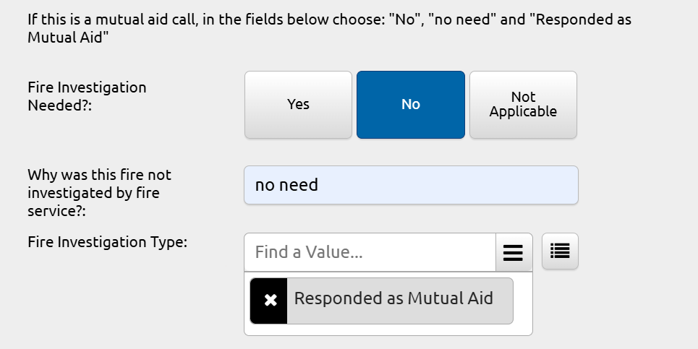
- If your mutual aid response was in lieu of a primary entity, or you were acting as another entity, choose the correct response in the Incident Aid Given/Received field.

Adding insurance information to a NERIS Fire report
The following fields are available in the Incident/Incident Details section of the fire report under the “People Involved” grid:
- Owner Insurance Company Name
- Total Amount of Owner Insurance Policy
- Insurance Policy Number

Add an exposure to a NERIS Fire report
An Exposure is defined as a fire that results from an original fire in a building, structure or vehicle. Example: if a building fire sets a truck on fire, the truck fire is an exposure fire from the original building fire. Exposure reports are contained within a NERIS fire run report.

To create one, the Primary Incident Type or Additional Incident Types fields must contain a fire incident type. A blue “Fire Exposures” section will appear, with “Exposures Details” showing under it. Add information to the “Exposures Details” grid for the first exposure (make sure to enter the location’s postal code), and use the “+Add Another” button if you need to add exposures to the report. Once done, choose the “OK” button to close the exposure report and get back to the main report.

Your incident list will not show if there is an exposure report embedded within the main report.

Deleting a fire report in MEFIRS
- Open your department’s list of reports by going to “Incidents/View Existing NERIS Fire”. Note: if you are a department which does Fire and EMS reports, you will look in the “Incidents/View Existing EMS/NERIS” section.
- Find the report in the Fire Incident List that you want to delete.
- Click the Arrow button on the right side of the report’s row. The report will open in a new tab in Google Chrome.
- Click on the Menu button at the bottom of the screen (it has 4 horizontal lines). Choose “Delete”.
- The report will be deleted, and you will be returned to the Incident list.

Adding attachments (pictures, etc.) to a fire report
- From within a NERIS fire run report, click on the Menu button at the bottom (it has 4 horizontal lines). Choose “Attachments” and then choose “+ Add New”.
- Choose the “Browse” button to go to where the picture or document is located on your computer. Choose the file, choose “Open”, then choose the lowest “OK” button to add it to your report. When the screen disappears and the fire report appears, this means the attachment has been added to your fire report. You can check by clicking on the “Attachments” button under the Menu and you should see the file listed that you just uploaded to the report.

Printing a completed fire report to a printer OR create a PDF of the report
- In the Fire incident list, click the Printer icon on the right side of the report’s row.
- A “Create Print Report” box will appear, so you can choose the template you want for the report and if you want to create a PDF or print the report.
- If you want to create a PDF of the report, under the “Type” dropdown list, choose PDF and OK. You will see a preview of the PDF. In the upper right side of the page, you will see a down arrow icon to click if you want to save the PDF to your computer: choose the printer icon if you want to print it to a local computer.
- If you want to print the report, under the “Type” dropdown list, make sure it says “Print View”; under the “Template” section; choose the print template you want to use for the report; then choose OK. The report will show in your browser. To print it, go to the upper right side of your browser, choose the 3 vertical dots, then choose “Print”.

Making the FMO NERIS fire incident list the default for your fire report list
- Go into the drop-down list under your department’s name, choose “Configuration”, then choose “Configurable List Views”.
- Click the arrow on the far-right side of the row that contains the “FMO NERIS fire incident list”.
- When the Configuration window opens, click the drop-down arrow on the “MORE” button on the upper-right side of the page, then choose “This is your default view” and click the green SAVE button.

When you go back into your Incident List, the “FMO NERIS fire incident list” should be the default view (it has a black star next to it).

How to view NFIRS and NERIS reports in your Incident Lists
Think of NFIRS reports and the new NERIS reports as two completely different animals: which they are. They are two completely different datasets, so you can’t view them both in the same incident list. If you put NFIRS fire reports into the ImageTrend MEFIRS system, you need to look for them under your Incidents tab under “View Existing NFIRS Fire” on the left side.

When you open your NFIRS incident list, you may get a notice saying “There are currently no fire forms in your system. Until a form is created, you will not be able to load an incident”. This is OK, because we turned off the NFIRS fire form so no one can use it to create new incidents. Simply say OK to the notice, and then your list will appear.

- To see all of your incidents, clear the date range on the left side by clicking the black circle with the white X. Then go to the right side and click the blue GO button next to “Reset Filters”. This will command the system to pull all of your NFIRS reports that are in MEFIRS into the incident list.

- If you use the FMO NERIS fire incident list to view reports, you can use the dropdown arrow on the right side (next to the Reset Filters button) to view options for searching for Incident Number or Station.

Your NERIS fire reports will show up in a separate section under your Incidents tab, under “View Existing NERIS Fire”. You can adjust that list the same way as I mentioned above for the NFIRS list.

If your department has EMS also and you want to see both EMS and Fire reports in the same list, choose the appropriate link under your Incident tab for “View Existing EMS/NFIRS” or “View Existing EMS/NERIS”.

NOTE: you can open a report’s Dispatch and Incident Unit grids directly from the NERIS Incident List by clicking on the fire truck icon on the right side of the page (next to the Print icon) for a specific report.

Making suggestions to ImageTrend to improve the system
- Go to the Community tab and choose “User Voice”
- In here, you can search to see if other people have already made a suggestion to improve the system. If they have, you can vote for those ideas that you want to support.
- ImageTrend monitors the voting system and when an idea has lots of votes, they consider making the change to the system to accommodate what people want to see changed.
- If you don’t see an existing suggestion, you can create one and other people using ImageTrend across the country can vote for your idea.

Hints for Fire or Fire/EMS Agency Administrators

How to add or remove a person to your department’s User list
Note: if a person doesn’t have an EMS license or an existing profile number in the License Management System, they need to enroll here: https://licensure.maineems.org/lms/public/portal#/login) .

- It is Maine EMS’ recommendation that staff rosters be managed in eLicensure. Users specifically designated as Administrative staff would have the ability to do so. This knowledgebase link provides details on how to add or remove people to your User list: Link to information on eLicensure program. See screenshots below to view the different steps:
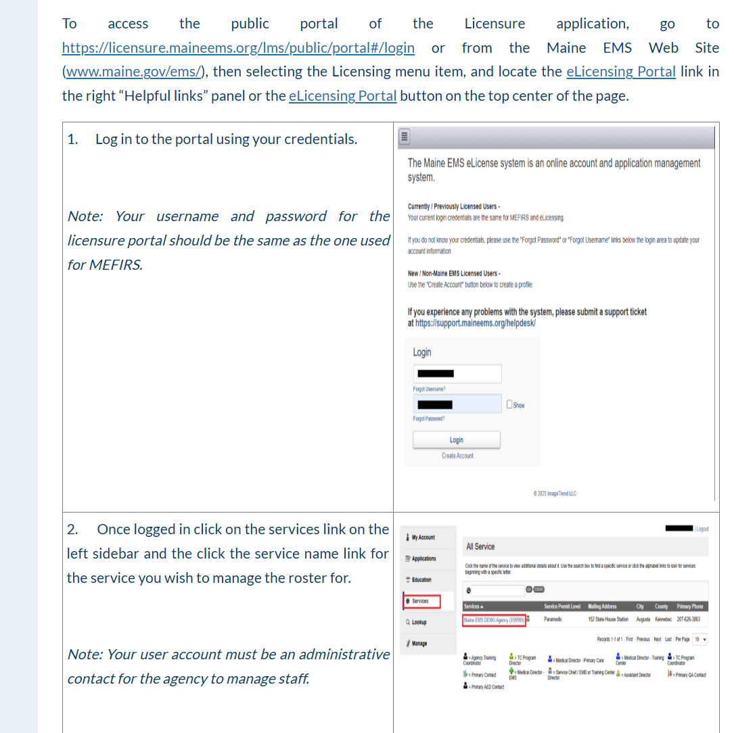
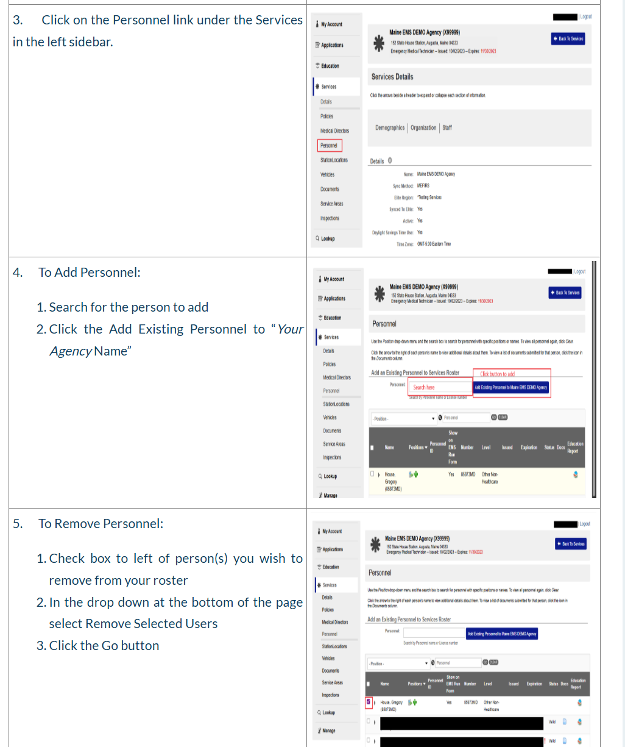

- In MEFIRS, go to your department’s User list and click on their name. In their Employment tab, give them a Personnel ID # that isn’t used by anyone else in your department. Using their badge # in this field isn’t recommended because that could change over time.

- Further down the page is the “Other Duties as Assigned” section: make sure the person is Active in the “Show in Fire Run Form”. Also make them Active in the “Show in EMS Run Form” if you are a department that does both Fire and EMS reporting. If you aren’t a duel department, set them as Inactive for the EMS run form.
- Next to that section, you can make the person Active for any of the activities you want them to do, such as: CQI Reviewer, Inspector or Permit Plan Reviewer. Make sure to choose the green “SAVE” button on the upper right when you are done.
- In their Account Details tab, assign them to the correct permissions group (see details below). Choose the green “SAVE” button on the upper right when you are done.
- This is also where you can unlock their account so they can log into MEFIRS (see details below). Remember to click the green SAVE button if you make changes.

Unlocking someone’s MEFIRS account so they can log in
- Go to their fire department, click on the person’s name in the User list, and choose their Account Details tab
- Go down to Login Access, choose “Yes” to unlock them, and hit the green SAVE button.

***Note: neither FMO nor Maine EMS will unlock a user’s account, because there may be a very good reason why that user has been locked out, and we wouldn’t know about it. That’s why it is the local Fire Agency Administrators who must unlock a user’s account- so there won’t be any mix-ups.

Types of permission groups
Driver: Allows the person to show up on a fire run form, but they won’t be able to create reports

Agency User: This person can edit their own personal data and edit MEFIRS run reports they completed, but they can’t edit other people’s run reports.

Fire Agency Admin: For a fire-only department-this person can add/remove other people from the department’s User list; unlock a person’s MEFIRS account; create run reports and lock/unlock run reports; update the department’s information; manage Checklists and types of Forms.

Fire/EMS Agency Admin: For a department that does both EMS and Fire-this person can do the same activities as the Fire Agency Admin, but includes EMS reports.

Managing a person’s expired password
- Verify that the user’s login access (Account Details tab) is set to “Yes,”
- Review the user’s Demographics tab to confirm the email address is correct
- Instruct the user to use the self-service “Forgot Password” option on the MEFIRS login screen to reset their password securely.

Activating people so they can use Inspection forms
**** People need to be activated in their accounts if they are going to use Inspection forms as part of a department’s use of the Locations/Occupants/Inspections modules.

In a person’s Employment tab, in the “Other Duties as Assigned” box, choose the “Active” button next to the Inspector section. If the person creates a new Inspection report, this setting will allow the system to auto-populate the person’s name in the “Inspector” field of an Inspection form

Make sure to hit the green SAVE button when you are done.

Adjusting the User list to see certain groups of people
Using the different buttons at the top of the User list, you can select what groups of people you want to see in the list. For example: if you want to see everyone who shows up just in the Fire run form, in the “Show in Fire Run Form” you can select the button for YES, then choose the blue “GO” button in the grey section on the right side. The list will automatically sort, to show those people in your User list who only show up in the Fire run form. The list cannot be “frozen” into a certain selection at this time: you will have to change your selection every time you open your User list.

If you want to see all people listed, set all of the buttons to “Both” then choose the blue “GO” button in the grey section on the right side. Then you can Agency Status to Inactive for any people who don’t need to show in your fire run form or have access to your department.

If you click on a person’s name to view their information, make any changes you wish and click the green SAVE button to save your changes. When you click the “Back” button in their account to go back to the User list, the list will still show the last sort selection you made. To clear your sort choices, click the gray “Reset” button in the gray section on the right side.

Adjusting vehicles so they will work in the NERIS fire run form correctly
- The NERIS Units tab in your Resources/Vehicles & Call Signs is managed separately from your Vehicles list, although the list of vehicles that existed in your Vehicles tab was copied into the NERIS Units tab when it was first released to make data entry easier. If some vehicles are missing from your NERIS Units tab, you will have to create them from scratch, using the + New button. Make sure to complete all sections in the vehicle information, except for the NERIS ID # (that will be pulled in from the NERIS database when the API connection is made).

- Under your Resources/Vehicles & Call Signs, if you have units in your NERIS Units tab that are listed as Mutual Aid, you will NOT be able to add Personnel to that unit in a fire run report. Units marked as mutual aid are not your agency's vehicles, but the vehicles from agencies which provide mutual or automatic aid to you. For NERIS reports, these units appear for selection in the Incident Unit Response grid and the Dispatch Unit Response grid, but you will NOT be able to add your personnel to those units. Therefore, if you have units listed in the NERIS Units tab that are marked as Mutual Aid, we recommend that they be inactivated. Make sure to choose the green SAVE button after you make the change. You will be able to document in a different part of the fire run report whether you gave or received aid.

How to set up your supporting agencies for Mutual Aid, Transfer/Transport, etc.
- In your department’s Resources tab, choose “Supporting Agencies & Units”. When the list loads, you will see all the agencies that are in MEFIRS. There are over 500 of them in the system, so you will eventually use the “forward” and “back” buttons down in the bottom right corner to flip through the list.
- Click on the grey section of the “Name” column, so the list of agencies will sort alphabetically.
- The easiest way to manage this process is to inactivate all the agencies on a page and then activate only the ones on the page that your department works with. So, you would go to the far-right column called “Status” and click the “Inactive-Select All” box: this should turn all the buttons underneath to “Inactive”. Then you can look at the list on that page and click the green “Active” button in that “Status” column for any fire department your department uses as mutual aid, etc. Some choices will be greyed out because your department won’t have access to certain agencies.
- Now you can click within each column of an agency’s row and choose YES or NO for each category that the agency may work in with your department. For example, if Acton Fire-Rescue only does Mutual Aid for your department, all the BLUE buttons in its row will be set to NO, except for the Mutual Aid Dept. button, which will be set to YES. Click the green SAVE button in the upper right corner of the list before you move to the next page. Remember to use the “forward” and “back” buttons down in the bottom right corner to flip through the list.

Adding a pay rate
- In your department’s Resources tab, choose “Pay Rates”
- Click on the “+New” button to add an active pay rate and fill out the fields. Note: use a dollar/cents format for the pay rate and include the starting and ending date (if it has an end date that is known). You have start and end dates in your pay rate names for when a pay rate changes. If this happens, you want to preserve the old pay rate in your previous fire run reports, wand have the new pay rates show up in any new fire run reports.
- For the default hours field, this applies only to pay rates where someone gets a certain number of hours automatically: such as when a pay rate is for a weekend call-out, and the person automatically gets 1.5 hours overtime for the call-out.
- Click the green SAVE button in the upper right corner of the page.

Changing a pay rate
- In your department’s Resources tab, choose “Pay Rates”
- Create an updated pay rate with the effective date in the name and no end date listed (if you don’t have an end date).
- Put an end date into the old pay rate’s title (if necessary) by clicking on the pay rate, updating the title , and choosing the No button. You can see a list of Active and Inactive pay rates by adjusting the filter on the right side of the Pay Rate window.
- ** The Standard Report Payroll report will correctly pull the “old” rate and “new” rate when you run a report that covers the time period when there was an increase or change in pay.

Doing bulk updates to incident status in Incident List view
- Navigate to your department’s NERIS incidents by choosing the “Incidents” tab, then go to “View Existing/NERIS Fire”.
- When the incident list loads, choose several incidents on the list by holding down the Control key on your keyboard and click on the incidents for which you want to change the Status. The rows will highlight in light blue.
- Go to the “Bulk Actions” button located under the date range, then use the dropdown menu to choose “Update Status”. Select the Status you want to change for the selected reports.
- The incidents chosen in the list will have their Status updated. This is helpful if you need to change the status of many incidents to either “Complete/Reviewed” or “Billed”, in preparation for their export to the NERIS database.

How to adjust the Auto Numbering field in a NERIS fire report
You can adjust the NERIS Incident Number in your fire reports. This is the read-only number that NERIS receives from your fire incidents. This can be adjusted by going to the tab containing your department’s name and choose the dropdown menu to travel to Configuration/Auto Number/NERIS Fire Auto Number.

These are the steps to take:

- Set “Auto-Generate NERIS Incident Number” to ON.
- Adjust the fields to the format you want (remember that the NERIS Incident Number cannot contain periods, forward/back slashes, asterisks, parenthesis or commas). Incident Numbers can include only the following special characters: an underscore (_), a dash (-) or a colon (:).

Explanation of the different fields:

Reset Auto Number: Select when to reset the auto number count.

Next Auto Number: Enter a positive integer for the next auto number that generates.

Text: (Optional) Enter text to appear prior to the date.

Date Format: Select the date format.

Text: (Optional) Enter text to appear after the date.

Auto Number Format: Select the number of digits to be included in the auto number format.

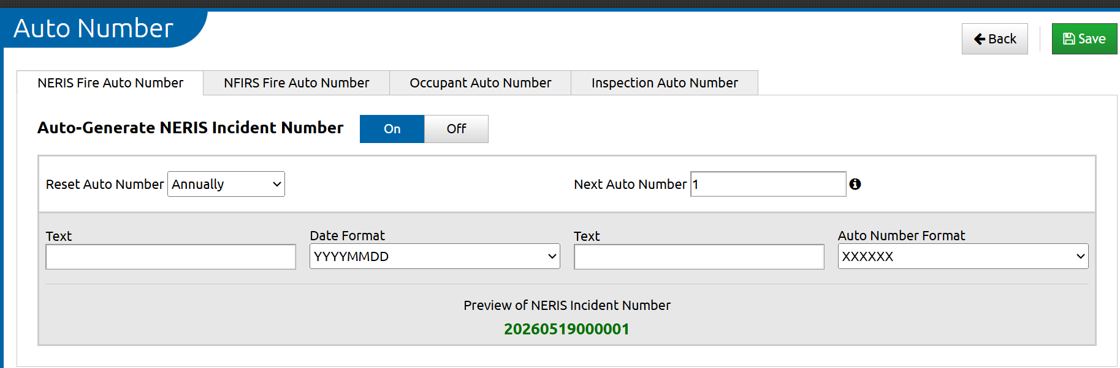

- Preview the auto-generated number and adjust accordingly.
- Choose the green SAVE button at the top of the page to save your changes.

Monitoring NERIS fire reports exporting to NERIS database
- Under your department’s name, choose: Data Exchange/Export History.
- Under “View Export Type”, choose NERIS INCIDENT V1.0 and then click the blue GO button in the grey area on the right side. You will see a list of your incidents that have exported to NERIS.

Sending an entity export to NERIS database
Entity exports need to be done by departments if information changes, including station or vehicles being added or removed. Any time data is pushed to NERIS, the data confirmation process in the department’s NERIS account needs to be done again.
- In MEFIRS, go to the dropdown menu next to your department’s name and choose “Data Exchange”.
- Choose Entity Export
- For Export Type, choose “NERIS ENTITY V1.0”
- For Endpoint, choose “NERIS Endpoint”, then choose the Begin button
- Open the status box to see if it was successful (there should be a green check mark showing)
- Once it is processed and successful, use the dropdown menu on the upper right side to choose “Post Export File” and choose “NERIS endpoint”; then choose “Post”.
- You should see a notification box saying the export was successful, if it went through.
- Check your Vehicles & Call Signs/NERIS Units to see if each unit has a NERIS ID #. If so, the API connection is valid and working between MEFIRS and the NERIS account.

Using the Unit Power Tool in the NERIS fire report
You can use either the Unit Power Tool or the Dispatch Unit Response grid and Incident Unit Response unit/personnel grids to document your unit and personnel response.

- Fill out the sections of the fire report, except for the Dispatch Unit Response grid and the Incident Unit Response grids. Then choose the red Power Tool icon in the lower right corner of the fire run report.

Adding Dispatch Units to the power tool

- Choose the “+Add Dispatch Unit” button and complete the Dispatch Unit Call Sign and Apparatus ID fields.
- Under the Dispatch Apparatus Action section, use the lettered keys or the “Search Dispatch Apparatus Action” box to find the correct action.
  - Example: if you want to find a suppression code, you can choose the button with Q-T on it or type “suppression” in the search field on the right side of the page. A list of codes with “suppression” in them will appear so you can choose the correct one.
- NOTE: choosing the “Update with Incident Times” button will not load in times unless you have entered times into the Dispatch Timestamps section for:
- Dispatch Center Call Received Time
- Dispatch Center Notified Time
- Dispatch Incident Created Time
You will have to enter any other relevant times by hand.
- Enter in any medical response for the unit, as needed.
- When done, choose the OK button at the top of the page. You cannot add Personnel to Dispatch units.
- Repeat the process to add additional Dispatch Units.
- When done, choose the OK button at the top of the page, and to close out of the Power Tool choose the X button on the upper right side of the screen.

Adding Incident Units to the power tool

- Choose the “+Add Incident Unit” button and complete the and complete the Dispatch Unit Call Sign and Apparatus ID fields.
- Under the Apparatus Action section, use the lettered keys or the “Search Apparatus Action” box to find the correct action.
  - Example: if you want to find a suppression code, you can choose the button with Q-T on it or type “suppression” in the search field on the right side of the page. A list of codes with “suppression” in them will appear so you can choose the correct one.
- NOTE: choosing the “Update with Incident Times” button will not load in times unless you have entered times into the Incident Timestamps section for:
- Incident Alarm Date Time
- Incident First Arriving Unit Date Time
- Incident Clear Time
- In Service Date Time
You will have to enter any other relevant times by hand.
- Enter in any narrative or medical response for the unit, as needed.
- When done, choose the OK button at the top of the page, and to close out of the Power Tool choose the X button on the upper right side of the screen.

Adding Personnel to the Incident Units in the power tool

- Within the box for a specific Incident Unit, choose the “Edit Personnel” button.
- Choose the “+ Add Personnel” button
- Choose one or more names to be added to the unit.
- For each name, choose the arrow on the right side of the person’s row.
- Add information as needed. If you had previously added, in your User list, the person’s Rank, Pay Rate and Pay Rate Description, these should populate into the fields.
- Choose the “OK” button at the top of the page to save the person’s information. You can also delete the person from the unit by choosing the “Delete” button.
- To close out of the Personnel list, choose the X button on the upper right side of the screen, or choose the “Back” button to return to the main Power Tool page.

