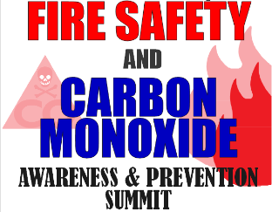
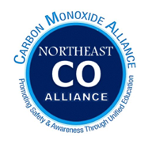

Save the Date!

What: Northeast Carbon Monoxide Awareness and Prevention Summit
Where: New Hampshire Fire Academy in Concord, NH.
When: October 25, 2023
Agenda: TBA

The program is designed to enhance community risk reduction education and provide information on research and national efforts. Attendees for the event will include Emergency First Responders, Fire and Life Safety Educators, Medical and Health Professionals, Technicians, Government Officials, and anyone who wishes to know about carbon monoxide safety.

Contact:
Richard E. Taylor, MA, Senior Research and Planning Analyst
NFIRS State Manager
Office of the Maine State Fire Marshal
45 Commerce Drive, Ste. 1
Augusta, Maine 04330
Office (207) 626-3873

