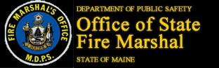
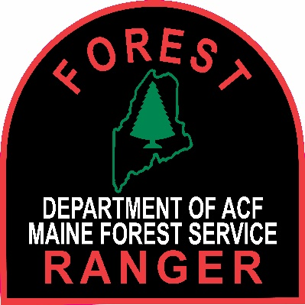

FOR IMMEDIATE RELEASE
JUNE 28, 2022
CONTACT PIO Shannon Moss
Shannon.Moss@Maine.Gov

Maine Forest Service and Fire Marshal’s Office Concerned About Uptick in Burn Injuries from Outdoor Fires

Summer is the peak season to enjoy outdoor fires for cooking and recreation, but that fun can lead to serious injuries in seconds.

In 2021 Maine had 76 incidents of burn injuries resulting from people being unsafe with their outdoor fires. Those 76 incidents accounted for 36% of the total number of burn injuries in our state. Of that 76 two of those incidents were fatalities. In 2022, with the summer season just getting started the Fire Marshal’s Office predicts another year of high numbers.

On Thursday, June 30, 2022, at 11:00 a.m. Officials with of the Forest Service and Fire Marshal’s Office will hold a news conference to talk about this concerning trend, what fire officials are seeing as the cause of these injuries and what people can do to keep themselves and their families safe.

With the 4th of July weekend approaching, there will be a lot of people camping and having campfires in the woods and in their backyards. In addition to the focus on reducing burn injuries, this event will also offer some tips on burning safely and responsibly, to prevent wildfires.

As we approach the dryer, hotter part of summer, Maine’s Forest Rangers advise people camping and recreating outdoors to keep their campfires small and make sure they are completely out before leaving the area. In the last five years, there has been a 35% increase in wildfires caused by campfires. These fires were either too big or left unattended and spread into the woods threatening or damaging structures.

AGENCIES: Maine Forest Service and Fire Marshal’s Office

EVENT: News conference and demonstrations regarding hazards and safety of burn piles, campfires, and fire pits

DATE: Thursday, June 30, 2022, at 11:00 a.m.

LOCATION: Maine Forest Service’s Southern Region Headquarters at 2870 North Belfast Ave (Route 3), Augusta.

