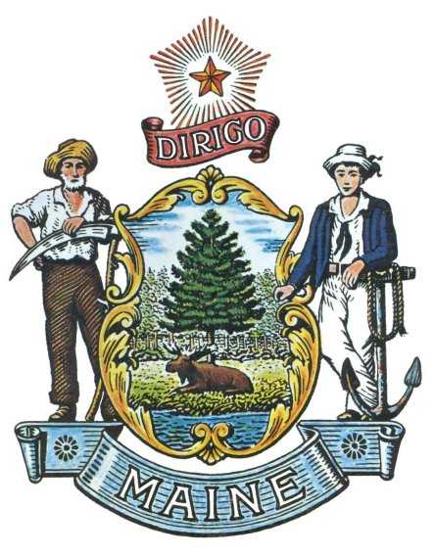

MAINE FIRE PROTECTION SERVICES COMMISSION

Best Practices Award
Adopted March 3, 2003

Introduction
The Maine Fire Protection Services Commission (“Fire Commission”) was established in the year 2000 by state statute (Title 5 MRSA Chapter 319 § 3371) to monitor and evaluate the state's fire protection services system on a continuing basis and to provide recommendations to the appropriate state agencies and to the Legislature regarding necessary changes in the fire protection services system.

Best Practices Award Establishment and Goal
The Best Practices Award was established by the Fire Commission in 2002 to highlight individuals, fire/rescue departments, agencies, organizations, communities and others within Maine who show initiative and creativity; develop, adopt and improve the best ideas; and encourage and support safety and health for emergency responders in Maine. The award is given periodically as “best practices” are identified, with an annual presentation at the “Maine Fire/Rescue Services Day at the Legislature”. Awards are publicized by press release and posting on the Commission Web site.

Eligibility and Application Criteria
Nominations must be made on the Best Practices Award Nomination Form and include a cover letter briefly stating the importance of recognition of the best practice.

Selection Criteria
The Best Practices Award Selection Committee shall choose recipients based on the following criteria:
- Positive impact, or potential impact, on health and safety of Maine citizens and fire/rescue members.
- Initiative and creativity shown by nominee(s).
- Innovations shown through development, adoption or improvement of ideas and concepts.
- Cost-effective and collaborative solutions to fire/rescue challenges

Nomination Process
The Commission will post the Best Practices Award information and nomination form on its Web site. Nominations may be made at any time, and submitted electronically or via the mail. Nominations received will be acknowledged by the Fire Commission staff. The Selection Committee will meet as needed to review nominations and recommend awards. The Fire Commission members will determine awards by vote.

Notification
Within 15 days of award, Fire Commission staff will notify the nominator that the nominee has been selected. Initial presentations may be made, with formal presentation to follow at the “Maine Fire/Rescue Services Day at the Legislature”.

Forward Nominations to:
Maine Fire Protection Services Commission
Best Practices Award Nomination
Office of State Fire Marshal
52 State House Station
Augusta, ME 04333-0052

MAINE FIRE PROTECTION SERVICES COMMISSION

Best Practices Award

NOMINATION FORM

Person Making Nomination

Name Organization

Address State Zip

Phone: Day Evening Email:

Person/Organization Being Nominated

Name Organization

Address State Zip

Phone: Day Evening Email: Web site:____________

Brief Description of Best Practice
(Who, what, when, where, how, why, etc). Use back and/or additional pages if necessary

Why is this important , or potentially important? What impact will/might it make?
Use back and/or additional pages if necessary.

Mail to:
Maine Fire Protection Services Commission, Best Practices Award Nomination
Office of State Fire Marshal, 52 State House Station, Augusta, ME 04333-0052

Staff Use:

Date Received___________ Confirmation by ____________________ Date_____________________
Award Date _____________ Presentation by _____________________ Date _____________________
Notification ___________ By_________

__ Financial Need Rating (1-5) cc’s: Committee / JK / Chief / ______

