
Notice of Virtual PUBLIC Zoom Webinar
for the Maine Coordinating Working Group on Access and Mobility

This is a biweekly meeting of the Maine Coordinating Working Group on Access and Mobility as required per LD 1451 Resolve. It will be a live virtual meeting held via Zoom Webinar: https://mainestate.zoom.us/j/86029922735

MaineDOT invites you to attend a bi-weekly live virtual public meeting of the working group. This meeting will take place on Wednesday, November 26, 2025 from 2:30 pm-3:30 pm.

Questions, comments, or inquiries can be directed to the Project Manager below.
Jennifer Grant Project Manager Maine Department of Transportation,
24 Child Street, 16 State House Station, Augusta, Maine 04333-0016.
Telephone: 207-624-3227 Email: Jennifer.grant@maine.gov

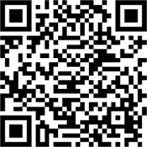
Access to this and all other active meeting presentations is available on our Public Meetings Page located at bit.ly/mainedot-meetings. You can also access those meetings using the QR Code to the right.

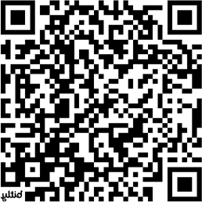
For more information regarding MaineDOT Public Involvement, including meeting accessibility and available accommodations you may request for all types of meetings, please see the link to our Background Information page. bit.ly/background-publicinvolvement. You can access that page using the QR Code to the left.

