LINE UP AND SUBSTITUTION OF
NON-RESERVED VEHICLES:
These rules will not supersede any Town ordinance where ferry traffic lines up on property not owned by the State of Maine. Violation of these procedures will result in the vehicle being directed to the end of the line unless otherwise stated.

a. Vehicles must line up in the non-reserved line on a first come, first served basis. All vehicles must fit within the painted lines on the pavement. All vehicles must line up in the direction of the flow of traffic. When signaled by Ferry Service personnel loading the vessel, drivers will proceed on board as directed.

b. The selection of vehicles for loading will begin 15 minutes prior to the scheduled departure time. A licensed driver must be in the vehicle and prepared to board immediately. If a vehicle does not have a driver, the vehicles behind it will be loaded. Once the vessel is loaded, other vehicles may move ahead of the vacant vehicle. Vehicles must park close enough together to prevent another vehicle from parking between them.

c. One vehicle may be substituted for another in line provided the substituting vehicle would require the same ticket and completely fit in the vacated space. Ex: a car for another car, or a car for a pickup. A truck may be substituted for another truck provided the line truck is of equal or greater length than the substituted truck.

d. Placing a vehicle in line means it, or a substitute vehicle, must go on a boat within 24 hours. Moving a vehicle out of line, without replacing it with a substitute, means forfeiting its position and it must go to the end of the line. Any person who leaves a vehicle in line for more than 24 hours (unless the scheduled ferry is cancelled) will be assessed a violation fee and may have the vehicle towed. Passage aboard MSFS vessels will not be granted until the violation fee is paid.
e. Vacant spaces in the line may be filled, except during the loading process for that line. The loading process is defined as the following: From 15 minutes prior to scheduled departure until the time when all the occupied vehicles have been loaded or moved up in line. The vehicle must completely fit inside the vacated space.

f. A space cannot be created by moving other vehicles.

g. Only motorized vehicles will be permitted in the lineup area. A vehicle towing a trailer, vehicle or other equipment must remain with the object being towed.

h. Vehicles that are not registered and inspected will be refused passage by the Maine State Ferry Service.

i. Trucks must provide their length and gross vehicle weight to Ferry Service personnel. The Ferry Service may require a dated weight slip.

Rockland Terminal
Safe Vehicle Policy
(I.A.W. MSFS TARIFF #11)

To ensure a safe and environmentally friendly trip for our passengers & crew the following vehicle conditions will be deemed unsafe for transport:

- Significant oil or any fuel leakage
- Unsecured loads
- Loose bulk loads without impermeable covers, i.e. tarps
- Excessive leakage of liquid or semi-liquid material
- Loads with excessive noxious odors
- Uneven loads which may adversely effect vehicle & vessel stability
- Vehicles not under their own power, unless in tow
- Vehicles with substantial defects that limit their ability to maneuver on & off the vessel
- Vehicles transporting hazardous or dangerous material prohibited by State and/or Federal Law
- Non-commercial transportation of pressurized gas, i.e. propane, oxygen, acetylene, etc., if not transported as follows:
- In open vehicles
- Properly secured and upright
- Hoses and regulators disconnected
- Safety caps & plugs in place
- 20 lb tanks (2 max.)
- Non-commercial transportation of fuel i.e. gasoline, kerosene, etc., if not transported as follows:
- In open vehicles
- Properly secured, and upright
- Safety caps (no nozzles) in place
- 5 gal. approved container (2 max.)

Rockland Terminal Reservations Policy
(I.A.W. MSFS TARIFF #10.2 and POLICY MEMORANDUM #112)

- Reservations for regular vehicles and trucks may be requested up to one month in advance of travel date.

- Reservations go off sale two hours before scheduled departure times.

- Return reservations may be made at the same time as long as the return travel date is within one month of the date that the reservation is made.

- Requests for reserved space will not be accepted prior to the opening of the terminal (from which the travel will take place) to the public.

- Upon opening of the terminal to the public, reservations will be granted as follows:

  - First Priority: Walk-ins. Reservations will be accepted on a first come first serve basis.
  - Second Priority: Requests via Phone. Requests for reservations being made via phone will be processed starting at 9:30 am daily.

- Reservations may also be made from another MSFS Terminal with reservation fees being paid at that terminal.

- Reservations may not be made between terminals until both terminals are open to the public.

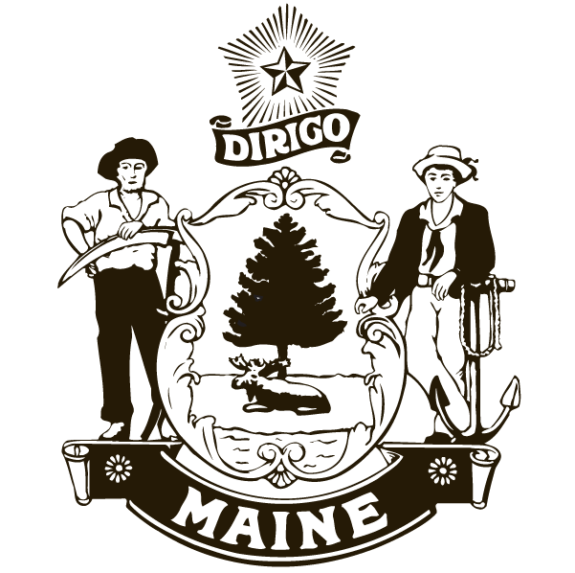

517A Main Street
Rockland, ME 04841
(207) 596-5400

Maine State
Ferry Service
Rockland Terminal
Vehicle Policies

I.A.W. MSFS Tariff # 11
&
Policy Memorandum #112

