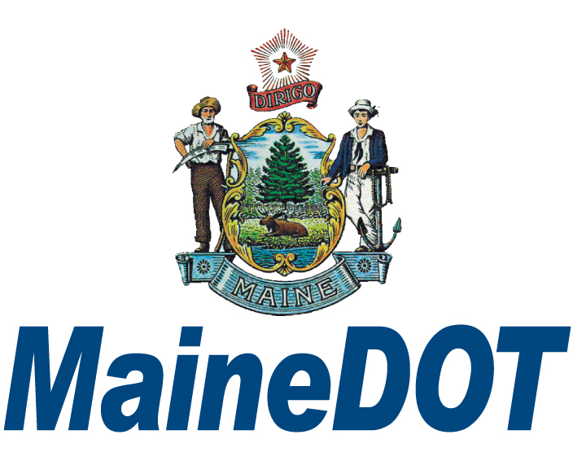

MAINE DEPARTMENT OF TRANSPORTATION

Contract Procurement Office (CPO)

Insurance Waiver Request Protocol

The Department has policies which require consultant firms to carry a minimum amount of insurance coverage listing MaineDOT as additional insured. It is understood that, on an individual case basis, there may be need to waive certain requirements relating to these policies.

**Note:** Negligent Acts Errors and Omissions has been added as an insurance type to the Professional Liability Section of the Waiver Request Form. If a firm does not have licensed professionals, i.e. Engineers, Appraisers, etc., they must get a Negligent Acts Errors and Omissions Policy in place of the Professional Liability Policy.

Following are the procedures to request **an *Insurance Waiver, Reduction, or Increase of Insurance Deductible,*** along with the respective forms.

1. Insurance Waiver forms can be found in CPO’s “R” Drive.
2. The Waiver Request form must be completed by the Consultant and submitted with their proposal package.
3. The completed form must be reviewed and signed by the Contract Administrator with their comments.
4. The Contract Specialist will forward the completed request form to the Director of CPO along with the following:

* A current Certificate of Insurance;
* The Consultant Proposal - if a project specific contract;
* The Scope of Work - if a multi-PIN contract.
* The insurance policy declaration page - If the Insurance Waiver Request form is requesting an increase in the insurance deductible.

1. A fully executed waiver form will be returned to the Contract Specialist for incorporation into their pre-execution review package.
2. The fully executed waiver form must be scanned into TEDOCS with the respective contract.
3. The Contract Specialist will return a copy of the fully executed waiver form *(whether approved or denied)* to the Consultant for its files.